FAQs Template: Sample Questions / Responses

Profile Page

How can I change my profile photo?

On your profile page, click on Edit my profile to change your image and then save.
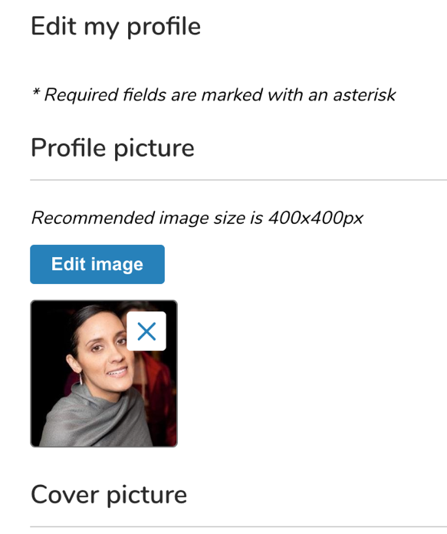

How do I change my banner image?
On your profile page, click on Edit my profile and scroll down to edit your banner image, then save.

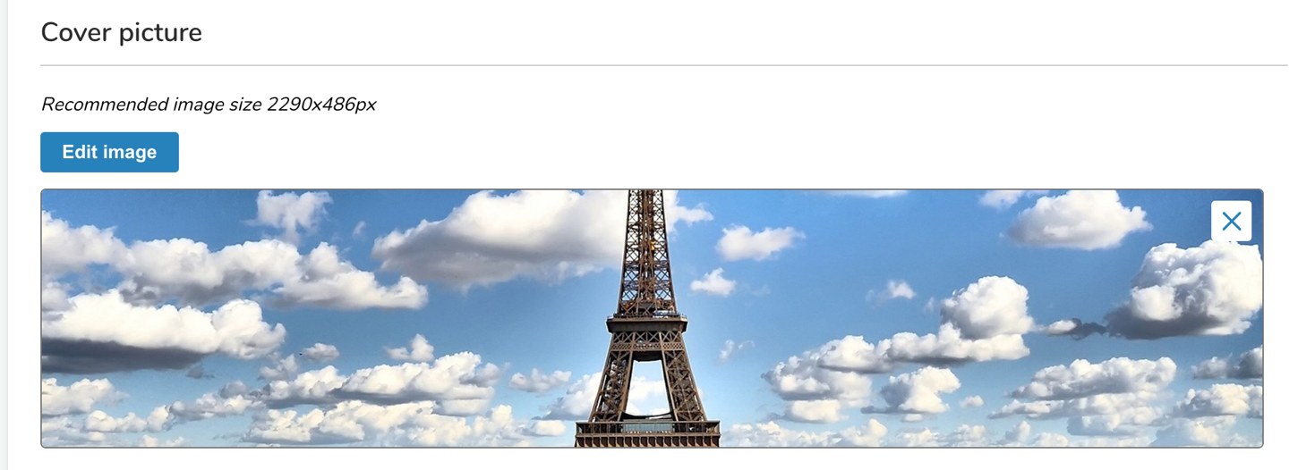

Can I change my contact email or update its visibility to others in the community?
Yes, you have the option to change your email address or add a secondary email to your profile. You may also update the visibility to all those in your community or only to community admins by clicking on the Edit link in the right-hand corner of the Contact on your profile.
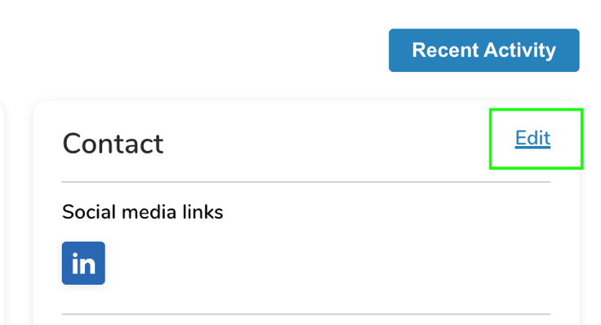

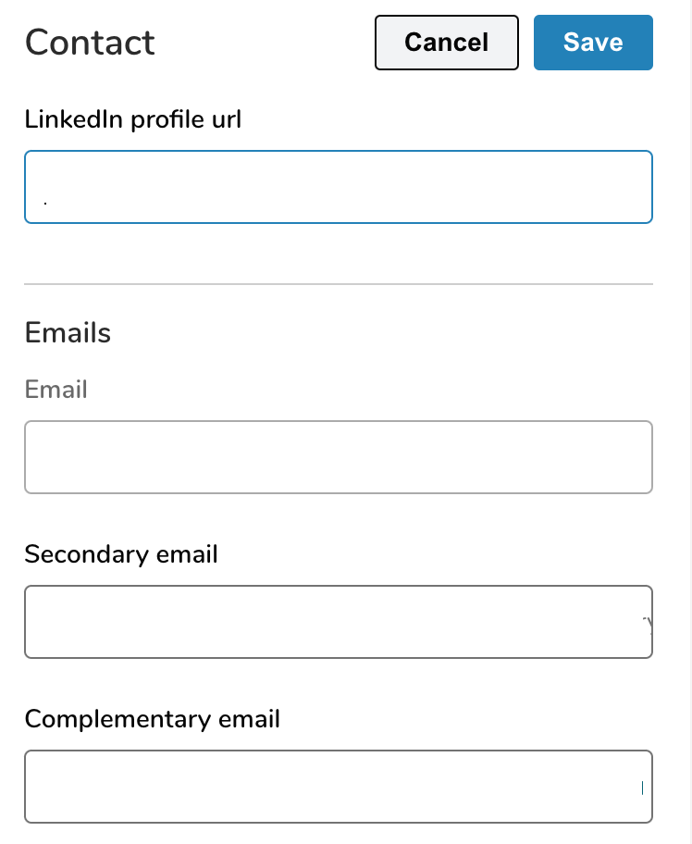

How can I add social media handles to my profile page?
Under Contact on the right hand side of your profile page, click on the Edit in the top right-hand corner of the box to populate your options.
May I change my permission settings? For instance, I don't want others to send me emails or I do not want to receive certain email notifications.
If you prefer to be contacted via email, you may update the visibility of your email to Visible to admin only. For additional notifications settings, click on your profile photo on the top right corner of the screen and make changes under the My Settings.

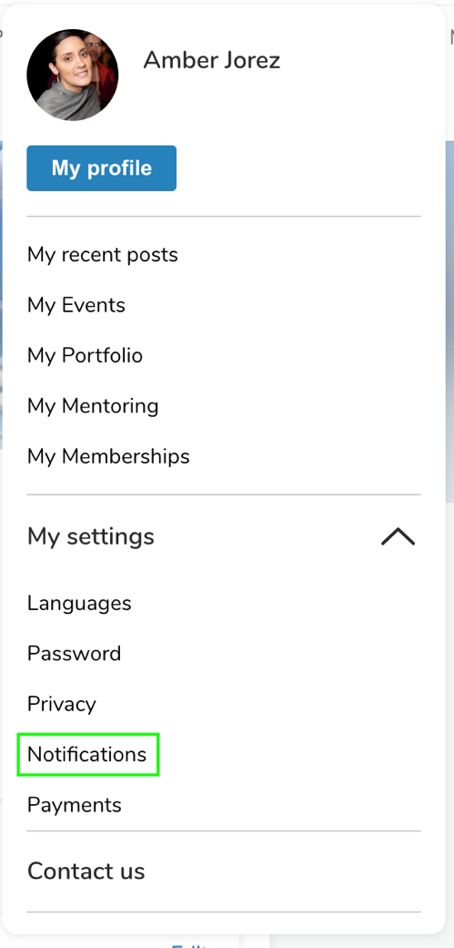

How do I modify my location on the Google map?
Click Edit my profile on your profile page and scroll down to modify your location, then save. If you type in and then click on the drop-down option, your location may be updated. The Google map does not reflect your location entered in the Postal Addresses section.
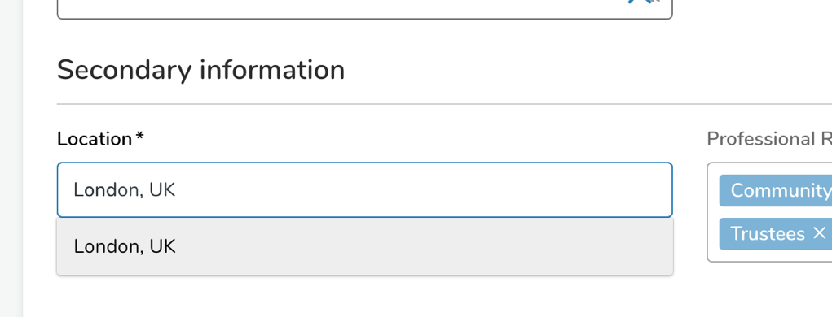

Live Feed
What activity reflects on the Live Feed? Can I make actions private?
When you post a comment or create an event, it will reflect on the Live Feed. Notify people means a notification email will be sent to those people you tag. Every action on the feed is public. There is a private messaging function which you may use to send private communications.
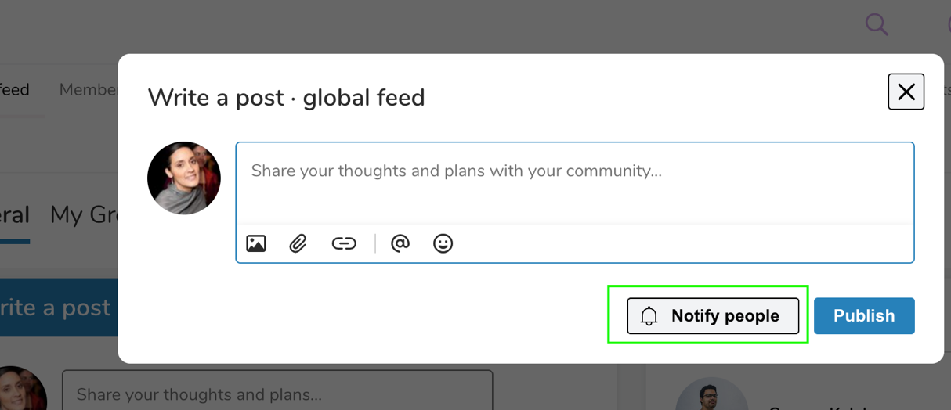

Events
Where do the events I create appear?
Any event you create on the Live Feed tab also appears on the Events tab. You can use the search functionality on that tab to view events created by both admin and users.
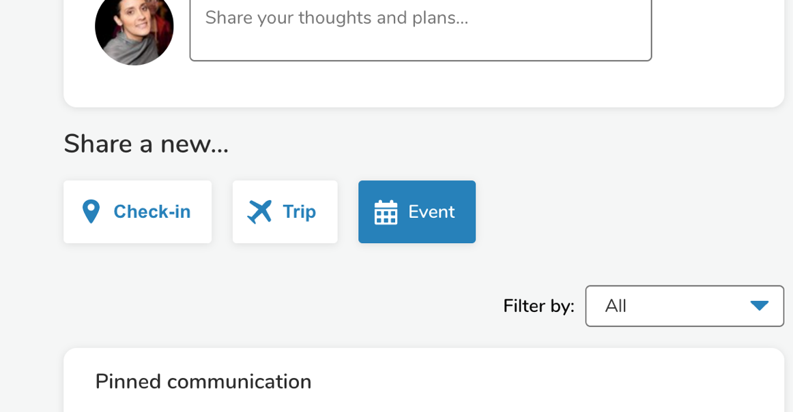
News
How do I post news?
Only admins can add posts to News tab. Therefore, please use the Live Feed functionality to share news within the general community or in a specific group.

Opportunities
Can I share professional opportunities with others in the community?
You may share your opportunities with the general community by clicking into the ‘Publish Your Opportunity’ and submitting the opportunity details. This post will be available on the Careers ta. You may also notify others in your community should you choose.
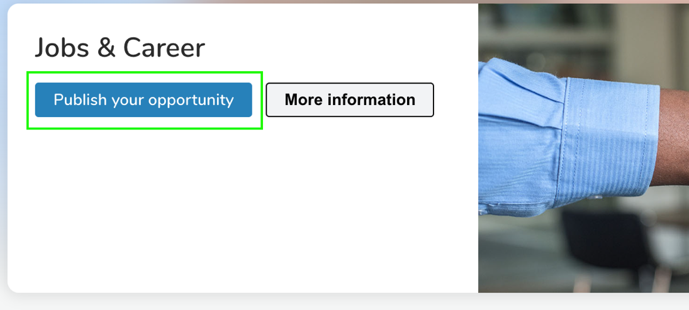

Groups
May I create a group?
Yes, you may create/host a group by contacting our team at: CONTACT EMAIL.
What is the difference between making a group public and private?
If a group is public, anyone logged into the community platform will be able to access the group and follow it. With a private group, those logged into the community would have to request to join. Private groups are marked on the upper left-hand corner of the group card in the Group index page.

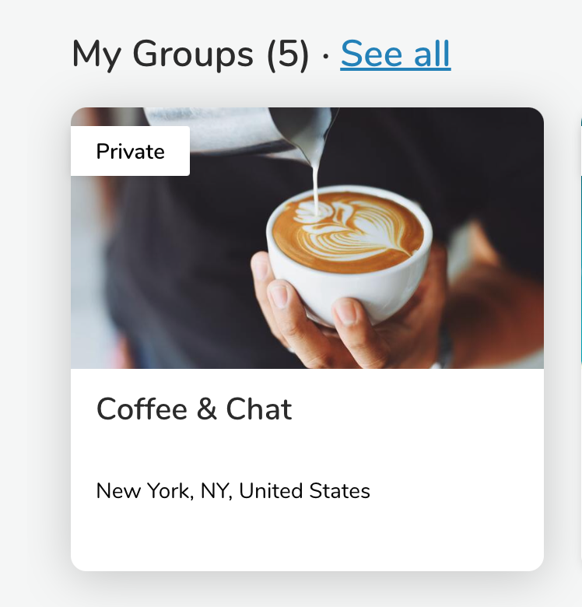

Forums
Is this the place to post news related content or discussions?
Forums allows you to share your thoughts or start a discussion with fellow members.
Can people vote on responses?
Yes, fellow members may vote on responses by clicking the up and down arrows in front of each comment. Click Votes in the answers section to see all the votes by ranking.

Media Center
May users share media in the Media Center?
No, only administrators may upload and share media on this tab to the larger community which includes documents, photos, external links / video embeds and small video uploads.

Portfolios
May users share media through Portfolios?
Yes, as a compliment to the Media Center, this function allows individuals to upload media to their personal profiles to showcase to fellow community members. Media options include documents, photos, and external links / video embeds. It can be found under your personal icon or on your profile page.
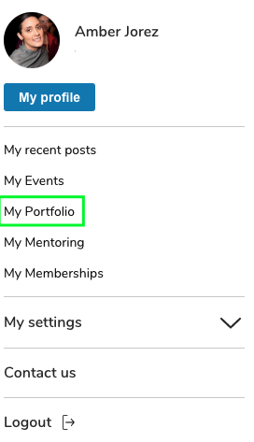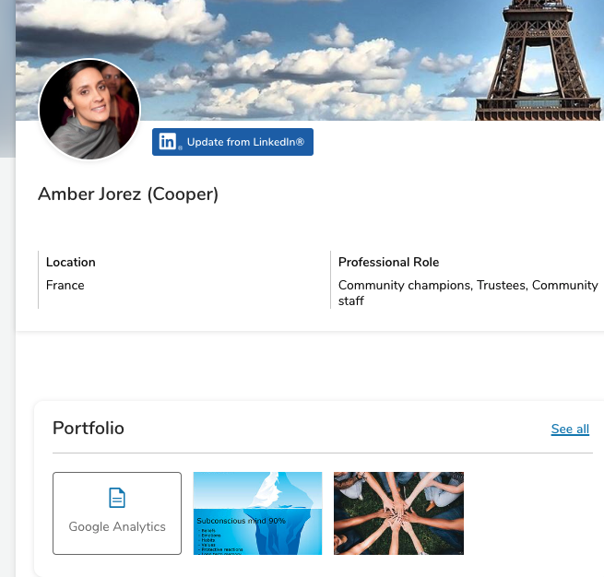

Can I create and share my own articles using this option?
Yes, when you click on the Add button found on your personal portfolio page, you may choose the option to create a personal article or blog post by clicking on Article.
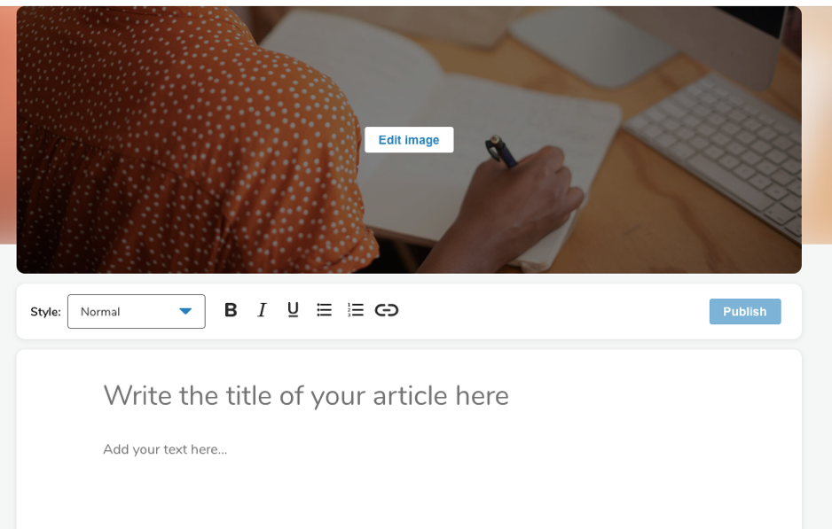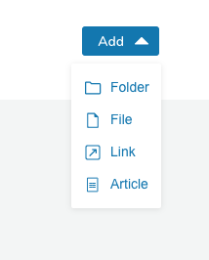

Projects
What is the purpose of this tab?
To showcase current projects of community members seeking fellow collaborators.
Can interested financial investors provide funding through this interface?
No, those types of transactions would have to take place outside the platform. This feature is intended to showcase and highlight your projects. It does not have crowdsourcing options.
Is it possible for anyone on my team to edit our project?
Yes, any profiles listed as team members on a project page will be able to make edits to their particular project posting.
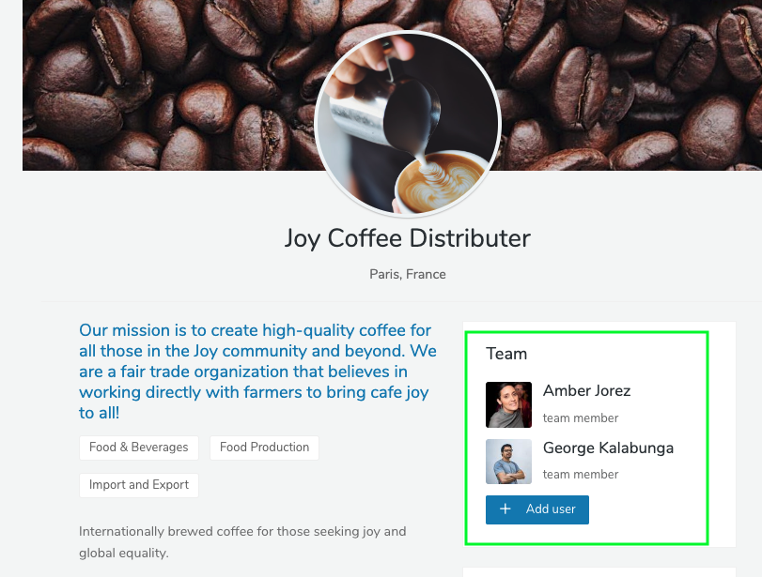

Organizations
Can I add my organization?
Yes, you may add your organization by going into the Organizations tab and complete the form that pops up when you click on Create Organizations at the top of your screen in the banner.
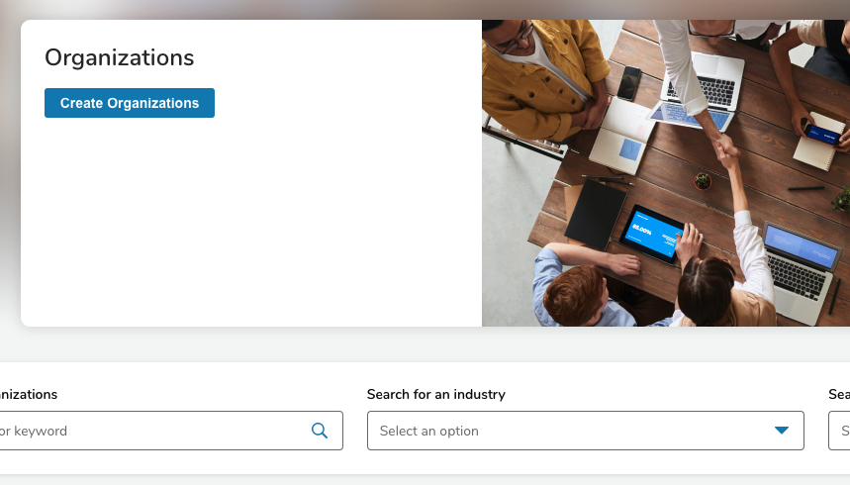
Can I edit the organizations profile after it’s created?
If you created the organization, then you should be able to edit it.

People Directory
What keywords are available to search in the Directory?
- Emails (primary, secondary, and complementary)
- Clusters
- First name, Last name
- Maiden name
- Headline
- Experience, Company name, Position, and Industry

May I search other filters?
Yes, you may do so by clicking on the More filters option on the search bar above the map.
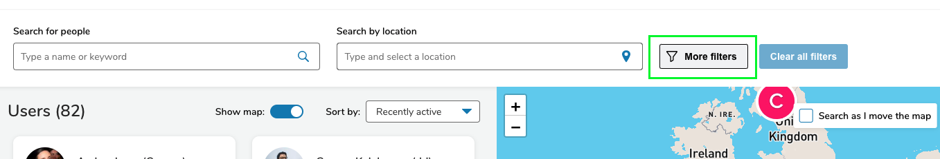
Why do some of those in the directory only have the letter of their first name?
For those who have not activated or have not uploaded a photo to their profile, only the first letter of their first name will appear.
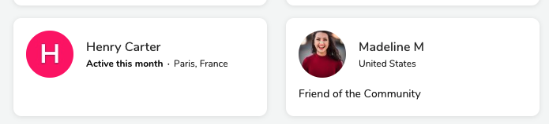

Personal Settings
Where may I edit my privacy settings?
You may find your privacy settings under the personal icon found in the upper right-hand corner of your platform.
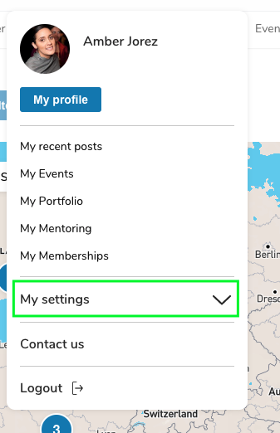
What settings may I edit?
You may edit settings related to your preferences including: Languages, Password, Privacy, Notifications, and Payments.
May I determine my own language settings?
If you’re community offers additional languages, you may choose from the drop-down list. This will update the language on the main menu and many of the fields but not all the content and not on posts.
May I view my payment history for memberships and events?
Yes, you may these details under the Settings > Billing tab.
Can I update my Password?
Yes, you may find the option to change your password any time under My settings located as a drop-down under your profile icon on the top navigation bar.
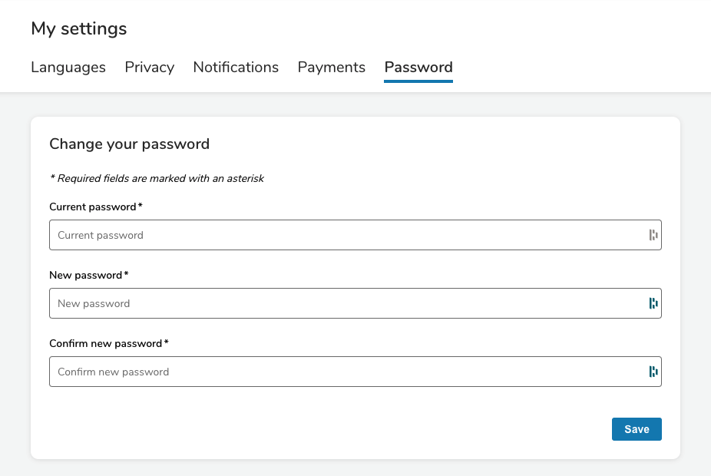

Additional Tips
Are there additional options for viewing the pages in different languages?
Yes, many web browsers now have language extensions that you may plug in so you may view your pages in your language of choice. Some of the most popular web browsers that offer language extensions and are compatible with your online network include: Chrome, Firefox, Edge and Safari

