I Am From: Exploring Our Stories Through Poetry
Freedom 250
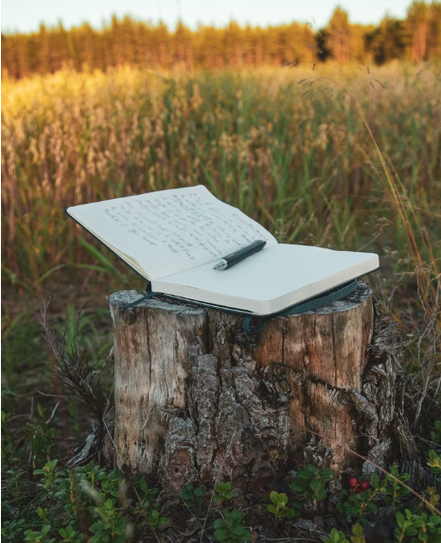
Overview
In this lesson, students explore key themes of identity and journey as they learn about early 20th Century American urbanization. Students will analyze and write poetry as they make connections to aspects of their own personal histories.

Goals
As a result of this lesson, students will be able to:
- express personal histories through writing
- understand reasons people in the United States moved from rural to urban areas in the 20th Century
- deepen their appreciation for unique histories and experiences that shape American culture
As a result of this lesson, teachers will be able to:
- use student-centered teaching practices
(CC0)
- guide students to express creativity through original poems
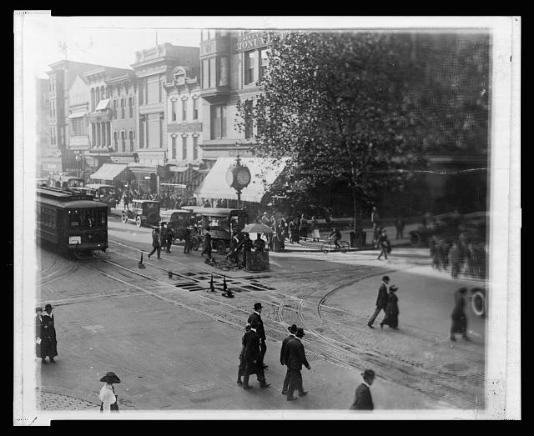
- prompt students to collaborate, communicate, and think critically

Lesson Materials
IN YOUR CLASSROOM
- Paper and pencils or pens
- Chalkboard and chalk or whiteboard and markers
Library of Congress Prints and Photographs Division

- Projector for displaying lesson materials or copies
PROVIDED WITH THIS LESSON PLAN
- Rural and Urban Historical Pictures
- Timeline Reading
- “I Am From” Poem and Poem Template
- Key Vocabulary Glossary
- Additional Resources and References

Preparation
- This lesson explores early 20th Century American urbanization. Consider reasons that people move from rural to urban areas in your context, either historical or contemporary. It may be helpful to find examples from your country to reference or compare during the lesson. Think about ways to connect ideas of home and national history for your students.
- Review the Procedures and Lesson Materials sections, then determine the formats you will use for the Lesson Materials.
  - Many items can be photocopied, enlarged, or projected onto the board or a wall. More suggestions for formatting these materials are in the Procedures steps and notes.
  - After selecting the formats for the activities, prepare the required number of materials to suit your class size, considering how many groups or individuals will participate in each lesson stage.
- Read the Skills and Language Topics and Key Vocabulary lists below. Review the glossary (Lesson Materials - Item D) to see how key vocabulary terms are used in this lesson. Will you need to activate prior knowledge, pre-teach, or otherwise provide scaffolding (support) for your students beyond the suggestions in the Procedures section? See the Variations and Extensions section for ideas.

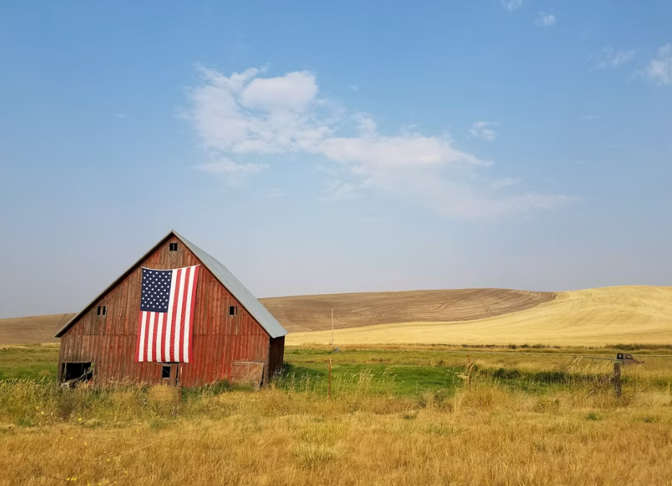
Skills and Language Topics
- Reading and visual analysis for main ideas and details
- Developing and expressing creativity through imagination and innovation
- Communicating ideas in writing
Key Vocabulary
- conditions
- crowded
- factory
- immigrate
- manufacturing
- opportunity
- rural
- surrounded
(CC0)
- urban

Procedures
TIME | STEPS | NOTES
5 min | 1. Warm up: Senses brainstorming  - Begin by eliciting the five senses: sight, smell, hearing, taste, and touch. List them on the board.  - Display the two historical pictures. Ask a volunteer to read the image titles aloud.  - Direct students to imagine that they are in one of the pictures. What would they see? Smell? Hear? Feel? Is there something they could taste in the picture?  - As students describe the images, provide vocabulary support and prompt them to be specific. Write key vocabulary words and phrases on the board. | Whole class discussion  Lesson Materials – Item A  See the Variations and Extensions for more descriptive vocabulary development ideas.
10 min | 2. Timeline Reading  - Display or hand out copies of the timeline. Direct students to read the timeline and look at the images to answer the comprehension questions. (Answers for teachers are in parentheses below.)  - What is the main idea of the timeline? What title could you give this reading? (The timeline shows the history of Americans moving to larger cities. Titles will vary.)  - What kind of jobs did most Americans have before 1870? (They worked on farms.)  - What happened in 1908 that helped cities grow? (The first mass-produced car, the Ford Model T, was introduced.)  - Why did many people move to the cities? (People moved to find better jobs and work in factories.)  - Where do most Americans live today? (Most Americans live in cities today.)  - Review the answers as a class. Ask students to think about how the timeline connects to the pictures they examined at the beginning of the lesson. Where would they place the pictures on the timeline? | Individual  Lesson Materials – Item B  Whole-class debrief
15 min | 3. Explore: “I Am From” poem  - Ask students to think about how they might feel if they experienced the events in the timeline. Invite a few volunteers to share their ideas with the class. Tell students they will read a poem imagining how a young person might feel if they moved from their rural home to a city.  - Direct students to read the example poem individually. As they read, they should underline or highlight details that relate to the five senses. Then ask them to compare their annotations with a partner and identify which of the five senses each underlined detail relates to.  - When ready, conduct a whole class discussion. Check students’ understanding of the poem and ask volunteers to share the sensory details they identified. As students share details, create a mind map or write notes on the board, labeling the details from the poem, such as:  - Sounds: cluck of chickens, moo of cows, car horns  - Smells: fresh bread, dirt after the rain, smoke  - Sights: wide fields, shining stars  - Textures: soft quilt, hot bread  - Tastes: sweet corn, juicy tomato  - Elicit additional format features of the poem by asking key questions such as:  - Are all of the lines in complete sentences? (No)  - Why are some words in quotes? (They are things others have told the writer.)  - Wrap up the discussion by emphasizing that everyone has a story about where they are from. | Individual  Lesson Materials – Item C  If students finish early, they can practice reading the poem aloud to their partner.  Teacher-led class discussion
15 min | 4. Identity map and poetry writing  - Point out that the poet describes they are “from” places, things, people, and other memories. Remind students that experiences shape us, not just locations.  - Invite students to create their own identity mind map on a piece of paper. Explain that this is a kind of brainstorming to help them create their own “I Am From” poems. Encourage them to include specific sensory details for each of the five senses and to be creative as they think about where they are from.  - When ready, direct students to write their poems using the ideas they have brainstormed. If desired, they can use the poem template.  - As students work, ask prompting questions to help them be more specific in their language use, and encourage them to consult each other or reference materials for additional vocabulary support. | Individual  Lesson Materials – Item C
15 min | 5. Wrap Up: Poetry reading and reflection  - After students have written their poems, invite them to read their poems aloud to each other in small groups.  - As time permits, ask students to reflect on their experience with the poems with discussion questions such as:  - How did you feel reading your poem aloud?  - What was similar and different between your poem and your classmates’ poems?  - What did you learn about yourself in this activity?  - How does the poem help you think about and share your personal history? | Small group sharing and reflection  See the Variations and Extensions for other options to share the students’ poems.

Variations and Extensions
VARIATIONS

1. General Differentiation and Scaffolding
- Based on students’ levels and prior knowledge, teachers can choose to cover the lesson content over one or more class sessions. This approach will allow teachers to provide additional instruction, review, and support as appropriate.
- Teachers can modify the poem template as needed to suit their students’ levels. Use more or fewer prompts or select a different poem format such as an acrostic poem (a poem where the first letter of each line spells out a word or phrase when read vertically). Students can also write their poems without using a template, if desired.

Historical Perspective Taking
- To engage critical and creative thinking skills, students can write their poems from the perspective of a historical figure, either from the United States or from their own culture.

3. Poetry Share
- Depending on interest and available time, there are many options for sharing the students’ “I Am From” poems in Step 5. Some options may include swapping poems with a partner, a gallery walk, or a poetry slam where each student recites their poem for the class.

EXTENSIONS

1. Descriptive Vocabulary Development
- Use this lesson as an opportunity to help students develop specific descriptive vocabulary. Teach about adjectives and adverbs and spend time brainstorming and/or using reference materials to build a descriptive vocabulary word bank.
- Bring in objects with unique textures, smells, or sounds. Ask students to select an object, explore its sensory qualities, and write detailed descriptions. Encourage them to use specific language to describe their experiences.
- To help students connect places and sensory experiences, ask students to spend a few minutes sitting still in a familiar place in their home or around the school. Ask them to make notes about what they see, smell, hear, feel, or (possibly) taste. Students can use these ideas in their poems or in other descriptive writing.

2. Adding Visual Elements to Poetry
- Invite students to include a visual element with their written poems, such as drawings, photos, or a collage. These could be displayed in the class or shared with family members.
- Interested students might use tech tools to create a video or post for social media with music, voiceover or text, and images for their poems.

3. Poetry Book
- Celebrate your class’s poetry by compiling all of the poems into a booklet or website to share with others.
External links are provided for informational purposes only; there is no implied U.S. Department of State endorsement of the individuals, views, opinions, media content,
or privacy policies contained therein.

Unless otherwise noted, images in this resource are in the public domain or “no-attribution required” items. If sharing, adapting, or remixing portions of this lesson plan, please respect excepted permission and licensing statements noted in the credit statements for individual images, graphics, or other content. To learn about Creative Commons licenses, their uses, and their restrictions, visit the Creative Commons license explanation site.

I Am From: Exploring Our Stories Through Poetry – Lesson Materials
America250

A. Rural and Urban Historical Pictures

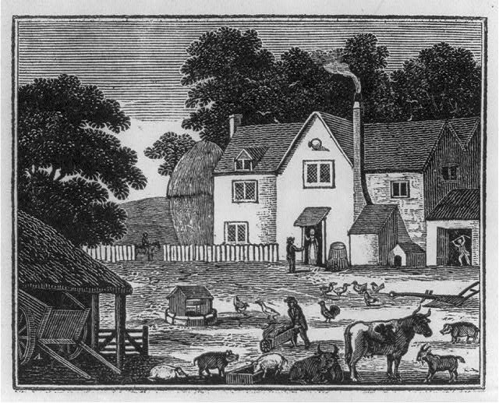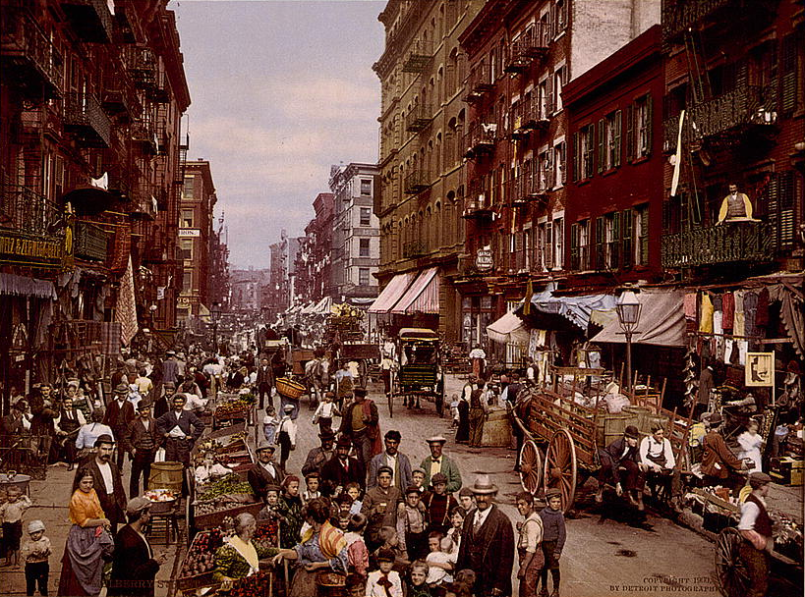
Farm Scene showing house, animals, people working (1800s)

Image: Library of Congress, Prints & Photographs Division.
Mulberry Street, New York City (1900)

Photo: Library of Congress, Prints & Photographs Division, Detroit Publishing Company Collection.

B. Timeline Reading

Urban areas grew crowded as more people moved away from their farms to work in factories. People worked to improve living and working conditions.

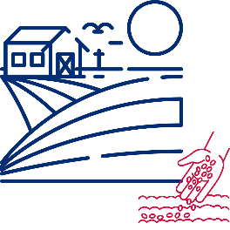

Americans continued moving from rural areas to urban areas for better jobs. Many people worked in manufacturing jobs.
Electricity and machines became more advanced. More factories were built, and cities grew quickly because factories needed workers.


Before 1870
The Ford Model T was introduced in 1908. It was the first mass-produced car. Cars caused more city growth.
By 1920, more than half of Americans lived in cities, representing a big change in American culture. Most Americans live in cities today!
Many people immigrated to the United States from Europe. They wanted to find better jobs and more opportunities.
Most Americans lived in rural areas. They worked on farms.
1880s
1900s
1920s



1890s
1910s
1870s

Comprehension Questions
- What is the main idea of the timeline? What title could you give this reading?
- What kind of jobs did most Americans have before 1870?
- What happened in 1908 that helped cities grow?
- Why did many people move to the cities?
- Where do most Americans live today?

C. “I Am From” Poem and Poem Template

I Am From

I am from a simple home surrounded by wide fields and shining stars
From planting and growing and harvesting.
I am from the cluck of chickens and the moo of cows.
I am from tall grass and the smell of dirt after the rain.

I am from Mama and Papa and baby brother
From Grandma’s sewing and Grandpa’s singing.
I am from “Be careful!” and “Wash your hands!”
and “Help me with this.”

I am from soft bread hot in my hands
From sweet yellow corn and juicy red tomatoes dripping on my chin.
I am from the long road disappearing over the hill.

Now I’m from crowded streets and new faces
From smoke and car horns in the air
And streetlights blinking in the night.

I am from soft, homemade quilts wrapping me tightly and keeping me safe.

“I Am From” Poem Template

I am from (object or place from your childhood),
from (action) and (action).
I am from (description of your home),
and (sensory detail or memory).
I am from (family members’ names)
from (family action or memory) and (family memory).
I am from (family saying or cultural expression)
and (another saying or belief).
I am from (food or dish),
from (food or dish) and (another food or dish).
I am from (description of place).
I am from (location of family photos or heirlooms),
and (object or place that holds meaning),
I am from (summary of your identity or what shaped you).

D. Key Vocabulary Glossary
Definitions below illustrate how key vocabulary terms are used in the context of this lesson.

conditions n. the situation in which people live and work
crowded adj. full of people with little space to move around
factory n. a large building where things are made, usually using machines
to immigrate v. to move to another country
manufacturing n. making things, usually by machines in a factory
opportunity n. a chance for a positive situation
rural adj. related to farms and countryside
surround v. to be on all sides
urban adj. related to a city or town

E. Additional Resources and References
Discover more about the topics featured in this lesson! The links below can help teachers build background knowledge before teaching the lesson and can inspire additional adaptation or extension ideas to use with students.
- This lesson and the “I Am From” poem template were inspired by the poem “Where I’m From,” written by George Ella Lyon in 1993.
- The American English website hosts a poetry collection written by students from all over the world in celebration of National Poetry Month. Check out an example “I’m From” poem written by a student from Jordan!
- The Library of Congress has collections of historical images of the United States to explore, including the farm scene woodcut from 1818 and the New York City in 1900 photo featured in this lesson.

