What is Service Learning?
SERVICE LEARNING
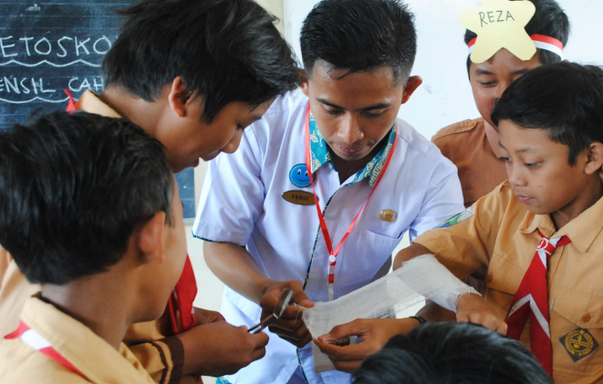
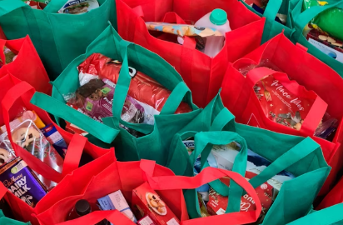

Overview
This lesson introduces vocabulary and concepts related to service learning. Students explore four types of service learning and consider questions related to planning a service-learning project in their community.

Goals
As a result of this lesson, students will be able to:
- understand the difference between community service and service learning
- use vocabulary associated with service learning
- identify questions to answer before planning a service-learning project
(CC0)
As a result of this lesson, teachers will be able to:
- assess students’ understanding of service learning
- create opportunities for students to practice collaboration and spontaneous speech

guide students through the initial step of planning a possible service-learning project

Lesson Materials
IN YOUR CLASSROOM
- Paper and pencils or pens
(CC0)
- Chalkboard and chalk or whiteboard and markers
- Blank paper (optional)
- Projector or TV for displaying images (optional)
- Clock or timing device
PROVIDED WITH THIS LESSON PLAN
- Word Litter
- Community Service and Service Learning Venn Diagram
- Four Types of Service Learning Jigsaw Reading Texts
(CC0)
- Service Learning Mind Map
- Exit Ticket
- Key Vocabulary Glossary

TESOL Focus: 21st Century Skills – Collaboration and Communication

Preparation
- This lesson utilizes techniques to help students develop collaboration and communication skills as they explore the idea of service learning. Brainstorm or research a few examples of service-learning projects in your community, country, or region to use as examples during the lesson. It may be helpful to find images to share with the class. Consider how these projects support the community and also develop collaboration and communication skills.
- Review the Procedures and Lesson Materials sections, then determine the formats you will use for the Lesson Materials.
  - Many items can be photocopied, enlarged, or projected onto the board or a wall. More suggestions for formatting and sharing these materials are in the Procedures steps and notes.
  - After selecting the formats for the activities, prepare the required number of materials to suit your class size, considering how many groups or individuals will participate in each lesson stage.
  - If using printed versions of Items A, C, and E, cut up the materials and group them as needed.
- Read the Skills and Language Topics and Key Vocabulary lists below. Review the glossary (Lesson Materials - Item F) to see how Key Vocabulary terms are used in this lesson. Will you need to activate prior knowledge, pre-teach, or otherwise provide scaffolding (support) for your students beyond the suggestions in the Procedures section? See the Variations and Extensions section for ideas.


Skills and Language Topics
- Identifying meaning in prefixes
Iran (CC0)
- Comparing and contrasting ideas
- Reading for main ideas and details
- Brainstorming ideas and asking questions
- Teamwork: communicating and collaborating to complete a series of tasks

Key Vocabulary
(CC0)
- collaboration  - collecting  - combination  - community  - communicate | - concerns  - confidence  - cooperate  - litter  - service

Inquiry Notebook Prompts
PROMPTS | NOTES
- Think about a time when you helped someone. Who did you help? What did you do? What skills did you use to help? What did you learn from helping?  - Think about a time when someone helped you. Who helped you? What did they do? What skills did they need in order to help you? What did they need to know in order to help you? | Adopt or modify these prompts for Inquiry Notebook engagement with concepts featured in this lesson. Before teaching this lesson, direct students to select one prompt to respond to in their Inquiry Notebook. For these prompts, consider asking students to answer using a graphic organizer such as a chart with sentence starters.

Procedures
TIME | STEPS | NOTES
5 min | 1. Prepare for Word Litter Game  - Explain that other languages have influenced English. One of those languages is Latin.  - Write the morphemes com, con, and co on the board. Explain that these prefixes mean “together” or “with” and they appear in many English words.  - Write the words listed below on the board. Check to see if students know the meanings of these words. If students are unfamiliar with these words, you can share the definitions from the glossary included with this lesson.  - collaboration  - collecting  - combination  - community  - communicate  - concerns  - confidence  - cooperate  - Ask students to share any other com, con, or co words they know in English, and list them on the board. | Teacher-led class discussion  A morpheme is the smallest meaningful part of a word. These morphemes are prefixes because they are added at the beginning of a word.  Lesson Materials – Item F  Some additional English words using “com,” “con,” or “co” prefixes include: compete, competition, company, complete, compass, complex, compact, common, companion, compost, coexist, co-worker, coordinate, and many others.
10 min | 2. Word Litter Game  - Ask each student to take one slip of paper from the Word Litter handout, crumple it into a ball, and litter (intentionally drop) it in the classroom. Each slip will have a com, con, or co prefix or an ending to complete a word.  - Ask students to do a litter pick up by finding a piece of paper. Consider playing music or setting a timer and asking students to continue to mingle until time is up or the music stops.  - After each student finds a piece of paper, instruct them to find another student with a prefix or word ending to make a complete word in English. Tell students to use the list of words on the board (from Step 1) as a guide to make sure they have found a partner to create a correct word.  - Bring students back together for a brief wrap-up discussion of the activity.  - Ask students: “When did you cooperate in this activity?” (working together to pick up litter, finding a partner to make a word)  - Ask students: “When did you communicate in this activity?” (sharing information from their slips of paper to find a match)  - Explain that picking up litter is an example of community service, doing something to help the community.  - Work together as a class to create a list of other kinds of community service. | Pair work  Lesson Materials - Item A  Collaboration and communication are important 21st Century Skills. These skills are valuable for students as they continue their academic studies. Employers also regularly include these skills as necessary for successful employees. This activity helps students practice forming and asking questions, listening, and giving answers.  Whole-class discussion
10 min | 3. Introduction to Service Learning  - Give each student a copy of the Community Service and Service Learning handout.  - Explain that this handout is a Venn diagram, a visual way to show similarities and differences between two things.  - Ask students to fill in the blanks on the Venn diagram using the com, con, and co words from the previous activity.  - Review the answers together as a class and review the similarities and differences between community service and service learning. While both involve volunteering and helping others, service learning usually happens over a longer period of time and involves more preparation and reflection activities. | Individual  Lesson Materials – Item B  Community service is a positive activity. However, the extra preparation, time, and reflection involved in service learning allows for greater impact in the community as well as increased skills development in students. Teacher-led class discussion
10 min | 4. Reading Jigsaw - Four Types of Service Learning: Part 1, Preparing  - Divide the class as evenly as possible into four groups. Assign each group one of the Four Types of Service Learning jigsaw reading texts and distribute copies of the reading texts accordingly.  - Tell students to read their group’s text and work together to add one additional example. Explain that teams should make sure that everyone in their group understands the type of service learning described in their text. | Groups created by dividing the class into quarters  Lesson Materials - Item C  Ideally, all students will have a copy of the reading text; however, students can work with one copy per 2-3 students.
20 min | 5. Reading Jigsaw - Four Types of Service Learning: Part 2, Sharing  - Create mixed groups of four that include an “expert” representing each type of service learning. If you have an odd number in one or more of the original groups, direct those groups to send one pair of experts to a mixed group.  - Tell the mixed groups to work together to learn about the four types of service learning and add more examples of each type.  - As time permits, conduct a whole-class debrief, answering any questions about the texts and asking a few students to share interesting insights from their mixed group discussions. | New mixed groups of 4 (each reading text is represented in the mixed groups)  Monitor students as they work, offering support as needed.
20 min | 6. Service Learning Mind Map  - Remind students that preparation and planning are important parts of service learning.  - Give each student a copy of the Service Learning Mind Map handout or display it with a projector so all of the students can see it.  - Explain that a mind map is tool to help organize information and ideas. If needed, review the example mind map to help students better understand the purpose.  - Divide students into small groups of 3 to 5 students. Give each group a blank piece of paper to create their mind map. As an alternative, give each group a section of a chalkboard or white board to create their mind map.  - Ask each group to choose one example service-learning project. Tell them to write the example they choose, and what type of service learning it is, in the middle of their paper.  - Tell students to work with their group members to think of questions they need to ask before starting this project. Students should create a new circle for each question and connect it back to their project idea. As students brainstorm possible answers or additional questions, they should create new circles and connections.  - If there is time, ask students to exchange mind maps with another group. As they review it, ask them to put a star next to ideas they like. Ask them to expand the map by creating additional questions and adding ideas. | Groups of 3 or 4 students  Lesson Materials – Item D  Try to keep groups smaller so that everyone has a chance to share ideas and questions. It’s okay if several groups choose the same project. Each group will have some unique questions and ideas. If you have especially creative or independent students, you can let them choose their own project.  Group work like this requires students to cooperate to negotiate tasks and share ideas. To help ensure that all group members participate, you can tell students that each group member must contribute one question or idea before anyone else can add a second one.
10 min | 7. 3-2-1 Exit Tickets  - Ask a volunteer to pass out the exit tickets or have students copy the task information onto their own paper from a model supplied on the board.  - Ask students to choose one of the three exit ticket tasks to answer before leaving the class. Encourage students to think quietly for a moment about what they learned during the lesson, reviewing materials or talking with a partner as needed.  - Collect written responses from students who choose written tasks. Ask students who choose to complete the verbal response to come up and tell you their answers one at a time. | Individual  Lesson Materials - Item E  Letting students choose how they want to communicate (through writing or speaking) helps to increase student confidence and motivation. Exit tickets also help teachers assess students’ understanding of and interest in lesson topics.

Variations and Extensions
VARIATIONS

1. General Differentiation and Scaffolding
- Based on students’ levels and prior knowledge, teachers can choose to cover the lesson content over two or more class sessions. This approach will allow teachers to provide additional instruction, review, and support as appropriate.
- To make the lesson more accessible for lower-level students, teachers can use labeled visuals to reinforce vocabulary terms, show realia (real items) related to the lesson, and adjust the complexity of the reading texts. Teachers can create mixed-level groups for the reading jigsaw activity, so students can assist each other. Teachers can also assign less-proficient students to groups reading the first two texts, which contain simpler language.

2. Listening Jigsaw
- Replace Step 4 written texts with the audio texts from this lesson’s resource page. Set up “listening stations” in different parts of the room and let groups listen to their text at a low volume as many times as needed while making notes. Alternatively, let groups listen in different nearby rooms/areas or make the audio available on student mobile devices for headphone listening.

3. Impact Project Mind Map
- If students have already started the Impact Project for this unit (“Creating a Student-Led Service Club”), they can use the mind map activity to brainstorm questions and ideas for developing their club or planning a club service-learning activity.

EXTENSIONS

1. Write a Service-Learning Proposal
- Ask students to expand their mind map into a paragraph-length proposal for “How I Want to Serve My Community.” The paragraph should include:
  - What issue they want to address;
  - Why they want to address it;
  - What skills they would use;
  - What knowledge they would need to learn; and
  - What resources are available.
- This could be a good lead-in to the unit’s Impact Project, in which they’ll be creating a club led by students to engage in service learning.

2. Create a Survey
- Ask individuals or groups to create and distribute a short survey for class or community members to learn more about their service-learning topic. Ask them to share the results in a future class or a shared digital space.

External links are provided for informational purposes only; there is no implied U.S. Department of State endorsement of the individuals, views, opinions, media content,
or privacy policies contained therein.

Unless otherwise noted, CC0 images in this resource are “no-attribution required” items sourced under the Pixabay simplified license, Pexels License, or Unsplash license. If sharing, adapting, or remixing portions of this lesson plan, please respect excepted permission and licensing statements noted in the credit statements for individual images, graphics, or other content. To learn about Creative Commons licenses, their uses, and their restrictions, visit the Creative Commons license explanation site.

What is Service Learning? – Lesson Materials
SERVICE LEARNING


A. Word Litter
Copy and cut up; distribute one half of a word to each student. Add more word parts as needed so that each student has one slip of paper.
col | laboration
col | lecting
com | bination
com | munity
com | municate
con | cerns
con | fidence
co | operate

B. Community Service and Service Learning Venn Diagram

Often short term

Often focuses on physical tasks like _______________ litter from public areas

Can develop skills and _____________________

Goal is service

Helps others in the _______________

Involves volunteering

Mid-to-long term

Can involve research, __________________, sharing ___________________, and more!

Develops academic and personal skills

Students ___________________ their ideas, ____________________ with others, and reflect on their actions

Goal is a ____________________ of service plus learning and developing skills

Community Service
Service Learning

B2. Community Service and Service Learning Venn Diagram (Teacher Version)

Often short term

Often focuses on physical tasks like collecting litter from public areas

Can develop skills and confidence

Goal is service

Helps others in the community

Involves volunteering

Mid-to-long term

Can involve research, collaboration, sharing concerns, and more!

Develops academic and personal skills

Students communicate their ideas, cooperate with others, and reflect on their actions

Goal is a combination of service plus learning and developing skills

Community Service
Service Learning

C. Four Types of Service Learning

Direct Service
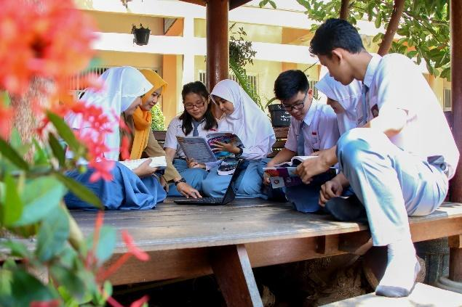
This is a type of service learning that involves face-to-face work with someone or something. Examples of direct service are cleaning up a park, organizing an afterschool program, visiting people, and bringing food to families in the community. What are some other examples?
(CC0)

_______________________________________________________________________________________________________
_______________________________________________________________________________________________________
_______________________________________________________________________________________________________

Indirect Service

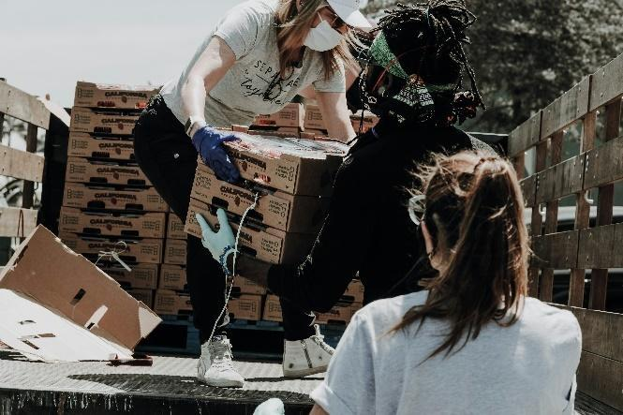
This is a type of service learning that may not be face-to-face. While it may involve work with others, it is work that happens behind the scenes. Examples of indirect service are organizing help after a storm, raising funds, and collecting needed resources. What are some other examples?
(CC0)
_______________________________________________________________________________________________________
_______________________________________________________________________________________________________
_______________________________________________________________________________________________________

Research
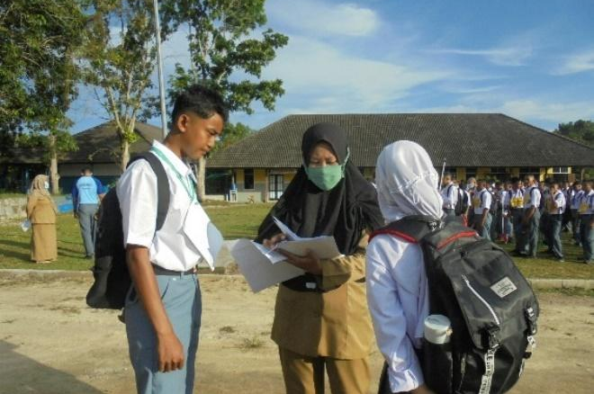
This is a type of service learning that involves finding out new information that helps lead to action. Examples of research are collecting or analyzing scientific data and surveying a group. What are some other examples?
(CC0)

_______________________________________________________________________________________________________
_______________________________________________________________________________________________________
_______________________________________________________________________________________________________

Championing


This is a type of service learning that involves supporting an issue or solution. Examples of championing are raising awareness, communicating concerns, and sharing knowledge through social media. What are some other examples?
(CC0)

_______________________________________________________________________________________________________
_______________________________________________________________________________________________________
_______________________________________________________________________________________________________

D. Service Learning Mind Map
A mind map is a way to organize information and find connections between ideas. Mind maps help with brainstorming, planning, and problem-solving. The example below shows a mind map for students thinking about a service-learning project to clean up a beach.
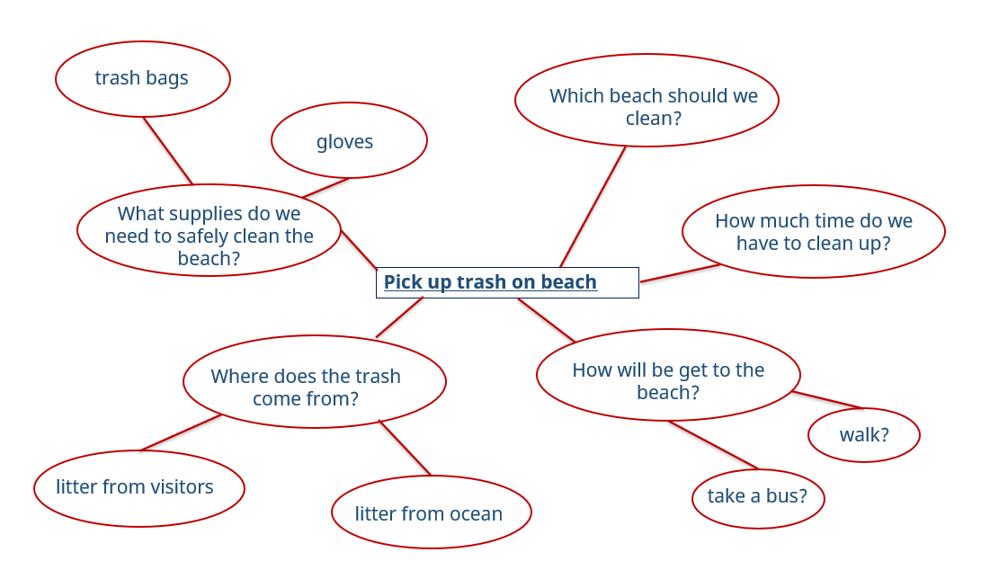

Instructions:
- Read the ideas for service-learning projects listed below.
- Choose one example that you might like to try.
- Write your example in the middle of the mind map.
- Add questions and ideas to the mind map to help you think about and plan your service-learning project.
Idea 1: Collect supplies to repair homes damaged in a recent flood.
Idea 2: Start a community garden.
Idea 3: Help people learn how they can help stray cats.
Idea 4: (Add your own idea!)

E. Exit Tickets

Copy and cut up; distribute one ticket to each student.

3-2-1 Exit Ticket
Complete one of the tasks below. Circle your choice, then complete the task below.
- Choose 3 com, con, or co words and write a sentence using all 3 words.
- Tell me 2 things you enjoyed about working in groups today.
- Write 1 question you have about today’s lesson.
______________________________________________________________________________________________________________________________________________________________________________________________________________________________________________________________

3-2-1 Exit Ticket
Complete one of the tasks below. Circle your choice, then complete the task below.
- Choose 3 com, con, or co words and write a sentence using all 3 words.
- Tell me 2 things you enjoyed about working in groups today.
- Write 1 question you have about today’s lesson.
______________________________________________________________________________________________________________________________________________________________________________________________________________________________________________________________

3-2-1 Exit Ticket
Complete one of the tasks below. Circle your choice, then complete the task below.
- Choose 3 com, con, or co words and write a sentence using all 3 words.
- Tell me 2 things you enjoyed about working in groups today.
- Write 1 question you have about today’s lesson.
______________________________________________________________________________________________________________________________________________________________________________________________________________________________________________________________

3-2-1 Exit Ticket
Complete one of the tasks below. Circle your choice, then complete the task below.
- Choose 3 com, con, or co words and write a sentence using all 3 words.
- Tell me 2 things you enjoyed about working in groups today.
- Write 1 question you have about today’s lesson.
______________________________________________________________________________________________________________________________________________________________________________________________________________________________________________________________

F. Key Vocabulary Glossary
Definitions below illustrate how Key Vocabulary terms are used in the context of this lesson.

collaboration n. working with others to create or do something
collecting v. bringing things together from different people or places
combination n. two or more things joined or mixed together
community n. a group of people who live in a particular place or who are part of a specific group
communicate v. to share or exchange ideas and information
concerns n. feelings of worry
confidence n. a belief in your own ability to do things and be successful
cooperate v. to work together with others in order to achieve or complete something
litter v. to purposely leave trash in a public place; n. small pieces of trash left in a public place
service v. to give people something they need

