The Community Web
SERVICE LEARNING
Overview
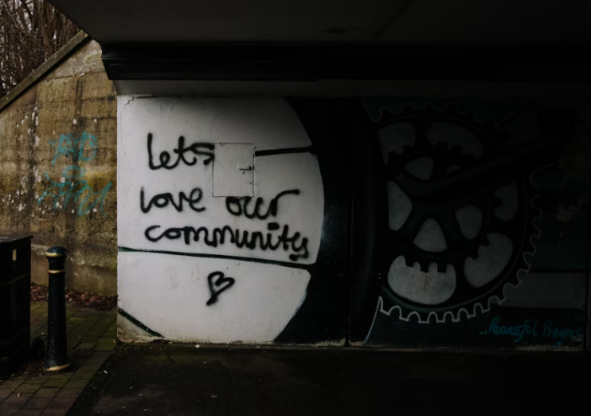
In this lesson, students explore how their unique interests, talents, and perspectives can contribute to building a stronger, more connected community. They will be introduced to a step-by-step approach for helping their community: identifying a local issue, researching its causes and impacts, and engaging with community leaders to advocate for meaningful change.

Goals
As a result of this lesson, students will be able to:
- develop a deeper appreciation of the value and importance of community
- recognize their potential to create positive change within their community
- feel empowered and motivated to contribute as responsible, engaged community members
- communicate ideas about the role of young people in addressing community issues
- develop deeper skills in collaborative problem solving
(CC0)
As a result of this lesson, teachers will be able to:
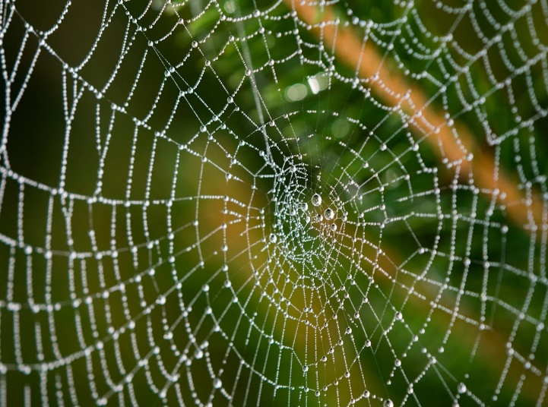
- guide students in making connections between community needs and their own skills or passions
- encourage critical thinking and respectful discussion about real-world community issues
- encourage collaboration and creative problem solving among student groups

Lesson Materials
IN YOUR CLASSROOM
- Paper and pencils or pens; chalkboard and chalk or whiteboard and markers
- Projector or TV for showing videos (optional)
- A ball of string or yarn
PROVIDED WITH THIS LESSON PLAN
- Summary of Laya’s Changemaker Journey
(CC0)
- Learning from Laya's Story; Learning from Laya's Story (simplified)
- Exploring Your Role in the Community
- Key Vocabulary Glossary

TESOL Focus: 21st Century Skills – Collaboration and Communication

Preparation
- This lesson utilizes techniques to help students develop collaboration and communication skills as they explore the ideas of service learning and serving their community. Brainstorm or research a few examples of people or groups addressing community needs to use as examples during the lesson. It may be helpful to find images to share with the class. Consider how these projects support the community and also develop collaboration and communication skills.
- Review the Procedures and Lesson Materials sections, then determine the formats you will use for the Lesson Materials.
  - Many items can be photocopied, enlarged, or projected onto the board or a wall. More suggestions for formatting and sharing these materials are in the Procedures steps and notes.
  - After selecting the formats for the activities, prepare the required number of materials to suit your class size, considering how many groups or individuals will participate in each lesson stage.
- Read the Skills and Language Topics and Key Vocabulary lists below. Review the glossary (Lesson Materials – Item D) to see how Key Vocabulary terms are used in this lesson. Will you need to activate prior knowledge, pre-teach, or otherwise provide scaffolding (support) for your students beyond the suggestions in the Procedures section? See the Variations and Extensions section for ideas.

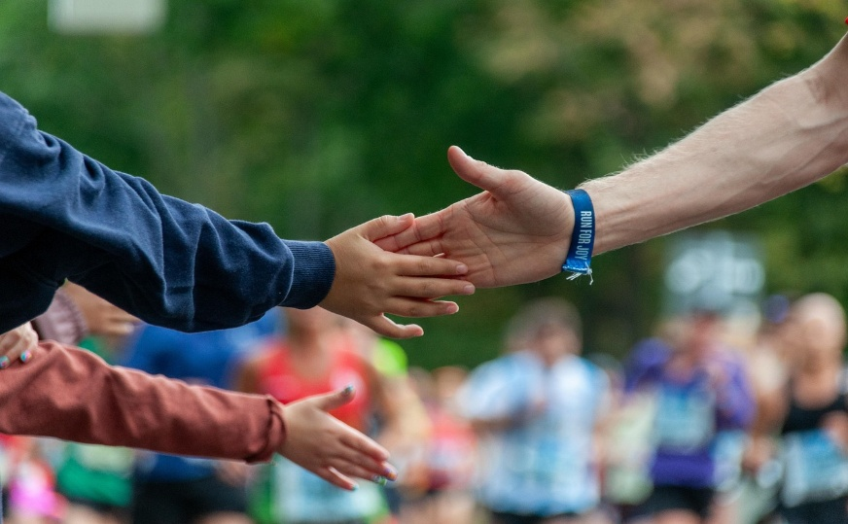
Skills and Language Topics
- Critical thinking and problem solving
- Oral fluency
- Teamwork: communicating and collaborating to complete a series of tasks

Key Vocabulary
(CC0)
- changemaker  - community  - device  - emergency responders | - sensor  - stakeholder  - STEM  - visually impaired

Procedures
TIME | STEPS | NOTES
20 min |   1. Creating a Community Web  - Ask students to stand in a tight circle and then close their eyes and mentally take a walk through their neighborhood or town. Tell them to notice what they love about what they see and hear around them. As they continue their mental walk, invite them to notice what problems or challenges they see for the people in their community. Tell students to open their eyes.  - After giving students some time to think, take a ball of string or yarn and unravel some of the length. Then share an example of something you love about the community and, holding onto the end of the string, throw the ball to someone across the circle. They should catch it and share their own idea of what they love about their community. Then pulling the string tight between you, they should unravel the ball of string a little more and throw the ball to someone else across the circle. Continue to repeat the process, slowly creating a web as each student shares an idea.  - After each student has shared what they love about their community, ask them to think of something they could personally do (or are doing) to build a more positive community. Give them an example like: “I have an elderly neighbor who probably feels lonely. I could have a friendly conversation with her each week.” The students’ ideas can be something they could accomplish alone or working with others.  - After giving students some time to think, share your own example of how you could help your community and then, holding onto the end of the string, throw the ball to someone across the circle. Repeat as before, growing the web as each student shares an idea. If a student cannot think of an idea, they can offer to help with an idea someone else has already shared.  - When the web is complete and every student has shared their ideas, ask students to step back slightly if needed to pull the web tight. Then ask them:  - “What do you notice about this web?” (It connects everyone; everyone’s part matters.)  - Pull on the part of the string that you are holding and ask students who could feel the pull (they should all feel it). Point out that the actions of each person in the community affect others around them. Doing something positive in the community strengthens everyone around them.  - “What would happen if several people dropped their lengths of string?” (The web would be smaller and weaker.)  - Point out to students that their community is like a web, with the actions of each member of the community affecting others around them. When we each use our unique interests, talents and skills to contribute to or improve something in the community, everyone benefits. It takes everyone working together to make the community a great place to live. | Whole-class activity  This group activity helps students visualize the importance of connection in a community and how the actions of each person affect others around them. It provides a foundation for discussing the principles of service learning in this lesson and the rest of the unit. It also helps them develop their skills in expressing ideas and opinions in English.  You may need to give students several ideas to get them started. They can even help each other come up with an idea if someone gets stuck.
10 min | 2. Laya Sees a Community Need  - Explain to students that they are going to meet Laya, a teen who found a way to make a difference in her community. Together with a friend, she designed a flood sensor for a school project, which was then used to address an important community issue.  - Show the video “Laya’s Changemaker Journey” from the beginning to 0:37. After the video clip, ask students: “What problem did Laya see in her community?” (High water levels during heavy rain often created dangerous road conditions, especially at bridge crossings.)  - Show the video from 0:38 to 0:46 and ask students to listen for the step that Laya took next. After the video clip, ask students: “What step did Laya take to address the problem?” (She researched the problem.).  - Show the video from 0:47 to 1:17. Point out that Laya found a friend interested in the same community problem and they worked together (collaborated) to find a solution. After the video clip, ask students to describe the solution that Laya and her friend created. | Whole-class activity  Watching this video is a preview for the reading and discussion activity that follows. It will provide students with an introduction to Laya and her idea to improve her community. Tell the students not to worry about understanding everything in the video, as you can come back to it at the end of the lesson for more language practice if desired.  If it is not possible to play the video in class, tell students Laya’s story by reading aloud the Summary of Laya’s Changemaker Journey (Lesson Materials - Item A).
20 min | 3. Learning from Laya’s Story  Divide students into small groups. Distribute copies of the Learning from Laya’s Story handout. Ask a few students in each group to read the first example of how Laya saw a problem in her community and found a way to address it. Ask the other students in the group to read the second example. After reading, ask them to summarize what they read for the other members of the group. Direct the group members to work together to answer the questions at the bottom of the page.  Draw a simple web design on the board and title it Community Web. After groups have completed their work with Learning from Laya’s Story, discuss the questions as a class and add the names of those who were affected by the problem or who were part of the solution to the Community Web drawing. For example:  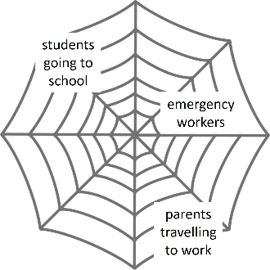  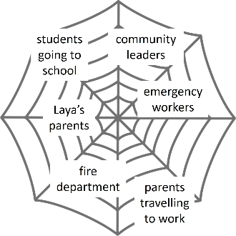  For the question Who was affected by the problem?, encourage students to name as many groups of people as they can. For example, in the story about the blind students, people affected might include the blind students, their teachers, and the students’ parents. In the flooding problem, people affected might include students going to school, parents traveling to work, trucks making deliveries to local businesses, kids riding bikes, or emergency workers such as the local fire department who respond to calls for help by people trapped by flooding. Add the names that students share to the web drawing.  For the question Who was part of the solution?, students will have to imagine who might have helped Laya and her friends. For example, in the flooding problem, people helping Laya might include her teachers at school who helped her think through the science project, her parents who encouraged her, the community leaders who listened to her idea for using the sensors to warn of flooding, and the fire department workers who installed the sensor device at a local bridge. Add the names that students share to the web drawing. Point out that many people in the community contributed to help make the community a stronger, safer place. Tell students that people who are affected by a problem as well as those who have an interest or ability to solve it are called stakeholders.  Ask students to reflect on the ways Laya used her interests, talents, and skills to benefit her community. Point out that Laya's journey included: (1) discovering a community problem and researching it, (2) creating a potential solution to address the problem, and (3) approaching local leaders to use her work to improve public safety. Just like in the Community Web activity, Laya’s positive actions affected others in the community around her.  Emphasize how important it is for members of the community to work together to solve community problems using the same pattern Laya used: (1) discover community problems, (2) create potential solutions to address the problems, and (3) work with local leaders to use their ideas to improve the community.  - Ask students to write an Inquiry Notebook entry using the prompts provided. | Small group activity  Lesson Materials – Item B  Asking students to work in small groups to complete this activity gives each of them more opportunities to share their ideas and insights and more fluency practice.  If you have lower proficiency students (or less time) consider using Laya’s Story (simplified), Lesson Materials - Item B.  This activity introduces students to the steps of the community problem solving process (identify needs, create potential solutions, work with leaders to implement ideas), which will help prepare them to participate in the Impact Project for this unit.  Taking time to review the discussion questions as a group gives the students a chance to hear the ideas of their peers and gives the teacher an opportunity to explain how different groups of people in the “community web” are affected by problems and can work together to find solutions.  This pattern of discovery and problem solving in the community is reinforced in activities throughout the unit and the Impact Project.
15 min | 4. Exploring Your Role in the Community Web  Part 1: Ask students to consider the statements in Part 1 of the Exploring Your Role in the Community handout. Give them several minutes to reflect and respond. Then ask students to share and discuss their responses with a partner.  Part 2: Ask students to discuss the two questions in Part 2 of the Exploring Your Role in the Community handout with a partner. After several minutes of discussion, invite each student to write a few phrases or statements summarizing their ideas. | Pair work  Lesson Materials – Item C  This activity helps students focus on the role young people can play in addressing community problems and the potential positive impact they can have.
5 min | 5. Wrap Up  - Thank students for their hard work. To conclude, ask several students to share something they learned about their role in the community. | Whole class discussion

Inquiry Notebook Prompts
PROMPTS | NOTES
Every community has issues that are important to them. To help keep the community strong, members can work together to solve problems (just like Laya and those in her community did).  - Ask three of your classmates what issues are important to them in the community. Write them in your Inquiry Notebook. Then, draw a web. Choose one issue from the list and write it on the center of the web. Next, write which stakeholders are affected by the issue and which stakeholders could be part of the solution. Add their names to the web.  - Work in a group. Share examples of issues that are important in your community. Then, choose one issue and write about it in your Inquiry Notebook. How are stakeholders in the community affected by this issue? | Adopt or modify these prompts for Inquiry Notebook engagement with concepts featured in this lesson. After completing Step 3, direct students to select one prompt to respond to in their Inquiry Notebook.

Variations and Extensions
VARIATIONS

1. General Differentiation and Scaffolding
- Based on students’ levels and prior knowledge, teachers can choose to cover the lesson content over two or more class sessions. This approach will allow teachers to provide additional instruction, review, and support as appropriate.
- To make the lesson more accessible for lower-level students, or if you have limited time, consider substituting the reading in Step 3 with the simplified version (Lesson Materials – Item B), which is shorter and contains only one story for students to read, discuss, and reflect on.
- To support students in class and group discussions, provide sentence stems on the board or on small slips of paper to guide their conversations. As needed, give them time to organize their thoughts in writing before speaking in a group.

2. Video Alternative
- If it is not possible to play the video in class for Step 2, tell students Laya’s story by reading aloud the Summary of Laya’s Changemaker Journey (Lesson Materials - Item A).

EXTENSIONS

Additional listening practice

For additional listening and discussion practice: If time allows, end the class by showing the video “Laya’s Changemaker Journey” again from the beginning to 1:17. Stop the video and ask students what they learned about Laya’s project by watching it again. Then play the remainder of the video, asking students to listen for the following:

What did Laya learn about working with community leaders? (beginning at 1:18)

What does Laya feel is the impact of her flood sensor project? (beginning at 1:52)

What advice does Laya give to teens about making a difference? (beginning at 2:16)

2. Share the results!

Take pictures as your students create their community web and upload them to class social media (if appropriate) with a few of the statements that students write in Activity 5 about the role of young people in addressing community problems.

External links are provided for informational purposes only; there is no implied U.S. Department of State endorsement of the individuals, views, opinions, media content,
or privacy policies contained therein.

Unless otherwise noted, CC0 images in this resource are “no-attribution required” items sourced under the Pixabay simplified license, Pexels License, or Unsplash license. If sharing, adapting, or remixing portions of this lesson plan, please respect excepted permission and licensing statements noted in the credit statements for individual images, graphics, or other content. To learn about Creative Commons licenses, their uses, and their restrictions, visit the Creative Commons license explanation site.

The Community Web – Lesson Materials
SERVICE LEARNING

A. Summary of Laya’s Changemaker Journey
Photo: A. Christensen (CC0)
Teachers: If it is not possible to play the “Laya’s Changemaker Journey” video in class, consider telling students Laya’s story by summarizing (or reading aloud) the following summary.

The first time Laya encountered the dangers of flooding in her community was during a drive with her mother after heavy rain. They approached an area of the road that was completely flooded, forcing them to turn back. For others in her neighborhood, the consequences were far worse. A man in her community tragically drowned when his truck was swept away by floodwaters. That heartbreaking event was what motivated Laya to take action.

At just 15 years old, Laya began researching why such flooding continued to create danger in her community. She discovered gaps in the existing flood warning systems and decided something had to change. Teaming up with a friend, Laya developed a solution: a device that measures water levels on roads and sends real-time alerts to a mobile app.

Getting people to use the system wasn’t easy. One of the biggest challenges was getting local government leaders to listen. With persistence and determination, Laya connected with them and presented her flood warning system. They quickly realized that Laya’s invention was easy to use and had the potential to save lives by giving people information during floods.

Laya believes that young people can look at everyday problems with a mindset of change-making. She says the path to making a difference begins by asking one question: How can I fix this?

B. Learning from Laya's Story

Laya’s father was an engineer. He encouraged Laya to look for ways to solve problems
whenever she saw something that didn’t work or needed improvement. At her school, Laya and her friends often participated in science activities where they built simple balloon powered cars or learned about technology. Laya felt curious about using science to solve problems. Read below about the two problems that Laya discovered in her community. Think about who was affected by the problems and who helped Laya find solutions.


Helping the Visually Impaired: In the fifth grade, Laya joined a team at her school that taught young students to use science to solve real-world challenges. Laya and her friends designed a simple e-learning app to help visually impaired children read their textbooks and learning materials. With permission from school officials, they tested the app with the students and then made improvements to their design.


Warning of Danger: When Laya was in high school, she lived in a city that often experienced flooding. In some areas, bridges were dangerous for vehicles during heavy rains when water levels rose quickly. For a school project, Laya and a friend designed a simple device with sensors to measure how far the water was from the road and how quickly the water level was rising. They created an app that received messages from the device to warn drivers and emergency responders when water levels were too high for safe crossing. Later, Laya worked with city officials and the local fire department to have the first sensor installed at a bridge near her home.
Who was part of the solution?
Who was affected by the problem?
Community Problem 2:
Heavy rains created flooding on
area bridges, making it dangerous
for cars to cross.
Community Problem 1:
Visually impaired students could
not read all of their textbooks or
learning materials.


Who was part of the solution?

Who was affected by the problem?
Who was part of the solution?

B. Learning from Laya's Story (simplified)


Warning of Danger:
Laya lived in a city that often flooded during heavy rain. Bridges were sometimes covered with water. For a school project, Laya and a friend designed a device to measure how far the water was from the road and how quickly the water level was rising.

They created an app that received messages from the device to warn when water levels were too high for safe crossing. Later, Laya worked with city officials to have the first sensor installed at a bridge near her home.

Community Problem:
Heavy rains created flooding on area bridges, making it dangerous for cars to cross.
Who was part of the solution?

Who was part of the solution?
Who was affected by the problem?

C. Exploring Your Role in the Community

PART 1: What do you do? Think about what you do when you see a problem in your community. Read the question below and then circle never, sometimes, or often. Then share your responses with a partner.
When you see a problem in your home, your school, or your community, what do you do? | I let others know about the problem. | NEVER | SOMETIMES | OFTEN
 | I complain about it. | NEVER | SOMETIMES | OFTEN
 | I take time to notice who in the community is affected by the problem. | NEVER | SOMETIMES | OFTEN
 | I look for ways to address the problem. | NEVER | SOMETIMES | OFTEN
 | I ask others for help. | NEVER | SOMETIMES | OFTEN

PART 2: What do you think?
Discuss the questions below with a partner.
What do you think the role of young people should be in addressing problems in their community?

What do you think the impact would be if they did so?

D. Key Vocabulary Glossary
Definitions below illustrate how Key Vocabulary terms are used in the context of this lesson.

changemaker n . someone who works to improve a situation or community
community n. a group of people who live in a particular place or who are part of a specific group
device n. equipment that is used for a particular purpose
emergency responder n. someone whose job is to be one of the first people to arrive to help with an emergency
sensor n. equipment that can find heat, light, movement, etc.
stakeholder n. a person who has an interest in the success of something
STEM n. phr. science, technology, engineering, and math
visually impaired adj. unable to see well

