Community Partnerships
SERVICE LEARNING

Overview

In this lesson, students plan for meaningful community partnerships. Students consider various types of service actions, what they can offer their community, and what they can learn through service.

Goals
As a result of this lesson, students will be able to:
- identify types of successful community partnerships
- evaluate the feasibility of partnership actions
- set learning goals for a community partnership
- present their knowledge, skills, and resources
- feel inspired to plan their own community partnerships
CC0
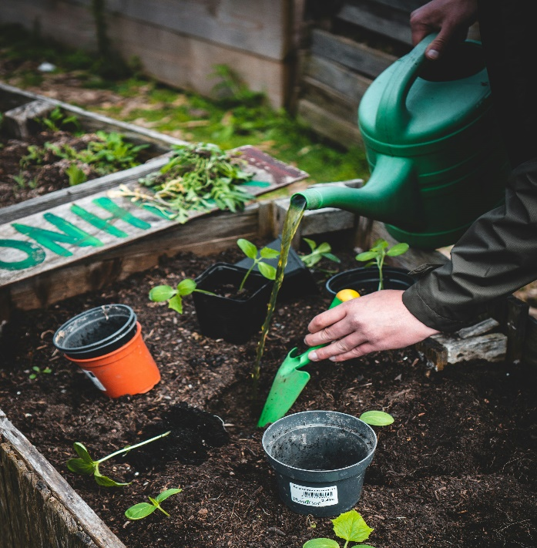
As a result of this lesson, teachers will be able to:

explain the factors involved in successful community partnerships
- engage students in meaningful planning for a student-led service project
- facilitate collaboration and communication among students and with the community

Lesson Materials
IN YOUR CLASSROOM
- Paper and pencils or pens
- Chalkboard and chalk or whiteboard and markers
- Clock or timing device
- TV or projector for displaying lesson content (optional)
PROVIDED WITH THIS LESSON PLAN
- Offers of Help
- Planning a Partnership Chart and Action Cards
- Partnering to Share Resources, Skills, and Knowledge
CC0
- Role Play Partnership Profile
- Key Vocabulary Glossary

TESOL Focus: 21st Century Skills – Collaboration and Communication

Preparation
- This lesson utilizes techniques to help students develop collaboration and communication skills as they prepare for meaningful service-learning activities. Brainstorm or research a few examples of service-learning projects in your community, country, or region to use as examples during the lesson. It may be helpful to find images to share with the class. Look into what has made those partnerships successful, what types of service are involved, and what students learned through the service.
- Review the Procedures and Lesson Materials sections, then determine the formats you will use for the Lesson Materials.
  - Many items can be photocopied, enlarged, or projected onto the board or a wall. More suggestions for formatting and sharing these materials are in the Procedures steps and notes.
  - After selecting the formats for the activities, prepare the required number of materials to suit your class size, considering how many groups or individuals will participate in each lesson stage.
  - If using printed versions of Item B, prepare one set for each group. For Item D, print and cut blank profiles so that half of the class has “Community Member” profiles and the other half has “Student Partner” profiles.
- Read the Skills and Language Topics and Key Vocabulary lists below. Review the glossary (Lesson Materials - Item E) to see how Key Vocabulary terms are used in this lesson. Will you need to activate prior knowledge, pre-teach, or otherwise provide scaffolding (support) for your students beyond the suggestions in the Procedures section? See the Variations and Extensions section for ideas.

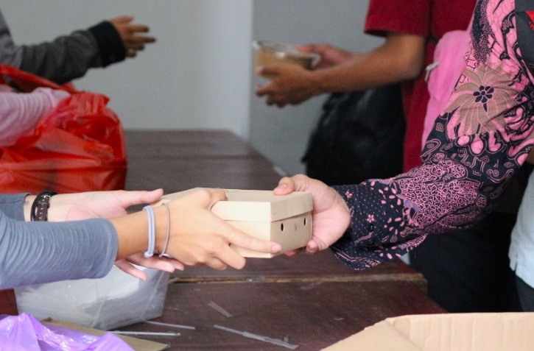
Skills and Language Topics
- Communication: sharing opinions, discussing options, and negotiation
- Collaboration: working together to solve problems

Key Vocabulary
CC0
- action  - to contribute  - doable  - knowledge  - offer | - one-time  - ongoing  - partnership  - resource  - skill

Procedures
TIME | STEPS | NOTES
10 min | 1. Warm Up: Offers of Help  - Ask students to imagine that they are having trouble with schoolwork. They told some friends that they didn’t understand a recent assignment. Now, there is another assignment on a similar topic. Four friends are offering some help.  - Tell students that some of the friends have offers of help that are one-time, and some offers of help are ongoing. Elicit or explain the meaning of these terms.  - Display or distribute the four Offers of Help images. Ask volunteers to read the dialogue aloud.  - Ask students to identify which offers are one-time actions, and which offers are ongoing actions. Label the offers on the handout or board as one-time (A and B) or ongoing (C and D).  - Ask students to review the offers again and determine which are doable – possible or can be done conveniently and easily. Tell students to discuss with a partner and then share their answers with the whole class. Label the offers on the board or handout as doable (A and C) or not doable (B and D).  - Invite students to review the complete chart. Which offers of help would they like to receive?  - Tell students that in this lesson, they will think about how to offer help to their local community in various ways. | Teacher-led concept introduction  Lesson Materials – Item A  This activity prompts students to consider a familiar classmate-to-classmate collaboration situation from the perspective of the person needing help. This concept will be expanded and applied throughout the lesson.
25 min | 2. Sorting Activity: Community Partnership Options  - Explain that just as friends may offer each other one-time help and ongoing help, successful community partnerships may be one-time or ongoing. When partnering with the community, students should think about their community’s needs and what kinds of help are doable.  - Tell students that now they will think about several options for helping their school.  - Arrange students into small groups. Distribute one Planning a Partnership chart and set of Action Cards to each group. Explain that each card describes a way that students want to partner with their school community. Point out that the reason we need many partnership ideas is that some are more doable for different groups.  - Lead a discussion with students to clarify what makes a partnership doable. Ideas might include the partners’ knowledge and skills, the availability of resources, and whether those meet the community need.  - Tell students to evaluate each of the partnership options and arrange them on the chart, assigning each card to one of the four boxes. Students will determine if each action is one-time or ongoing and doable or not doable based on their own knowledge, skills, and resources.  - Once all the groups have discussed and sorted their cards, review their answers as a class. Ask students to provide reasons for their decisions, emphasizing the concepts of one-time and ongoing actions as well as doable and not doable.  - Guide students to focus on doable options as they plan for future community partnerships. | Small group discussion  After establishing the concepts through an example of collaboration with a peer, students expand their focus to collaboration with a familiar community: their school.  Lesson Materials – Item B  Note that the cards can be sorted in multiple ways. Encourage students to share their opinions by giving reasons for their sorting decisions. These ongoing small group and whole group discussions provide opportunities for students to develop communication and collaboration skills.
20 min | 3. Partnering to Share Resources, Skills, and Knowledge  - Remind students that community partnerships involve sharing knowledge, skills, and resources to meet community needs. Explain that a partnership involves working together, and each partner can contribute something. Students can develop skills through their service to the community as well.  - Distribute copies of the Partnering to Share Resources, Knowledge, and Skills handout or ask students to write on their own paper from a model supplied on the board. Point out that the listed partnership actions are the same as those they sorted in the previous activity.  - Guide students to think about what knowledge or skills they need for each partnership action to be doable. What could they learn through the partnership action?  - Tell students to work in pairs to complete the chart, noting the required knowledge, skills, and resources and what they will learn from each action. Ask students to write two of their own action ideas to complete the chart. If pairs complete the task early, they can join another pair to review their answers or brainstorm other actions.  - Once the groups have completed the chart, ask the whole class to answer the question at the bottom of the page: “What ideas do you have for planning service projects to help the community? What knowledge and skills will you learn?” | Think – Pair – Share  Recall the components of service-learning from the lesson plan “What is Service Learning?”  Lesson Materials – Item C  Encourage students to be creative as they brainstorm projects to help the community. These ideas will help guide their future service-learning projects and motivate them to participate.
25 min | 4. Role Play: Outreach to Partners  - Tell students that now they will practice finding suitable partnership matches. Explain that they will take part in a role play. Divide the class into two large groups. One group will be the “Community Members,” and the other group will be the “Student Partners.”  - Distribute a blank Partnership Profile template to each student or ask them to write on their own paper based on a model displayed on the board.  - “Community Members” should complete the profile expressing their specific needs and what they can help “Student Partners” learn.  - “Student Partners” will complete the profile expressing their available knowledge, skills, and resources as well as what they would like to learn from a partnership.  - Direct students to begin working; monitor their progress and offer assistance when needed. Preview their profiles as they work to ensure they are appropriate to share in class.  - After they complete their profiles, tell students they will have about 10 minutes to mingle around the classroom to find a suitable partnership match. Model the role play conversation with a student before the students begin to mingle.  - Ask students to stand up and bring their profile. Tell them their goal is to clearly communicate community needs and available “Student Partner” contributions. Write a model dialogue or sentence frames on the board for language support, if desired.  - When students find a potential match, they should role play what the imagined community partnership discussion would look like. Would it be one-time or ongoing? What do they need to make the partnership doable?  - If students do not find a perfect match, that’s ok! Tell them to discuss the reasons why the match is not ideal and what other options for a partnership may be available.  - Let students know when the mingle period is over. Give students a few minutes to wrap up their conversations and return to their seats. | Individual creative brainstorming  Lesson Materials – Item D  In this activity, students move from considering a school service-learning project to a larger community collaboration. Students will practice cooperation and negotiation as they plan to take positive action. This also requires clear communication skills to gather information about community needs and convey their knowledge, skills, and resources to contribute.  Whole-group mingle activity  See the Variations and Extensions section for more ideas about facilitating this activity.
10 min | 5. Reflection: Making Meaningful Partnerships  - Lead a debrief of the mingle activity: invite students to think about their experience looking for a partnership match. Tell students to listen carefully as you read several sentences. If the statement is true for them, they should stand up. If not, they should stay seated.  - Read each of the statements aloud. Pause after each statement to ask a couple of students to share their experience in the activity.  - “Stand up if you found a good match.”  - “Stand up if it was easy to find a match.”  - “Stand up if you did NOT find a match.”  - “Stand up if it was difficult to find a match for your community need.”  - “Stand up if it was difficult to find a match for your service offers.”  - “Stand up if you found many good matches.”  - “Stand up if you have some new ideas for partnerships in our community.”  - Guide students to think about their experience determining community needs and offering service partnerships. How does the activity lead them to think about their plans for implementing a service-learning project? | Movement-based reflection activity  This debrief activity calmly closes out the mingling activity and lets students see their classmates’ responses summarized in a visual way. Help students understand that community partnerships involve collaboration among students AND between the community and those offering service. Through clear communication, everyone involved in the partnership can benefit!

Inquiry Notebook Prompts
PROMPTS | NOTES
- Describe your personal knowledge, skills, and resources. Then tell what you want to learn from a community partnership.  - Name a community that you belong to. Write some questions to understand their needs. | Adopt or modify these prompts for Inquiry Notebook engagement with concepts featured in this lesson. After completing this lesson, direct students to select one prompt to respond to in their Inquiry Notebook.

Variations and Extensions
VARIATIONS

1. General Differentiation and Scaffolding
- Based on students’ levels and prior knowledge, teachers can choose to cover the lesson content over two or more class sessions. This approach will allow teachers to provide additional instruction, review, and support as appropriate.
- To challenge students in Step 2, ask them to consider how they would change not doable partnership options. Invite them to revise the partnership cards so that the service is doable based on their knowledge, skills, and available resources.
- For lower proficiency students, provide a model for the Community Member and Student Partner profiles in the role play activity (Step 4). Write question and sentence stems on the board for reference during the mingle. For higher proficiency students, require more details in the profiles and repeat the mingle activity so that students have a chance to role play both as a Community Member and as a Student Partner.

2. Collaboration to Meet Community Needs

During the role play mingle (Step 4), if students cannot find an ideal one-to-one match between Community Member needs and a Student Partner profile, tell the “Student Partners” to join together. Students can continue the role play and look for a match of multiple “Student Partners” to meet a “Community Member’s” need.
EXTENSIONS

1. Formal Community Partnership Proposals
- After role-playing the outreach to partners in Step 4, ask students to imagine they are reaching out to a community member to offer help. Invite students to draft a formal email or letter stating their proposed service action, the knowledge, skills, and resources they will contribute, and what they would like to learn.

2. Class Capacity Statement
- Everyone has something to contribute! Invite students to design a survey to find out the knowledge, skills, and resources their classmates can contribute to a service-learning project.
- Students should summarize their findings and choose a creative way to share this information with other stakeholders in the community. A written description, an infographic, or a video are some ideas.

3. Working Together to Meet Community Needs
- Ask students to research local organizations that may address a challenge they identify in their community. Students could consider whether a partnership with a community organization could help expand what actions are doable. Help students appropriately communicate with and plan for service-learning projects with the organization(s).

External links are provided for informational purposes only; there is no implied U.S. Department of State endorsement of the individuals, views, opinions, media content,
or privacy policies contained therein.

Unless otherwise noted, CC0 images in this resource are “no-attribution required” items sourced under the Pixabay simplified license, Pexels License, or Unsplash license. If sharing, adapting, or remixing portions of this lesson plan, please respect excepted permission and licensing statements noted in the credit statements for individual images, graphics, or other content. To learn about Creative Commons licenses, their uses, and their restrictions, visit the Creative Commons license explanation site.

Community Partnerships – Lesson Materials
SERVICE LEARNING

A. Offers of Help
A.  I know it’s hard. I will help you complete this assignment. | B.  I will build a robot to take the exam for you.  
  C.  I know it’s hard. Let’s study together every week to prepare for the exam.   |   D.  Let’s persuade our teacher to never give assignments again!


B. Planning a Partnership Chart
Situation: You and your classmates would like to plan service actions for your school community. You are thinking about several ways to help your school.
Directions: Read each action card. Discuss with your group members:
- Is it a one-time action or an ongoing action?
- Is the action doable or not doable for you? Why?
Be sure to give reasons for your answers. Put the cards on the chart in the box that best describes it.
One-time; doable | One-time; not doable
Ongoing; doable | Ongoing; not doable

Action Cards: Print out and cut one set of cards for each group.
Organize a School Clean Up Day to clean the grounds and common areas | Create a program to help younger students with their schoolwork every week
Ask a local business or other families to donate school supplies for students who need them | Plan a School Spirit Day to encourage school pride
Organize a Career Day and invite local professionals to speak to the students about their work | Create a student-led club that plans service-learning projects every term
Write skits to teach younger children how to save water, avoid littering, and stay healthy | Make posters about staying healthy and display them around the school
Organize a school presentation for 500 students about using technology for learning | Manage a school lunch program including meal planning, cooking, serving, and maintaining health and safety regulations
Set up a new school-wide technology system that includes smart devices | Remodel classrooms, add new air conditioners, and upgrade the electricity system

C. Partnering to Share Resources, Skills, and Knowledge

Instructions: Think about what knowledge or skills you need for each action to be doable. What could you learn through partnership? Work with your classmates to complete the chart.
Action | What knowledge, skills, and resources are needed? | What could you learn?
Make posters about staying healthy and display them around the school
Create a student-led club that plans service-learning projects every term
Ask a local business or other families to donate school supplies for students who need them
Create a program to help younger students with their schoolwork
Add your own idea!
Add your own idea!

Discuss with your classmates: What ideas do you have for planning service projects to help the community? What knowledge and skills will you learn?


D. Role Play Partnership Profiles: Cut and give Community Member Profiles to one half of the class. Give Student Partner Profiles to the other half.

Community Member Profile

- I need ______________________________________________________
______________________________________________________________
- Partners should know about __________________________________
_____________________________________________________________
- I can help you learn ______________________________________
_____________________________________________________________
- I would like this help one time / more than one time.
Circle one.
- Other important information: ___________________________
_____________________________________________________________

Student Partner Profile

- I have _________________________________________________________
________________________________________________________________
- I know ________________________________________________________
________________________________________________________________
- I can ___________________________________________________________
_________________________________________________________________
- I would like to learn ___________________________________________
_________________________________________________________________
- Other important information: ________________________________
__________________________________________________________________

E. Key Vocabulary Glossary
Definitions below illustrate how Key Vocabulary terms are used in the context of this lesson.

action n. something that is done
contribute v. to give something to help others
doable adj. can be done
knowledge n. learned facts, details, and understanding
offer n. something that is given or made available; to offer v.
one-time adj. happening or done only once
ongoing adj. continuing; happening over a length of time
partnership n. a relationship where two or more people or groups work together; partner n.
resource n. things that can be used to take action
skill n. the ability to do an activity or job well

