Our American Story: Collecting Oral Histories
Freedom 250
Overview
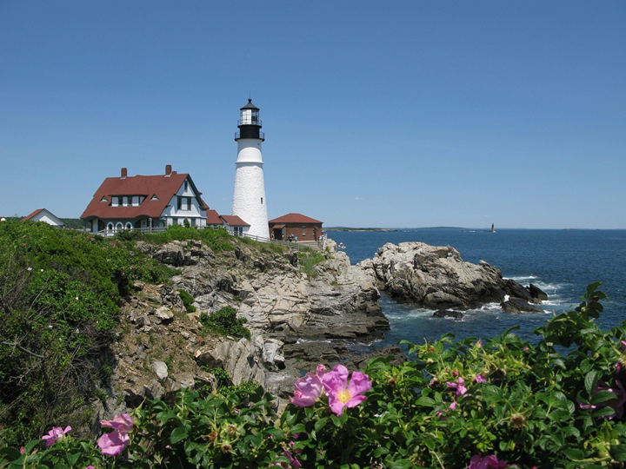
In this 60-minute lesson, students learn how stories help bring facts to life. Students practice their listening skills, learn about open and closed questions, and write interview questions they could use to interview friends, family members, or community members.

Goals
As a result of this lesson, students will be able to:
Germany (CC0)
- understand the difference between open and closed questions
- identify key information from an Our American Stories video
- create interview questions to collect oral history
As a result of this lesson, teachers will be able to:
- guide students to make predictions based on new information
- model active listening and clear speech
- help students create open and closed questions

Lesson Materials
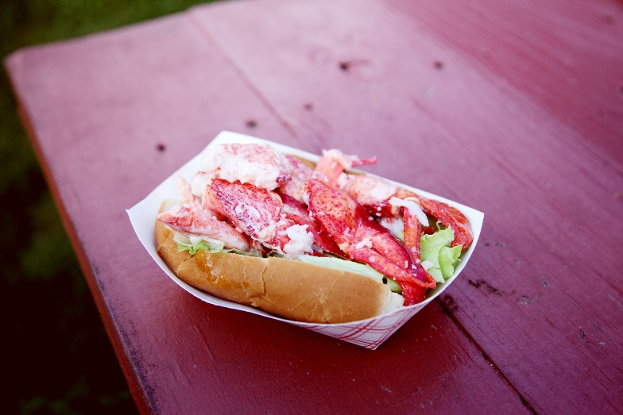
IN YOUR CLASSROOM
- Paper and pencils or pens
- Chalkboard and chalk or whiteboard and markers
- Projector or TV for displaying images and video (optional)
- Ball or other soft item to toss
PROVIDED WITH THIS LESSON PLAN
- American Lobster (graphic)
- American Lobster (labeled graphic)
- Tossing Phrases from Our American Story: Cape Elizabeth, Maine (sentence strips)
- Audio Transcript from “Cape Elizabeth, Maine” video
- Exit Ticket: Questions and Answers
- Key Vocabulary Glossary

Preparation
- This lesson utilizes student-centered learning techniques to explore an example of oral history from the United States. You may want to brainstorm or research a few examples of oral histories in your community, country, or region to use as examples during the lesson. Consider how these stories help bring facts to life.
- Review the Procedures and Lesson Materials sections, then determine the formats you will use for the Lesson Materials.
  - Many items can be photocopied, enlarged, or projected onto the board or a wall. More suggestions for formatting and sharing these materials are in the Procedures steps and notes.
  - After selecting the formats for the activities, prepare the required number of materials to suit your class size, considering how many groups or individuals will participate in each lesson stage.
  - If using printed versions, cut up the materials and group them as needed.
- Read the Skills and Language Topics and Key Vocabulary lists below. Review the glossary (Lesson Materials - Item F) to see how Key Vocabulary terms are used in this lesson. Will you need to activate prior knowledge, pre-teach, or otherwise provide scaffolding (support) for your students beyond the suggestions in the Procedures section? See the Variations and Extensions section for ideas.

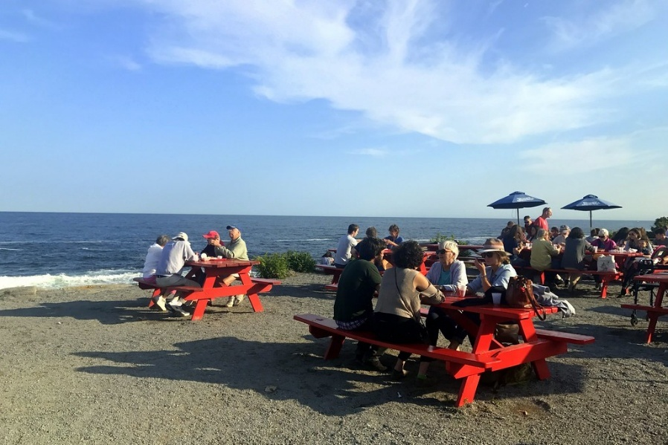
Skills and Language Topics
- Identifying facts
- Forming open and closed questions
Iran (CC0)
- Predicting topics
- Listening for key information
- Summarizing

Key Vocabulary
(CC0)
- closed question  - fact  - friendliness  - generation  - lobster | - made to order  - open question  - oral  - take for granted

Procedures
TIME | STEPS | NOTES
10 min | 1. Warm Up: Living Timeline  - Explain to students that they will be learning about oral history in this lesson. Oral history means talking to people about their past and recording their stories. It is a way to learn about history from people’s real experiences.  - Clear a space in the room and designate one end as “long ago” and the other as “today.” You may want to use chalk or tape to make a line on the floor.  - Ask students to think of a short story they’ve heard from someone older, like a grandparent, parent, or neighbor.  - Share an example from your own life to help students get started. Move to a place on the timeline that represents when your story took place.  - Invite a student volunteer to join you. Model asking the student when their story occurred and helping them decide if they should stand to your left or to your right on the timeline.  - Tell students to move and place themselves chronologically along the timeline based on when their story happened. Once placed, they briefly share the story with a partner or small group near them.  - Bring the class back together for a quick reflection.  - What kind of stories were shared?  - How do these stories help us understand the past?  - Why is it important to remember and share them?  - What are some examples of oral storytelling from your community? | Whole class and partner or small group  If you have an especially large class, you could use visual timeline markers such as decades or symbols.  For shy or less proficient students, provide sentence frames like:  - This story happened in….  - It’s about….  - I heard it from….
10 min | 2. Fact and Question Builder  - Display the American Lobster graphic.  - Put students in pairs and ask them to write facts based on the graphic. See examples below. (You may need to explain that lbs. is the abbreviation for pounds. Weight is measured in pounds in the U.S.)  - American lobster is produced in the northeast part of the U.S.  - Maine produces the most American lobster.  - New York produces less than 1 million pounds of American lobster.  - Tell students that asking questions and hearing stories can help bring facts to life.  - Elicit or explain the difference between a closed question and an open question. A closed question can be answered with a short response like “yes,” “no,” or a simple fact (Examples: Did you come to school today? What is your favorite color?) An open question invites a longer, more detailed answer. It often starts with words like how, why, what or tell me about.  - Ask students to write at least one open question and one closed question based on a fact from the graphic.  - Students who finish quickly can find another pair and practice asking and answering their questions. | Pair work  Lesson Materials – Item A  If your students are less familiar with U.S. states, you can use the labeled map in Lesson Materials – Item B  For more advanced students, add the prompt “Tell me about . . . .” It isn’t a question, but it is a good way to get longer answers. For example, “Tell me about a food your family likes to eat together.”
15 min | 3. Tossing Phrases  - Distribute sentence strips from the Tossing Phrases handout to students and give them time to practice individually. Tell students that these phrases are from a video they will watch later.  - Give students a few minutes - or overnight, if appropriate - to memorize and practice their lines.  - When ready, ask students to form a circle and give one student a ball. After students say their line, direct them to gently toss the ball to another student.  - Students toss the ball throughout the circle until all lines have been heard a few times.  - Give students time to write their ideas and questions about the possible content of the audio. If students aren’t sure what to write, you can use these prompts to get them started:  - What do you already know about this video?  - What do you think this video will be about?  - What do you think you will see in the video?  - What mood do these phrases create? | Whole class  Lesson Materials – Item C  There are 10 phrases in this activity. If you have more than 10 students, you can choose 10 students to start and rotate groups after everyone in the first group has had a turn. You could also assign each line to 2-3 students. After the student who catches the ball says their line, the others who have the same line echo it before the ball is tossed.
10 min | 4. What was the question?  - In previous activities, students practiced using different kinds of interview questions. Now, students will deepen their understanding of how information is generated through an oral history interview by inferring interview questions based on interviewees’ responses.  - Play 2:10-3:38 from the video American Profiles Massachusetts & Maine. (This part of the video begins with the title “Cape Elizabeth, Maine.”)  - Give students time to have a short discussion with a partner or small group. Were their predictions about the video correct? What information and stories did they learn from this video?  - Tell students that they are going to watch the video again. This time students should think about what questions or prompts the interviewer used to get these stories.  - Lead a class discussion to generate a list of possible questions or prompts used by the interviewer. | Individual and whole class  If students are unable to watch the video you use the transcript in Lesson Materials – Item D.
5 min | 5. Creating Interview Questions  - Put students into pairs or small groups and ask them to choose someone from their family or community that they would like to interview.  - Ask students to brainstorm 3 to 5 open questions they could ask this person about their past. They might ask about their childhood, school, traditions, or challenges they faced.  - Encourage students to focus on stories, not just facts. Remind students to create respectful and appropriate questions and avoid topics that might cause embarrassment. | Pairs or Small Groups  If students finish quickly, encourage them to practice asking their questions.
5 min | 6. Exit Ticket: Questions and Answers  - Distribute copies of Exit Ticket: Questions and Answers, or display the questions for the class.  - Ask students to work individually or in pairs to complete the questions.  - Collect student answers to check for understanding of the lesson. | Individual or Pairs  Lesson Materials - Item E

Variations and Extensions
VARIATIONS

1. General Differentiation and Scaffolding
- Based on students’ levels and prior knowledge, teachers can choose to cover the lesson content over two or more class sessions. This approach will allow teachers to provide additional instruction, review, and support as appropriate.
- Use the transcript in Lesson Materials – Item D along with the video for additional language support while listening.

2. Listening for Key Words
  - If the Tossing Phrases activity is too difficult, create a list of key vocabulary words and display them for the students. Let students choose a word from the vocabulary list to listen for while the video is played. When students hear their chosen words, ask them to stand or raise their hand. After the video, ask each student to share what their word was.
brothers friendliness order sister
catching lobster peace toast
family Maine people working
fresh ocean restaurant

3. Sorting Questions
- Prepare a series of open and closed questions based on the “Which States Eat the Most Lobster” graphic and ask students to sort them into open or closed categories. After sorting, ask students to choose a closed question and rewrite it as an open question.
EXTENSIONS

1. Interview Role Play
- Pair up students and ask them to take turns being the interviewer or interviewee using the questions they created for the “Creating Interview Questions” activity (Step 5). The interviewee can pretend to take on the persona of the person the interviewer chose, like a family or community member.

Report and Compare
- Ask students to connect with a partner and compare their partner’s answers from their interviews. Encourage use of comparative language like both, also, but, and however.
- Create a Profile Poster
- Ask students to turn their interview answers into creative posters featuring the people they interviewed. They can share the interviewee name, a summary of what they learned, and one interesting detail or quote. Display the posters in the room or create a digital gallery in a shared space online.

External links are provided for informational purposes only; there is no implied U.S. Department of State endorsement of the individuals, views, opinions, media content,
or privacy policies contained therein.

Images in this lesson plan are in the public domain or “no attribution required” unless otherwise noted. If sharing, adapting, or remixing portions of this lesson plan, please respect excepted permission and licensing statements noted in the credit statements for individual images, graphics, or other content. To learn about Creative Commons licenses, their uses, and their restrictions, visit the Creative Commons license explanation site.

Our American Story: Collecting Oral Histories – Lesson Materials
Freedom 250

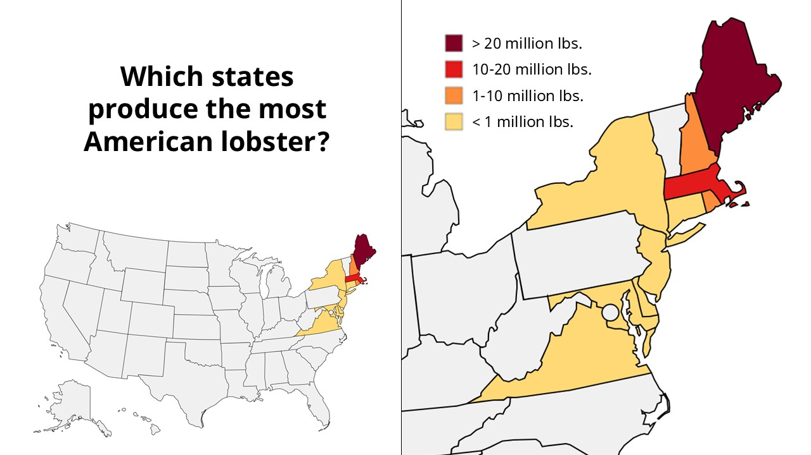
A. American Lobster

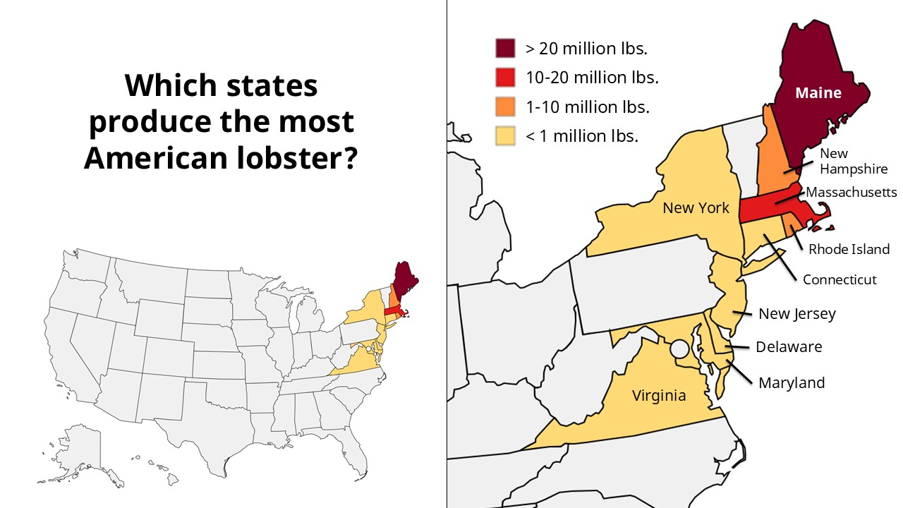
B. American Lobster (Labeled Map)
C. Tossing Phrases from Our American Story: Cape Elizabeth, Maine (sentence strips)
Photo: A. Christensen (CC0)
To the Teacher: Cut apart and distribute to students.

I’m third generation.

Hannah is one of my kids.

I have five brothers and one sister.

I kind of take the ocean for granted.

I miss the calm and peace.

All of the famous lobster rolls are made right here.

We toast it.

There’s someone out there catching it.

You could go to a restaurant to get it.

It’s just the American way.

D. Audio Transcript from “Cape Elizabeth, Maine” video

Video Link: American Profiles | Massachusetts & Maine

We own the lobster shack at Two Lights, which has been a seafood restaurant in Cape Elizabeth since 1969. I started working here as my last job. I'm third generation and Hannah is one of my kids.

I have five brothers and one sister. Two of the youngest are not old enough, but so far everyone else works either at the restaurant or at the gift shop next door. I kind of take the ocean for granted, but I think when I'm in other places or more inland, I miss the calm and the peace and just like the people, like the friendliness and all that. I think that's also a major part that like makes Maine - Maine.

All of the world-famous lobster rolls are made right here. Someone orders lobster, just scoop one up and put it in the boiling tank. One at a time, made to order. We toast it, put a little bit of lettuce, fresh lobster meat, and then a dollop of mayonnaise on top. Fresh daily. There's someone out there catching it. Somebody bringing it to you. You could go to a restaurant to get it. It's just the American way.

Exit Ticket: Questions and Answers
Name(s) _______________________

Rewrite one open question and one closed question you wrote in today’s lesson. ___________________________________________________________________________________________________
___________________________________________________________________________________________________
What is one new thing you learned about oral histories? __________________________________________________________________________________________________
___________________________________________________________________________________________________
What do you think will happen when you ask your interview questions? ___________________________________________________________________________________________________
___________________________________________________________________________________________________

Name(s) _______________________

Rewrite one open question and one closed question you wrote in today’s lesson. ___________________________________________________________________________________________________
___________________________________________________________________________________________________
What is one new thing you learned about oral histories? __________________________________________________________________________________________________
___________________________________________________________________________________________________
What do you think will happen when you ask your interview questions? ___________________________________________________________________________________________________
___________________________________________________________________________________________________

F. Key Vocabulary Glossary
Definitions below illustrate how Key Vocabulary terms are used in the context of this lesson.

closed question n. phr. a question that can be answered with a short, specific answer like “yes” or “no.”
fact n. a true piece of information that can be proved
friendliness n. kind, pleasant behavior towards somebody you like or want to help
generation n. a group of people in the family born and living around the same time
lobster n. a sea creature with eight legs, two large claws, a hard shell, and a body divided into sections.
made to order adj. phr. not prepared until someone requests it
open question n. phr. a question that encourages a longer, more detailed answer
oral adj. spoken instead of written
take for granted idiom. to not appreciate something or someone enough

