From Object to Exhibit: Telling Our Stories Through Artifacts
Freedom 250
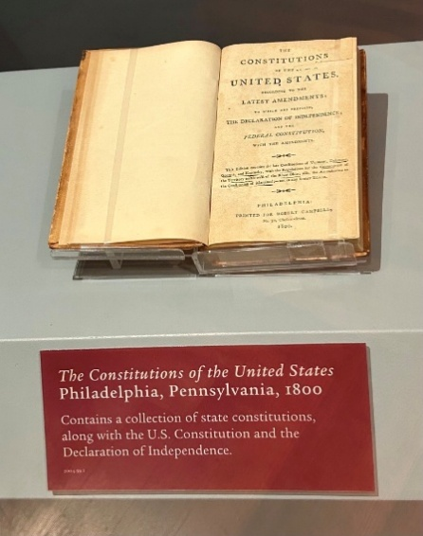
Overview
This 60-minute lesson uses a collection of artifacts to help students learn more about U.S. culture. Students practice descriptive language and think about how objects tell stories. Students interact with artifacts and use prompts to observe, connect, and reflect. Finally, students choose items from their own lives to help tell their stories.

Goals
As a result of this lesson, students will be able to:
Germany (CC0)
- practice using descriptive and creative language
- learn vocabulary used to describe and discuss museum exhibits
- practice critical thinking skills as they consider how artifacts are used to curate stories
As a result of this lesson, teachers will be able to:
- guide students to look carefully at objects
- model explaining and supporting choices
- help students consider the connection between objects and stories
Photo: A. Christensen (CC0)

Lesson Materials
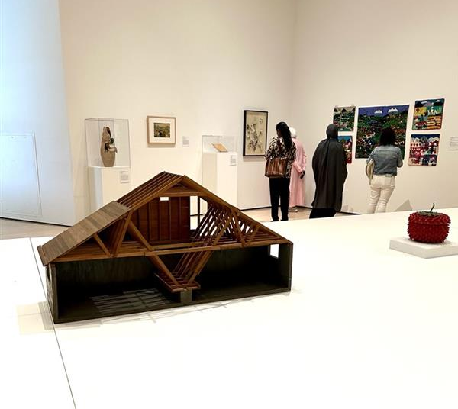
IN YOUR CLASSROOM
- Paper and pencils or pens
- Chalkboard and chalk or whiteboard and markers
- Projector or TV for displaying images (optional)
- Clock or timing device
PROVIDED WITH THIS LESSON PLAN
- Sunglasses (image)
- Main Collection (photos with descriptions)
- Additional Artifacts (photos with descriptions)
- Cards for Interacting with Artifacts
- Advanced Cards for Interacting with Artifacts
Photo: A. Christensen (CC0)
- Key Vocabulary Glossary

Preparation
- This lesson utilizes student-centered learning techniques to explore connections between objects and stories the United States. You may want to brainstorm or research a few objects used to tell stories in your community, country, or region to share as examples during the lesson. While cards depicting artifacts are included with the lesson (see Lesson Materials – Items B and C), teachers may wish to create additional cards showing artifacts that are relevant to their classrooms.
- Review the Procedures and Lesson Materials sections, then determine the formats you will use for the Lesson Materials.
- Many items can be photocopied, enlarged, or projected onto the board or a wall. More suggestions for formatting and sharing these materials are in the Procedures steps and notes.
- After selecting the formats for the activities, prepare the required number of materials to suit your class size, considering how many groups or individuals will participate in each lesson stage.
- If using printed versions, cut up the materials and display them as needed.
- Read the Skills and Language Topics and Key Vocabulary list below. Review the glossary (Lesson Materials - Item F) to see how Key Vocabulary terms are used in this lesson. Will you need to activate prior knowledge, pre-teach, or otherwise provide scaffolding (support) for your students beyond the suggestions in the Procedures section? See the Variations and Extensions section for ideas.

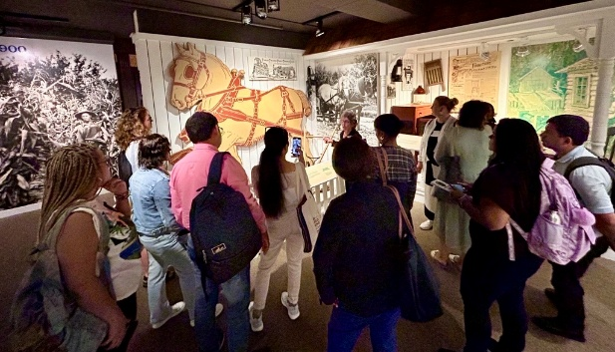
Skills and Language Topics
- Making observations and connections
- Reading descriptions
Iran (CC0)
- Reflecting
- Summarizing

Key Vocabulary
Photo: A. Christensen (CC0)
(CC0)
- artifact  - audience  - collection  - curate | - exhibit  - museum  - object  - reflect

Procedures
TIME | STEPS | NOTES
5 min | 1. What Makes This Special?  - Show students the photo of the sunglasses without the description.  - Ask students to discuss these questions with a partner:  - What do you see?  - What might this object mean to someone?  - Is this a valuable object? Why or why not?  - Encourage students to share ideas with other pairs. If helpful, share sentence starters like:  - I see . . .  - I think this object is important because . . .  - It might belong to someone who . . . | Pair work  Lesson Materials - Item A
10 min | 2. Objects as Storytellers  - Introduce the concept that objects become meaningful when connected to stories.  - Share the description of the Apollo 11 Sunglasses. Point out the elements of the description. Ask students:  - What is the name/title of the object?  - Where did it come from? Who made it? When was it made?  - What was it used for? Why was it important at the time?  - Explain that when objects have specific public meaning in a culture and are used to tell a story, they are called artifacts. We often see special artifacts displayed in museums to help tell stories.  - Lead students through a brief reflection:  - How does the description change your view of the sunglasses?  - Why do you think these sunglasses were saved?  - Do you think the sunglasses are more valuable now? Why or why not? | Whole class  Lesson Materials - Item B  Consider sharing a personal or local example of an object that is meaningful to you.
15 min | 3. Interacting with Artifacts  - Choose artifacts to use for this activity that will be appropriate and interesting for your students.  - Set up an exhibit in your classroom by placing the photos with descriptions around the room.  - Tell students they are going to explore an exhibit, a special collection of artifacts and information that helps people learn about a topic. Explain that each artifact will have a title and description to help students learn more about U.S. culture.  - Ask students to find a partner.  - Hand out one card from Cards for Interacting with Artifacts to each pair.  - Ask each pair to read their card and follow the instructions as they interact with an artifact from the exhibit.  - As students finish their prompt, they should exchange cards with another pair and find a new artifact.  - Students can continue to exchange cards and interact with artifacts as long as they are interested or time allows. They do not need to interact with all of the artifacts. | Pair work  Lesson Materials – Item B  There are 10 objects in the Main Collection, but you can choose to add or substitute from the Additional Artifacts (Lesson Materials - Item C).  Lesson Materials – Item D  If it is not possible print the collection or cards, use a screen to display a few artifacts at a time. Then, write some prompts from the Cards for Interacting with Artifacts on the board.  If you have more advanced students, you can use the Advanced Cards for Interacting with Artifacts.
15 min | 4. Becoming a Curator  - Explain that a curator is a person who cares for artifacts and uses them to tell stories by including them in exhibits. Emphasize that it is impossible to say everything about a topic, so a curator helps to decide which objects can best help tell a story. A curator chooses artifacts to help the audience, the people viewing the exhibit, to focus on important parts of the story.  - Ask students to imagine they are telling a story about American fashion. Which objects from this lesson would they choose for this topic?  - Put students in small groups and ask them to choose one of the prompts below.  - Imagine you are trying to tell other students your age a story about innovation in the US. Which objects from the last activity would you choose? Explain your answer.  - Imagine you are trying to tell people from your community a story about courageous Americans. Which objects from the last activity would you choose and why?  - Imagine you are trying to tell young children about the history of the U.S. Which objects from the last activity would you choose and why?  - If there is time, ask students to share their prompts and choices with the class. | Whole class and small groups  Lesson Materials - Items B and C  Use the same artifacts for this activity that you used in the previous activity.
10 min | 5. Curating Your Story  - Ask students to think of an object from their own life or culture with a story that is meaningful to them.  - Tell students to think about that object and answer the prompts below. It’s okay if students don’t know some of the answers.  - What is the name/title of the object?  - Where did it come from? Who made it? When was it made?  - What was it used for? Why was it important to you or others?  - What story does it help to tell? Who would especially enjoy this story? | Individual
5 min | 6. Share Your Title  - Ask students to write the name/title of their artifact on a piece of paper.  - Invite students to tell a partner about their artifact and discuss these questions:  - What did you learn about how objects tell stories?  - What skill did you use most today?  - Collect the artifact names as students leave the classroom. | Pair work

Variations and Extensions
VARIATIONS

1. General Differentiation and Scaffolding
- Based on students’ levels and prior knowledge, teachers can choose to cover the lesson content over two or more class sessions. This approach will allow teachers to provide additional instruction, review, and support as appropriate.
- For students with less English language proficiency, consider adding oral explanations of items and sentence frames to help students discuss artifacts.

2. Curating What We Love
- If students are less engaged with the collection from this lesson, ask them to choose something they love (like a movie, a musician, a place, a book, or a hobby) for the Becoming a Curator activity. Tell students to imagine a museum exhibit that teaches people about it. Ask them to choose three artifacts to include in the exhibit and explain why they chose them. Students can find photographs or create drawings of their artifacts. Ask students to think about audiences. Who would be most interested in this exhibit? Would you choose different artifacts for someone unfamiliar with your topic? Would you choose different artifacts for someone who knows a lot about your topic?
EXTENSIONS

1. Curating the Classroom

Ask students to find objects in the classroom and work in groups to curate an exhibit that tells the story of their Access classroom. Invite them to add artifact titles and short descriptions to help tell the story. Use the cards from the Interacting with Artifacts activity to engage with their exhibit.

A Collection of Our Stories
- Invite students to bring a photograph or object from home that has a special story. (If possible and appropriate, students can also bring audio or video artifacts.) Ask students to include a title and brief description to help classmates understand why the artifact is special. Display the artifacts around the classroom and use the cards from the Interacting with Artifacts activity to let students engage with their classmate’s artifacts.

3. Scavenger Hunt for Artifacts
- Share one of the prompts below or create your own. Put students in small groups and give them a set amount of time, maybe 10 minutes, to go outside and find objects that help tell the story from the prompt. If appropriate, they can bring objects back with them. Students may also take photos of objects or draw them. When students return, ask them to share their objects with the class and explain how they help tell the story.
  - Imagine you are trying to tell visitors to your community a story about the current season. (spring, summer, fall, winter)
  - Imagine you are trying to tell other students a story about new technology.
  - Imagine you are trying to tell adults in your community about what it is like to be a teenager.
  - Imagine you are trying to tell teenagers from another country about what it is like to be a teen in your community.
  - Imagine you are trying to tell your friends about what you think is beautiful.
  - Imagine you are trying to tell your family a story about things that bring you joy.

External links are provided for informational purposes only; there is no implied U.S. Department of State endorsement of the individuals, views, opinions, media content,
or privacy policies contained therein.

Images in this lesson plan are in the public domain or “no attribution required” unless otherwise noted. If sharing, adapting, or remixing portions of this lesson plan, please respect excepted permission and licensing statements noted in the credit statements for individual images, graphics, or other content. To learn about Creative Commons licenses, their uses, and their restrictions, visit the Creative Commons license explanation site.

From Object to Exhibit: Telling Our Stories Through Artifacts – Lesson Materials
Freedom 250

A. Sunglasses

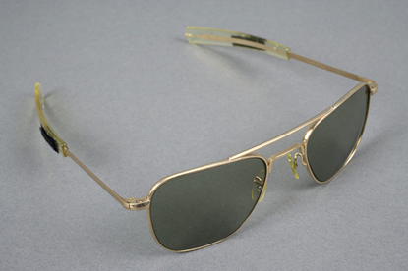

Smithsonian Images

B. Main Collection
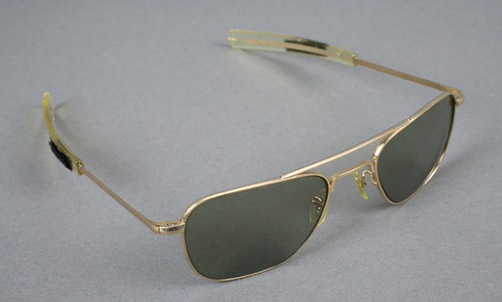  Smithsonian Images | Apollo 11 Sunglasses  American Optical Company; glass, aluminum, gold plating, and plastic  These special sunglasses were created to protect U.S. astronauts in space. On July 20, 1969, the courageous astronauts from Apollo 11 became the first humans to walk on moon.
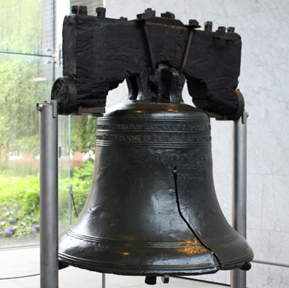 | Liberty Bell  1753; Whitechapel Foundry; bronze  A message on this bell reads “Proclaim Liberty Throughout All the Land….” The bell is a symbol of liberty and freedom for many Americans. It weighs 2,000 pounds (over 900 kg). It was created for the Pennsylvania State House in Philadelphia to call lawmakers to meetings and call local people to hear the reading of the news.
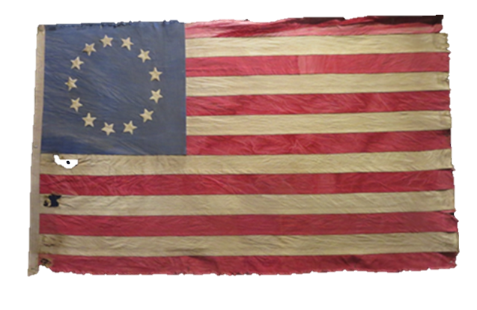  Photo: A. Christensen (CC0) | Betsy Ross Flag  Unknown; woven textile  This flag first appeared in 1792 in a painting of America’s first president, George Washington. Some people believe it was designed by an American woman named Betsy Ross. This early U.S. flag became a symbol for the American Revolution. It is still popular at events celebrating the United States.
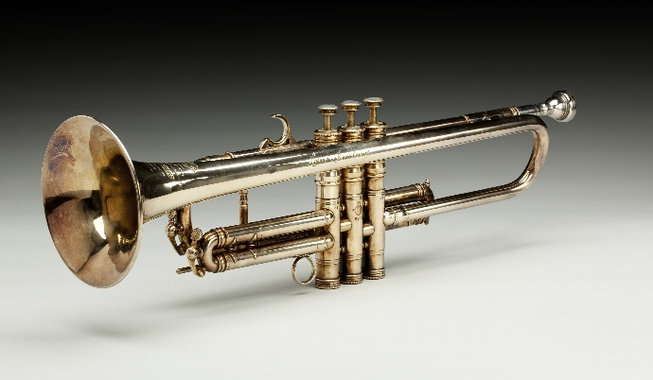  Smithsonian Images | Louis Armstrong’s Trumpet  1946; Henri Selmer Paris; brass  This trumpet was made for Louis Armstrong, a famous American jazz musician. He won many awards and was in more than 30 films. He was from New Orleans, Louisiana and traveled around the world playing jazz music. He used jazz music to entertain people and teach them about U.S. culture and values.

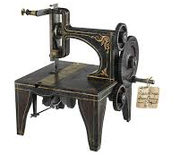  Smithsonian Images | Isaac Singer’s Sewing Machine  1851; cast iron  Isaac Singer did not invent the sewing machine, but he improved the design. He designed it to be used in factories. His company’s innovative advertising also made his sewing machine popular in homes. The company offered the first installment-payment plan in the United States. This plan let people take the machine home and pay a little money each month toward the total cost.
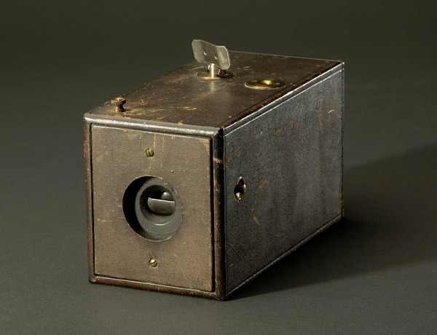  Smithsonian Images | Original Kodak Camera  1888, New York; wood, leather, metal, and glass  George Eastman’s company created this camera that used film to capture an image. This design improved earlier cameras. It was lighter and less expensive than other cameras. Each roll of film took 100 photos. Americans took photos of their everyday lives. They also took photos of beautiful places in the United States.
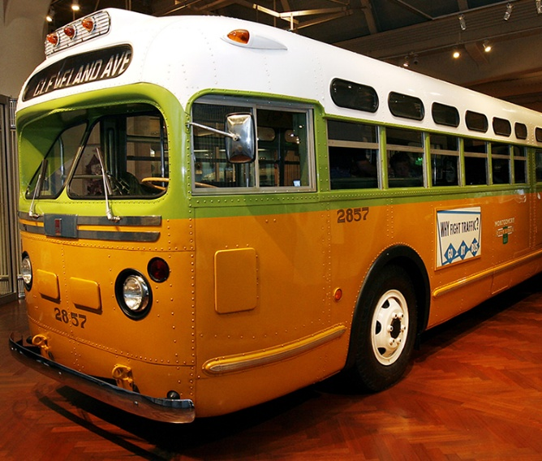 | The Rosa Parks Bus  1948; General Motors  Rosa Parks was a Black American seamstress who lived in Montgomery, Alabama. On December 1, 1955, she was arrested for not giving up her seat on a city bus to a white man, breaking local segregation laws. This act helped to inspire the Civil Rights Movement in the United States. She was a courageous American who believed in liberty for all Americans.

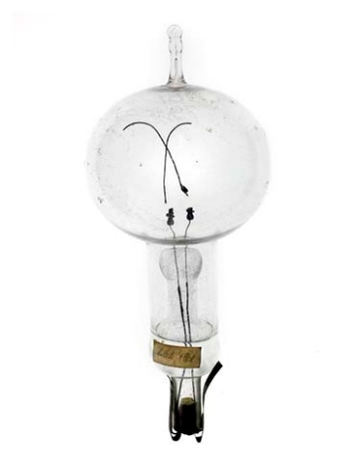  Smithsonian Images | Edison Light Bulb  1879; carbon, metal, and glass  Thomas Edison invented this electric lightbulb in his famous laboratory in New Jersey. This light bulb changed how people lived and worked. Edison invented over a thousand devices and was also a skilled businessman. The light bulb has become a symbol for ideas and inventions around the world.
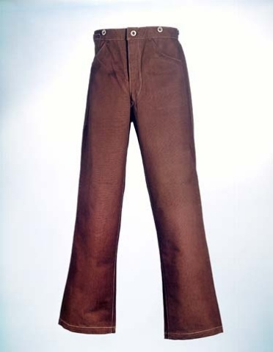  Smithsonian Images | Levi Strauss Jeans  1875-1896; Levi Strauss; denim with copper rivets  Jacob Davis and Levi Strauss lived in San Francisco, California. They created these pants for miners and cowboys. The pants were made to be strong and came in two colors, indigo blue and brown duck. Later, these pants were called jeans. They became popular with many people across the U.S. Blue jeans also became the world’s best-selling item of clothing.
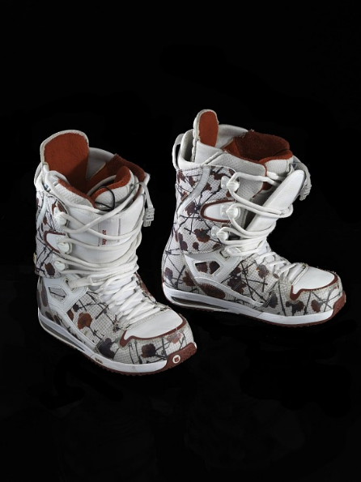  Smithsonian Images | Hannah Teter’s Snowboard Boots  2010; Burton Snowboards; rubber and fabric  American snowboarder Hannah Teter wore these boots at the 2010 Winter Olympics in Vancouver, Canada. She won a silver medal in the women’s halfpipe event. She has also won medals in other Olympic and World Cup events. Her success is an example of American skills, strength and leadership in winter sports.

C. Additional Artifacts
Photo: A. Christensen (CC0)
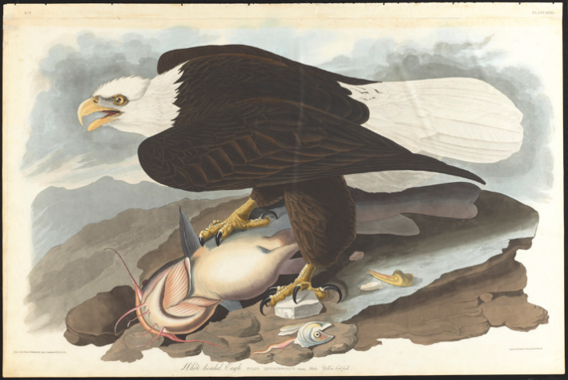  Courtesy of the John James Audubon Center at Mill Grove, Montgomery County Audubon Collection, and Zebra Publishing. | White-headed Eagle  1827-1830; John James Audubon; pencil, watercolor, and ink on paper  John James Audubon loved birds. He painted and wrote about them as he traveled across the United States. His collection, “The Birds of America” shows over 400 species of North American birds, many shown life-size. Also called a bald eagle, this large bird is a symbol of American strength, courage, and freedom.
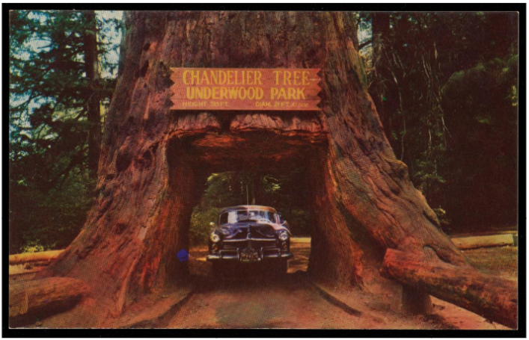  Smithsonian Images | Chandler Tree, Underwood Park  1950-1960; Mike Roberts Color Productions; postcard  Giant Coast Redwood trees grow on the western coast of the state of California. They are the tallest trees in the world. They live for hundreds of years, growing taller and wider each year. Some of the oldest are over 2,000 years old and wider than a car. More than 400,000 people come to see these amazing trees every year in beautiful Redwood National Park.
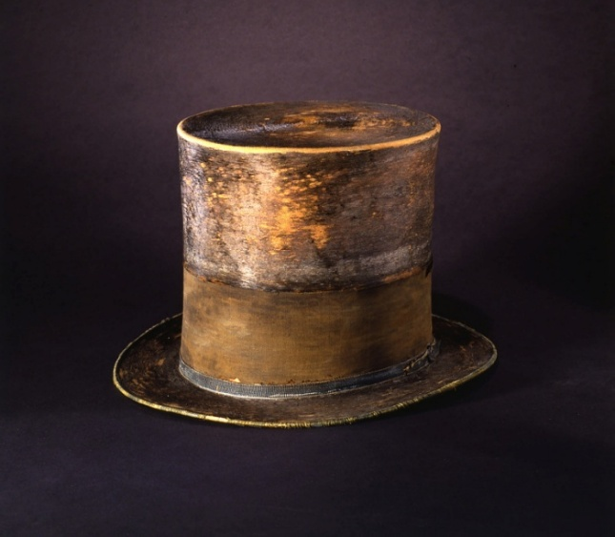  Smithsonian Images | Abraham Lincoln’s Top Hat  unknown; J.Y. Davis; silk  President Abraham Lincoln was six feet four inches tall (about 2 meters). He often wore a top hat that made him seem even taller. He is remembered as one of America’s most respected presidents. He is one of the presidents celebrated during Presidents’ Day. His image is on the U.S. five-dollar bill. He is also remembered through art and the names of public places. The Lincoln Memorial in Washington, D.C. is an amazing place that shares some of his famous quotes.
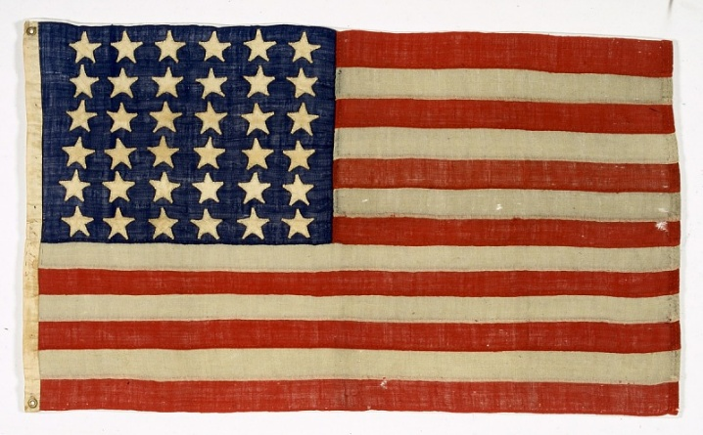 | Flag from Abraham Lincoln’s Funeral Train  unknown; red, white, and blue fabric  When President Abraham Lincoln died in 1865, there were thirty-six states in the United States of America. That is why this flag has 36 stars. A star is added to the flag when a new state joins the U.S.A. The current U.S. flag has fifty stars.  Smithsonian Images

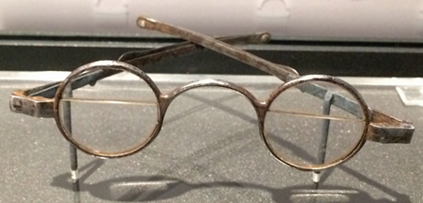  Photo: A. Christensen (CC0) | Benjamin Franklin Bifocals  1804; glass and sterling silver  Benjamin Franklin was a famous inventor, politician, and writer. He helped to write the U.S. Declaration of Independence. In 1794, when he was 78 years old, he created special glasses called bifocals. They helped him to see both close up and far away. Some of his inventions, like these bifocals, are still used by people today.
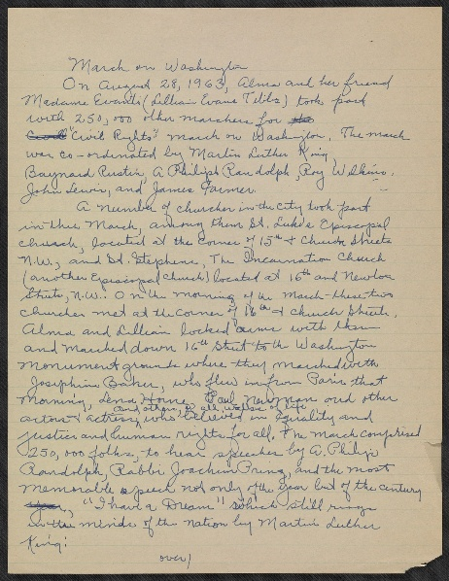  Smithsonian Images | Notes on Participation in March on Washington  paper and ink  On these pages, J. Maurice describes the March on Washington on August 18, 1963. She and her sister Alma Thomas participated in the march with her friend Madam Evant. At this event, they heard Dr. Martin Luther King Jr.’s famous “I Have a Dream” speech. This speech represents his hope for American progress and peace. His words continue to inspire Americans and people around the world.
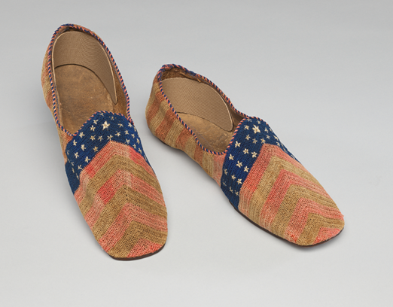  Smithsonian Images | Star and Stripes Bedroom Slippers  1865; fiber, leather and thread  These slippers were inspired by the U.S. flag. They have red and white stripes from the toe to the heel and a blue band with white stars. They were designed by seamstress and author Elizabeth Keckley. She made them especially for Gideon Welles. He was the Secretary of the Navy for President Lincoln. The U.S. flag continues to inspire Americans today.
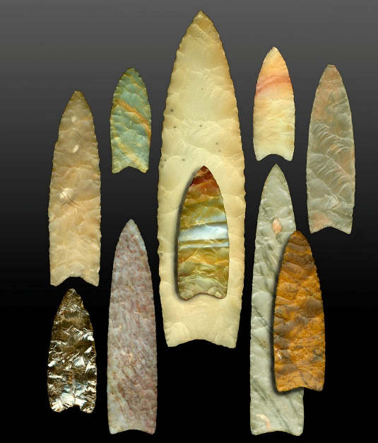  Smithsonian Images | Clovis Points  unknown; carved stones and minerals  These points were found in the state of Colorado from 1977-1978. Orville Drake found them in a wheat field. They were carved from special rocks, called agates and chert, by the Clovis people. They lived in North America about 13,000 years ago. These sharp tools were used to hunt large animals. These beautiful artifacts are some of the incredible things you can see in the Smithsonian museums in Washington, D.C. The United States has some of the best museums in the world.

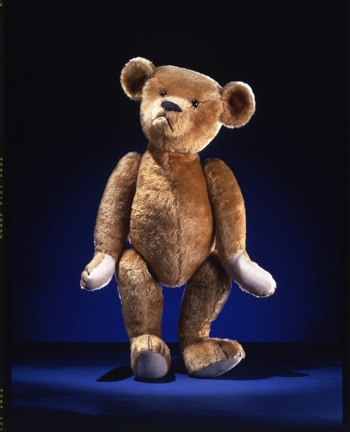  Smithsonian Images | Teddy Bear  1903; Ideal Toy Company; mohair and thread  U.S. President Theodore Roosevelt was known for hunting wild animals. In 1902, he refused to shoot a bear because it had been tied to a tree. He did not think that was fair. The story inspired Rose and Morris Michtom from New York to make a stuffed bear toy. They called it Teddy’s Bear. Teddy is a shortened version of the name Theodore. Teddy bears are very popular in the U.S., especially with children. They are also popular in many countries around the world.
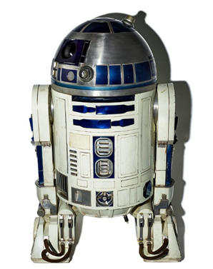 | R2D2 from Star Wars  2005; Adam Savage; aluminum, paint, plastic, electronics  American designer and educator, Adam Savage, worked on some of the famous Star Wars movies. He built this amazing model of R2D2, a character in the movie, that is in an exhibit at the National Air and Space Museum in Washington, D.C. Star Wars is an example of creative and innovative American entertainment that is popular around the world.
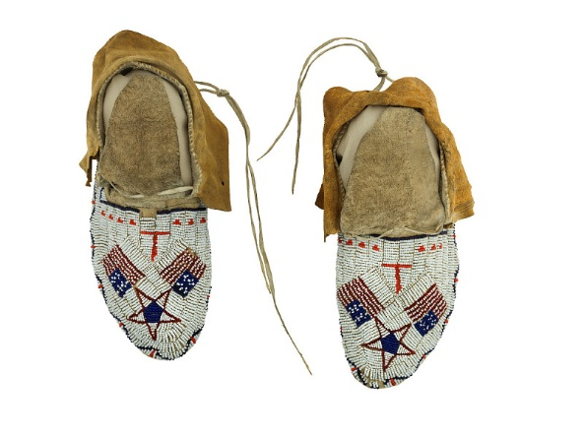  Smithsonian Images  Smithsonian Images | U.S. Flag Moccasins  1870; Plains Indians; leather and colored glass beads  A group of leaders from the Plains Indians gave these special shoes, called moccasins, to U.S. President Ulysses S. Grant. They show symbols from both Plains Indians’ and U.S. cultures. These moccasins were inspired by the U.S. flag.

D. Cards for Interacting with Artifacts
Find an object that is very interesting to you. What makes it interesting? | Find an object.  List five things you see in this object.
Find an object that confuses you. What questions do you want to ask the person who owned or used it? | Focus on the shape of an object. Use your finger to draw the shape in the air.
Move your body into the shape of an object or part of an object. How does it feel to be in this position? | Look at an object. Now close your eyes. What do you remember? Look again. What did you miss?
Find two objects that are similar in some way. How are they the same? | Find two objects that are very different.  How are they different?
Find an object that reminds you of a book, song, or picture. What is the connection? | Do you think a person or a machine made this object? What makes you think this?
Find an object that reminds you of someone you know. What is the connection? | Artifacts can make you feel many things at the same time. Find an object you feel strongly about. List all of the things you feel.
Find an object you want to show to a friend or family member. Why do you want to show it to this person? | Find an object you like. Imagine talking to an older person (like a grandparent). Describe it to the older person.
Find an object that you like. Imagine you are talking to a young child. Describe it to the child. | What is your first reaction to this object? Look at it for one minute. What is your reaction now?

E. Advanced Cards for Interacting with Artifacts
If you stepped into the world of this artifact, what sounds might you hear? | If you could enter the world of this artifact, how would it feel?
Think about a topic you’ve heard a lot about lately. Which artifacts add to the discussion? How so? | Think about something that is important to you. Find an artifact that connects to this. How is it connected?
Choose a song to represent this artifact. Why did you choose this song? | Find an artifact to illustrate a current event. Why did you pick this artifact?
Find an artifact that offers comfort and one that causes discomfort. What makes you feel this way? | Which artifact has the best story? What story does it tell? How does this story connect with yours?
Find an artifact that adds to your idea of history. How does it surprise or challenge you? | Reflect on the artifact in front of you. In what ways do your personal beliefs influence your response?
How long do you think it took to make this artifact? What makes you think this? | Find an artifact that confuses you. What questions would you ask the person who owned or used it?
Find an artifact that is unfamiliar to you. What did it teach you? | Find an artifact that you want to know more about. What do you want to know? How could you find out more about it?

F. Key Vocabulary Glossary
Definitions below illustrate how Key Vocabulary terms are used in the context of this lesson.

artifact n. an object with a specific, public meaning that is part of a curated story
audience n. the specific people seeing or reading something
collection n. a group of items that have been selected and organized because they have something in common
curate v. to collect, select, and share artifacts to help tell a story
curator n. a person who cares for special objects and uses them to tell stories by including them in exhibits
exhibit n. a collection of objects, images, and information displayed to help people learn about a topic
museum n. a place to keep and display special artifacts in exhibits
object n. a very general word used to refer to any physical thing
reflect v. to think carefully and deeply about something

