Merit in Motion: Creating a Class Dream Mobile
Freedom 250
Overview

This lesson introduces the concept of merit as a key part of the American Dream. Students explore merit and create a class dream mobile to express their future hopes and goals.

Goals
As a result of this lesson, students will be able to:
- relate the concept of merit to a U.S. historical figure and the American Dream
- express a future dream through text, drawing, or object
As a result of this lesson, teachers will be able to:
- implement scaffolded listening comprehension activities that move students from general to detailed understanding of a video
- connect the concept of merit with the American Dream and personal dreams
- prompt students to express their dreams concisely and creatively


Lesson Materials
IN YOUR CLASSROOM
- Paper and pencils or pens
- Chalkboard and chalk or whiteboard and markers
- Items to make a dream mobile apparatus (see Teacher Knowledge Builder)
- Art materials for students to create dream mobile items
- Projector or TV for displaying images and video (optional)
PROVIDED WITH THIS LESSON PLAN
- Teacher Knowledge Builder – All About Mobiles
- Photo of Grace Hopper
- Video Tasks
- Video Tasks – Answer Key
- Original Audio Transcript from Grace Hopper Biography Video
- Simplified Audio Transcript from Grace Hopper Biography Video
- Key Vocabulary Glossary

Preparation
- The main product of this lesson is a class mobile. Review the Teacher Knowledge Builder – All About Mobiles (Lesson Materials – Item A) before beginning the lesson to understand more about mobiles and decide the type of mobile apparatus you will create for the class dream mobile.
- This lesson asks for a personal or local story of merit in Step 2 of the Procedures section. Before beginning the lesson, decide which story you will tell. The story should be short and clearly show how merit helped achieve a dream or goal.
- Review the Procedures and Lesson Materials sections, then determine the formats you will use for the Lesson Materials.
  - Many items can be photocopied, enlarged, or projected onto the board or a wall. More suggestions for formatting these materials are in the Procedures steps and notes.
  - After selecting the formats for the activities, prepare the required number of materials to suit your class size, considering how many groups or individuals will participate in each lesson stage.
  - If using printed versions of the Video Tasks (Lesson Materials – Item C), pre-fold the materials according to the recommendations in Step 3 of the Procedures section.
- Read the Skills and Language Topics and Key Vocabulary lists below. Review the glossary (Lesson Materials – Item G) to see how key vocabulary terms are used in this lesson. Will you need to activate prior knowledge, pre-teach, or otherwise provide scaffolding (support) for your students beyond the suggestions in the Procedures section? Note that pre-teaching some vocabulary items may affect tasks, like making predictions. See the Variations and Extensions section for ideas.

Skills and Language Topics

- Identifying future goals and steps to achieve them
- Understanding concepts through personal and/or local experience
- Listening for main ideas and details
- Expressing and supporting ideas using examples
Key Vocabulary
- compiler  - computer programmer  - dream  - effort  - merit | - meritocratic  - Navy  - Skill  - talent

Procedures
TIME | STEPS | NOTES
5 min | 1. Warm up: Visualizing Our Future Dreams  - Explain to students that they will do a “guided visualization” to help them think about their future dreams in life. They should sit in a comfortable position and close their eyes (if they want). Use the script below, adjust it, or write one of your own. Speak at a slow, steady pace to give students time to listen, understand, and visualize.  Sit in a comfortable position. Put your feet on the floor. Close your eyes if you want. Take a deep breath in…and out. Relax your shoulders. Let your mind feel calm. Now, imagine it is 10 years in the future. You wake up in the morning. Where are you? [pause] What does your room look like? [pause] Go outside. What do you see? [pause] Are you in a big city? A small town? Near the sea or mountains? [pause] Think about your day. [pause] What are you doing? Are you working? Studying? Helping people? [pause] How do you feel? [pause] Who is with you? Friends? Family? People you work with? [pause] Look around. What colors do you see? [pause] What sounds do you hear? [pause] What makes you happy in this future? [pause] Take one more deep breath. Slowly come back to now. Open your eyes when you are ready. [pause for students to open eyes]  - Tell students to write a few words or draw a simple picture about what they saw during the guided visualization.  - Walk around the class to observe students’ words and/or pictures. Help with any vocabulary.  - Ask students to turn to a partner and briefly share their words or pictures about the future dream they just visualized. | Whole group, individual, and pair share  If needed or wanted, do the guided visualization in students’ home language.
5 min | 2. Introduction to ‘Merit’  - Explain that making their future dreams a reality requires hard work and determination. When you earn something in life through your own talent, skills, and effort, you achieve your dream through merit.  - To help students understand merit in practice, tell a short story of merit from your life. It can be a story of a dream you have already achieved through talent, skills, and effort, or it can be a dream you are still trying to achieve. It can be a professional dream or personal dream. Be sure to highlight how your own talent, skills, and effort helped you (or are helping you) achieve the dream.  - Optional: To provide a definition of merit and give students visual support during your story, you can write this acrostic poem on the board and point to different phrases when they connect to your story.  M – Make an effort  E – Everyone can learn  R – Respect others  I – “I can do it!”  T – Try every day  - Ask students to individually reflect on their dream from the warm-up activity. Is their dream achievable through merit? Why or why not? | Whole group  If you prefer, tell a story of merit from a familiar, well-known person in your country or community.
20 min | 3. The American Dream: Grace Hopper’s Meritocratic Story  - Pre-viewing:  - Explain that merit is a key part of the American Dream. Many Americans believe ordinary people can achieve great things in their life just through merit – this is the American Dream.  - Show a photo of Grace Hopper (Lesson Materials – Item B) and explain that students will learn about an ordinary American woman who achieved great things through merit. Her story of merit has helped the United States and the world.  - Give students the video tasks (Lesson Materials – Item C), pre-folded so only the Pre-Viewing Activity and Video Activity 1 are showing. (Note: pre-folding the video handout and limiting students’ view will help their predictions be more honest.)  - Write this list of job fields on the board: business, agriculture, education, technology, health. Ask students to look at the pictures and write the one they think Grace Hopper made the most significant contributions to in the Pre-Viewing Activity section.  - Optional: Students can practice critical thinking by explaining to a partner why they chose their prediction.  - During-viewing (https://www.youtube.com/watch?v=meeCAFacrG0):  - Video Activity 1: Checking Predictions  - Explain that students will watch the video and determine how accurate their prediction was. Remind them that predictions are a guess they make based on available information (in this case, pictures). It’s okay if their prediction is not correct because they only have a little information. They will learn more from the video.  - Tell students to complete Video Activity 1 while they watch. Play the video.  - After the video, elicit the job field in which Grace Hopper contributed (answers may vary, but her biggest contributions were in technology and education). Encourage students to share more details (e.g. computers, computer programming, professor).  - Video Activity 2: Understanding Details  - Tell students to unfold their paper. Explain they will watch the video again and put Hopper’s achievements in order by writing the numbers 1 to 5 on the lines next to the statements (with number 1 being the first event and 5 being the last).  - Give students time to read the statements. Clarify any vocabulary, but do not give answers. Play the video.  - After watching, ask pairs to check their answers together. Then, share answers with the whole class.  - Video Activity 3: Symbolizing Hopper  - Tell students they will watch the video one more time to complete the final activity. While watching, they should draw a symbol or image that represents Hopper’s story of merit. Their image should include information from the video.  - After watching the video, ask students to turn to a partner and explain how their image represents Hopper’s story of merit. | Individual and Think-Pair-Share  The aim of watching this video is not for students to understand every word. The viewing tasks represent the information students need to understand to work toward the lesson’s larger goals. With that in mind, decide if you want or need to scaffold students’ listening by turning on the captions, repeating the video more than one time for a during-viewing activity, or slowing the pace of the video in YouTube’s settings. If you choose to slow the pace, the speaker still sounds natural with .8 speed or higher.  If students are unable to watch the video, you can use the original transcript in Lesson Materials – Item E or the simplified transcript in Lesson Materials – Item F.  The goal of Video Task 1 is for students to be able to name the area(s). If they cannot give more details, that’s okay! They will understand more and more with each video task.
25 min | 4. Our Dreams: Creating a Class Dream Mobile  - Before creating the class dream mobile:  - Announce that now it is time for students to create an image on paper or a small 3-Dimensional object that represents their own meritocratic dream (a dream they would like to work toward). It can be the same dream from the warm-up activity or another dream they have. Their dream can be about work, hobbies, places to visit, personal achievements, etc.  - Explain that all their images or objects (artifacts) will hang on a class dream mobile. If needed, show pictures of mobiles from Lesson Materials – Item A and/or show the apparatus (device) you have created for their artifacts to hang on.  - Give students time to collect any supplies they need for their artifact.  - While creating the artifacts:  - Let students create their artifacts! Consider putting on some music or letting students create their artifact in a place of their choosing (inside or outside).  - After creating the artifacts:  - In pairs or small groups, ask students to show their artifact, explain how it represents their dream, and one way they will use their own talent, skills, or effort to achieve it.  - Help students attach their artifact to the class dream mobile and put it in a place where all students can see it. | Individual and small group  Depending on your preparation time, you might not be able to create the mobile apparatus before the lesson. In order to do the wrap-up, use the final 2 to 3 minutes of this activity to have students put their artifacts in a visible place, like on the board, a wall, or a table. If you choose a table, students can stand around it for the wrap-up.
5 min | 5. Wrap-up: Visualizing Our Class Dreams  - Explain to students that they will do another “guided visualization” to help them reflect on the group’s dreams. They should sit in a comfortable position and close their eyes (if they want). Use the script below, adjust it, or write one of your own. Speak at a slow, steady pace to give students time to listen, understand, and visualize.  Sit comfortably. Look at our class dream mobile for a moment. See all the dreams hanging there. These are your ideas, your hopes. [pause] Now, close your eyes if you want. Take a deep breath in…and out. Imagine the mobile is moving slowly in the air. Each dream is turning gently. One dream is yours. Can you see it? [pause] What color is it? What shape? [pause] Now, imagine this dream is real. You are living it. Where are you? [pause] What are you doing? [pause] How do you feel? [pause] Look around in your mind. Who is with you? [pause] What sounds do you hear? [pause] What makes you happy in this moment? [pause] Take one more deep breath. Slowly come back to now. Open your eyes when you are ready. [pause to let students open eyes]  - Ask students to write one word about their dream. Then, tell them to share their word. They can share with a partner, one-by-one for the whole class to hear, by all shouting their different words at the same time, or another idea you have! | Whole group  Variation/extension: ask students to enter their word into a digital word cloud generator, like Mentimeter. Share the word cloud digitally or print it and attach it to the top of the class dream mobile.

Variations and Extensions
VARIATIONS

1. General Differentiation and Scaffolding
- Based on students’ levels and prior knowledge, teachers can choose to cover the lesson content over one or more class sessions. This approach will allow teachers to provide additional instruction, review, and support as appropriate.
- To make the lesson more accessible for lower proficiency students, teachers may use students’ primary language for activities that introduce core concepts, like Steps 1, 2, and 5 in the Procedures section.

EXTENSIONS

1. Create a Dream Roadmap
- After identifying their dream, students can create a simple plan (roadmap) with 3 to 5 steps they will take toward achieving their dream. For example:
  - Step 1: Something I can do this month
  - Step 2: Something I can do this year
  - Step 3: A future action
- Revisit the roadmap when appropriate to reflect on progress and/or adjust the steps.

2. Organize a “Dream Mentor Panel”
- Invite one or two community members who have merit-based stories to talk with the students about achieving dreams through hard work.
- Ask students to prepare and ask simple questions. For example:
  - What was your dream?
  - What helped you succeed?
  - What advice do you have for us?
- After the panel, provide time for students to connect the advice to their own dreams on the class dream mobile.

3. Create a Mini-Research Gallery
- Students choose different people from the United States and/or their community or country with a meritocratic story and research specific information about them. For example:
  - What was the person’s dream or goal?
  - What challenges did they face?
  - What merit-based actions helped them succeed?
- Students create a slide or poster with information about the people’s meritocratic story and present them or do a gallery walk.

External links are provided for informational purposes only; there is no implied U.S. Department of State endorsement of the individuals, views, opinions, media content,
or privacy policies contained therein.

Images in this lesson plan are in the public domain or “no attribution required” unless otherwise noted. If sharing, adapting, or remixing portions of this lesson plan, please respect excepted permission and licensing statements noted in the credit statements for individual images, graphics, or other content. To learn about Creative Commons licenses, their uses, and their restrictions, visit the Creative Commons license explanation site.

Merit in Motion: Creating a Class Dream Mobile – Lesson Materials
Freedom 250

A. Teacher Knowledge Builder – All About Mobiles
This is a teacher reference document to help you understand dream mobiles and feel confident building one in class. You can share any information with students that you think will help them understand the lesson more.
What is a mobile?
Mobiles are typically used to entertain babies and help them develop early skills. Parents might hang a mobile above their baby’s bed. Bedroom mobiles usually have small, soft objects that the baby can look at when they wake up. Sometimes these objects are black, white, or red – colors that babies’ eyes can see the most clearly in their first months of life. Sometimes parents also hang mobiles in a baby’s play area. The baby can practice reaching and grabbing the items on the mobile. Play-area mobiles might have objects with different textures and sounds to help the baby experience new sensations.
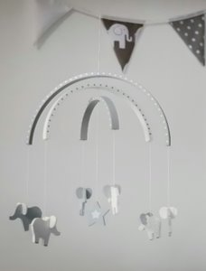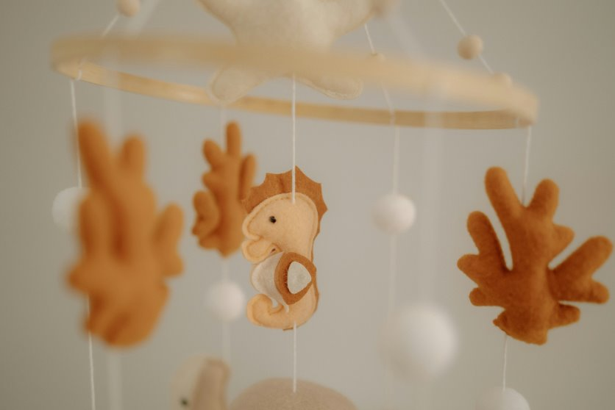

How does a mobile connect to this lesson plan?
A dream mobile helps people see a physical representation of a future dream in life (goal). It can help them think about the skills and effort they need to develop to achieve their dream. A dream mobile is a tool to inspire learning, growth, and success, just like a mobile does for a baby.
What could my class dream mobile look like?
Before the lesson, think about (and if you have time, build) the dream mobile apparatus (the object from which items will hang). Look at the pictures above and notice the different shapes the mobile apparatus can have. The picture on the left uses two wooden pieces crossed like a lower-case ‘t.’ Items hang from the ‘t’ with string. The picture in the middle uses three curved pieces of wood that hang over each other, like three rainbows with items hanging from them. The picture on the right uses a circular piece of wood for the items to hang from. Use these images to inspire a dream mobile apparatus that will hold one item per student. Be creative! Your dream mobile apparatus can have a different shape than the pictures (e.g., one long stick with string hanging down to attach each student’s item to) or use a different material (e.g., metal, plastic, etc.). You can even imagine a digital dream mobile.

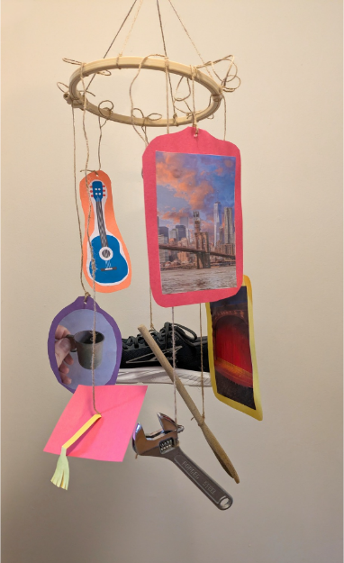
The image below shows an example dream mobile from the Access Team. It uses a circular piece of wood and string to hang the items. Notice there is a mix of real items, printed pictures, and handmade crafts. Based on available materials, you can let students choose which type of item they want to hang on the class mobile.

B. Pictures of Grace Hopper
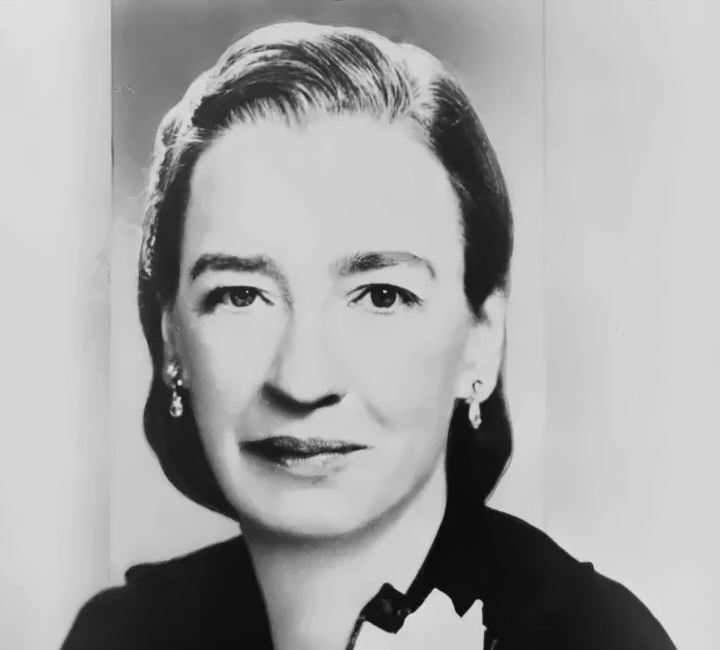

Photo: A. Christensen (CC0)
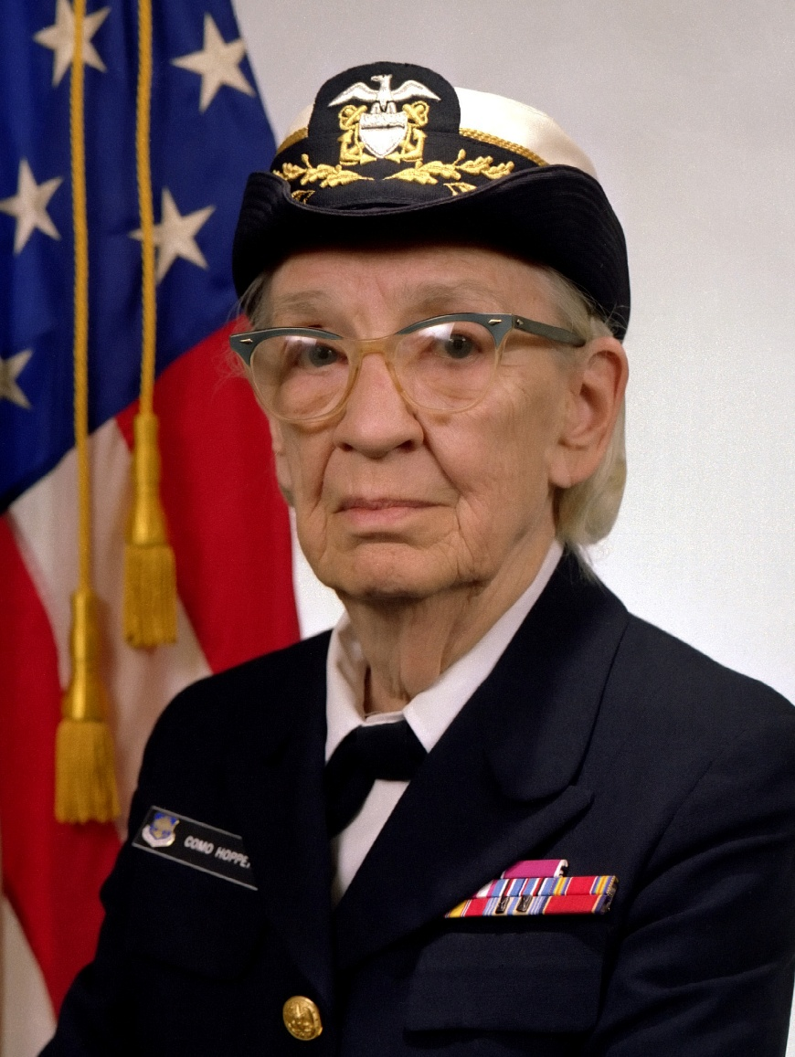

Grace Hopper, 1940s

Grace Hopper, 1980s
Photo: U.S. Navy (Public Domain)

C. Video Tasks

Pre-Viewing Activity: Making Predictions
Look at the pictures below about Grace Hopper’s story of merit. Think about the job fields (areas) your teacher tells you. In what area do you think Grace Hopper contributed the most?


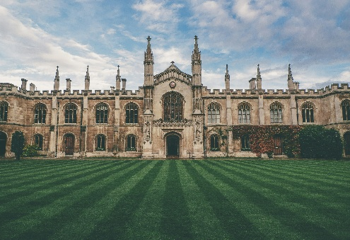
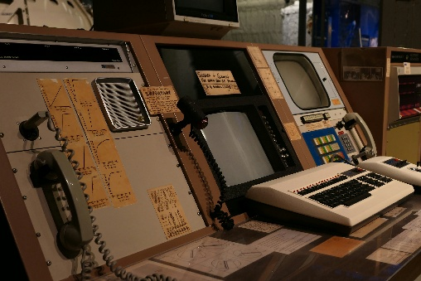

My prediction: ______________________________

Video Activity 1: Checking Predictions
Watch the video. Write the area Grace Hopper contributed to. How close was your prediction?

Grace Hopper contributed to: ______________________________

*********************************Fold*********************************

Video Activity 2: Understanding Details
While watching the video, put Hopper’s achievements in order of her life. Write the numbers 1 to 5 next to the statements.
_____ Hopper returned to the Navy and served the United States for 20 more years.
_____ Hopper earned university degrees in mathematics and physics.
_____ Hopper worked as a computer programmer and created the first compiler.
_____ Hopper was accepted to the United States Navy’s WAVES program.
_____ Hopper worked as a professor.

Video Activity 3: Symbolizing Hopper
While watching the video, draw a symbol or image that represents Hopper’s achievements. Include information from the video in your image. (If you need more space, use the back of this paper.)

D. Video Tasks – Answer Key

Pre-Viewing Activity: Making Predictions
Look at the pictures below about Grace Hopper’s story of merit. Think about the job fields (areas) your teacher tells you. In what area do you think Grace Hopper contributed the most?

My prediction: __Answers will vary__

Video Activity 1: Checking Predictions
Watch the video. Write the area Grace Hopper contributed to. How close was your prediction?

Grace Hopper contributed to: __Technology and/or Education__

*********************************Fold*********************************

Video Activity 2: Understanding Details
While watching the video, put Hopper’s achievements in order of her life. Write the numbers 1 to 5 next to the statements.
__5__ Hopper returned to the Navy and served the United States for 20 more years.
__1__ Hopper earned university degrees in mathematics and physics.
__4__ Hopper worked as a computer programmer and created the first compiler.
__3__ Hopper was accepted to the United States Navy’s WAVES program.
__2__ Hopper worked as a professor.

Video Activity 3: Symbolizing Hopper
While watching the video, draw a symbol or image that represents Hopper’s achievements. Include information from the video in your image. (If you need more space, use the back of this paper.)

Drawings will vary. Check to make sure information from the video is represented in the drawing.

E. Original Audio Transcript of Grace Hopper Biography Video
Video Link: Grace Hopper, Computer Scientist and Military Leader Biography (https://www.youtube.com/watch?v=meeCAFacrG0)

Teacher note: This is the original transcript of the video at an advanced level of English. If you would like a simplified version of the transcript, see Lesson Materials – Item F.

Grace Murray Hopper, the grandmother of computer programming, was born on December 9, 1906. She attended Vassar College, graduating in 1928 with a degree in math and physics. After graduating, she accepted a position as an assistant professor at Vassar, which would help her pay her way through Yale, where she received both a Master’s and a PhD in Mathematics.

Satisfied with three math degrees under her belt, Hopper went back to Vassar, now as a full-time professor. She spent the next ten years molding young minds. And then, World War II broke out. Hopper wanted to do her part in the war effort, so she applied for the WAVES program, which stood for Women Accepted for Volunteer Emergency Service. It was basically the first program that expanded women’s wartime roles beyond nursing and administrative duties. In 1943, she was accepted to WAVES and joined the U.S. Naval Reserve.

She was then assigned to work on the Mark series of computers at Harvard. The Mark I was one of the first electromechanical computers used in war efforts and the first of its kind produced in the United States. While working on the Mark II, Hopper discovered an unusual glitch. One day the computer inexplicably shorted out due to a moth stuck in the hardware. The bug was removed, and Hopper referred to this solution as “debugging” the computer.

Finally, in 1952, she revolutionized computer programming as we know it. She and her team invented the first compiler—a program that converted common-sense commands into binary computer language. This blew the doors off computer programming. Every subsequent programming language is built on her work, and it is no exaggeration to say that we owe computer programming as we know it to Hopper.

At 60, Hopper retired from the Navy with more than two decades of Naval service under her belt. But her retirement didn’t last long. Less than a year later, Uncle Sam came calling again, asking her to come back to standardize COBOL for the Navy. Always the dutiful patriot, Hopper returned to active service for another 20 years.

Grace Hopper died on January 1, 1992. In her later life, when asked what her greatest accomplishment was, Hopper was known to respond, “All of the young people I’ve trained.”

F. Simplified Audio Transcript of Grace Hopper Biography Video
Video Link: Grace Hopper, Computer Scientist and Military Leader Biography (https://www.youtube.com/watch?v=meeCAFacrG0)

Teacher note: This is simplified version of the video transcript. It conveys the same ideas as the video but uses different words. If you would like the original version of the transcript, see Lesson Materials – Item E.

Grace Murray Hopper was born on December 9, 1906. People call her the “grandmother of computer programming.” She went to Vassar College and finished in 1928. She studied math and physics. After she finished, she became an assistant professor at Vassar. This job helped her pay for more studies at Yale. At Yale, she got a Master’s degree and a PhD in Mathematics.

After Hopper finished her three math degrees, she went back to Vassar. She worked there as a full-time professor. She taught students for ten years. Then, World War II started. Hopper wanted to help her country. She applied to a program called WAVES. WAVES was Women Accepted for Volunteer Emergency Service. It was one of the first programs that gave women more important jobs in the war. In 1943, she joined WAVES and entered the U.S. Naval Reserve.

Later, she went to Harvard. She worked on the Mark computers there. The Mark I was one of the first big computers used in the war. It was also the first machine like this in the United States. She also worked on the Mark II. One day, she found a strange problem. The Mark II computer stopped working because a moth was inside it. Someone removed the moth, and Hopper called this “debugging” the computer.

In 1952, she changed computer programming forever. She and her team made the first compiler. A compiler is a program that changes simple, everyday commands into the computer’s language (binary). This invention made programming much easier. Every computer language after that was built on her idea. Many people say we have modern computer programming because of Hopper.

When she was 60 years old, Hopper retired from the Navy. She had worked there for more than 20 years. But she did not stay retired for long. Less than a year later, the government asked her to return. They asked her to help the Navy with a computer language called COBOL. She loved serving her country, so she went back to work for another 20 years.

Grace Hopper died on January 1, 1992. In her later years, people often asked her about her greatest achievement. She usually said, “All of the young people I’ve trained.”

G. Key Vocabulary Glossary
Definitions below illustrate how key vocabulary terms are used in the context of this lesson.

compiler n. a computer program that changes simple commands into computer language
computer programmer n. a person who creates computer programs
dream n. a future hope or goal
effort n. work done by mind or body
merit n. the quality of achieving something based on a person’s talent, effort, and skills
meritocratic adj. describing a situation where people achieve things through merit
Navy n. a branch of a nation’s armed forces that focuses on operations at sea
skill n. the ability to do something from training, experience, or practice
talent n. a special ability that allows someone to do something well

