From Stadiums to Streets: Discovering Cities Through Local Landmarks
Freedom 250
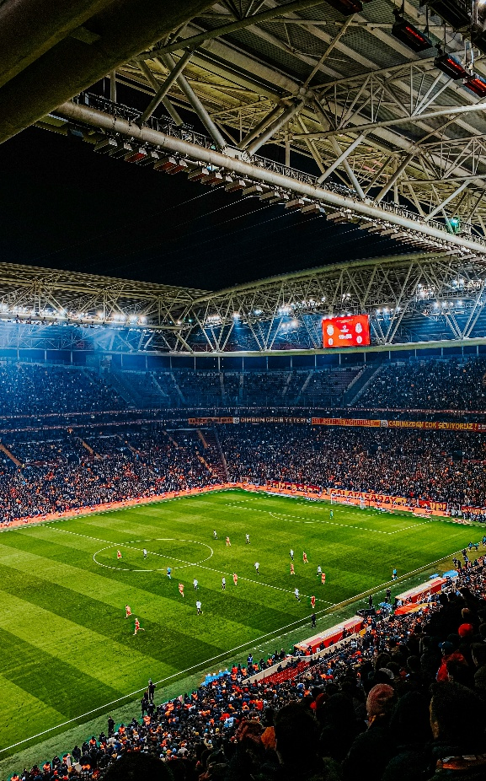
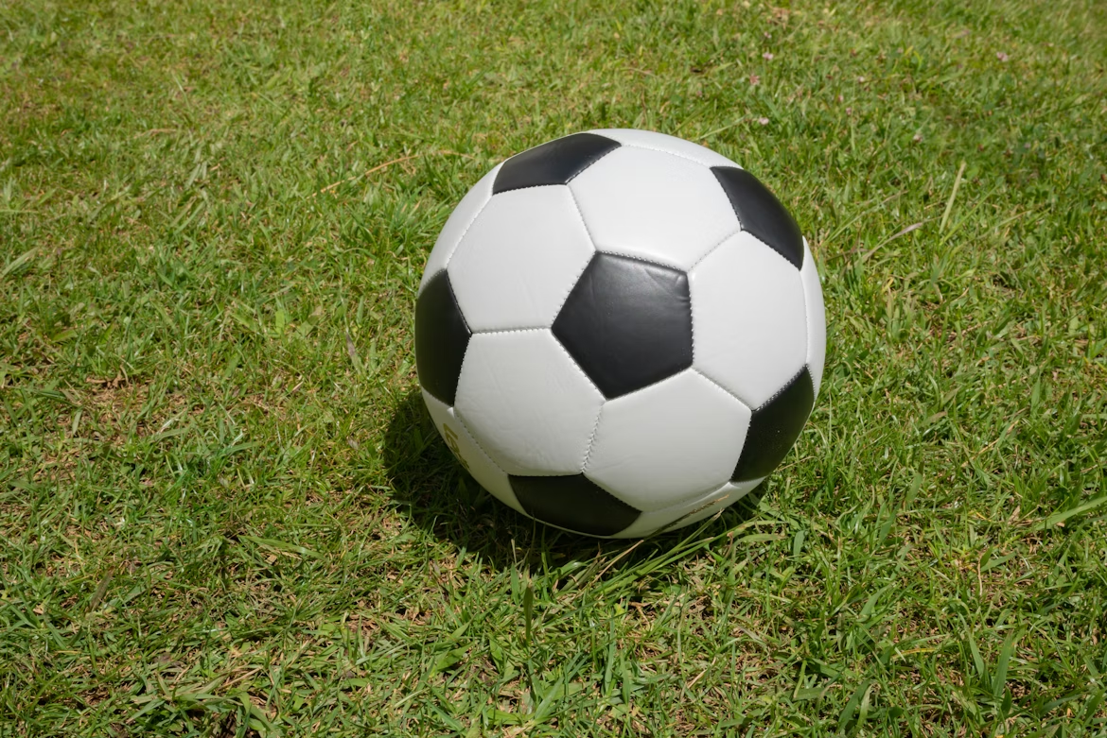
Overview
This lesson introduces students to the history of soccer and how local landmarks reveal a community’s cultural, geographic, and historical identity. Students take a virtual road trip to cities across the United States, create an infographic that highlights key landmarks, and reflect on the economic impact of tourism on their local community.

0BGoals
As a result of this lesson, students will be able to:
- identify key moments in the history of soccer and its global significance
- explore American cities and their characteristics through a virtual road trip
- compare landmarks across communities and how they reflect local identity
- create an infographic that demonstrates what makes a strong host city for a soccer tournament while considering economic impact, tourism, and career opportunities
As a result of this lesson, teachers will be able to:
- use student-centered teaching practices
- collaborate with students to foster local pride
- prompt students to collaborate, communicate, and think critically

1BLesson Materials
IN YOUR CLASSROOM
- Paper and pencils or pens
- Chalkboard and chalk or whiteboard and markers
- Tape
PROVIDED WITH THIS LESSON PLAN
- Goal or No Goal? True or False Statements
- North American Host Cities Map
- Host City Infographics
- Road Trip Graphic Organizer
- Key Vocabulary Glossary

2BPreparation
- This lesson explores the world of soccer and local landmarks across different cities in the U.S. to help students reflect on the cultural, geographic, historical, and economic identity of their own communities. Students activate prior knowledge about the history, culture, and rules of soccer by engaging in a True or False warm up activity. Review answers to these questions before teaching the lesson plan (Lesson Materials – Item A).
- Students take a virtual road trip and “visit” several U.S. cities that host major soccer tournaments (Lesson Materials – Item C). Each infographic contains basic historical and cultural information about the city along with three tourist attractions or local landmarks. Consider your own community and what you might want to show a visitor who is curious to learn more about your local identity. Examples might include historical and/or cultural landmarks, neighborhoods, parks, nature, architecture, public art, restaurants, and even experiences, activities, and local food. These examples might be helpful to share with students. At the end of the lesson, students will write a short “postcard” to a friend or family member. Consider showing students an example of a real postcard.
- Review the Procedures and Lesson Materials sections, then determine the formats you will use for the Lesson Materials.
  - Many items can be photocopied, enlarged, or projected onto the board or a wall. More suggestions for formatting these materials are in the Procedures steps and notes.
  - After selecting formats for the activities, prepare the required number of materials to suit your class size, considering how many groups or individuals will participate in each lesson stage.
- Read the Skills and Language Topics and Key Vocabulary lists below. Review the glossary (Lesson Materials – Item E) to see how key vocabulary terms are used in this lesson. Will you need to activate prior knowledge, pre-teach, or otherwise provide scaffolding (support) for your students beyond the suggestions in the Procedures section? See the Variations and Extensions section for ideas.
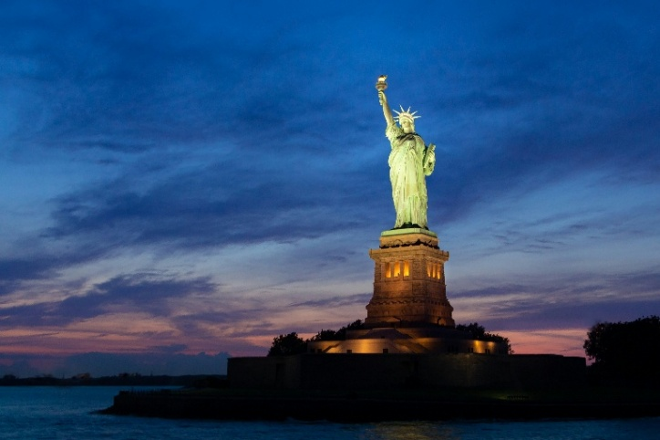
Skills and Language Topics
- Expressing and supporting ideas using examples
- Understanding concepts through personal and/or local experience
- Teamwork: communicating and collaborating to complete a series of tasks
Key Vocabulary
- attraction  - fan(s)  - infographic  - landmark/site  - loyalty | - patriotism  - road trip  - tourism  - unity

3BProcedures
TIME | STEPS | NOTES
5 min | 5B1. Warm up: Goal or No Goal? True or False  - Ask students if they are familiar with the history, rules, and culture of football (also known as “soccer” in the United States) and call on one or two volunteers to share what they know. After soliciting student responses, explain that soccer is popular all over the world, and that national teams often compete in international soccer events, bringing together different countries, cultures, and language through sport.  - Tell students they are going to engage in a fun, movement activity to test their soccer knowledge with a series of “True” or “False” questions.  - Explain that during soccer matches, referees use different hand gestures to clearly and quickly communicate decisions, like fouls, goals, or restarts, so everyone on the field understands what is happening without words. Students will use similar gestures to indicate whether a statement is true or false.  - If a statement is true (“goal!”), students give a thumbs up 👍  - If a statement is false (“no goal!”), students cross their arms 🙅  - Read each statement from the “Goal or No Goal? True or False Statements” (Lesson Materials – Item A).  - Direct students to discuss each statement with a partner before indicating whether it is true or false.  - Ask one volunteer per statement to justify their response using the sentence frame: I think the statement is true/false because… | Pair/Individual  Lesson Materials – Item A  Adapt gestures and/or movements as needed – students might use a different gesture to signal true/false or move to one side of the room or the other.
25 min | 6B2. Soccer Road Trip  - Explain that international soccer tournaments are more than just an event; these competitions are an opportunity to bring people together from across the globe.  - Show students the “North American Host Cities Map” (Lesson Materials – Item B) and tell them that there are 16 cities in North America hosting global matches in a summer 2026 international soccer tournament, including 11 cities in the United States, three cities in Mexico, and two cities in Canada.  - Cut out the “Host City Infographics” (Lesson Materials – Item C) and place them around the classroom (use tape or another adhesive to attach them to the wall).  - Ask students to think about the principles that capture the spirit of an international soccer tournament (or any international sporting event).  - Give students 1 minute to write down at least one idea independently before sharing as a group. After collecting a few responses, guide students towards the following principles:  - Shared Pride: International sporting events let countries show their culture and skills to the world. People feel proud when they play for their country or support their country’s team.  - Patriotism: Fans show love of their country by cheering for their national team. They use flags and songs to celebrate.  - Loyalty: Fans support their team when they win or lose. They follow their country’s players over time for years and years.  - Unity: Large, global sporting events bring people together from all over the world. People in each country and across the globe share happy moments, hope, and connection.  - Tell students they are going to go on a virtual road trip to learn about several cities in the United States. As students prepare to move around the room, remind them that each city has unique places, or attractions, that make them interesting destinations for tourists. Host cities for major international sporting events are selected because they offer a lot of exciting things for visitors to do or see! These tourist attractions can be landmarks, neighborhoods, parks, nature, architecture, public art, food, or even fun activities. Explain that these attractions help show the community’s local culture and identity, and they often create a sense of community pride.  - Assign students to small groups of three or four.  - Provide each student (or group) with a “Graphic Organizer” (Lesson Materials – Item D). As students rotate around the room and “visit” each city, they will record the following observations:  - What attractions do you see?  - What do you wonder about these attractions?  - Based on the written description, what do you think these attractions say about each city’s local identity or culture?  - Give students 7 to 8 minutes before rotating to the next city.  - Encourage students to discuss their observations as they record them in their graphic organizers. Provide students with the following sentence frames to support speaking:  - I see…  - There is/are…  - I wonder…  - I wonder if…  - I think…  - Maybe… | Small-group  Lesson Materials – Item B  Lesson Materials – Item C  Lesson Materials – Item D  Consider assigning roles to each group member, like reader, speaker, writer, timekeeper, group leader, etc.
25 min | 7B3. Host City Pitch  - Remind students that a host city for a major international sporting event would typically offer many exciting things for tourists to do and see. Cities with a strong tourism industry are more likely to be selected as host cities because they are places people might want to visit. Tourism also brings money to the local economy by supporting restaurants, hotels, museums, national parks, and other businesses, and it creates jobs for people who live in the community.  - Tell students they are going to create a “pitch” (a short talk about an idea) that demonstrates why a place would make a great host city for an international soccer tournament. Students will create an infographic that illustrates an ideal host city. They should include a stadium and three tourist attractions. Select one of the following for students to represent in their infographics:  - Students’ own local community  - A city in their country or region  - A remaining North American host city  - An imaginary city that students invent  - Give students a blank piece of white paper and ask them to fold it into four quadrants. Students can also use the back of their graphic organizer.  - Instruct students to use words or drawings to describe or illustrate their ideal host city (real or imagined). Encourage them to include different types of attractions in each quadrant, like historical/cultural landmarks, neighborhoods, parks, nature, architecture, public art, restaurants, and/or interesting activities.  - Provide students with the following sentence frames to support writing:  - This city has…  - Tourists can visit…  - The city would be a good host city because…  - People can learn about…  - Fans can experience the culture by…  - One interesting attraction is… | Individual or small group  Students can complete this activity individually or in small groups.  Consider your students’ background when selecting the type of infographic they create. If students live in a rural area with less tourism, you might ask them to invent a host city from imagination. If students live in an urban area with a strong tourism sector, you might ask them to reflect on attractions in their own community.
5 min | 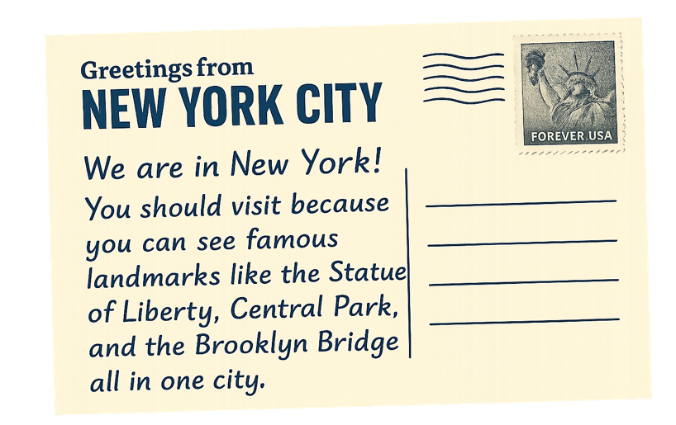  8B4. Post Card  - Tell students they are going to pretend to be a tourist who has just visited one of the U.S. host cities (or the city they referenced for their infographic).  - If needed, explain that a postcard is a small card with a picture that people send to friends to share messages and experiences from a place they visit. People usually send postcards through the mail.  - Consider showing students an example of a real postcard or an image of a postcard.  - Instruct students to write a short postcard to a friend sharing what they liked about the city and why their friend should visit. Students can use the back of their infographic for the postcard.  - Provide students with the following sentence frame to help them craft their message: You should visit… because…  - Ask students to practice reading their postcard to a partner before sharing with the whole group. | Whole group reflection  If you have time, invite 2 or 3 student volunteers to share their postcards with the entire class.

4BVariations and Extensions
VARIATIONS

9B1. General Differentiation and Scaffolding
- Based on students’ levels and prior knowledge, teachers can choose to cover the lesson content over one or more class sessions. This approach will allow teachers to provide additional instruction, review, and support as appropriate.
- To make the lesson more accessible for low-resource or low-mobility classrooms, project the host city infographics on a whiteboard and assign groups of students to each city. Alternatively, instead of students moving around the classroom, give each group a printed infographic and instruct students to pass their infographic to the next group when it’s time to rotate.
- To challenge more advanced students, teachers can encourage students to explore the nicknames of the global soccer host cities. Teachers might explain that cities sometimes have nicknames, which are unofficial names to promote the identity of the city. For example, New York City is often known as “The Big Apple,” which dates back to 1920s horse-racing. Writers used “The Big Apple” to describe a big prize during horse races, and New York City became known as the city with the biggest races and rewards. Ask students to discuss why they think each city has its unique nickname and what it says about the city’s identity. Instruct students to create a memorable nickname for their own city or community.

10B2. Goal or No Goal? True or False Warm Up Variation
- Instead of the teacher reading out the True or False statements, print the statements from Lesson Materials – Item A and cut them out along the dotted lines. Put students in groups of 3 to 4 and give each group several statements to discuss until they agree. Groups then read their statements to the class and explain their answers.

11BEXTENSIONS

12B1. Traveler’s Pack
- Explain to students that a road trip is a long journey taken by car, bus, or train, usually for fun. People stop at different places along the way.
- Tell students to imagine they are going to travel on a one-month road trip for a major sporting event and need to think about what essential items they are going to pack.
- Assign students to small groups and ask students to identify 4 to 6 essential items they would need to travel on a long road trip.
- Ask each group to share why they selected the items they chose.

13B2. Jigsaw Share Out
- After students embark on their virtual road trip and complete their graphic organizers, facilitate a jigsaw share out.
- Pair each group with a partner group that visited a different host city. Group 1 teaches Group 2 about their city’s identity and local landmarks/tourist attractions. Then, groups switch roles and Group 2 teaches Group 1 about their host city.
- Provide students with the following sentence frames to support speaking:
  - Our host city is known/famous for…
  - In this city, you can visit…
  - This local landmark is important because…
- Give groups 5 to 7 minutes to share with each other. Then, rotate groups until all groups have learned about the remaining host cities.

14B3. Remaining Global Soccer Host Cities
- To make this lesson more challenging for advanced and/or older students, teachers can integrate this extension activity focused on researching the remaining global soccer host cities (Houston, Los Angeles, San Francisco, Seattle, Toronto, Vancouver, Guadalajara, Mexico City, and Monterrey).
- Show students the “North American Host Cities Map” (Lesson Materials – Item B).
- Tell students they are going to choose one or two remaining host cities to research. Students can create an infographic or a formal presentation.
- Ask students to present what they learn about the new host city to their classmates.

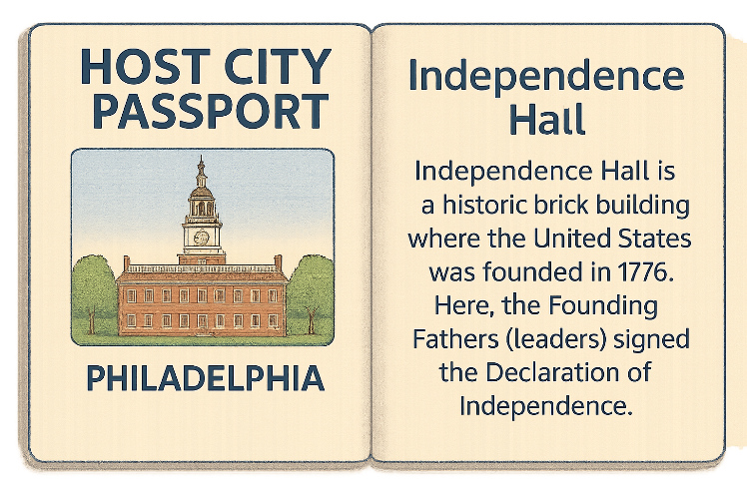
15B4. Tourism passport
- To make this lesson more challenging for advanced and/or older students, teachers can integrate this extension activity focused on creating a passport that incorporates information about a community and its local landmarks.
- Students design a passport that tourists might use to visit a city or the students’ home country, region, or community (real or imagined). Each page represents a local attraction and can include as many attractions as students like.
- Challenge students to include at least one attraction from each of the following tourism categories:
  - Adventure and activities (hiking, rafting, skiing)
  - Architecture (buildings, bridges, piers, and other human-made infrastructure)
  - Cities and towns (skylines, neighborhoods, streets)
  - Events and festivals (cultural celebrations, sporting events, and local festivals)
  - Food and drink (restaurants, street vendors, shops)
  - Fun and entertainment (theme parks, movie theaters, concerts)
  - History and culture (museums, historical sites, monuments, public art)
  - Learning and experiences (tours, classes, hands-on activities)
  - Nature and scenery (beaches, mountains, parks, scenic landscapes)
  - Wildlife (animals, nature parks, aquariums)
- Extend this activity even further by discussing what types of economic and/or professional opportunities each type of tourism can create for local community members. Discuss the kinds of workforce readiness skills students would need to pursue a career in each area.
External links are provided for informational purposes only; there is no implied U.S. Department of State endorsement of the views, opinions, media content,
or privacy policies contained therein.

Images in this lesson plan are in the public domain or “no attribution required” unless otherwise noted. If sharing, adapting, or remixing portions of this lesson plan, please respect excepted permission and licensing statements noted in the credit statements for individual images, graphics, or other content. To learn about Creative Commons licenses, their uses, and their restrictions, visit the Creative Commons license explanation site.

A. Goal or No Goal? True or False Statements
Statement | True/False | Explanation
Soccer began in the United States. | False | Modern soccer began in England in the 1800s. The official rules of the game were written in 1863.
The first major global soccer tournament took place in 1930 in Uruguay. | True | The first major global soccer tournament took place in 1930. Uruguay was the host country and won the tournament.
All players can use their hands to control the ball at any time in a match. | False | Most players cannot use their hands. They pass and shoot the ball with their feet. They can also use their head or body, but not their hands. Only the goalkeeper can use their hands.
A soccer team has 15 players on the field during a game. | False | A soccer team has 11 players on the field during a game. This includes one goalkeeper and ten field players.
Referees use yellow cards to warn players. | True | A referee gives a yellow card for breaking rules. Two yellow cards or one red card means the player must leave the game.
Fans often show their loyalty and national pride when their country’s team and players compete on the world stage. | True | Fans often show strong loyalty and shared pride by wearing team colors, waving flags, and loudly supporting their country and players.
Big soccer tournaments bring together people from around the world. | True | Fans support their teams and learn about other cultures. These events create a strong sense of global connection and unity.
International sporting events do not affect tourism because fans stay at home to watch games. | False | International sporting events bring more tourism. Fans travel to host countries to attend matches and visit cities.

B. North American Host Cities Map
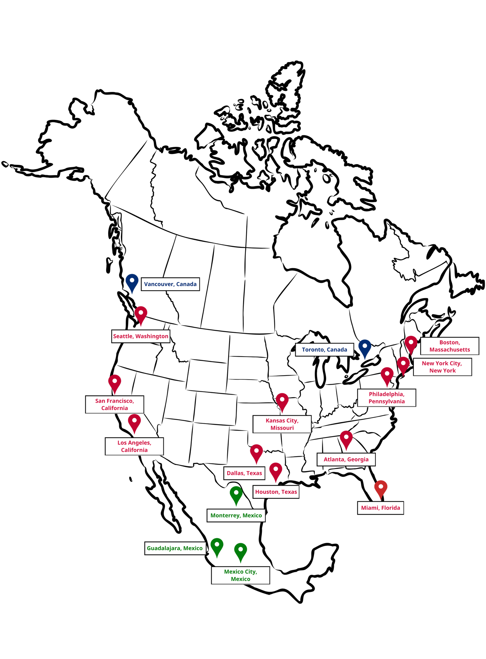

C. Host City Infographics
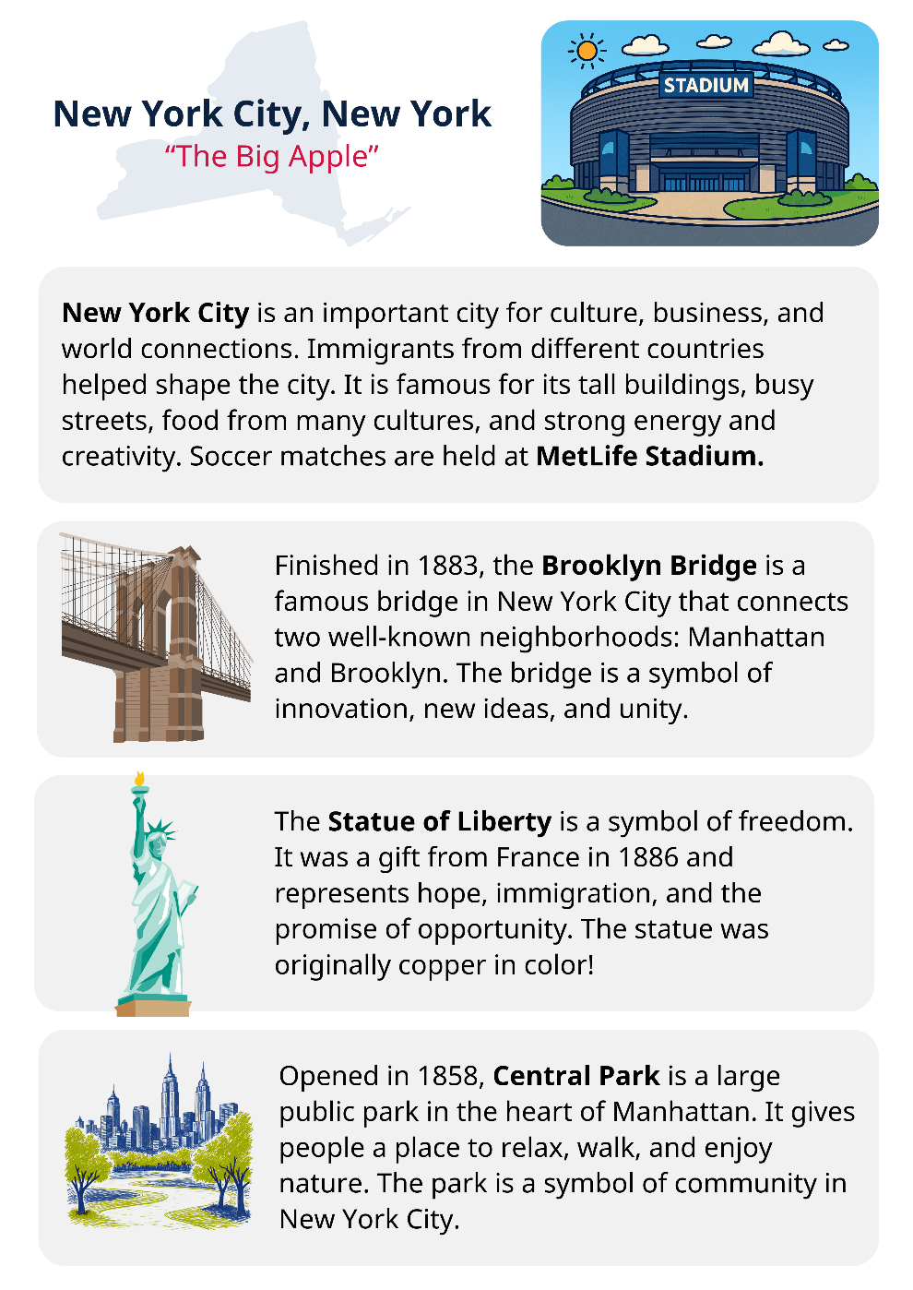 | 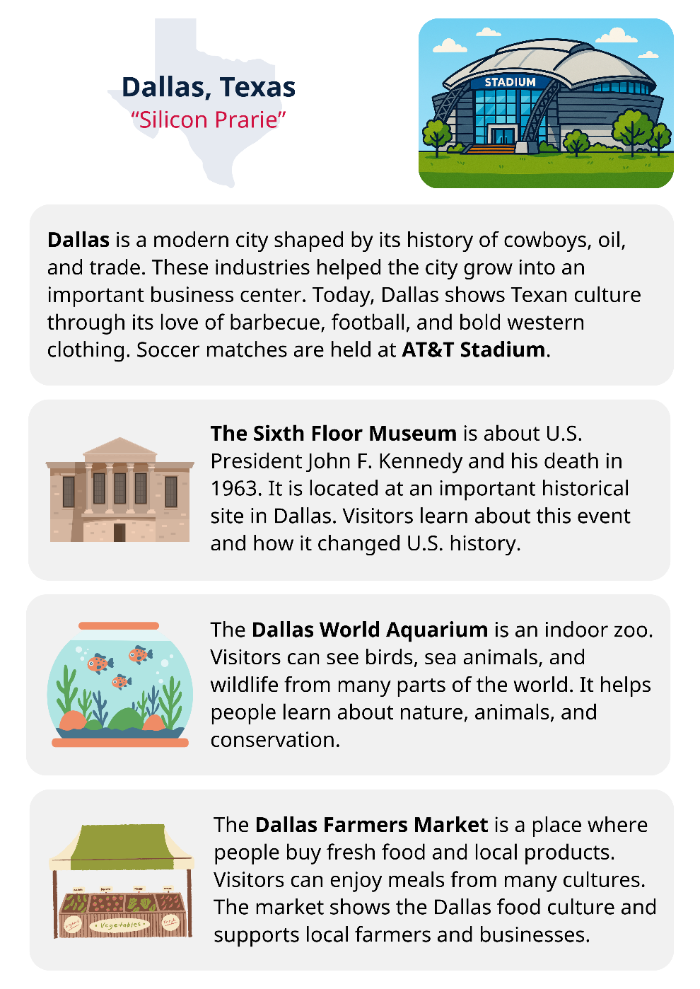

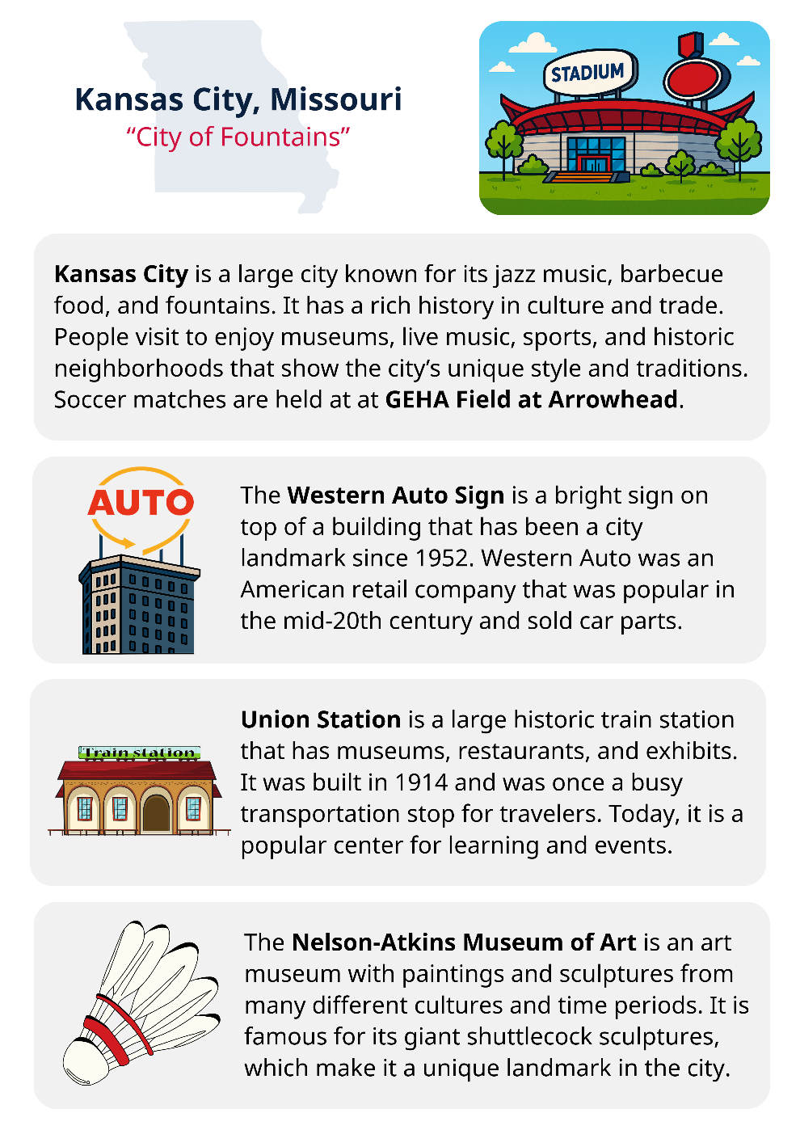 | 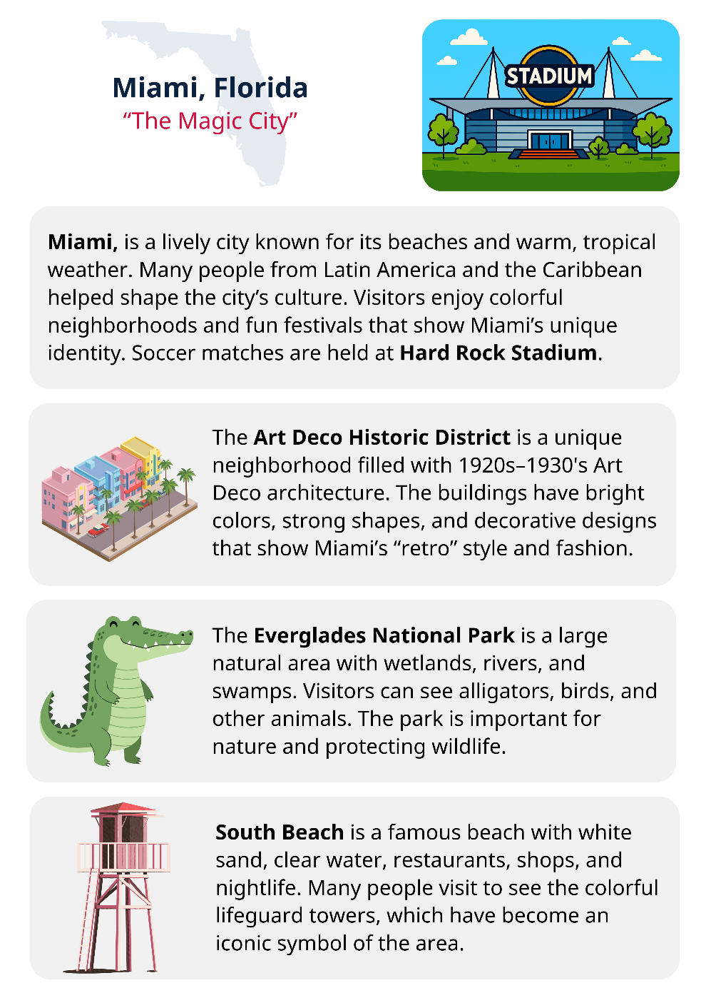

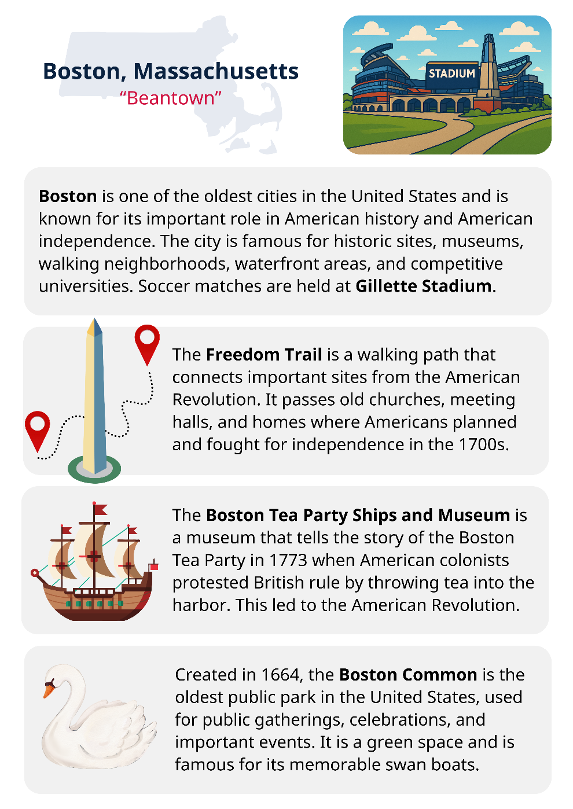 | 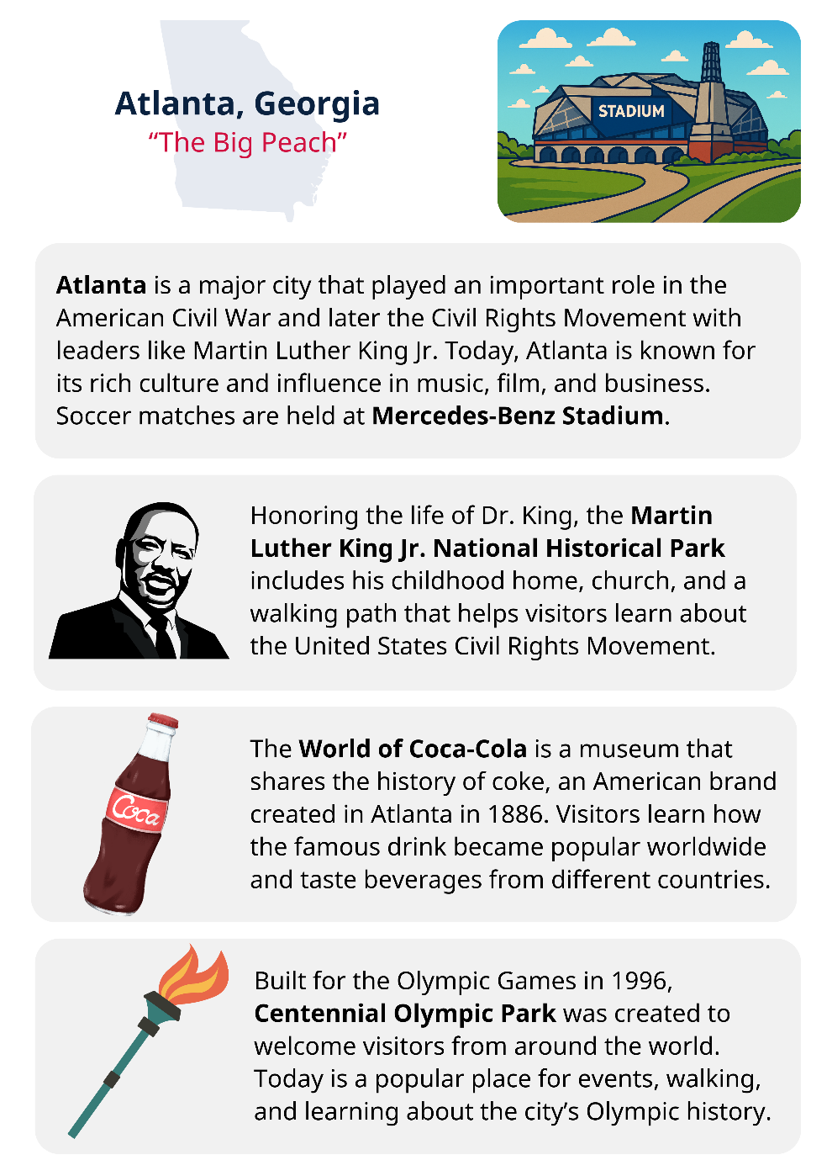

D. Graphic Organizer
Name of Host City:
What attractions do you see? | What do you wonder about these attractions? | What do you think the attractions say about the city’s local identity?

Name of Host City:
What attractions do you see? | What do you wonder about the attractions? | What do you think the attractions say about the city’s local identity?
Photo: A. Christensen (CC0)

E. Key Vocabulary Glossary
Definitions below illustrate how key vocabulary terms are used in the context of this lesson.

attraction n. a place tourists visit because it is interesting or fun
fan n. a person who likes and strongly supports a team
infographic n. a picture with information, numbers, and images to explain a topic
landmark/site n. a culturally important or famous place that people recognize and visit
loyalty n. being faithful or dedicated to a person, team, or group
patriotism n. love for and commitment to one’s country, including respect for its history and shared values
road trip n. a long journey taken by car, bus, or train, often for fun
tourism n. traveling to different places for fun, learning, or relaxation
unity n. people working together as one group, sharing goals

