Small Acts, Strong Communities
Freedom 250
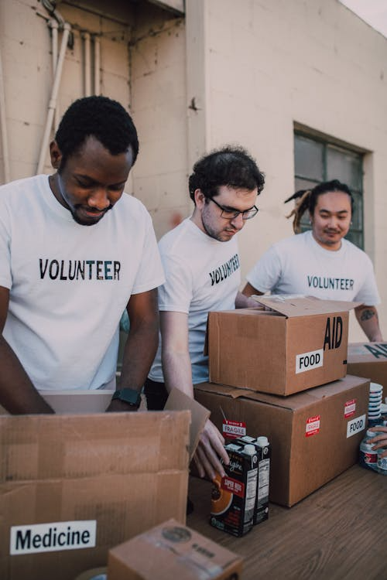
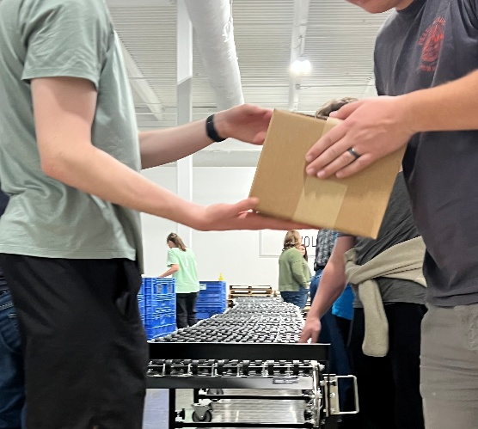
Overview
Photo: R. Keogh
(CC0)
In this 60-minute lesson, students learn how volunteering and community service are important parts of life in the United States and how people “give back” to strengthen their communities. Then students plan action to practice giving back in their own community.

Goals
As a result of this lesson, students will be able to:
- learn and use key vocabulary (e.g., volunteer, community service, impact)
- summarize a short informational text and identify main ideas/supporting details
- understand the importance of volunteering and community service
- use collaboration and critical thinking skills to plan a service event for their class
As a result of this lesson, teachers will be able to:
- guide students to explore the legacy of volunteering in the U.S.
- help students consider the connections between service and strong community ties

Lesson Materials
IN YOUR CLASSROOM
- Paper and pencils or pens
- Chalkboard and chalk or whiteboard and markers
PROVIDED WITH THIS LESSON
- Community Service History Cards
- The Spirit of Volunteerism in the U.S. Today - Reading
- Small Acts Service Challenge Log
- Key Vocabulary Glossary

Preparation
- This lesson introduces the tradition of volunteering and “giving back” in the United States and invites students to plan service in their own communities. Consider how volunteering is viewed in your local context and what forms of informal or formal service are most common for young people. You may wish to prepare a few local examples of community help—such as neighborhood support, school projects, or other community projects—to connect the U.S. examples to students’ real lives. Adapt the service challenge so that it reflects realistic needs, cultural expectations, and safety considerations in your community.
- Review the Procedures and Lesson Materials sections, then determine the formats you will use for the Lesson Materials.
  - Many items can be photocopied, enlarged, or projected onto the board or a wall. More suggestions for formatting and sharing these materials are in the Procedures steps and notes.
  - After selecting the formats for the activities, prepare the required number of materials to suit your class size, considering how many groups or individuals will participate in each lesson stage.
  - If using printed versions of Items A, B, and C, cut up the materials and group them as needed.
- Read the Skills and Language Topics and Key Vocabulary lists below. Review the glossary (Lesson Materials – Item D) to see how Key Vocabulary terms are used in this lesson. Will you need to activate prior knowledge, pre-teach, or otherwise provide scaffolding (support) for your students beyond the suggestions in the Procedures section? See the Variations and Extensions section for ideas.

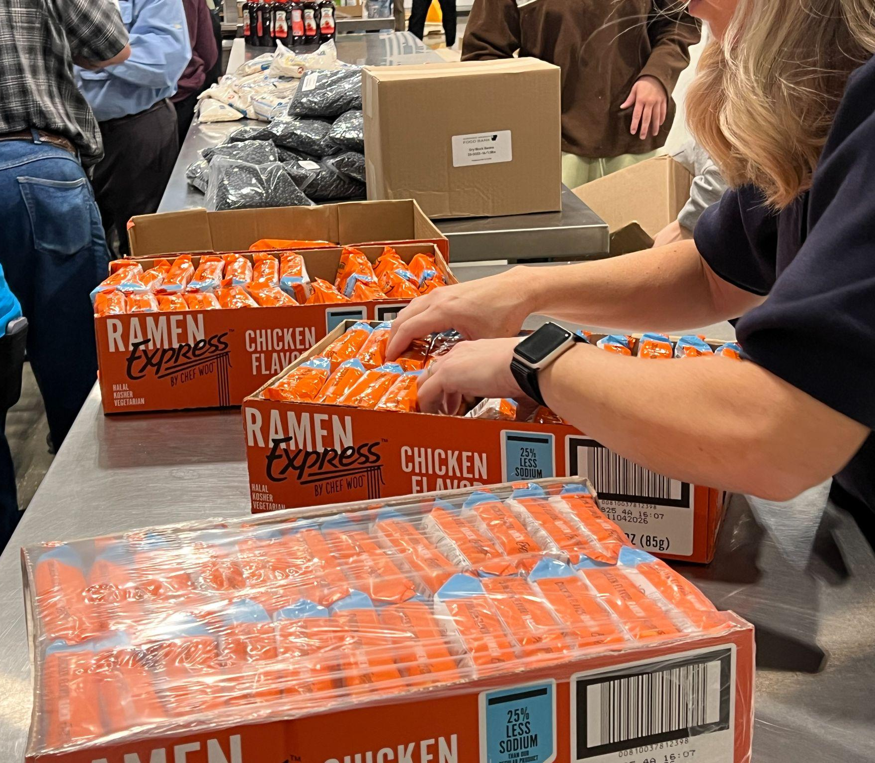
Skills and Language Topics
- Reading for main ideas and details
- Summarizing
- Teamwork: communicating and collaborating to plan service action

Key Vocabulary
- community service
- disaster
- donate
- impact
- need
- volunteer
Photo: R. Keogh (CC0)
- volunteerism

Procedures
TIME | STEPS | NOTES
5 min | 1. Warm up: “What counts as service?”  - Explain that students will do a movement activity to share their opinions about service. Read each statement below and ask students to step to one side of the room if they agree and the other side if they disagree. Invite a few students from each side to briefly explain their choice.  - “Volunteering must be organized by a group.”  - “Volunteering is common in my community.”  - “I have participated in a group community service project.”  - “I have helped someone out when I saw they needed my help.”  - After considering the statements, have students share with a partner about a time they helped someone, either formally or informally. | Think-Pair-Share  Remind students that informal service—such as helping family at home, tutoring a younger student, or spending time with an elderly neighbor—is valuable and strengthens communities. Explain that formal volunteering is usually organized by a group, while informal service happens in everyday life when we notice a need and choose to help.
20 min | 2. U.S. Community Service History Cards  - Explain that students will read about real examples of community service in American history and then teach their classmates what they learned. If needed, briefly review the key words volunteer, community service, and impact before starting.  - Divide students into groups and give each group one Community Service History Card. Ask students to read the card together and discuss three questions:  - What need existed?  - What did people do about it?  - What impact did it have on the community then or now?  - After groups discuss, ask students to stand up and find a partner from a different group. Each student should summarize their Community Service History Card and explain what it shows about the value of community service in the U.S. Partners listen to each other, then students find a new partner and repeat the retell with someone else. | Small group + pair discussion  Lesson Materials – Item A  Encourage students to speak in their own words, not read from the card. You can model one short example to show how to retell the main ideas.
20 min | 3. Reading: The Spirit of Volunteerism in the U.S. Today  - Remind students that helping others and serving the community are long-standing values in the United States. Explain that the class will now connect the historical examples they learned about to the ways Americans volunteer and serve today.  - Give each student the short reading about volunteerism in the U.S. today. Ask students to read the text and underline important details about why people volunteer and how service helps communities.  - After reading, invite students to turn to a partner and share a short summary of the key ideas. Write several sentence starters on the board to support speaking:  - “In the United States, people volunteer by… “  - “Volunteer work helps communities because… “  - “One example of service from the reading is…”  - When pairs finish sharing, bring the class back together and discuss:  - What do some people in the U.S. do to help their community?  - What might happen in our community if we planned a service project where each of us found simple ways to help others? | Reading for details + pair discussion and whole group reflection  Lesson Materials – Item B  Encourage students to use their own words and personal opinions, not only repeat sentences from the text. Praise any connections they make to service in their own country or community.
15 min | 4. Project Planning: Local “Small Acts Service Challenge” Action Plan  - Emphasize that small, everyday actions count as real service.  - Explain that students will plan simple ways to serve people in their own community. Invite them to participate in a Small Acts Service Challenge during the next week or two (determine length and dates according to the needs of your class). Tell students they will record their service time on a class tracker so everyone can celebrate the good they do together. As a class, set a shared goal for total service hours (for example: 15 students × 2 hours × 2 weeks = 60 hours of service).  - Ask students to brainstorm informal ways they can help others and write their ideas on the board. After the class creates a list, invite each student to choose several ideas and make a simple plan for when and how they will serve. Ideas to help students begin:  - Tutor or help younger siblings or classmates with homework  - Practice English with younger students  - Write thank-you notes to school staff or community helpers  - Help more at home with family tasks  - Visit or talk with an elderly neighbor | Whole group discussion  Lesson Materials – Item C

Variations and Extensions
VARIATIONS

1. General Differentiation and Scaffolding
- Based on students’ levels and prior knowledge, teachers can choose to cover the lesson content over two or more class sessions. This approach will allow teachers to provide additional instruction, review, and support as appropriate.

2. Variations for Step 2: U.S. Community Service History Cards
- Teachers can ask student groups to put the U.S. Community Service History Cards in timeline order. Teach additional vocabulary and grammar structures, such as time clauses, as needed. Use this activity to emphasize the long history and importance of service in the United States.
- Teachers can create mixed-level groups for the U.S. Community Service History Cards activity or the reading activity so students can assist each other.

EXTENSIONS

1. Track Student Service Time
- Ask students to keep a simple log of their service time using the Small Acts Service Challenge Log (Lesson Materials – Item C). Create a visible class chart in the classroom where students can add their hours each lesson so they can see progress toward the class goal and encourage one another.
- Teach additional vocabulary and grammatical structures to describe charts.

2. Celebrate Success!
- At the end of the Small Acts Service Challenge, invite students to share one short story (about 30 seconds) using the sentence frame:
“I served by… I learned… I felt…”
- Lead a discussion or journaling activity using these questions:
  - What impact did you have on others?
  - What was harder than you expected while helping others in your community?
  - What will you do in the future to keep helping others?
  - What might happen if our whole school or community joined the next project?
- Focus your celebration on effort and kindness rather than the number of hours students served. Encourage students to notice how service made them feel and how it helped strengthen relationships.

External links are provided for informational purposes only; there is no implied U.S. Department of State endorsement of the individuals, views, opinions, media content,
or privacy policies contained therein.

Images in this lesson plan are in the public domain or “no attribution required” unless otherwise noted. If sharing, adapting, or remixing portions of this lesson plan, please respect excepted permission and licensing statements noted in the credit statements for individual images, graphics, or other content. To learn about Creative Commons licenses, their uses, and their restrictions, visit the Creative Commons license explanation site.

Small Acts, Strong Communities – Lesson Materials
Freedom 250

A. Community Service History Cards
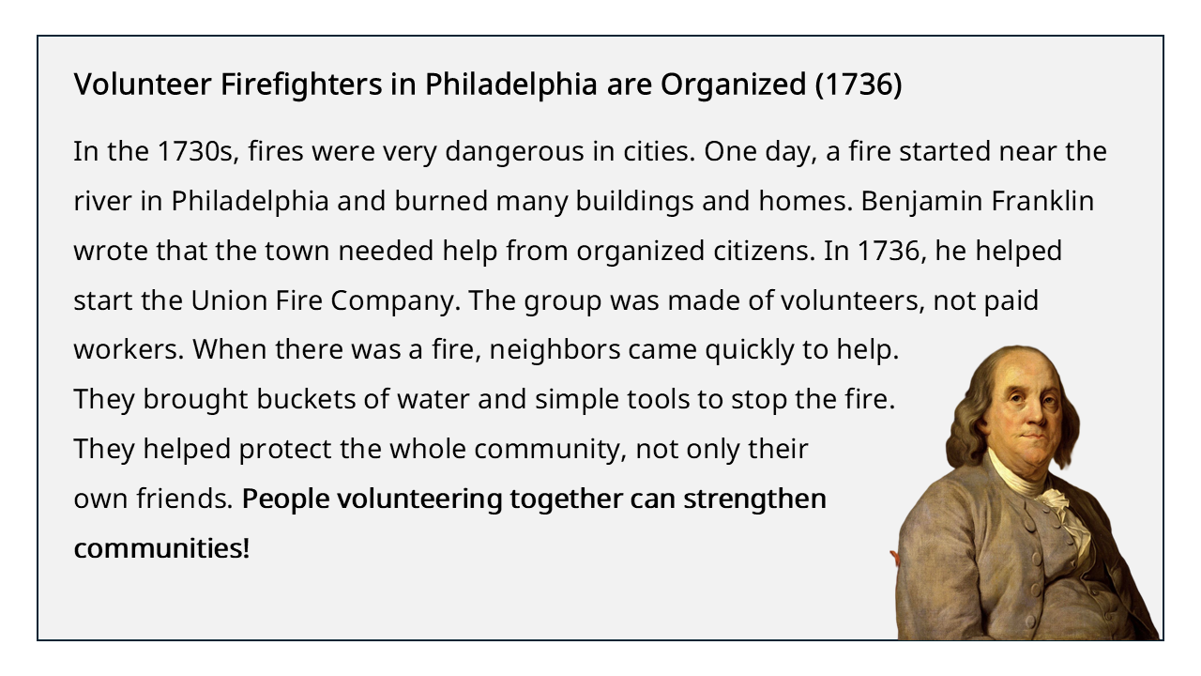
Image: National Portrait Gallery, Smithsonian Institution (CC0)
Photo: A. Christensen (CC0)

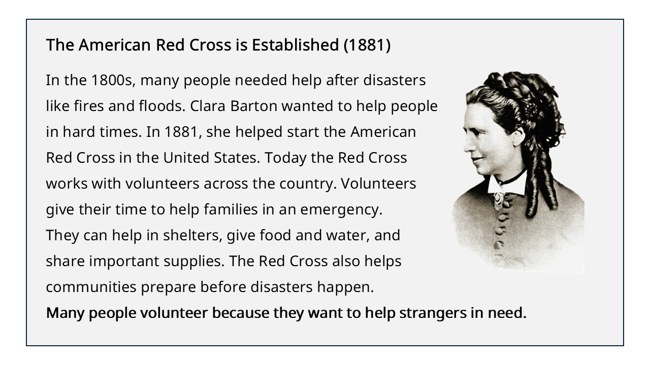
Photo: National Park Service (Public Domain)
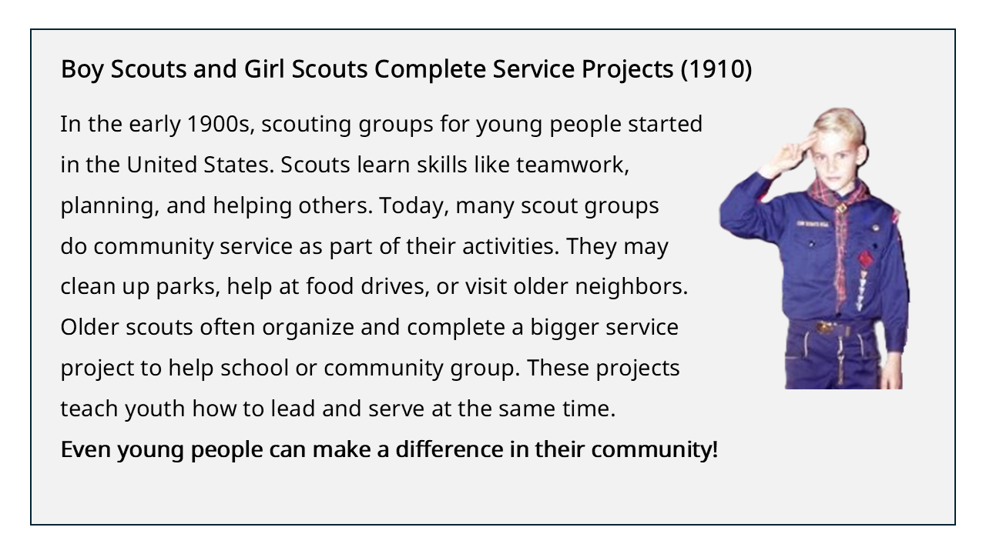
Photo: R. Keogh (CC0)

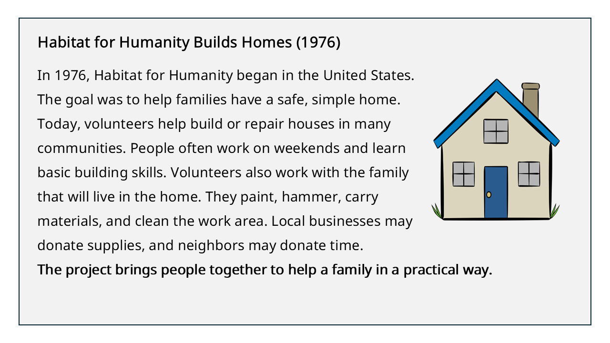

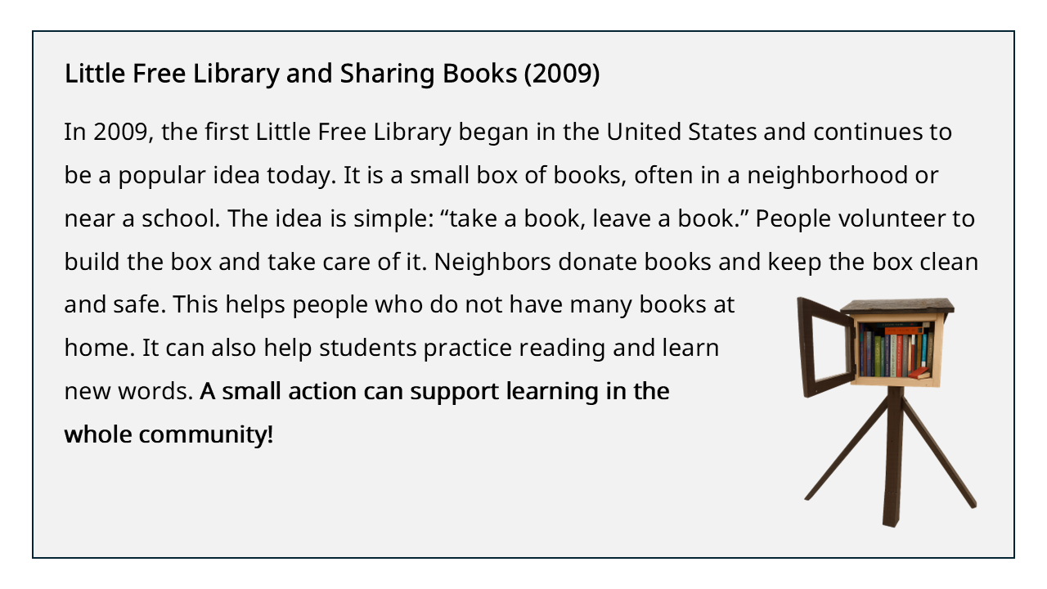
Photo: R. Keogh (CC0)

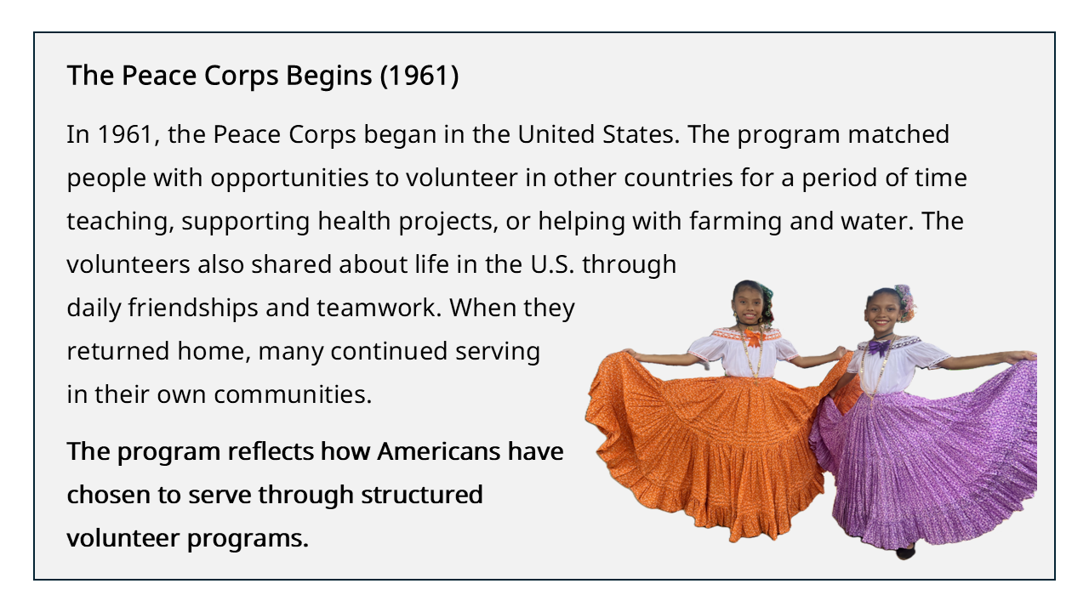
Photo: R. Keogh (CC0)

B. The Spirit of Volunteerism in the U.S. Today - Reading

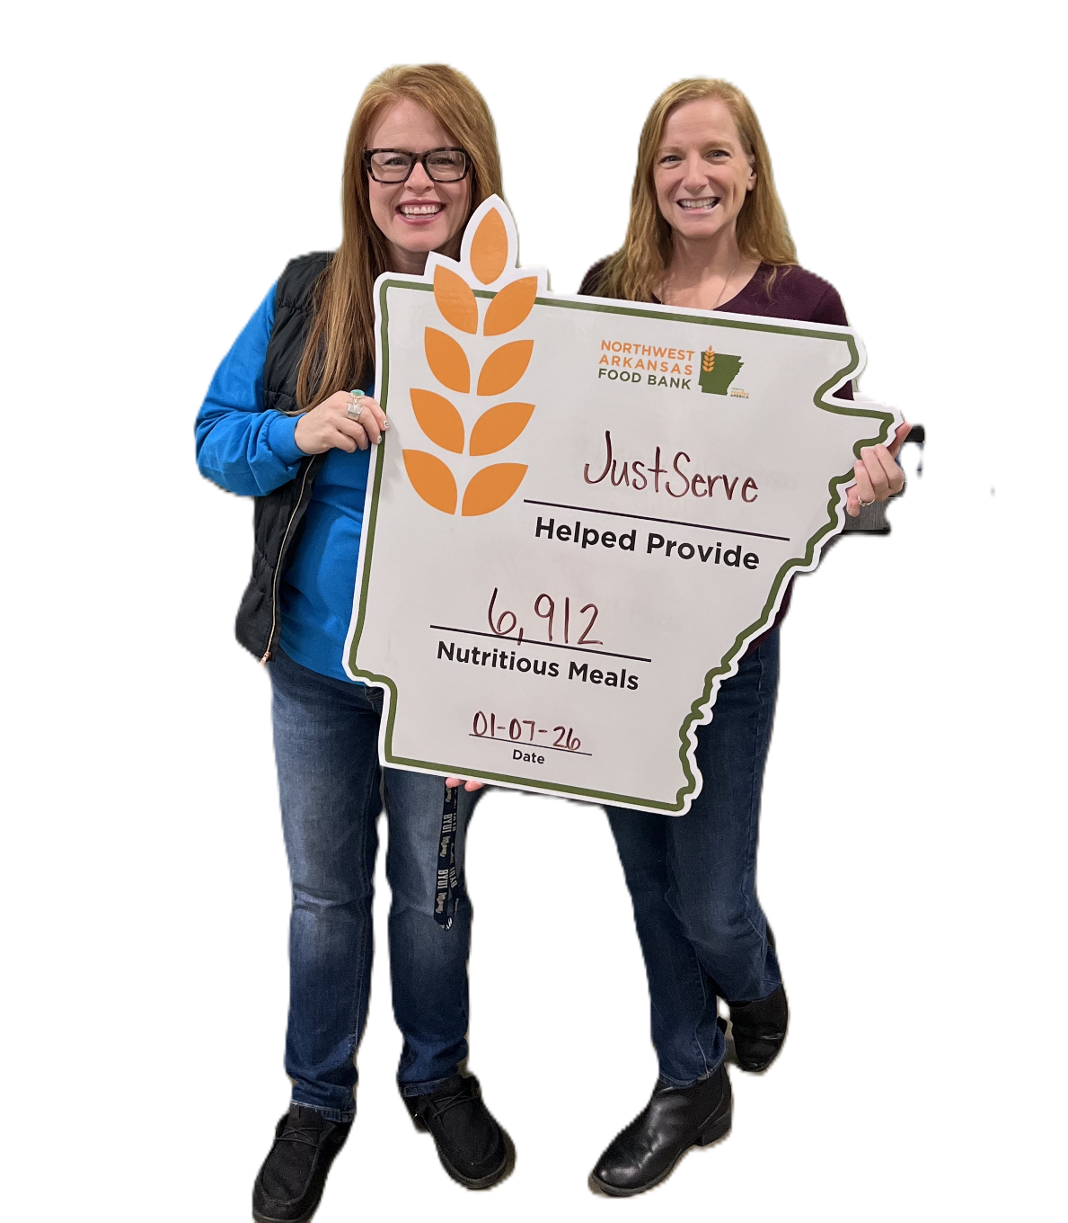
Instructions: Read the text below and underline important details about why people in the United States volunteer and how service helps communities.

Volunteerism is an important part of life in the United States. For many years, Americans have helped their communities by giving their time, skills, and care to others. People volunteer through schools, nonprofits, faith groups, workplaces, and neighborhood organizations. This tradition shows the American belief that strong communities are built when people help one another.

People in the U.S. volunteer in many different ways. Some help at food banks, clean parks, or support elderly neighbors. Others tutor students, coach sports teams, or respond during emergencies. Many Americans volunteer alone, with friends, or with their families. They often share their experiences through stories and photos on social media and encourage others to serve in their own communities. Young people are also an important part of this tradition. Teens can help their communities by giving their time and talents in small ways, such as helping an elderly neighbor, assisting a teacher with classroom cleanup, tutoring a younger student, caring for animals, or helping at a community event.
Photo: R. Keogh (CC0)

The goal of volunteerism in the United States is long-term community support, not just one-time help. Service brings people together and builds trust within communities. As one American leader said, through service, people strengthen the bonds that connect them and show that generosity and community care are lasting American values.

After reading, turn to a partner and share a short summary of main ideas using these sentence starters:
- In the United States, people volunteer by…
- Volunteer work helps communities because…
- One example of service from the reading is…

C. Small Acts Service Challenge Log

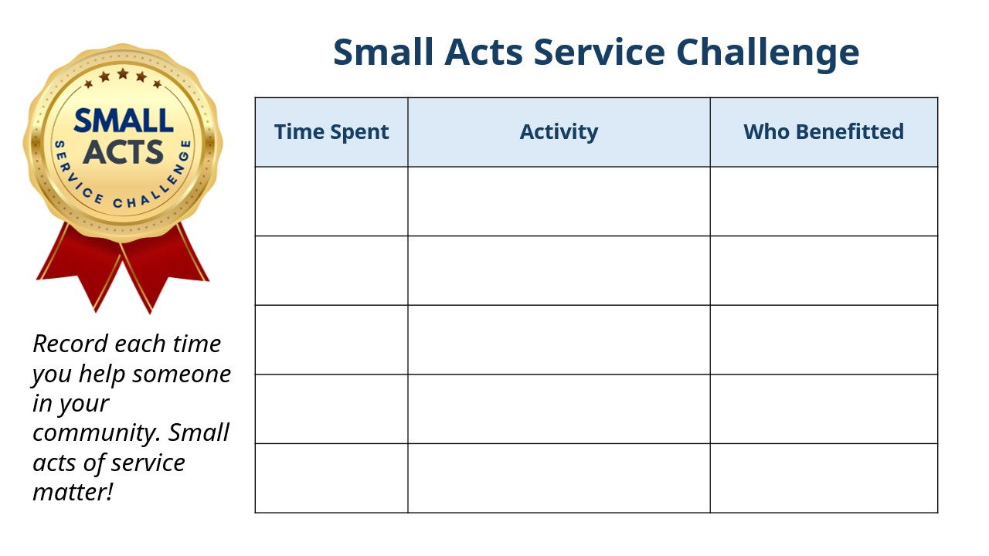

D. Key Vocabulary Glossary
Definitions below illustrate how Key Vocabulary terms are used in the context of this lesson.

community service n. work helping people in the local community without being paid
disaster n. an unexpected event that causes a lot of damage
donate v. to give money, food, clothes, or other needs to people or organizations
impact n. the effect that something has on somebody or something
need n. the state of not having enough food, money or support
volunteer n. a person who does a job or helps others without being paid for it
volunteerism n. working as a volunteer doing community service

