This is Us: Using Time Capsules to Create History
Freedom 250
Overview
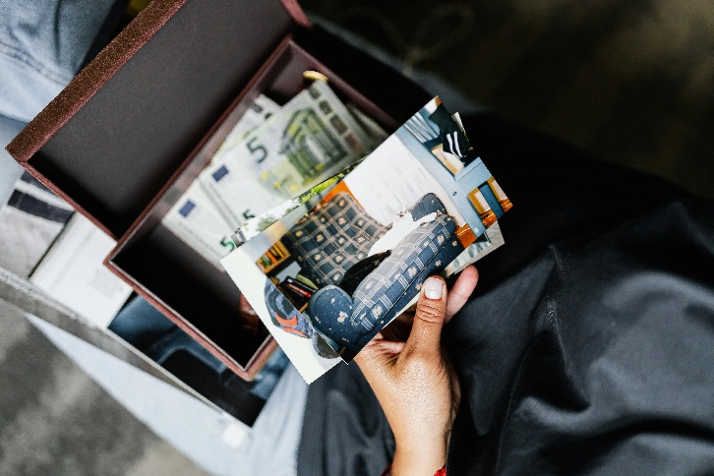
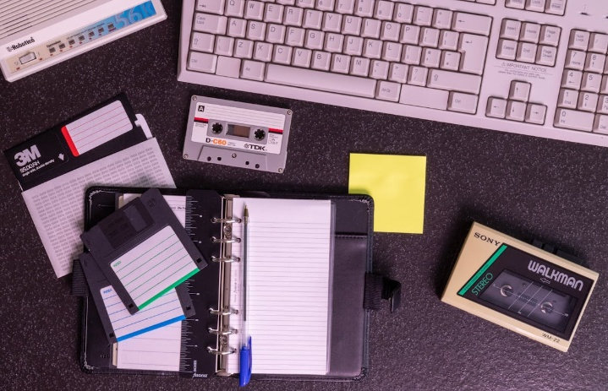
This lesson introduces students to American pop culture in the 1990s through a time capsule. Students then plan what could go in their own time capsule.

Goals
As a result of this lesson, students will be able to:
- think critically about a 1990s American pop culture time capsule by completing a KWL (Know - Want to Know - Learned) chart
- identify and explain items for a class time capsule that represents their everyday lives, interests, communities, and current time period
As a result of this lesson, teachers will be able to:
- use student-centered teaching practices
- prompt students to collaborate, communicate, and think critically
- facilitate collaborative decision-making through voting activities

Lesson Materials
IN YOUR CLASSROOM
- Paper and pencils or pens
- Chalkboard and chalk or whiteboard and markers
- Sticky notes or small squares of paper and tape
- Projector for displaying student reading text or copies
PROVIDED WITH THIS LESSON PLAN
- Teacher Knowledge Builder – All About Time Capsules
- 1990s American Time Capsule Items
- KWL Chart
- “Hello from the past!” Letter
- Exit Ticket
- Key Vocabulary Glossary

Preparation
- Read the Teacher Knowledge Builder – All About Time Capsules (Lesson Materials – Item A) to understand what a time capsule is and how it connects to the United States’ 250th anniversary.
- Review the Procedures and Lesson Materials sections, then determine the formats you will use for the Lesson Materials.
  - Many items can be photocopied, enlarged, or projected onto the board or a wall. More suggestions for formatting these materials are in the Procedures steps and notes.
  - After selecting the formats for the activities, prepare the required number of materials to suit your class size, considering how many groups or individuals will participate in each lesson stage.
- Read the Skills and Language Topics and Key Vocabulary lists below. Review the glossary (Lesson Materials - Item F) to see how key vocabulary terms are used in this lesson. Will you need to activate prior knowledge, pre-teach, or otherwise provide scaffolding (support) for your students beyond the suggestions in the Procedures section? See the Variations and Extensions section for ideas.
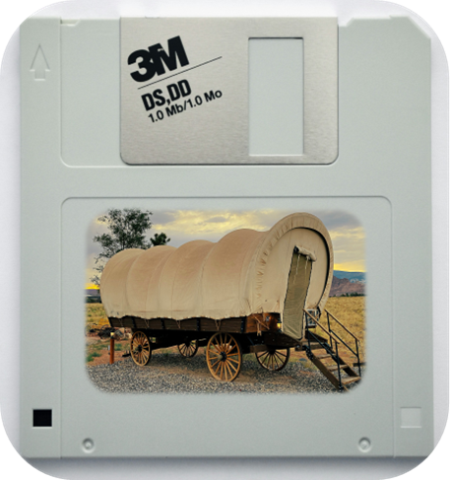
- (Optional) Create an example time capsule with copies of the 1990s American time capsule items (Lesson Materials – Item B). Use it throughout the lesson to explain the concept of a time capsule and/or dramatically introduce items during Steps 1 and 3 of the Procedures section.

Skills and Language Topics
- Thinking critically about the purpose and significance of items
- Reading for main ideas and details
- Teamwork: communicating and collaborating to complete a series of tasks

Key Vocabulary
- category / categorize
- entertainment
- internet and communication
- on the go
- slang
- time capsule
- trends and lifestyle

Procedures
TIME | STEPS | NOTES
5 min | 1. Warm Up: What is a time capsule?  - Show students two 1990s time capsule items from Lesson Materials – Item B.  - Use the think-pair-share method to have students discuss the two items: 1) students think individually, 2) they share ideas with a partner, and then 3) the teacher facilitates a whole-group share of ideas.  - What is this?  - Is it old or new?  - What do people do with it?  - Do you use something similar today?  - After discussing each item, explain that these items are part of a time capsule. A time capsule is a collection of items from a specific time that show life and culture. The two items just discussed come from a time capsule from the United States in the 1990s. | Think – Pair – Share  Extension: If appropriate, ask students to tell about a person they know who was a child or young adult in the 1990s. OR, tell your own story of an item from the 1990s that was important to the culture at the time.
5 min | 2. Introduction to KWL Chart  - Give students the KWL chart (Lesson Materials – Item C). Explain this chart will help them analyze and understand the two 1990s American pop culture time capsule items.  - Show one of the items from the warm-up and tell students to write the item letter in the chart (e.g., Item A). If they know the name of the item, they can also add it to the first column labeled “Item.”  - Ask the group what they know (or think they know) about the item. Tell students to write their ideas in the “K” column of the chart, using the sentence starters as needed.  - Using the same item, ask the class what questions they have about the item. Tell students to write their questions in the “W” column of the chart, using the question starters as needed.  - Explain they will complete the “L” column later after they learn more about each item.  - Repeat the steps above with warm-up item #2. | Whole group  Depending on your students’ level, you can add or delete sentence and question starters from the chart.  Variation: Do item #1 together as a whole group and ask pairs to do item #2 while you observe and help.
10 min | 3. KWL: What do we know? What do we want to know?  - Ask students to find a partner to work with.  - Put all the other time capsule items from the 1990s American pop culture time capsule (Lesson Materials – Item B) on the classroom walls.  - Ask partners to walk around the room with their charts and complete only the “K” and “W” columns for as many items as they can in 8 minutes, using the sentence/question starters as needed. | Pair work  Variation (non-moving): Students work in small groups. One group member gets a time capsule item from the teacher. Then, groups complete the “K” and “W” columns of the chart and pass their item to the next group when ready.
15 min | 4. KWL: “Hello from the Past!”  - Tell students the time capsule has a surprise! There is a “hello from the past” letter to help them know more about each item.  - Give the letter (Lesson Materials – Item D) to the students. Point out the “1990s Slang” vocabulary box in the top right corner to help them understand some of the authentic language in the letter.  - Ask students to quickly scan the letter to find the first item from the warm-up activity.  - Read about the item together and ask students what new information they learned about it. Tell them to find the item in their chart and write what they learned in the “L” column.  - Tell students to continue working in pairs. They should read the letter and complete the “L” column for different items together, using the sentence starters as needed.  - When pairs finish, ask them to turn to another pair and explain one surprising idea they learned from the letter. | Whole group and pair work  Variation (Think – Pair – Share): After doing one example together, students work individually and then share what they learned from the letter with a partner. Finally, the teacher leads a whole-class share-out.  Extension: In the final step, give students other options to share pair-to-pair. In addition to a “surprising idea,” they could share something from the letter that makes them confused, curious, happy, sad, etc.
5 min | 5. From Then to Now  - Ask students to reflect on the 1990s American pop culture time capsule. How did it feel to explore it? How did the time capsule help them understand the 1990s in the United States more?  - Explain that the time capsule items can be grouped together under different categories. On the board write the categories: entertainment, internet and communication, trends and lifestyle.  - Check students understand the categories by asking them to give one example from the 1990s American pop culture time capsule for each category.  - Explain that now it is time to create history and make a class time capsule. In the next activities, they will brainstorm, identify, and begin to explain items that describe their current life and culture. They will think of items in the same categories – entertainment, internet and communication, trends and lifestyle.  - If you choose to extend the lesson by building a time capsule with students, explain they will do it in another class. Today’s class is just for planning their time capsule. | Whole group discussion  To categorize the 1990s items, students can work together to put the pictures under the correct category name on the board. Or, ask students to add a column to their KWL chart and write the category of each item.
15 min | 6. “Yes, and…!” Brainstorm  - Put students in groups of three. Assign or have them choose a role: Facilitator, Scribe, or Representative.  - Facilitator: encourages all group members to participate  - Scribe: writes time capsule items on sticky notes  - Representative: takes the group’s sticky notes to the board and organizes them (according to Step 7 below)  - Tell groups they will brainstorm items for a class time capsule that represents their own life and culture.  - Write one time capsule category on the board (entertainment, internet and communication, or trends and lifestyle). Tell groups they will have one minute to quickly brainstorm items in this category for a class time capsule. They will use the “yes, and…” talking routine to brainstorm. Explain they should think and talk quickly. There are no bad ideas! The Facilitator should encourage participation and keep the brainstorm quick and fun.  - Before groups start, model the “yes, and…” conversation with student volunteers and answer any questions students have about the activity.  - Student A: “For (category), I put…(item) in our time capsule.”  - Student B: “Yes, and I put…(item).”  - Student C: “Yes, and I put…(item).”  - Set a timer for one minute and let groups brainstorm.  - At the end of one minute, tell groups to quickly choose two items from their brainstorm. The Scribe writes each item on different sticky notes.  - Repeat the “yes, and…” brainstorming process for the other two time capsule categories. | Small groups  Extend the brainstorming time based on your students’ levels. To support the “yes, and…” speaking routine, provide a word bank of current cultural items for students to reference while brainstorming.
10 min | 7. Sticky Decisions  - Tell students they will now “vote” on items for their time capsule.  - Ask all group Representatives to bring their group’s sticky notes to the board. The Representatives should work together to categorize the sticky notes from all groups under each time capsule category (entertainment, internet and communication, and trends and lifestyle). When they find similar items or ideas, they should stack them vertically to create a “sticky note bar graph.” In total, there will be three “sticky note bar graphs,” one for each time capsule category. (See an example for the “Entertainment” category below.)  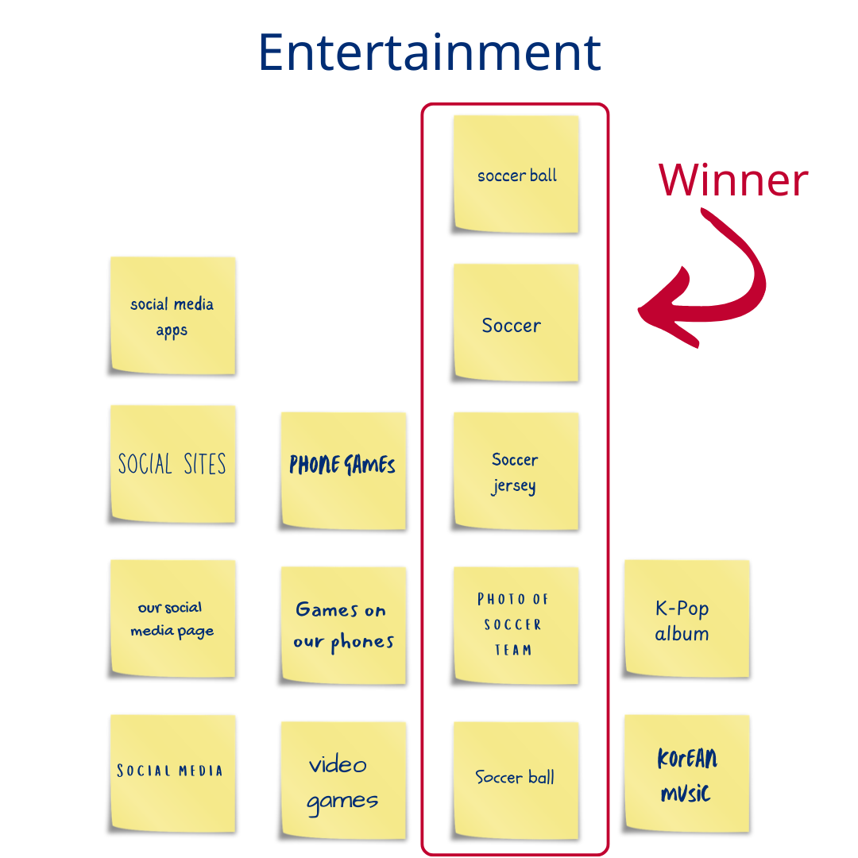  - Explain the item with the tallest “bar” wins the vote! (In the example image above, an item about soccer is the winner of the Entertainment category and would be added to the class time capsule.) You may allow more than one winner per category if you like. If there is a tie, choose a tie-breaker method that is appropriate for your class.  - Write or show the final list of time capsule items for all to see. | Whole group  Extension: Explain that students just participated in a style of voting called “majority rule.” The items with the most votes won! Explain that in this voting system, a voter might be disappointed because their item did not win, but they still accept the decision because more than half (the majority) of the group voted for it. Ask students to talk about how they felt during the process and if they can think of other examples of voting (“majority rule” or other).
5 min | 8. Wrap up: Exit Ticket  - Give students the exit ticket (Lesson Materials – Item E). Explain they will choose one prompt to answer by writing.  - Collect the exit tickets and keep them for a future class when students build their own time capsule and create supporting documentation (like the “hello from the past” letter). | Individual  Extension: Give students time to share their exit ticket response with a partner or as a whole class.  See the Variations and Extensions section for ideas about students creating their own time capsule.

Variations and Extensions
VARIATIONS

1. General Differentiation and Scaffolding
- Based on students’ levels and prior knowledge, teachers can choose to cover the lesson content over one or more class sessions. This approach will allow teachers to provide additional instruction, review, and support as appropriate.
- To make the lesson more accessible for lower proficiency students or limited class time, teachers may select fewer 1990s time capsule items from the Lesson Materials and help students scan the “Hello from the past!” letter to learn only about those items.

EXTENSIONS

1. Create a Time Capsule (Real or Digital)
- This lesson helps students plan which items they could put in a time capsule. As a next step, have students create a real time capsule. Guide them to think about:
  - Format of the items: real objects, photos, or another format
  - Explanation of items: letter, item tags, audio description, or another format
  - Type and material of time capsule container
  - Date to open the time capsule in the future
  - The people they want to open the time capsule in the future
  - Method of telling the people in the future it is time to open the capsule and how to find it
  - Place to bury (or keep) the time capsule

2. Respond to the 1990s “Hello from the past!” Letter
- Ask students to write a letter back to the people who created the 1990s American time capsule. Their letter could discuss various topics, like items from the 1990s American time capsule that surprised them and why, items they still use today and how they use them, etc.

3. Create “Then/Now” Posters
- Ask students to match items from the 1990s American time capsule to items from today.
- Create posters showcasing the evolution of an item or activity. Consider the skills and ideas you would like students to focus on with their posters. For example:
  - Language focus: posters could help students practice comparative language, simple past tense, etc.
  - Cultural focus: students could use their posters to explain why both items were/are important in everyday life and culture
  - 21st Century Skill focus: students could practice formal communication skills by giving short oral presentations during a gallery walk
  - Your own idea!
External links are provided for informational purposes only; there is no implied U.S. Department of State endorsement of the views, opinions, media content,
or privacy policies contained therein.

Images in this lesson plan are in the public domain or “no attribution required” unless otherwise noted. If sharing, adapting, or remixing portions of this lesson plan, please respect excepted permission and licensing statements noted in the credit statements for individual images, graphics, or other content. To learn about Creative Commons licenses, their uses, and their restrictions, visit the Creative Commons license explanation site.

This is Us: Using Time Capsules to Create History – Lesson Materials
Freedom 250

A. Teacher Knowledge Builder – All About Time Capsules
This is a teacher reference document to help you understand time capsules and feel confident planning one in class. You can share any information with students that you think will help them understand the lesson more.
What is a time capsule?
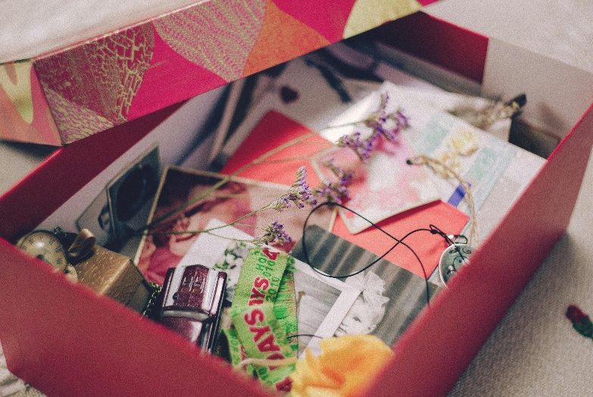
A time capsule is a collection of items that represent the lifestyle and culture of a time in history. Often, the items are from everyday life. Time capsule items are usually put in a weather-proof container and buried in the ground. The time capsule creators will usually set a date for many years in the future when the box should be opened. In the box, some people will also put information about the items. For example, they can write a letter about the items, put an informational tag on each item, or record an audio description on a device (and include the device in the capsule).
How does a time capsule connect to the United States’ 250th anniversary?
This lesson is the final one in a series of lesson plans that commemorates the United States’ 250th Anniversary. One of the United States’ national activities is to create a formal record of history with a time capsule that will be buried on July 4, 2026. “America’s Time Capsule” will include items from the U.S. Government and each of the 56 states and territories. The items will show an authentic record of leadership, community, and culture. It will be opened in the year 2276. You can find out more about “America’s Time Capsule” at this website (https://america250.org/time-capsule/).
What are the names of the everyday items in this lesson plan’s 1990s time capsule?
- Item A: toy dinosaur
- Item B: bean bag chair
- Item C: basketball
- Items D and H: collectible stuffed animal
- Item E: portable video game player
- Item F: cell phone
- Item G: portable tape player for music

B. Time Capsule Items – 1990s American Time Capsule

Item A  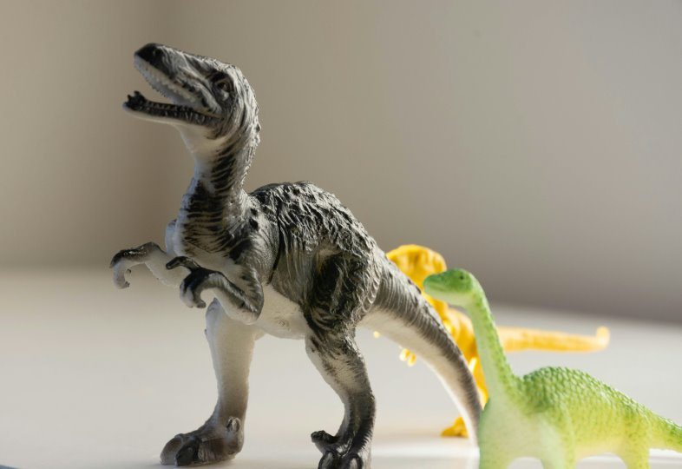 | Item B  
Item C   | Item D  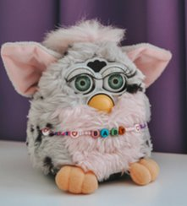

Item E  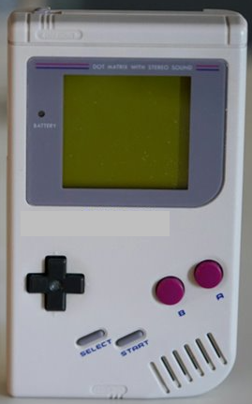 | Item F  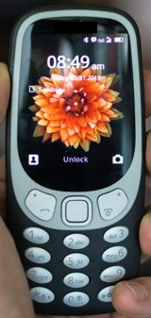
Item G  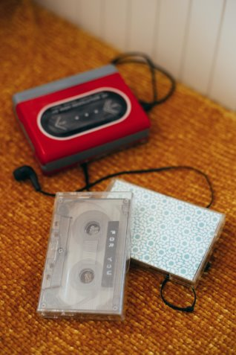 | Item H  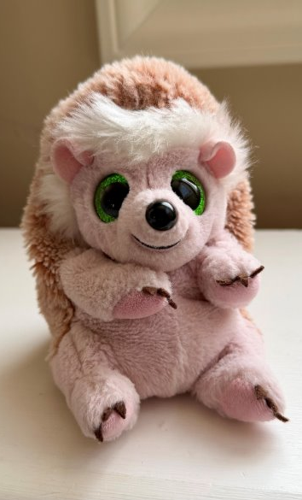
Photo: A. Christensen (CC0)

C. KWL Chart – 1990s American Time Capsule
Instructions: use this chart to help you learn about the time capsule items from the United States in the 1990s.
Item  Example: Item F | Know  I know this is… I think this is…  I think people use it for… | Want to know  How do/does…? Is it like…today?  I would like to find out… | Learned  I learned that… Now I know…  People use it for…

D. “Hello from the past!” Letter – 1990s American Time Capsule

Wassup Future Friends!
1990s Slang

Wassup – What’s up? How are you?
Rad, slammin’ – excellent or impressive
Sweet, major – great, awesome
Props to – proper respect to (to give recognition)
Chillax – “chill” and “relax”
We’re outtie – goodbye

It’s so cool you found our time capsule! We hope you enjoy learning about our life in the 1990s.

We love to have fun! Movies, music, games, and sports are a big part of our lives. A few years ago, a rad movie about dinosaurs came out. They look so real in the movie, so we put a small dinosaur toy in our time capsule – a T-Rex. It’s one of the scariest dinosaurs in the movie. Do you know which movie we are talking about? Maybe you can use the World Wide Web to find it!

They also made a video game for the movie. We usually play it on a portable game player, like the one in our time capsule. We also play adventure and puzzle games. We love that we can play games anywhere now! No cords or electricity – all you need are some batteries!

Do you know what? We can also listen to music on the go, like on the school bus, walking around town, or just hanging out. The radios at home are so big, but these portable ones are small and easy to carry around. They’re sweet!

Another game we like to play and watch is basketball! The teams in the U.S. are slammin’ right now. Do you like basketball? There is a basketball court at our school, and we play most days at lunch. We imagine we are basketball players in Chicago or Houston.

Speaking of school, we love our classroom. Props to our teacher! She put two bean bag chairs in our class so we can chillax and read or do group activities. It feels really cool to sit in one, like sitting on a big bag of beans!

When we are not together at school, we still talk all the time. In the past, we used landline phones, but now some of us have cell phones! Can you believe it? It’s so major! We can make calls and send messages from many places! But we need to be careful – if we talk too long or send long messages, it costs extra money. That's why our messages are short. Can you read this one? “Gr8 c u l8tr” It says, “Great! See you later!” How do you send messages to each other?

Before we go, remember to hug the cute stuffed animals. One of our friends had 30 in his collection, so he gave two for the time capsule. Aren’t they so soft and squishy?

We’re outtie,
Your friends from the 1990s

E. Exit Ticket

Exit ticket: Look at our time capsule items. Check the box next to one question and write your answer.
- Choose one item from our time capsule. What does it say about our life and culture today?
- Imagine a person in the future opening our time capsule. What questions do you think they will ask?
- If you could add one more item to our time capsule, what would you add and why?

----------------------------------------------------------------------------------------------------------------------------------------------

Exit ticket: Look at our time capsule items. Check the box next to one question and write your answer.
- Choose one item from our time capsule. What does it say about our life and culture today?
- Imagine a person in the future opening our time capsule. What questions do you think they will ask?
- If you could add one more item to our time capsule, what would you add and why?

----------------------------------------------------------------------------------------------------------------------------------------------

Exit ticket: Look at our time capsule items. Check the box next to one question and write your answer.
- Choose one item from our time capsule. What does it say about our life and culture today?
- Imagine a person in the future opening our time capsule. What questions do you think they will ask?
- If you could add one more item to our time capsule, what would you add and why?

F. Key Vocabulary Glossary
Definitions below illustrate how key vocabulary terms are used in the context of this lesson.

categorize v. to put similar things into a group (category)
category n. a group of things that are similar in some way
entertainment n. a time capsule category for activities or things that help people feel happy or relaxed (e.g., movies, plays, video games, sports)
internet and communication n. a time capsule category for things people use to talk to each other and/or find information (e.g., phones, web browsers, social media)
on the go v. going from one place to another place
slang n. informal words or phrases people use in everyday conversation
time capsule n. a collection of everyday items that represents the life and culture of a specific time in history
trends and lifestyle n. a time capsule category for popular ways people live, act, and enjoy their daily lives

