What Makes a Good Leader?
YOUTH LEADERSHIP
Overview

In this lesson, students explore principles of good leadership, characteristics of strong leaders, and several leadership styles. They develop vocabulary needed to discuss these topics, reflect on their strengths and weaknesses as leaders, and set goals for personal development.
(CC0)

Goals
As a result of this lesson, students will be able to:
- explore principles of good leadership and characteristics of strong leaders
- develop the vocabulary and language structures needed to discuss these topics
- investigate several models of leadership and evaluate their effectiveness
- reflect on their strengths and weaknesses as leaders
- set goals for personal development in leadership qualities
As a result of this lesson, teachers will be able to:
- engage students with meaningful, real-world content

- guide students to develop leadership and teamwork skills for collaboration
(CC0)
- help students reflect on their own skills and set authentic goals for personal development

Lesson Materials
IN YOUR CLASSROOM
- Paper and pencils or pens
- Chalkboard and chalk or whiteboard and markers
- Projector or TV for showing videos (optional)
PROVIDED WITH THIS LESSON PLAN
- Ideal Leaders: Word Web
- Four Types of Leaders matching activity
- An Interview with Patricia Falotico
- Leadership Characteristics: Reflection and Self-evaluation tool
- Key vocabulary glossary

TESOL Focus: Project-Based Learning

Preparation
- This lesson helps students learn about and develop leadership skills. If possible, explore how teens are leading their peers in your school or local community. What are they doing? What impact have they had? Consider sharing several local examples with your students during the lesson.
- Review the Procedures and Lesson Materials sections, then determine the formats you will use for the Lesson Materials.
  - Many items can be photocopied, enlarged, or projected onto the board or a wall. More suggestions for formatting and sharing these materials are in the Procedures steps and notes.
  - After selecting the formats for the activities, prepare the required number of materials to suit your class size, considering how many groups or individuals will participate in each lesson stage.
  - For Step 1, prepare to show a video in class. See the Variations section for an alternative to the video activity.
- Read the Skills and Language Topics and Key Vocabulary lists below. Review the glossary (Lesson Materials - Item E) to see how Key Vocabulary terms are used in this lesson. Will you need to activate prior knowledge, pre-teach, or otherwise provide scaffolding (support) for your students beyond the suggestions in the Procedures section? See the Variations and Extensions section for ideas.

(CC0)

Skills and Language Topics
- Listening and reading for main ideas and details
- Vocabulary development

Key Vocabulary
- compassionate  - drive  - empathy  - game changer  - honesty  - humility | - integrity  - leadership  - passionate  - servant leader  - to inspire  - unstoppable force

Inquiry Notebook Prompts
PROMPTS | NOTES
- Think of someone you know who is a leader. Who is it? What have they done that makes them a leader?  - Complete the sentence: A good leader is… | Adopt or modify these prompts for Inquiry Notebook engagement with concepts featured in this lesson. Before teaching this lesson, direct students to select one prompt to respond to in their Inquiry Notebook.

Procedures
TIME | STEPS | NOTES
10 min | 1. Explore and define principles of good leadership  Leadership video: What Makes a Great Leader? (1:58) from AIESEC, a non-profit organization working to help youth build leadership skills  - Before watching the video, ask students to listen for words the young people use that describe good leaders.  - Show students this video of young Americans talking about qualities of good leaders.  - Afterwards, ask students to write down any words they can remember that were used in the video to describe good leaders.  Guided discussion: Think-Pair-Share  - Help students explore the qualities of good leadership from the video by discussing the following questions with a partner. Then ask students to share their ideas with the class.  - What qualities of good leaders did these young people name?  - What qualities would you add to the list?  - On the board, write any unfamiliar words that come up in the discussion and clarify their meaning. | Before students watch a video, tell them what specific information to “listen for.” This helps them focus on specific information rather than worrying about understanding every word.  Pair work and whole class discussion  This activity helps students review the video content and surface what they already know about good leadership. They engage with authentic content directly related to their lives and the unit theme.
20 min | 2. Expand students’ vocabulary to describe ideal leaders  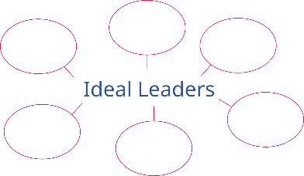  - Choose several words that describe good leaders which may be unfamiliar to your students (for example: passionate, inspiring, compassionate, humble, etc.). Introduce their meaning and add them to the list on the board.  - Ask students to work in pairs to create a word map using “Ideal Leaders” as the phrase in the center. List qualities of good leaders (from the video, the class discussion, or the list of new words on the board) around it.  - Ask each student pair to show and describe their completed word map to another group, indicating one or two characteristics they feel are most important for good leaders. | Lesson Materials – Item A  Pair work  Word maps allow students to brainstorm ideas related to the topic (in the center of the page). Working in pairs gives students an opportunity to discuss their ideas about leadership and build communication skills.  Students can add to their word maps as they listen to classmates share their ideas. Throughout the lesson, ask students to add new vocabulary words that they learn about leadership.
20 min | 3. Learn about leadership styles  - Tell students that the following activity will help them consider how different models of leadership can encourage or discourage team members from taking an active role in the work of the team.  Reading and discussion  - Ask students to work in small groups to read, discuss, and complete the Four Types of Leaders matching activity, which allows students to look at short scenarios and decide which type of leadership is being modeled.  - At the conclusion of the activity, briefly review the four types of leadership described. Ask students:  - Which of these leadership styles do you see used by leaders in your community? In your school? Can you give examples?  - Which of these leadership styles do you think you would like as a follower? Why?  - Which of these leadership styles would you use as a leader? Why?  - As students reflect on the activity, help them see how strong leaders inspire others to participate and then involve them in decision making, value their contributions, and respect their opinions. | This small group discussion allows students opportunities to explore and evaluate models of youth leadership, exchange ideas with others, and build fluency in using new content vocabulary.  Lesson Materials – Item B  Consider asking students to add any vocabulary words or phrases that came out of the discussion to their “Ideal Leaders” word map (for example: good leaders inspire, work together, develop others, etc.)
20 min | 4. Explore an example of strong leadership  Reading and discussion: Building Leadership Skills: An Interview with Patricia Falotico  - Preview vocabulary words from the reading that may be new for your students.  - Tell students they are going to read an interview with Patricia Falotico, a woman who leads an organization that trains people to be strong leaders. Ask them to look for her description of servant leadership, a leadership style where the leader enables others to develop and grow.  - Ask students to practice reading the interview in pairs, with one student taking the role of interviewer and the other the role of Patricia Falotico. For more speaking fluency practice, students can read it a second time, switching characters.  - Circulate around the room while students are reading, offering suggestions on pronunciation, and clarifying the meaning of unfamiliar words or phrases as needed.  - After students finish reading the interview, ask pairs of students to join with another pair to form a small group. They should discuss the “What do you think?” reflection questions at the end of the interview. | Lesson Materials – Item C  This reader’s theater-style interview gives students practice with lesson vocabulary and more exposure to the leadership concepts in the lesson.  A reader’s theater allows students to develop fluency in oral reading, practice pronunciation, and gain confidence in their speaking skills. The pair work provides many opportunities for meaningful target language use.
10 min | 5. Connect to student context: Leadership self-evaluation  - Ask students to reflect on what they have learned about the qualities of good leadership.  - Ask students to complete the Leadership Characteristics Reflection and Self-evaluation Tool. | Lesson Materials – Item D  Interpersonal reflection is a critical thinking skill. Completing this exercise will help students connect the lesson content to their own context and will serve as a foundation for setting individual goals in the following activity.
10 min | 6. Wrap Up and Reflection: Leadership development goal setting  - Direct students to look at their completed Leadership Characteristics Reflection and Self-evaluation Tool and set a goal for personal development in one key leadership characteristic. Tell them to write one sentence describing one thing they will do this week to improve in that area.  - If desired, have students discuss in small groups: What did you learn about yourself as you studied leadership today and set a goal for improving in one area? | Interpersonal reflection and goal setting

Variations and Extensions
VARIATIONS

1. General differentiation and scaffolding
- Based on students’ levels and prior knowledge, teachers can choose to cover the lesson content over two or more class sessions. This approach will allow teachers to provide additional instruction, review, and support as appropriate.
- To make the lesson more accessible for lower-level students, reduce the complexity or length of the reading texts or define/translate challenging vocabulary items. Modify the self-evaluation tool for lower-level learners by reducing the quantity and complexity of information it contains.
- Challenge more advanced students to write their own comprehension and discussion questions to share with their classmates after the reading.

2. Video alternative: Pair brainstorming
- For Step 1, if you do not have a TV or projector to play the video in class, students could watch the video in small groups on a cell phone or tablet. Alternatively, instead of showing the What Makes a Great Leader? video, begin the class by asking students to name good leaders that they know. Then proceed to the Think-Pair-Share discussion with students naming the qualities of good leaders.
EXTENSIONS

1. Speaking: Building leadership skills
- To give students more speaking practice, ask several pairs of students to perform the reader’s theater in front of the class. Take time to talk about presentation skills: speaking slowly and clearly, speaking up with a loud voice so everyone can hear. Remind students to do these things as they present the reader’s theater.

2. Vocabulary development
- To review the leadership characteristics vocabulary list, ask the students to stand in a circle. Say one of the words and toss a ball or soft toy to one of the students. The student should respond by defining or describing the word and then tossing the ball back to you. Repeat, tossing the ball randomly around the circle until you have reviewed all the words. For the second round, students must use the word in a complete sentence.

3. Writing fluency
- To give students the opportunity to develop writing fluency and solidify their ideas about strong leadership, ask them to write a one paragraph statement describing their ideal leader. They should use some of the words and phrases from their leadership word web. Students could share their finished statements by reading them to the class or small group.

External links are provided for informational purposes only; there is no implied U.S. Department of State endorsement of the individuals, views, opinions, media content,
or privacy policies contained therein.

Unless otherwise noted, CC0 images in this resource are “no-attribution required” items sourced under the Pixabay simplified license or the Unsplash license. If sharing, adapting, or remixing portions of this lesson plan, please respect excepted permission and licensing statements noted in the credit statements for individual images, graphics, or other content. To learn about Creative Commons licenses, their uses, and their restrictions, visit the Creative Commons license explanation site.

What Makes a Good Leader? – Lesson Materials
YOUTH LEADERSHIP

A. Leadership Word Map
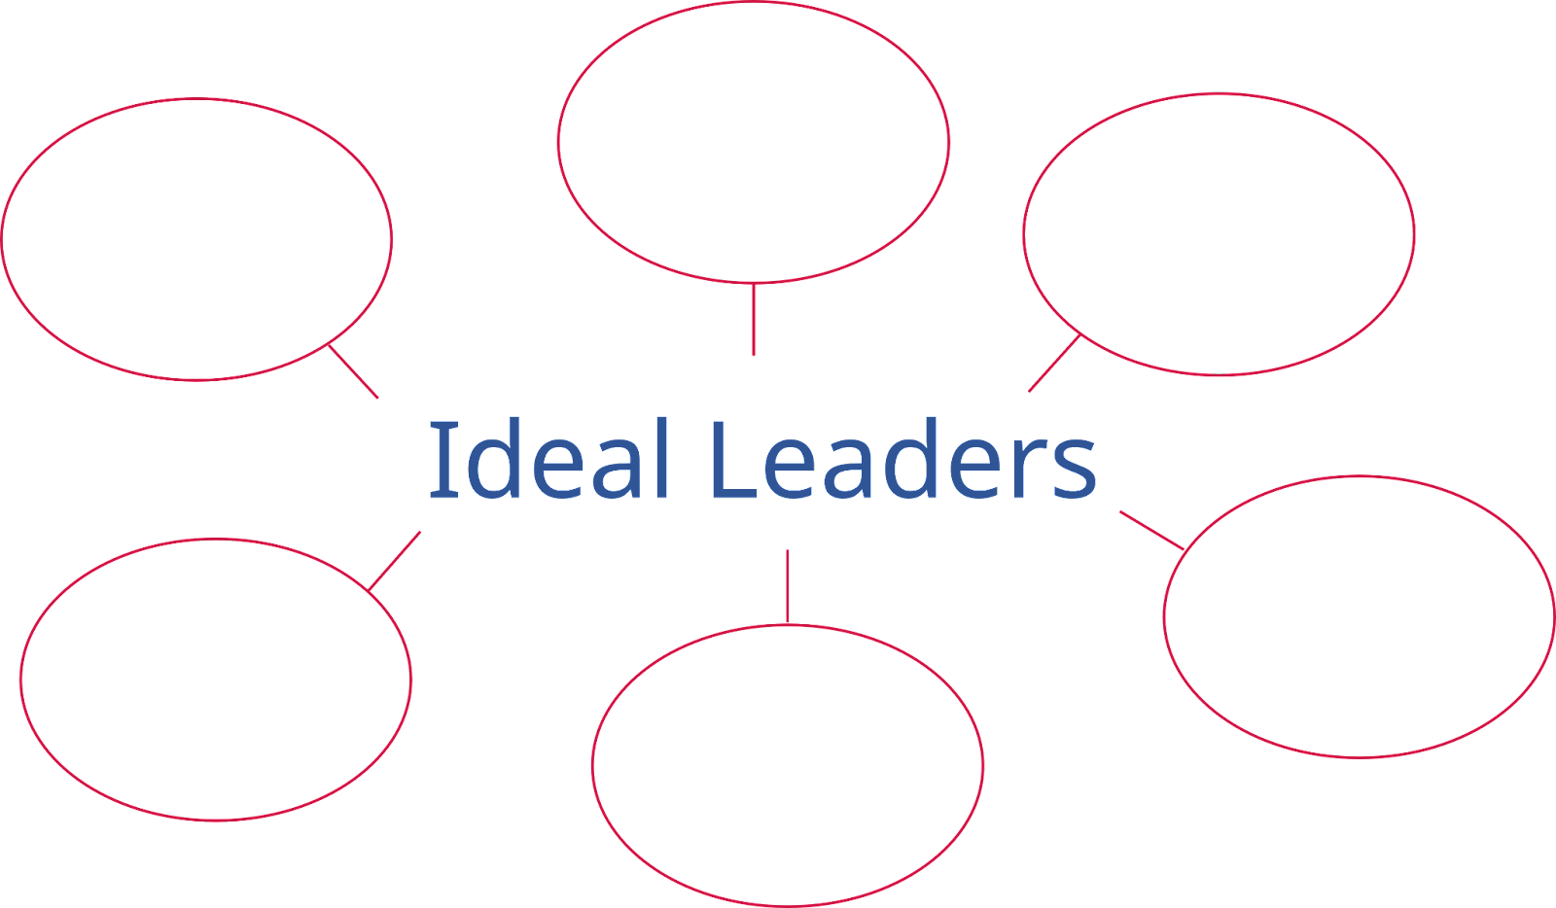

B. Four Types of Leaders

Directions: Four common leadership styles are described below. Match them to the descriptions of leaders working with their teams. In some of the examples, the leader may show more than one leadership style.

        - A. Decisive leaders make decisions for the group without asking for team members’ ideas.
B. Democratic leaders include team members in the decision-making process for the group.
C. Transformational leaders inspire their teams rather than controlling them.
D. Servant leaders focus on helping team members develop their own leadership skills. They work right alongside those they lead.

______ Isabella is a student leader. She’s part of a club that aims to improve her school. Because she has more experience, she usually takes charge of meetings. She makes decisions and gives assignments to team members without asking for their ideas.

______ Joseph is the student leader in his class. He prefers to let everyone vote before he makes a decision about an upcoming activity. He always includes team members in decision making.

______ Samuel is the manager at his construction company. He knows how to make good business decisions. But he wants to help his team build their leadership skills. He lets them learn about what needs to be done and make decisions.

______ Aaron leads a nonprofit organization that works to help people who are homeless. Before planning a new project, he takes time to share his vision for lifting the community. He wants to inspire his team to make positive contributions.

C. Building Leadership Skills
An Interview with Patricia Falotico

Patricia Falotico, the CEO of the Robert K. Greenleaf Center for Servant Leadership, worked for 30 years as a leader in large companies and then felt inspired to join the Greenleaf Center and share what she has learned about leadership with others. In the interview below, she describes a leadership style where the leader listens to the ideas of others, shows empathy, and enables others to develop and grow.

Useful words and expressions
- empathy - the ability to understand and share the feelings of another person
- servant leadership - a style of leadership that focuses on building people
(CC0)
Good leadership is about lifting up and developing others.
Interviewer: Patricia Falotico, thank you for being with us today. You have studied and worked with leaders from all over the world. In your opinion, what are some important skills for leaders to develop?

Patricia: Well first, listening is an important tool. It is necessary for good communication and to show respect for others. Listening helps people feel understood. All good leaders are good listeners.

Interviewer: I can see why that is so important. When people can share their ideas, they feel part of the group and more connected to the leader.

Patricia: Yes. Listening helps a leader show empathy. Empathy is the ability to understand and share the feelings of another person. A good leader works hard to understand others. They know that everyone wants to feel accepted.

Interviewer: Your organization promotes servant leadership. How is that different from other styles of leading?

Patricia: Servant leadership uses character and personal relationships instead of power from a title or position to influence followers and achieve goals. The focus is on people, not power. Servant leadership is a people-building versus a people-using model. Robert Greenleaf, the founder of the modern servant leadership movement, said that leadership is about lifting people up to grow taller than they would otherwise be.

Interviewer: You are saying that good leaders need to learn to listen to others, show empathy, and build up the people around them. They learn to use the power of their character rather than the power of their position to lead. How can young people start developing these skills?

Patricia: They can start by thinking about questions like: Who am I as a leader? Do I work with others to make decisions? Do I inspire them to do good or make change? Do I listen to the ideas of others? Do I show empathy and understanding of their ideas? So many people say, “I am committed to others, I am a servant leader,” but what they mean by that is, “I volunteer and do good things in the community.” There is a difference. You can volunteer and do good things in the community and not be a servant leader. Servant leaders practice listening, showing empathy, and building others. It is hard work!

Interviewer: You have given us a lot to think about today and some good examples of leadership skills. Thank you for joining us, Patricia.

What do you think?
Discuss these questions with a partner or small group.
- What are three skills that Patricia Falotico says are important for good leaders? Find and mark them in the dialogue.
(The interviewer summarizes them near the end of the interview.)
- Which one of these skills do you think is the most important? Why?
- Give an example of someone that you think is a servant leader. Do they listen to others, show empathy, and build up the people around them?
- What can you do to develop these characteristics?

D. Leadership Characteristics
Reflection and Self-Evaluation Tool

Think about what you have learned about the qualities of good leaders. Some of those qualities are listed below. Decide whether you have strong leadership skills in that area (put a check mark ✔️ in the column “I’m doing great with this!”) or need to continue to improve (put a check mark ✔️ in the column “I’d like to improve in this area”).

Leadership Characteristic | I’m doing great  with this! | I’d like to improve  in this area.
I'm passionate. People can tell that I care about the work that I do.
I want to make change and improve things.
I can accomplish more working with others than I can alone.
When I’m working with a group, I bring positive energy to the work.
I inspire other people to do good and improve themselves and the world around them.
I listen to others’ ideas with empathy. I try to learn from them.
I try to help others be the best they can be.
I am a hand raiser and a game changer!

E. Key Vocabulary glossary
Definitions below illustrate how Key Vocabulary terms are used in the context of this lesson.

compassionate adj. caring about or feeling concern for others; compassion n.
drive n. a strong desire to do something
empathy n. the ability to understand and share the feelings of another person
game changer n. a person or idea that causes a big effect
honesty n. the quality of being truthful; honest adj.
humility n. the quality of focusing on others more than yourself; humble adj.
integrity n. the quality of being honest and trustworthy
leadership n. the process of guiding others
passionate adj. showing strong feelings of excitement for something
servant leader n. a leadership style where the leader enables others to develop and grow
to inspire v. to give someone an idea or confidence to do something
unstoppable force phr. a powerful idea or person that can’t be stopped

