Lead What You Love
YOUTH LEADERSHIP
Overview


Students learn about choosing something they are passionate about leading and inspiring others to work together to achieve a goal. They discover examples of young leaders who have used their talents to improve their schools or communities.
(CC0)

Goals
As a result of this lesson, students will be able to:
- understand principles of good leadership more deeply
- appreciate the value of working as a team
- talk about what they are good at and what they are passionate about
- connect their talents (what they are good at) and their interests (what they are passionate about) to making positive changes in the world around them
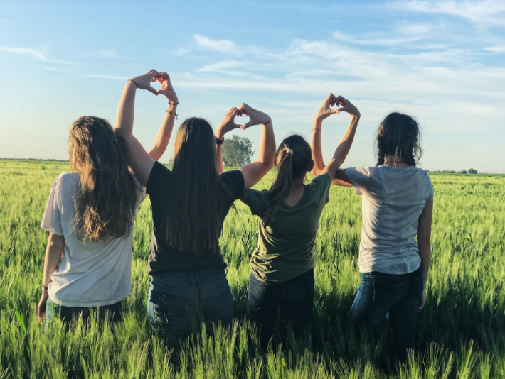
As a result of this lesson, teachers will be able to:
(CC0)
- guide students to evaluate an authentic model of effective leadership
- make learning relevant and engaging through real-world connections
- support students to plan for contributing to their own community

Lesson Materials
IN YOUR CLASSROOM
- Paper and pencils or pens
- Chalkboard and chalk or whiteboard and markers
- Projector or TV for showing videos (optional)
PROVIDED WITH THIS LESSON PLAN
- Stronger and Stronger (song and lyrics)
- Young Leader Spotlights
- Lead What You Love Note-Taking Sheet
- Words of Wisdom from a Young Leader (optional)
- Key vocabulary glossary

TESOL Focus: Project-Based Learning

Preparation
- This lesson helps students learn about and develop leadership skills. If possible, explore how teens are leading their peers in your school or local community. What are they doing? What impact have they had? Consider sharing several local examples with your students during the lesson.
- Review the Procedures and Lesson Materials sections, then determine the formats you will use for the Lesson Materials.
  - Many items can be photocopied, enlarged, or projected onto the board or a wall. More suggestions for formatting and sharing these materials are in the Procedures steps and notes.
  - After selecting the formats for the activities, prepare the required number of materials to suit your class size, considering how many groups or individuals will participate in each lesson stage.
  - For Step 1, download the MP3 of Stronger and Stronger from the American English website.
  - For Step 3, make copies of the Young Leader Spotlights sheet (Lesson Materials - Item B) and cut the spotlights out. Make enough copies for each student have one spotlight.
  - For Step 4, prepare to show a video in class. See the Variations section for an alternative to the video activity using Lesson Materials - Item D.
- Read the Skills and Language Topics and Key Vocabulary lists below. Review the glossary (Lesson Materials - Item E) to see how Key Vocabulary terms are used in this lesson. Will you need to activate prior knowledge, pre-teach, or otherwise provide scaffolding (support) for your students beyond the suggestions in the Procedures section? See the Variations and Extensions section for ideas.


Skills and Language Topics
(CC0)
- Listening and reading for main ideas and details
- Vocabulary development
- Oral fluency practice
- Critical thinking and real-world skill application

Key Vocabulary
- to accomplish  - community service  - to coordinate  - leadership  - nonprofit organization | - passion  - powerful  - refugee  - teamwork  - to volunteer

Procedures
TIME | STEPS | NOTES
10 min | 1. Warm-up: Listening to a song: Stronger and Stronger, song by Daniel Ho (from American English)  - Give students a copy of the song lyrics or display them so everyone can see.  - Play the first verse and chorus, ending with: I just might make it someday. Pause the song around 1:12.  - Ask students what they think the song is about. Answers may include making changes, getting stronger, trying something new, hope for the future, etc. Make a list on the board, but do not confirm or correct students’ answers yet.  - Play the rest of the song, asking students to listen if their predictions about the main idea were correct.  - After the song, lead a short discussion. Point out that making changes in our lives and reaching for new goals is not always easy, but the singer expresses hope that he will succeed: I’m getting closer and closer to finding my way. I’m getting stronger and stronger with each passing day. I just might make it someday.  - Explain that making positive changes in our own lives is the first step to making positive changes in our community, and making positive change takes leadership! (the topic of this lesson). | Lesson Materials – Item A  Whole class discussion  Music is a wonderful way to involve students in active listening in an engaging way. It strengthens their fluency and exposes them to new vocabulary and idioms. For this activity, tell students not to worry about understanding every word in the song. They are listening only for the main idea.  Teacher-led discussion
10 min | 2. Activity about leadership: Agree or Disagree?  - Come up with 6-8 statements of opinion about leadership such as:  - Good leaders make positive changes in their community.  - Adults are always better at leading than young people.  - If you want to make change, you should work alone.  - Working in groups is more fun than working alone.  - I think I can make positive changes in my community or school.  - Being a good leader is easy to do.  - Point to one side of the room and tell students to stand on that side if they agree with you. Point to the opposite side of the room and tell students to stand on that side if they disagree with you.  - Call out your opinions one by one, leaving time for students to move one corner or the other. After students understand the activity, ask one of them to call out several opinions for students to agree or disagree with.  - Ask students to sit down in their seats again and tell them that the lesson today will focus on working together with others to make positive changes in the world around them. | Whole group movement-based polling activity
25 min | 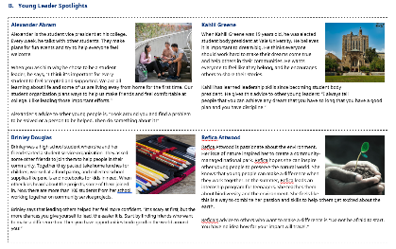  3. Reading: Young Leader Spotlights  - Divide students into pairs or small groups. Give each student one short Young Leader Spotlight to read silently. Tell students to report to their partner(s) what they notice about how the young person leads others to make positive changes in their community.  - While students are reading and reporting to their groups, circulate around the room, clarifying vocabulary and concepts as needed.  - After groups have finished discussing the Young Leader Spotlights, ask students:  - How did these young people work as a team to make changes in the world around them?  - What did they do that showed leadership skills?  - How do you think they decided what project or group to be involved in?  - Was it important for them to work with others to accomplish their goals? Why or why not?  - Ask students to write an Inquiry Notebook entry using the provided prompts. | Pair and small group discussions  Lesson Materials – Item B  This activity introduces students to real-world examples of ordinary young people who saw a need in their community or school and chose to lead others to create positive change.  Working in small groups allows students a comfortable place to read and discuss their ideas. It also gives the teacher a valuable opportunity to move from group to group offering personalized help and feedback.
30 min | 4. Video interview: Lead What You Love with Renee Gastelum (4:12)  Part 1: Lead what you love (0:00 to 1:49)  - Tell students that you want to introduce them to another young person that found something she was passionate (felt strongly) about and decided to use it to make a positive change in her community. She discovered other people who had the same desire and organized them to work together on an important project.  - Play the video to 1:49, asking students to listen as Renee describes her project.  - Stop the video at 1:49. Ask students:  - What are Renee and her friends passionate about?  - What project did Renee and her friends organize using their interests and talents?  - What three things does Renee suggest you ask yourself when deciding what to lead?  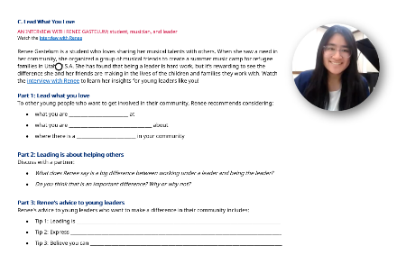  Answers include:  (1) what are you passionate about,  (2) what are you good at, and  (3) what need is there in the community  - Give students a copy of Lead What You Love Note Taking Sheet.  Ask them to fill in the blanks in the section labeled Part 1.  - Point out that Renee found something she was passionate about (connecting cultures) and good at (music) and then used those talents and interests to make a difference in her community. It was important for the success of her project to find other young people who cared about the same things.  Part 2: Leading is about helping others (1:50 to 2:14)  - Play the video from 1:50 to 2:14.  - Stop the video at 2:14 and give students time to discuss the questions in Part 2 of the Lead What You Love Note Taking Sheet with a partner.  Part 3: Renee’s advice to young leaders (2:15 to 4:12)  - Tell students that Renee has three tips (advice) for young leaders.  - Play the video from 2:15 to the end, asking students to watch for Renee’s advice and fill in the blanks in Part 3 of the Lead What You Love Note Taking Sheet.  - Ask students to discuss with a partner advice they might add to Renee’s list. | Whole-class and small group discussions  The three parts of this activity allow students to explore several important leadership ideas, practice listening for details, and work on their speaking fluency. Students evaluate an authentic example of youth leadership.  Lesson Materials – Item C  The Lead What You Love Note Taking Sheet reinforces learning and can be used to review or reflect on key concepts from the lesson.  For younger learners or those with lower language proficiency, see the Variations and Extensions section below for an alternative to the video activity using Lesson Materials – Item D.
15 min | 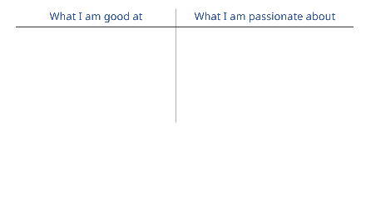  5. Wrap Up: Connecting to student context and action  - Ask students to draw a T Chart, labeling one column: “What I am passionate about” and the other column: “What I am good at.” Give them 2-3 minutes to add ideas in each column.  - Have students stand up and move around the room comparing what they wrote with other students to see if they can find 2 or 3 other students with similar talents and interests.  - Then ask them to brainstorm with that group a few ways they could use their talents (what I am good at) and their interests (what I am passionate about) to meet a need in their school or community.  - After a few minutes, ask each group to share at least one idea with the class.  - Have students return to their seats and write down one thing from the small group or whole class discussion that they could do to use their talents and interests for good during the coming week. | Individual reflection and small group discussion  Giving students a few minutes to reflect and write about the key leadership concepts from the lesson can help them personalize and apply the concepts to their own lives.  Asking students to write down a commitment to do something during the coming week to use their talents and interests helps them connect the leadership ideas from this lesson to positive action for change. They will use these ideas in future lessons as they plan a project to help their community.

Inquiry Notebook Prompts
PROMPTS | NOTES
- How can you connect your passions to making a positive change in your community?  - What challenges might you face when working as a team?  - Think about the song “Stronger and Stronger.” What message does it teach you about leadership? | Adopt or modify these prompts for Inquiry Notebook engagement with concepts featured in this lesson. After completing Step 3, direct students to select one prompt to respond to in their Inquiry Notebook.

Variations and Extensions
VARIATIONS

1. General differentiation and scaffolding
- Based on students’ levels and prior knowledge, teachers can choose to cover the lesson content over two or more class sessions. This approach will allow teachers to provide additional instruction, review, and support as appropriate.
- For younger learners or those with lower language proficiency, consider beginning the lesson by showing the video Teamwork and Leadership (1:15). Choose one or more of the three examples from the first 1 minute and 15 seconds of the animated video that illustrate the power of working together in a fun and engaging way. Ask students to tell a partner what the animals did to solve their problems (teamwork!). Ask students how working together (rather than independently) helps us make changes and accomplish things.
- For students who need more reading practice or visual support (or if you aren’t able to show a video in your classroom), supplement or replace the video: Lead What You Love: Video Interview with Renee Gastelum and the accompanying Lead What You Love Note Taking Sheet by reading Words of Wisdom from a Young Leader (Lesson Materials – Item D) and discussing it with students, which summarizes the interview with Renee. As you read and discuss each section with students, clarify key vocabulary words as needed.

2. Listening jigsaw
- Replace Step 3 written texts with the audio texts recorded by the teacher. Assign each group of students one Young Leaders Spotlight. Set up “listening stations” in different parts of the room and let groups listen to their text at a low volume as many times as needed while making notes; (2) let groups listen in different nearby rooms/areas; or (3) make the audio available on student mobile devices for headphone listening.

EXTENSIONS

1. Speaking: Young leader role play
- Ask students to work with a partner and imagine they are being interviewed about their work as a young leader, just like Renee. Each student should prepare several questions to ask their partner. Students can answer as themselves, their future selves, or as one of the leaders in the Young Leader Spotlights.

2. Listening: Positive messages in song
- For students who love music, extend the song activity by listening to the “Stronger and Stronger” song again and singing along using the lyrics. Ask students to bring examples of songs with similar messages (making changes, setting goals, looking forward to the future).

External links are provided for informational purposes only; there is no implied U.S. Department of State endorsement of the individuals, views, opinions, media content,
or privacy policies contained therein.

Unless otherwise noted, CC0 images in this resource are “no-attribution required” items sourced under the Pixabay simplified license or the Unsplash license. If sharing, adapting, or remixing portions of this lesson plan, please respect excepted permission and licensing statements noted in the credit statements for individual images, graphics, or other content. To learn about Creative Commons licenses, their uses, and their restrictions, visit the Creative Commons license explanation site.

Lead What You Love – Lesson Materials
YOUTH LEADERSHIP

A. Stronger and Stronger, song by Daniel Ho
A SONG ABOUT THE STRENGTH TO CHANGE | Music and Lyrics from: Sing Out Loud: American Rhythms.
In the song “Stronger and Stronger,” Daniel Ho, a native of Honolulu, Hawaii, sings about his decision to chase his dreams without being discouraged by people who do not think he can achieve them. It is a song about believing in yourself. In the song, you will hear the sound of an instrument called the slack key guitar, very common in Hawaiian music.

I’m sick and tired of hearing that I’ll never have what it takes.
Just need a few words of encouragement and I’ll be okay.
Is love or jealousy preventing you from seeing my way?
With or without your approval, I’ll do it anyway.

I’m getting stronger and stronger with each passing day.
Flying higher and higher like a bird flown away.
I’m getting closer and closer to finding my way.
I just might make it someday. You know, I just might make it someday.

I’m off to chase those silly dreams you always warned me about.
Don’t take it personal. It’s not to prove you wrong, but me right.
'Cause you know I’m right; you’ll see the light without a shadow of doubt.
Was that out loud? Oh well, I’m sorry got no time to fight, no.
I’m getting stronger and stronger with each passing day.
Flying higher and higher like a bird flown away.
I’m getting closer and closer to finding my way.
I just might make it someday. You know, I just might make it someday.

Yeah, Yeah, Yeah. Maybe someday. Maybe someday.
It’s not like me to be the one to say, “I told you so.”
But I told you so, I told you so, I told you so, I told you so!
I told you so, I told you so, I told you so, I told you so!
In case you missed it, listen carefully, I TOLD YOU SO! Yeah, Yeah.
I’m getting stronger and stronger with each passing day.
Flying higher and higher like a bird flown away.
I’m getting closer and closer to finding my way.
I just might make it someday. You know, I just might make it someday.

Looks like I made it. What were you thinking?
What did I tell you? I told you so.
Yeah, Yeah. I told you so, I told you so, I told you so.

B. Young Leader Spotlights
Photo credit: Justin Higuchi
  Alexander Abram  CC0  Alexander is the student vice president at his college. Every week, he talks with other students. They make plans for fun events and try to help everyone feel welcome.  When you ask him why he chose to be a student leader, he says, “I think it’s important for every student to feel accepted and supported. We are all learning about life and some of us are living away from home for the first time. Our student organization plans ways to help us make friends and feel comfortable at college. I like leading those important efforts.”  Alexander’s advice to other young people is, “Look around you and find a problem to be solved or a person to be helped. Then do something about it!” |   Kahlil Greene  CC0  When Kahlil Greene was 19 years old, he was elected student body president at Yale University. He believes it is important to dream big. He thinks everyone should work hard to make their dreams come true and help others in their communities. He wants everyone to feel like they belong, and he encourages others to share their stories.  Kahlil has learned leadership skills since becoming student body president. He gives this advice to other young leaders: “I always tell people that you can achieve any dream that you have so long that you have a good plan and you have discipline.”
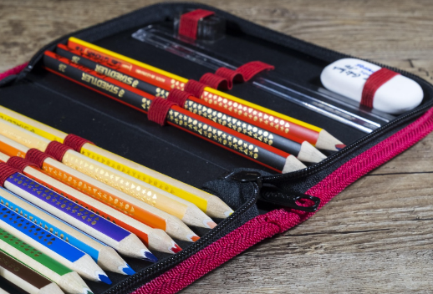  Brinley Douglas  CC0  Brinley was a high school student when she and her friend started a student service organization. They asked some other friends to join them to help people in their community. Together they packed take home lunches for children, worked at a food pantry, and collected school supplies like pencils and notebooks for kids in need. When other kids heard about the projects, some of them joined in. Now there are more than 100 students from her school working together on community service projects.  Brinley says that leading others helped her feel more confident. “It’s scary at first, but the more chances you give yourself to lead, the easier it is. Start by finding friends who want to make a difference too. Then you have opportunities to do good in the world around you!” |   Refica Attwood  CC0  Refica Attwood is passionate about the environment. Her love of nature inspired her to create a community-managed national park. Refica hopes she can inspire other young people to preserve the natural world. She knows that young people can make a difference when they work together. In the summer, Refica leads an internship program for teenagers. She teaches them about biodiversity and the environment. She feels like this is a way to combine her passion and skills to help others get excited about the earth.  Refica’s advice to others who want to make a difference is “Do not be afraid to start. You have no idea how far your impact will travel.”

C. Lead What You Love Note-Taking Sheet
An Interview with Renee Gastelum: Student, musician, and leader
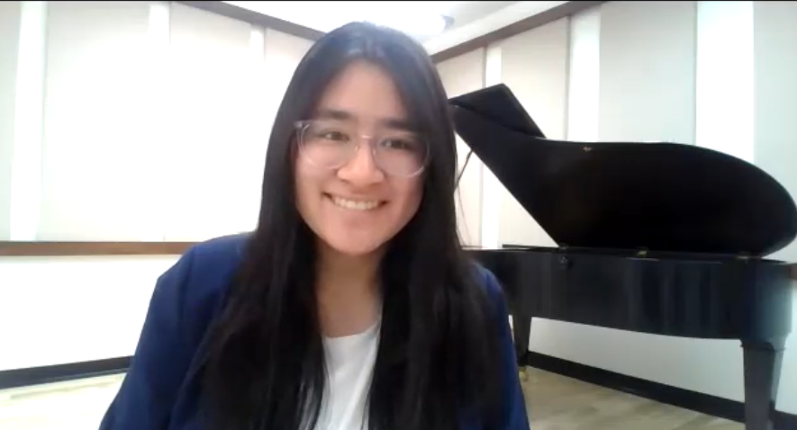
Watch the interview with Renee (4:11)
Renee Gastelum
Student, musician, leader
Image: R. Keogh
Renee Gastelum is a student who loves sharing her musical talents with others. When she saw a need in her community, she organized a group of musical friends to create a summer music camp for refugee families in Utah, U.S.A. She has found that being a leader is hard work, but it’s rewarding to see the difference she and her friends are making in the lives of the children and families they work with. Watch the interview with Renee to learn her insights for young leaders like you!

Part 1: Lead what you love
To other young people who want to get involved in their community, Renee recommends considering:
- what you are _________________________ at
- what you are ___________________________________ about
- where there is a _________________________ in your community

Part 2: Leading is about helping others
Discuss with a partner:
- What does Renee say is a big difference between working under a leader and being the leader?
- Do you think that is an important difference? Why or why not?

Part 3: Renee’s advice to young leaders
Renee’s advice to young leaders who want to make a difference in their community includes:
- Tip 1: Leading is ______________________________________________________________________________________
- Tip 2: Express _________________________________________________________________________________________
- Tip 3: Believe you can _________________________________________________________________________________

D. Words of Wisdom from a Young Leader

Leading is about
helping others
I have a teacher who once told me that when you're working underneath a leader it's about: “How do I get this done?"

Then for being a leader, it's about: “How can I help other people to get this done?" which is a very different question.
An Interview with Renee Gastelum: Student, musician, and leader

Leading is about
helping others
I have a teacher who once told me that when you're working underneath a leader it's about: “How do I get this done?"

Then for being a leader it's about: “How can I help other people to get this done?" which is a very different question.
Renee Gastelum is a college student who loves sharing her musical talents with others. When she saw a need in her community, she organized a group of musical friends to create a summer music camp for refugee families in Utah, U.S.A. She has found that being a leader is hard work, but it’s rewarding to see the difference she and her friends are making in the lives of the children and families they work with. Read what Renee has to say to young leaders like you!
Lead what you love
Image: R. Keogh
Sometimes people ask me, How do you decide on a project to lead? My advice is to ask yourself:
- What am I good at? What am I passionate about? Where is there a need in the community?
I’m good at music, so the first part was easy. Then I thought about how I love connecting cultures and how I love meeting people from different places. My friends and I often teach music lessons, and I thought about some refugee children in our community who could not afford to take music lessons or even buy musical instruments. That’s when I decided to create a summer music camp for refugees.

Renee’s advice to young leaders
My advice to young leaders who want to make a difference in their community is:
- Tip 1: Recognize that leading is hard work! It was a lot more work than I expected. Sometimes I would get frustrated because no one else understood all the things that I was trying to do, but later it was really nice to realize that I was doing something really big!
- Tip 2: Express your thanks to those you lead. These people are volunteering and they're doing it just because they're passionate about it. Acknowledge that and thank them for what they're doing.
- Tip 3: Believe you can make a difference. You have a lot more power to make change than you think you do. Most people don't trust young people with that big of a responsibility, but I think we're able to do it, and once we realize that then there's nothing we can't do!

Key Vocabulary glossary
Definitions below illustrate how Key Vocabulary terms are used in the context of this lesson.

to accomplish v. to do something successfully; accomplishment n.
community service n. work or actions that help people in the community without payment
to coordinate v. to organize people and activities
leadership n. the process of guiding others
nonprofit organization n. a group that focuses on helping others, not making money
passion n. a strong feeling of excitement or love; passionate adj.
powerful adj. very effective or influential
refugee n. a person who has left their country or home because of dangerous situations
teamwork n. many people working together
to volunteer v. to do something without being paid

