Celebrating Our Community
ART AS EXPRESSION: IMPACT PROJECT

Overview
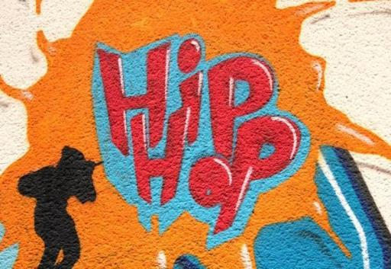
In this 18 to 20-hour Impact Project, students learn about their local community (which could be defined as their school, neighborhood, town, city, or region) and create art that celebrates a specific aspect of that community. First, students brainstorm possible topics and then identify a project focus. Through interviews with safe community contacts and other research, students gather information to inform an art project that celebrates the community, which they will then present to a local audience. Students can work individually, in pairs, or in groups to create poems, hip-hop songs, and song cover art/visual art pieces. Students are expected to draw on the knowledge and experiences from the three-lesson unit Art as Expression. This project can be adapted to beginners or more experienced language users.

Potential Impact
(CC0)
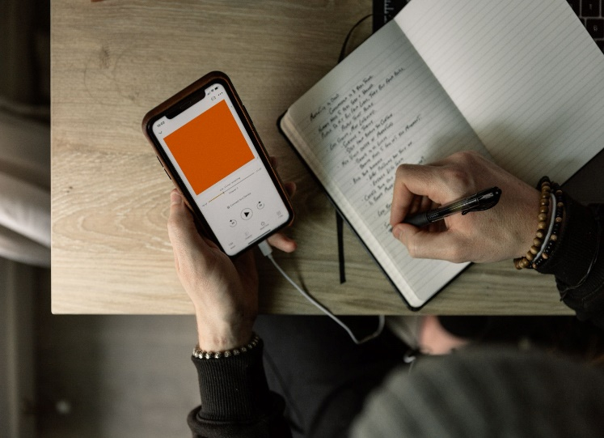
- Personal Impact: Students will experience the roles of artists; develop skills in creativity, communication, critical thinking, and collaboration; and conceive of and develop an art piece that triggers positive engagement, thoughts, and emotions.
- Community Impact: Students will engage the local audience in appreciating art, resulting in community members celebrating and cherishing their local community.

Goals
By participating in this Impact Project, students will be able to:
- summarize research materials into key themes and topics
- sort and organize information from research and interviews
- use creative and critical thinking skills to plan, draft, and create art pieces
(CC0)
- practice and refine art literacy and public speaking skills when creating and presenting artwork
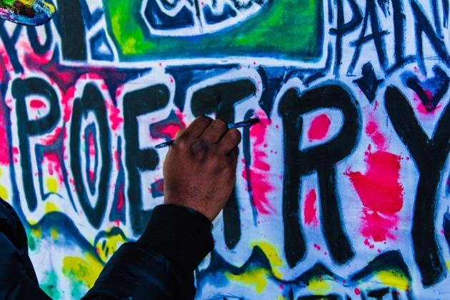
By participating in this Impact Project, teachers will apply Student-Centered Learning teaching techniques, including:
- acting as a guide or facilitator for student-led projects
- helping students weigh and justify their choices
- supporting student choice while providing appropriate limits
- identifying students’ individual needs to help them thrive while collaborating on a design process

Project Materials
IN YOUR CLASSROOM
(CC0)
- Paper and pencils or pens
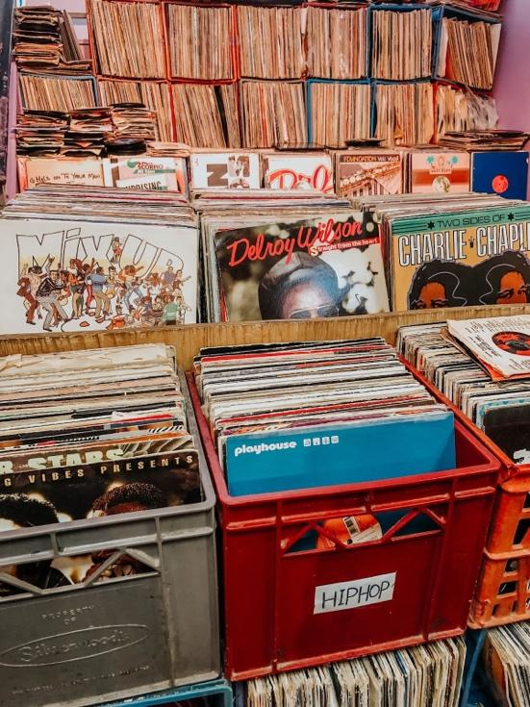
- Chalkboard and chalk or whiteboard and markers
- Clock or timing device
- Projector or TV for displaying project content (optional)
- Music player, computers or mobile devices, or other research tools
- Art supplies such as markers, paints, colored pencils, crayons, etc.
- Old magazines or other images to cut up (optional)
- Tape, mounting putty, or other adhesive for displaying art pieces
PROVIDED WITH THIS IMPACT PROJECT
A. Choosing Your Topic
B. Project Outcomes and Impact
C. Examples of Found Poems
D. Planning and Writing a Found Poem
E. Using Rhymes
F. From Poetry to…
G. Song Cover Art
(CC0)
H. Artistic Critique
I. Impact Statement

Preparation
- Review and teach the three lessons from the Art as Expression unit: “Public Art as a Tool for Expression,” “What is a Community Artist?,” and “Graffiti: Art or Crime?.” Connections to the lessons are noted in the Procedures section.
- Approach and present art as a universal form of expression that does not always require previous experience or training. The art pieces to be created in this project come with support tools and step-by-step procedures. They can be done by any student, even if it is their first time. What is important is that they experience using art to communicate, give voice, and celebrate.
- Completely review this Impact Project, including the Variations and Extensions and Project Materials sections, to determine the most appropriate materials, resources, and adaptations for your learners.
- Review the Procedures and Project Materials sections, then determine the formats you will use for the Project Materials.
  - Many items can be photocopied, enlarged, or projected onto the board or a wall.
  - After selecting the formats for the project stages, prepare the required number of materials to suit your class size, considering how many groups or individuals will participate in each project stage.
  - Review the materials provided to ensure they are appropriate for your classroom context. Make any changes as needed.
- Review the Inquiry Notebook Prompts. Plan to incorporate the prompts in three places during Impact Project development: at the beginning of the project, in the middle of the project, and at the end of the project.
- Review the Impact Statement Prompt and handout (Project Materials – Item I). At the end of the project, ask students to write an Impact Statement about their experience with the Art as Expression unit. Collect their responses.

Potential Partners
- Partners like local advocacy, non-profit, or government organizations may be good sources of information, background materials, or guest speakers. Relevant U.S. Embassy or Consulate staff or American Spaces staff may also be excellent in-person or virtual guest speakers.
- If possible, consider connecting your class with artists from the community or with local leaders who are knowledgeable about the community. Local artists or community leaders could speak in your class and inspire your students.

Inquiry Notebook Prompts
PROMPTS | NOTES
Beginning of the Impact Project (before starting Stage 1)  - When you think about your community, how do you feel? Draw a picture or select several emojis.  - What is something you would like others to know about your community?  Mid-Project (after completing Stage 3)  - Reflect on the information you found so far. Did anything surprise you? Why?  Imagine a party or celebration honoring your topic (the part of the community that students are focused on). What kinds of things would you see, feel, hear, smell, or taste at this party?  End of Project (after completing Stage 6)  - Describe your experience presenting and performing. How did you feel?  - What did you learn about yourself or your community through this project? | Adopt or modify these prompts for Inquiry Notebook engagement with concepts featured in this Impact Project. Ask students to select one of the two prompts at each stage to respond to in their Inquiry Notebook.

Procedures
TIME | PROJECT STAGES | NOTES
2 hours | 1. Understanding the Project and Identifying Aspects of Your Community to Celebrate  - Ask students to write an Inquiry Notebook entry using the Beginning of the Impact Project prompts.  - Start by reviewing key concepts and vocabulary terms from the three Art as Expression lesson plans.  - Explain that just like the artists and art explored in the lessons, the students will express their ideas about their community through various art forms. Let your students know that this is a project that uses art to celebrate the community. The main goal of the project is to elevate the community by identifying specific reasons to celebrate or honor it. In sum, students will identify a positive aspect of their community, learn more about it, interview a community member who cares about this aspect of the community, and create art pieces that celebrate this aspect of the community.  - Tell the class the art pieces involved in this project include 1) a poem, which will later be presented in the form of 2) a song, and 3) a song cover or visual art piece (drawing, collage, etc.).  - Give each group a copy of the Choosing Your Topic handout. Start by asking students to think about the different communities they participate in, such as school, neighborhood, city, town, or region. Direct students to work in pairs or small groups to brainstorm positive aspects of these communities. Suggested guiding questions include:  - What do you like about your community?  - What makes you feel proud about the area where you live or go to school?  - What are some ways your community shows resilience?  - What’s something positive that you wish more people knew about your community?  - Tell a story about something positive that happened in your local community.  - If you were showing a visitor around your community, what would you be excited to share with them?  These questions can help them decide a specific focus for their interviews and artwork. Ask follow-up questions to help students justify and narrow their topic. Be mindful about what topics may be too sensitive for students to address and redirect as needed.  - Have your class consider the logistics of choosing to focus on a shared, whole-class topic or if students would be interested in exploring different topics. Depending on the number of students and resources, it may work best for the whole class to work on one topic, especially if they will conduct interviews, which require that students be accompanied by an adult.  - When you feel students are ready, ask them to pay special attention to Step 3, which will help determine how to gather more information. Have them consider:  - Is it safe, appropriate, and possible to interview community members?  - Are there community members who know a lot about this topic who we can invite as speakers or write to?  - Are any local groups already working on this topic? Can we reach out to them?  - What other sources of information are available about this topic?  - Give students time to choose, with your guidance, a safe community member(s) they would like to connect with, either in person or through research. If you feel that students need more exposure to their local community before you start this process, consider inviting guest speakers or conducting research online or on local media to guide them to make a more informed decision. | In this Impact Project, students take the lead in selecting their project topic. Student choice is a core component of student-centered learning. Teachers should act as guides and facilitators, rather than managing the project themselves. Help students select strong topics by:  - Asking questions to help students identify and weigh their topic options.  - Being mindful about what topics might be sensitive in the community.  - Limiting their options, if needed, to guarantee a positive experience.  Project Materials – Item A. Choosing Your Topic  Using a graphic organizer to help students hold a focused discussion about their community is an effective student-centered learning technique. This task encourages students to speak in English. It helps them participate in an activity that feels meaningful because it is relevant to their lives.
2-4 hours | 2. Learning About the Community  - Invite students to reflect and decide whether they should continue in the same research teams they were in during the previous stage, or if any rearrangement is needed.  - Once students have chosen the focus of their project, instruct them to gather more information. Based on what is possible and appropriate in your setting, help students:  - Find and use 1) local media (TV channels, radio, newspapers) stories or reports or 2) the internet or social media sources that discuss the topic. Even if there has been nothing written about this topic in the student’s community, it may have been discussed more broadly elsewhere.  - Connect with relevant community members directly through interviews or by identifying partners students can work with. For example, if there are educators, artists, or any other willing community members who know about students’ chosen topic(s), they can be invited to share information with your class. If a visit is not possible, consider writing emails or conducting online interviews.  - Guide your students in planning for the expected impact of the project and how it will be measured. Display or give each student or group a copy of the Project Outcomes and Impact handout. Guide them through predicting the potential impact of their project work. Suggested discussion questions include:  - How can artwork celebrate an aspect of the community that deserves more attention?  - What types of evidence will show that the project had a positive impact on the audience? | If it is possible to interview community members, plan for the logistics of this interview with your students. Make sure students are always accompanied by an adult who is aware of what they are doing and of the goals of this project. If possible, go as a class.  In a student-centered classroom, balancing teacher support with student-led activities (like arranging and conducting an interview) enhances students’ investment in the project.  Project Materials – Item B. Project Outcomes and Impact
3-4  hours | 3. Writing a Found Poem  - Tell students that they will write poems based on the information they found about their chosen topic(s). The poems are a type of art that celebrates and honors their community. Consider whether the student groups need to be redesigned based on the research paths chosen and engagement in previous stages.  - Before students plan and write their poems, teach or review the “What is a Community Artist?” lesson. Direct students to recall the community artists featured in the lesson and how they create art to honor and interact with their communities. Review the Introducing a Community Artist – Graphic Organizer included in the lesson to help students reflect on their own goals as community artists before they start writing their poems.  - Guide students through reading the Examples of Found Poems. Explain that a found poem is a poem that uses borrowed text from one or more sources. It is like a collage made of words. Poets borrow words, phrases, or passages from sources like novels, interviews, and news articles to make found poems. Example 1 is a poem written using the reading about community artist Crystal Worl as a source text.  - Direct students to revisit the information they collected in Stage 2. Conduct a whole class review to share the different themes and topics that emerged from their research. This may help guide students in deciding what to write a poem about. As they consider the source materials to write their poems, students should have a clear goal in mind. Guide them in considering:  - What are the main ideas I would like to express in the poem?  - What is my focus as a writer?  - What should other community members feel and learn about my topic?  - Who is the audience for these poems?  - When students are ready, guide them to use the information they have gathered to write their poems. For this project, students will use quotes from interviews or excerpts from their research as their source texts.  - Students can work individually, in pairs, or in small groups to write their poem(s).  - Give each student a copy of the Planning and Writing a Found Poem handout. Decide if students should incorporate rhymes at this point in the project or later, when they turn their poems into songs. If desired, teach and review Using Rhymes.  - As students work on their poems, engage them in a discussion about using information accurately and in the provided context. No information should be removed out of its original context and intention. Throughout the poem, students should be as true as possible to their information sources and write poetry that will inspire community members to appreciate this aspect of the community.  - Encourage students to consider writing one version of the poem in the local language and another in English. This will allow them to share their creations with a larger audience. One version does not need to be a literal translation of the other, but they should be written with the same goal in mind.  - After first drafts of the poems are complete, engage students in a peer review process. Form peer groups where students can read and provide feedback about their poems to one another. This will also allow them to savor their successes up to this point. When providing feedback, ask them to consider:  - Does the poem meet its stated goal?  - How will it affect or impact audience members?  - Ask students to write an Inquiry Notebook entry using the Mid-Project prompts. | Managing group work by assigning students to roles or groups can help you meet individual students’ needs, which is a key component of a student-centered learning.  Project Materials – Item C. Examples of Found Poems  The examples in Item C have each been produced from one source text. Show these examples to your students and encourage them to follow a similar path: they should pick a source text that aligns with their topic and include interviews or other observations of their local community as source texts they can draw from to write their poem.  If working in groups, keep the groups small so students have plenty of opportunities to interact and exchange ideas.  Project Materials – Item D. Planning and Writing a Poem;  Project Materials – Item E. Using Rhymes  A found poem can be written from one or from many different source texts. However, using too many may make the task more challenging for students. Limit their choices as needed. Teachers can help students learn to make strong choices by limiting options when appropriate.
5  hours | 4. From Poetry to Music and/or Visual Art  - Now that students have created one type of art to celebrate their community—found poems—encourage them to expand their community engagement into other types of art. They can 1) turn their poems into songs, and 2) create a visual art representation of their poems/songs: cover art (a small poster). If time allows and there is interest, encourage them to do both. You can hold a class vote to encourage discussion on what options may work best.  - As students consider the options of going from poems to music and visual art, guide them in discussing the logistics of the new phase of the project:  - Are some students in our class more interested in creating songs while others are more interested in designing visual art? If so, can we work together?  - How should pairs or groups be redesigned to accommodate students’ interests?  - Are we creating these pieces for the same audience we envisioned for the poems? Who should we add as potential audience members in this new phase of the project?  - Option 1: From a Poem to a Rap or Hip-hop Song  - Even though not all hip-hop / rap songs are written to be read as poems and vice-versa, it is not uncommon for poems to be turned into rap songs. Let your students know that the goal is to find ways to engage audiences—especially younger people and others who like rap—with their message.  - Encourage students to create a bilingual song. This can be a great opportunity for students to experience translanguaging, a feature very common to rap. If they prefer, they can also do a version for each language.  - Guide students in reviewing the steps presented in the From Poetry to… handout for a simple, straightforward way to turn a poem into a rap song:  - Read the poem again.  - If needed, change a few words (keeping the same meaning) to add rhymes. Not all poems or rap songs use rhymes, so students are not required to make these changes, if they don’t wish to. Teach or review Using Rhymes to help students understand some basic rhymes they can add.  - Practice performing the song by keeping a steady beat.  - Add a track in the background.  - Practice, practice, and practice!  - Option 2: From a Poem/song to Cover Art  - Encourage students who are interested in visual arts to adapt the message of their poems/songs into cover art (image on a small poster). Explain that this will help audience members who are interested in visual arts to receive their message.  - If students are not familiar with album or song covers, show them some examples. Also, consider looking online for additional cover art that you can show your students, especially of musicians they already know. Remember to stress that the song covers are meant to be positive, celebratory pieces.  - Highlight that cover art can be made by drawing, painting, using collage, using a computer or phone, etc. Cover art often includes both text and images.  - Guide students in designing their poem/song cover art using the Song Cover Art handout:  - Read the poem/song.  - Write down its main themes and topics.  - Imagine and discuss how these themes and topics can be represented visually.  - Consider the medium: drawing, painting, collage, photography, digital art?  - Sketch some possible visual representations.  - Check to make sure the message of your image matches that of the poem/song.  - Get feedback from peers.  - Revise and improve the design.  - Work on the final design. | This project stage allows students to explore different types of art (beyond the poem they wrote) as tools for expression.  Providing many different pathways for students to express knowledge (e.g. poetry, rap/songwriting, musical performance, visual art) creates opportunities for student choice and supports student-centered learning.  The suggested music style for this project is hip-hop or rap. Teach and/or review the “Graffiti: Art of Crime?” lesson to help students understand the history of hip-hop culture in the United States and its connections to visual art such as graffiti.  Project Materials – Item E. Using Rhymes  Project Materials – Item F. From Poetry to…  Item F contains a few links to beats and background tracks that your students can add to their songs. However, if your students are enthusiastic about creating music, they can create their own beats.  Project Materials – Item G. Song Cover Art  If your group has easy access to computers and online tools, they can also create their album covers using digital tools like Canva or Figma.
1-2  hours | 5. Artistic Critique  - Now that students have created poems and songs and/or visual art, tell them the next step is to participate in a critique. Explain that an artistic critique is a way to describe and analyze works of art. The goal of the critique is to think critically about their art and decide which pieces will be shared with the larger community.  - To help students be precise and thoughtful in their critique, teach or review art-related language. Specific nouns, verbs, adjectives, and adverbs will help students describe the artwork and express their opinions about it.  - Based on the artistic output from the previous project stages, make small groups and assign each group several pieces of art to critique (a mix of poems, songs, and/or cover art). Give each student a copy of the Artistic Critique handout. Review the questions as a class and give students some time to think and respond individually.  - Engage your students in discussions with the goal of finalizing their art pieces before making them public. Remind students that when it comes to art, everyone may have a different opinion—and that’s ok! Encourage them to share their ideas openly and with respect for differing points of view. Have them consider:  - Is our class’s original project goal reflected in the pieces we created?  - How will members of the community see themselves, or the community, reflected in the pieces we created?  - What feelings and thoughts will these pieces generate in the audience members?  - What needs to be changed before these pieces are made public?  - Decide as a class which pieces will be shared with the larger community. Support students in finalizing their artwork as needed. | The critique process can also be a type of formative assessment, a student-centered learning technique where students check in at key points during a project.  Project Materials – Item H. Artistic Critique  Students can practice giving and receiving feedback and identifying the strengths and challenges of their own work. They will then have opportunities to make changes before the project is completed.  Be present and active in helping students select what should be shown to a larger audience. If in doubt, ask another teacher or administrator to assist you and the students in making the final call. This type of supported decision-making centers student voices with appropriate guidance.
1-2  hours | 6. Presentation  - As students prepare to present their artwork, explain that different art products may attract different audiences and may require separate presentations. Invite them to consider:  - What local audience members would be interested in 1) reading or listening to a poem, 2) listening to a hip-hop song, and/or 3) looking at a visual art piece? How can we promote the event to them?  - Should we consider one event where all these art pieces will be presented to the same audience or separate events for different audience groups?  - As a class, brainstorm options for sharing the art with the community. Explore the possibility of visiting local classrooms or public spaces available in your community, inviting guests to your class, or holding an online event. Present the options that are appropriate and reasonable for your community and decide as a class so that students can participate in the final decision.  - Discuss the presentation format with students to determine the best way to present their art pieces. Presentation options may include:  - Posting found poems physically and/or on social media, as well as reading them in a recital  - Performing hip-hop songs live to an audience or recording them and sharing them on social media  - Displaying cover art along with their poems and songs either in-person or online  - Help your students brainstorm a list of guests that includes people who could help promote the project to other community members.  - With your students, document (photograph and/or record) the presentations and consider later displaying them on social media to reach an even larger audience. | Holding a class vote is one way to enhance student choice in a student-centered classroom. Another option would be a consensus-building activity that considers all voices. Studies show that student-centered learning techniques increase students’ perception of quality teaching.
1  hour | 7. Reflecting on Your Impact Project  - After sharing their artwork with the community, invite students to celebrate and reflect on their experience. Start by asking students to revisit the Project Outcomes and Impact discussion questions and discuss which of their original goals for the project have been met.  - Propose a discovery chart: a reflection activity that allows students to share what they discovered about themselves or others during the project. The questions below can be written on a poster or on the board for students to respond to. Some suggested prompts include:  - What did you discover about the community during this project?  - What did you discover about yourself?  - What did you discover about your feelings about your community? Did they change during the project?  - What else did you discover?  - Based on what you discovered, what advice would you give to other students doing a similar project?  - Ask students to write an Inquiry Notebook entry using the End of Project prompts.  - Celebrate students’ hard work and their efforts to engage with their community through art. | Project Materials – Item B. Project Outcomes and Impact

Impact Statement Prompt
After completing the Art as Expression lessons and Celebrating Our Community Impact Project, ask students to review all their Inquiry Notebook entries and reflect on their experience. Direct students to write an Impact Statement to respond to the following prompt:
- Think about the artwork you created and review your inquiry notebook entries. How has this project impacted you? Your community?

Variations and Extensions
VARIATIONS

1. General differentiation and scaffolding
- Lower-level students may require more support, guidance, and modeling from the teacher during the project development. If so, provide it in a way that keeps students as the key decision makers. Simplify the found poems so that they include simple words, phrases, and sentences taken directly from the source texts. Students may also benefit from the support of their peers by writing poems in pairs or small groups instead of individually.
- In a multilevel class, consider organizing student groups in a way that ensures mixed abilities are represented within each group so students can support each other.
- Encourage higher-level students to take on more linguistically demanding roles of the project: explaining to the audience how the poem or song celebrates the community, how the class decided to focus on this aspect of the community, or what the class learned by doing this project. Higher-level-students could work on their poems and songs individually. They can also play the role of hosts (MCs) during presentations, in addition to presenting their own projects.

2. For virtual environments
- If your class meets virtually, use breakout rooms to create spaces for small group meetings. Final products can be shared through social media during a live event or posted on class accounts. If appropriate, consider having a class social media account where all the content is double-checked before it is made public, and get your students involved in making these editorial choices.

3. Other variations
- This project can be adapted to focus on the poem or on the song as a final product. Decide what works best for your class and program goals.
- Instead of using the provided beats to create a song, encourage students to make and/or record their own beats and later play them during their performance. Hip-hop music works as well with simple beats as it does with more sophisticated ones. Creating their own beats may lead to a more engaging and personalized performance.
EXTENSIONS

Write an artist statement: In preparation for a performance or display of their art, students can write their own artist statements to accompany their work. Direct students to write 1-2 paragraphs that provide context, understanding, and insight into their creative process and intentions. Consider asking students to write the artist statement in both English and a local language to expand their audience.
Compile an album: Celebrate your students’ songs! Invite willing students to record a performance of their songs. Compile the recordings in a playlist that can be shared with the class, family, friends, and community members. Students can also add their song cover art and write album notes.

External links are provided for informational purposes only; there is no implied U.S. Department of State endorsement of the views, opinions, media content,
or privacy policies contained therein.

Unless otherwise noted, CC0 images in this resource are “no-attribution required” items sourced under the Pixabay simplified license or the Unsplash license. If sharing, adapting, or remixing portions of this lesson plan, please respect excepted permission and licensing statements noted in the credit statements for individual images, graphics, or other content. To learn about Creative Commons licenses, their uses, and their restrictions, visit the Creative Commons license explanation site.

Celebrating Our Community – Project Materials
ART AS EXPRESSION: IMPACT PROJECT

A. Choosing Your Topic
Directions: With your class and teacher, use the prompts in the boxes below to guide you in selecting a specific part of your community to celebrate through art.

People participate in many communities, such as school, neighborhoods, towns or cities, regions, and online communities. For this project, you will identify something special about a community you are part of. You will research one positive aspect of your community and create art that celebrates it.
Step 1. Brainstorm: Think about your community. What are some special things about it? What makes you feel proud? What do you wish more people knew about?
Step 2. Narrow focus: What special part of your community would you like to learn more about? Who could you talk to about it?

Class choice(s):__________________________________

Step 3. Gather Information: What are some ways you could learn more about this special part of your community?

____ survey
____ interviews
____ observation
____ online research
____ focus group
____ guest speakers

Step 4. Analyze Information: What main ideas does the information show?

B. Project Outcomes and Impact
Participating in a community project can have a big impact on the people in your community—and on YOU! As you plan, organize, and carry out your project, you will learn more about your community, practice critical thinking and problem-solving skills, learn time management and organization skills, and make art that celebrates a special part of your community.

Impact on participating students

Impact on community members
BEFORE THE PROJECT
Think about how this project might impact:
- the students in your class
- people in your community

AFTER THE PROJECT
How did this project impact:
- the students in your class
- people in your community

What types of evidence show that the project has had a positive impact on:
- the students in your class
- people in your community

Discuss ways that you can share the impact that this project has had on YOU and on your community.

C. Examples of Found Poems
Example 1 – Meet the Community Artist: Crystal Worl
Source Text: The source text for this poem is the reading “Meet the Community Artist: Crystal Worl,” included in the “What is a Community Artist?” lesson. Read the source text and see how a poet has “borrowed” sentences, images, words, and ideas to use in their poem.
Goal of Poem: Promote Crystal Worl and her public art that combines people, animals, and nature
2. Writing the Poem (final version)
1. Preparing the Poem
EXCERPTS FROM SOURCE TEXT(S)
(key words, phrases, sentences that align with the poem’s goal)
Crystal Worl is a Native Alaskan artist living in Juneau, Alaska (USA).
Crystal grew up in the cities of Fairbanks and Juneau.
As an artist, Crystal works with glass, silver, printing, and painting.
She also uses interesting materials like fish skin and fur.
Her art explores the relationships between people, the land, and animals.
Athabascan images of ravens, eagles, salmon, whales, and other animals often appear in her work.
Crystal has created many types of public art, including murals (large wall paintings).
Elizabeth Peratrovich, a Native Alaskan woman who fought for equal rights in the 1940s and beyond.
…bright, modern colors to show connections—past and present—between Alaskans, water, land, the sun, and animals.

Crystal Worl

From Fairbanks and Juneau
Comes a Native Alaskan artist
Using glass, silver, and paint
Her name is Crystal Worl

Exploring relationships
Of people and animals and fish
And featuring activists
Like Elizabeth Peratrovich

Creating public art
Murals, designs, prints
But also using skin and fur
To represent animal spirits

Showing Native Alaska to visitors
By painting murals
Where people, animals and the land
Tell their stories

Example 1 – Meet an American Teenager: Trevor
Source Text: The source text for this poem is an interview with Trevor, a US teenager. Read the source text and see how a poet has “borrowed” sentences, images, words, and ideas to use in their poem.
Goal of Poem: Share what Trevor learned about history and about himself during his field trip.
2. Writing the Poem (final version)
1. Preparing the Poem

My State’s Past and My Future
a school field trip
across our state and back
learned about basketball history
and star basketball players

learned about Blackbeard
how he became a pirate
learned about the Wright brothers
what they flew and how they flew
what inspired them

I want to be a zoologist
I want to study animals

Just keep working hard
You are going to get there
EXCERPTS FROM SOURCE TEXT(S)
(key words, phrases, sentences that align with the poem’s goal)

We’re on a school field trip. It’s 4-day trip across our state and back.
We went to UNC and learned about the basketball history and their star basketball players.

Then we went to the Blackbeard museum, and we learned about Blackbeard, how he became a pirate…
Then we learned about the Wright brothers history.
We built replicas of their gliders at school.
We researched what they flew and how they flew and what inspired them

Tonight we’ll have a dance and last night we went bowling.
I like sports. I like basketball, and I’m on the baseball team.

I want to be a zoologist. I want to study animals.
You guys are going to get there. Just keep working hard.

D. Planning and Writing a Found Poem
Part 1: Planning a Found Poem
Source Text(s): ________________________________________________________________________________________
Goal(s) of Poem: How do you want to make people feel? What do you want them to think about? What should the mood of the poem be (serious, funny, friendly, formal)? _________________
______________________________________________________________________________________________________________________
EXCERPTS FROM SOURCE TEXTS
Directions: Copy words, phrases, or sentences from your chosen source text that match your poem’s goal.
Part 2: Writing a Found Poem
Directions: Review the excerpts from your source text and goal(s) for your poem. Use the excerpts to create a found poem. Give your poem a title.

Title: ________________________________________________________

E. Using Rhymes
1) Types of Rhymes
There are many types of rhymes. Two common types are perfect and imperfect rhymes. They are often in poems and hip-hop songs:
Perfect Rhyme
A perfect rhyme is a rhyme with two words that sound exactly alike:
… well / … sell

…form / …dorm

---chase / …face

Imperfect Rhyme
An imperfect rhyme (or half rhyme) has words with some syllables or sounds in common:
…mouth / …out

…looking / …bring

…time / …mine

When rhymes occur at the end of lines in a song or poem, they are called end rhymes. If they occur inside a line, they are called internal rhymes.
Internal Rhyme
I drove myself to the ocean
And dove into the water.

End Rhyme
I adopted a new cat,
And it is really fat.

2) Exploring Possible Rhymes
Look at your Found Poem and find the key words in your verses. List them and look for other words they may rhyme with. If you change words in your poem to add rhymes, make sure you keep the same meaning.
Key Word | Possible Rhyme | Key Word | Possible Rhyme

F. From Poetry to . . .
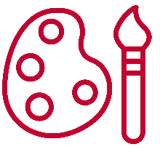
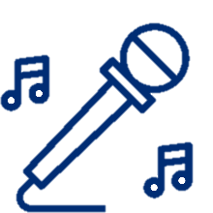
A Rap / Hip Hop Song

Directions
- Read your poem again.
- If you wish, add a few rhymes by changing some words. Keep the same meaning!
- Practice rapping and keeping a steady beat. You can clap your hands or tap your feet.
- Use the beat to highlight important words in your poem. You can rearrange a few sentences, if needed. Keep the same meaning.
- Practice again and play a music track in the background.
- Practice, practice, and practice some more.
- Perform your song for an audience!
Background music tracks:
- Jazzy Abstract Beat (1:25)
- Spirit Blossom (1:50)
- Hip Hop Beat (4:02)
Cover Art

Directions
- Read the poem/song.
- Write down its main themes and topics.
- Think about what images you connect to the theme and topics.
- Choose the best medium for your idea. Will it be drawing, painting, collage, photography, or digital art?
- Draw some possible ideas—use your imagination!
- Make sure the message of your drawing and your poem/song match.
- Share your cover art with your classmates and get their feedback.
- Make any changes and create your final cover art.
- Present your cover art to an audience!

G. Song Cover Art

Directions: Use the boxes below to plan two possible designs for your poem/song cover art. Then show them to your classmates and ask for their feedback.
Design Option 2
Design Option 1

Directions: Use the suggestions and comments your classmates provided to help you design your cover art. Be sure to add a title!
Final Design
Title:_____________________________________________________________________


H. Artistic Critique
Directions: Carefully review the art. Then, think about your answers to the following questions and write notes in each box. Discuss your thoughts with your group.

Describe
- What part of the community does this art celebrate?
- What do you hear or see when you experience the art?
- What adjectives can you use to describe the art?

Analyze
- What choices did the artists make to help you appreciate this part of their community?
- Is the project’s goal clear in this piece? Please explain.
- How will the audience feel about this piece of art?

Interpret
- What does the artist want us to know about their community?
- Does the art remind you of other things you’ve seen or experienced?

Evaluate
- What would you change to make this art stronger?
- Does anything need to be changed before this art is shared with the community?

I. Impact Statement

Name: ______________________________________________________
Prompt: Think about the artwork you created and review your inquiry notebook entries. How has this project impacted you? Your community?

__________________________________________________________________________________________________________________________________________________________________________________________________________________________________________________________________________________________________________________________________________________________________________________________________________________________________________________________________________________________________________________________________________________________________________________________________________________________________________________________________
_________________________________________________________________________________________________________________________________________________________________________________________________________________________________________________________________________________________________________________________________________________________________________________________________________________________________________________________________________________________________________________________________________________________________________________________________________________________________________________________________________________________________________________________________________________________________________________________________________________________________________________________________________________________________________________________________________________________________________________________________________________________________________________________________________________________________________________________________________________________________________________________________________________________
___________________________________________________________________________________________________________

Source Text: Ackles, Nancy. n.d. “Trevor.” In American Teens Talk!, 12–13. U.S. Department of State Office of English Language Programs. https://americanenglish.state.gov/resources/american-teens-talk
The music tracks included in this document are free to use under the Pixabay Content License and have the following creators: 1) Jazzy Abstract Beat - Music by Yrii Semchyshyn; 2) Spirit Blossom - Music by Roman Belov; 3) Hip Hop Beat - Music by Enhkamgalan ENYX.

