Students in Action: Making a Community Impact
YOUTH LEADERSHIP: IMPACT PROJECT

Overview

This 18 to 20-hour Impact Project allows students to put principles of good leadership studied in the Youth Leadership unit into action as they work for positive change in their community. As students design their own project to address a community issue, they consider qualities needed to lead peers and expand their leadership skills as they organize their project. Support materials include a step-by-step project planner to guide students in organizing their project and ideas for reflecting on the impact the project has on the community and on the students themselves.
(CC0)

Potential Impact

- Personal Impact: Students will develop and refine their leadership skills throughout a community service project; be better able to identify community issues and offer concrete solutions; and recognize their potential as leaders based on their interests, passions, and personality traits.
(CC0)
- Community Impact: Students will make a measurable impact on the community as they design and implement a project to address an important issue.

Goals
By participating in this project, students will be able to:
- identify and practice leadership qualities needed to lead peers, such as vision, planning, organizational skills, and clear communication
- feel empowered to use their developing leadership skills as they design and implement their project
- use vocabulary and language structures needed to discuss these topics and reflect on their work
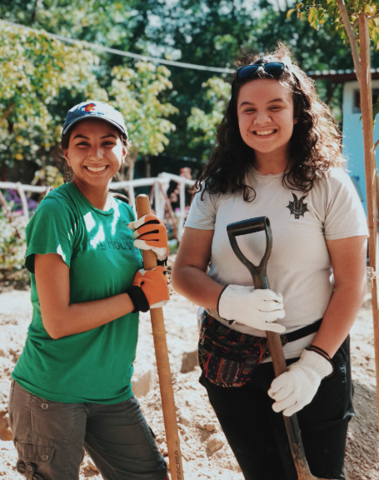
By participating in this Impact Project, teachers will guide students in project-based learning including:
(CC0)
- facilitating student-led projects with real-world relevance
- guiding students to effectively collaborate and build communication and teamwork skills
- incorporating meaningful target language development related to the project
- providing multiple points for students to reflect on their skills, interests, collaboration, and community impact

Project Materials
IN YOUR CLASSROOM
- Paper and pencils or pens; chalkboard and chalk or whiteboard and markers
- Projector or TV for displaying project content (optional)

PROVIDED WITH THIS IMPACT PROJECT
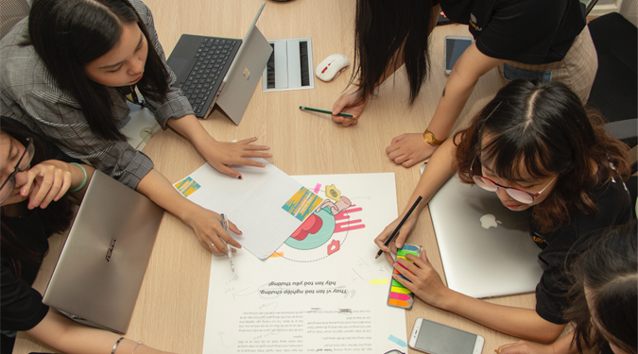
A. Uncovering Your Resources
(CC0)
B. Determining Community Needs
C. Discovering Your Impact
D. Planning a Project
E. Working as a Team
F. Impact Statement

Preparation
- Review and teach the three lessons from the Youth Leadership unit: “What Makes a Good Leader?,” “Lead What You Love,” and “Teamwork.” Review and recycle unit concepts and vocabulary so that students are prepared for leadership roles throughout the planning and implementation of this Impact Project. Connections to the lessons are noted in the Procedures section.
- Become familiar with issues that affect people in your local community so that as students select an issue to research and find ways to address it, you can guide their efforts.
- Consider how you can link language development to the activities that students will participate in during this project. Are there vocabulary words or language structures that students will need to know to successfully investigate the community issues they are interested in, create an action plan, complete their community project, or reflect on its impact? The article “Teacher's Corner: Service Learning in the Language Classroom” gives some great examples of how you can build students’ English skills at different stages of the project. Some suggestions are given in the Procedures section.
- Completely review this Impact Project, including the Variations and Extensions and Project Materials sections, to determine the most appropriate materials, resources, and adaptations for your learners.
- Review the Procedures and Project Materials sections, then determine the materials and formats you will use for each of the project stages.
  - Many items can be photocopied, enlarged, or projected onto the board or a wall.
  - After selecting the formats for the project stages, prepare the required number of materials to suit your class size, considering how many groups or individuals will participate in each project stage.
  - Review the materials provided to ensure they are appropriate for your classroom context. Make any changes as needed.
- Review the Inquiry Notebook Prompts. Plan to incorporate the prompts in three places during Impact Project development: at the beginning of the project, in the middle of the project, and at the end of the project.
- Review the Impact Statement Prompt and handout (Project Materials – Item F). At the end of the project, ask students to write an Impact Statement about their experience with the Youth Leadership unit. Collect their responses.

Potential partners
- Identify individuals and organizations in your community that are concerned with the local issues your students are interested in. Once the students have selected the issue they would like to address for their project, invite one or more community leaders to meet with your students to discuss the issue, how it affects the community, and what is already being done to address the issue. This could be accomplished in an in-person or virtual classroom visit.

Inquiry Notebook Prompts
PROMPTS | NOTES
Beginning of the Impact Project (during Stage 1)  - After watching the interview with youth leader Renee Gastelum, think about the following questions: What are you good at? What are you passionate about? Where is there a need in your community?  - What resources could you use to better understand a challenge in your community?  Mid-Project (after completing Stage 3)  - Leaders have many skills such as clear communication, active listening, creative thinking, and critical thinking. Choose one skill that you would like to develop. Why is this skill important to you?  - What do you predict will be the outcome of your project?  End of Project (after completing Stage 5)  - How do you feel after completing the project? Select an emoji or series of emojis that represents your feelings.  - Did you face any challenges during the project? What did you do to solve the problem? What would you do differently next time? | Adopt or modify these prompts for Inquiry Notebook engagement with concepts featured in this Impact Project. Ask students to select one of the two prompts at each stage to respond to in their Inquiry Notebook.

Procedures
TIME | PROJECT STAGES | NOTES
1 to 2 hours | 1. Discover talents and skills  Guide students to explore the pattern for leading change introduced in the lessons from the Youth Leadership unit: What am I good at? (skills), What am I passionate about? (interests), and How can I use those skills and interests to address a need in the community?  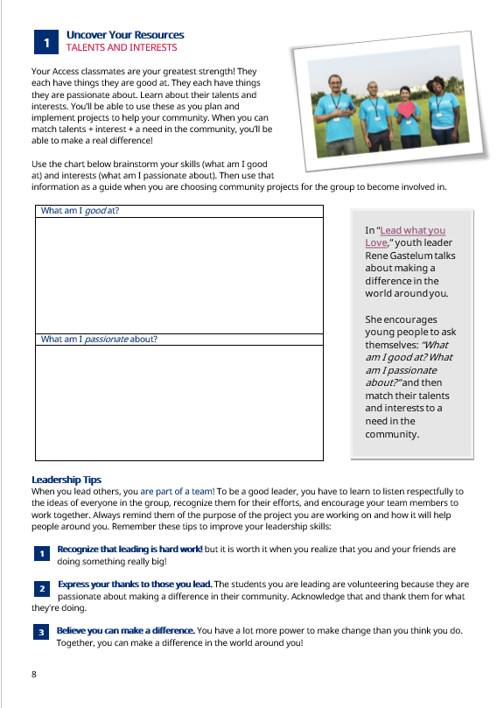    - Consider re-watching the interview with youth leader Renee Gastelum and/or reading its accompanying worksheet from the “Lead What You Love” lesson in the Youth Leadership unit. It describes how young people can link what they are passionate about and what they are good at to a need they see in their community. Ask students to talk about how Renee used this pattern to create a project addressing an issue in her community and how she used her unique talents and skills.  - Uncovering students’ interests and skills can help them determine the ways they can best serve the community. These are highly valued resources! Ask students to complete the brainstorming activity Uncovering Your Resources and then share their ideas with a small group. As they share their personal lists of interests and skills with each other, guide them to notice areas of interest that overlap with their classmates.  - Ask students to write an Inquiry Notebook entry using the Beginning of the Impact Project prompts. | You can reference materials and activities from the Youth Leadership unit at any point during this Impact Project.  Project Materials – Item A. Uncovering Your Resources  During this project stage, provide opportunities for students to drive the learning experience. Encourage them to think about their own skills and interests, focusing on their many strengths.
2 to 3 hours | 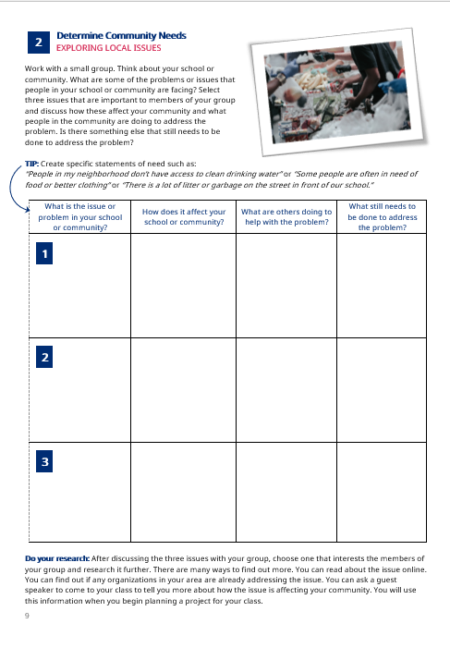  2. Investigate community issues  Now it is time for the students to do some real research into community problems or issues. You may want to start by asking students to think of needs they see in their school community as well as their neighborhood or town. Help students create specific statements of need such as: “People in my neighborhood don’t have access to clean drinking water.” or “Some people are often in need of food or better clothing.” or “There is a lot of litter or garbage on the street in front of our school.”  - Ask students to work in small groups and use the handout Determining Community Needs to guide their discussion of three issues that are important to them in their community. They should identify a need, discuss how they think it affects people in their community, determine whether anyone in the community is already addressing that need, and decide what more could be done.  - Bring the students back together as a class and ask each group to report on their discussion. Which community issues are most important to the class as a whole? Which one best matches the interests and talents of the group? Ask students to vote on a community issue for their group project.  - Ask students to research the issue further, looking for more information on how the issue affects community members and what has been done to address the problem. They might gather more information by talking to friends or family members, reading or watching local news stories, talking with community leaders, or reading about the problem online. This investigation phase helps open students’ eyes to some of the problems in the world around them and begin thinking of how these problems could be addressed. Students can report what they learn to the class or in small groups.  - Identify community leaders or organizations who care about the community need that your students have selected. Invite one or more of them to share their knowledge about the community issue with the class (in-person or virtually), as well as their insights about leadership and working as a team to accomplish something important. Ask them to comment on the importance of young people making a difference in their community. Discuss how the experience of planning and participating in a project can help them develop important leadership skills and prepare them to become positive contributing members of their community. If visitors are not able to participate in-person or virtually, you could ask them to record a short message or participate in a written Q&A with the students.  - Work with students to determine a project that they can plan and implement as a class to address the community issue they are interested in. Help them focus the project to allow them to make a positive impact on the community, while remaining doable given the time and resources required to complete the project.  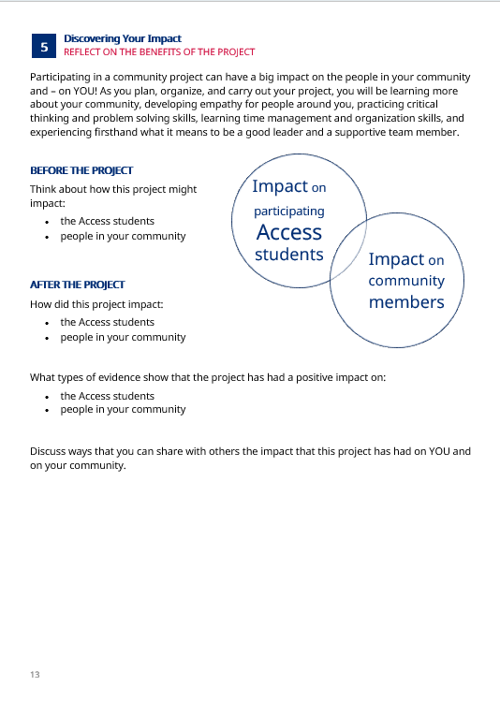  - One way to motivate students is by asking them to think about the impact they might make with their project. Of course, the project they design will help their community, so ask them to discuss the ways they think they might be helping people around them by successfully completing their project. The project will also help them develop personally. As they plan, organize, and carry out their project, they will be learning more about their community, developing empathy for people around them, practicing critical thinking and problem-solving skills, learning time management and organization skills, and experiencing firsthand what it means to be a good leader and a supportive team member. Give students time to discuss these ideas in pairs or small groups using the Discovering Your Impact handout. At the end of the project, you can use the same handout to lead a reflection discussion about the impact of the project on both the community and the students. | Project Materials – Item B. Determining Community Needs  Use your professional judgment to guide students in selecting an issue that is of high interest to students, important in the community, and could be addressed by a student-led project.  There are many ways to improve the community. Consider discussing different types of project options with students.  This project stage allows students to engage with real-world issues with relevance to their daily lives.  As you discuss potential projects with students, encourage them to think of ways to address the cause of the problem rather than just the effect. For example, instead of simply arranging a clean-up day to remove the garbage in a public park, encourage students to think about why the garbage is there in the first place. They might notice that there are no garbage cans in the area and then work to persuade city officials to add some, or they may want to raise awareness in the surrounding community of the importance of not littering.  Project Materials – Item C. Discovering Your Impact
2 to 3 hours | 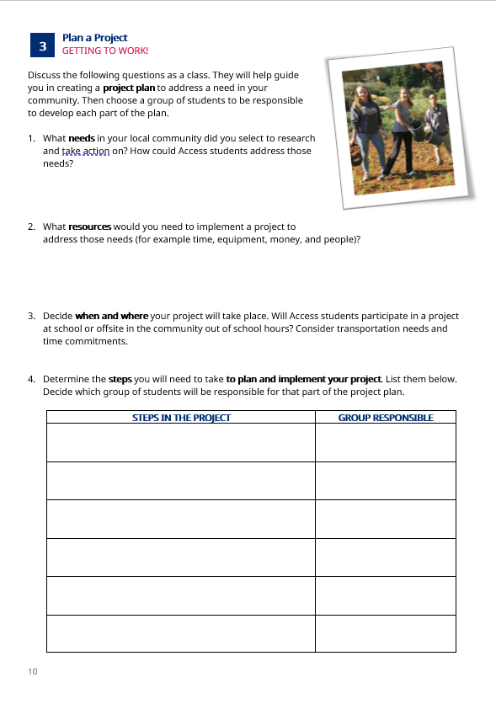  3. Create a project plan  Now the students are ready to begin planning their project to make a difference in the community. Here are some things to consider as you support students in selecting and planning their project:  - A project planning guide is often helpful to organize a project and set up reflection opportunities for students. Students can use the Planning a Project handout to lead them through the process. You may need to coach them on how to lead a discussion (including sentence frames or language scaffolding) or make suggestions on dividing the workload once the group determines a specific project to work on.  - Choose a “Project Director” or two “Co-Directors”—students who can (with your support) lead the class project, facilitate class discussions, and check in with various groups on the progress they are making with their specific assignments. As you describe the responsibilities of the Project Directors to the class, ask students to reflect on what it means to be a good team member. Their ideas might include offering suggestions for the success of the project, supporting the Project Director, fulfilling their specific responsibilities on time, encouraging other team members, etc.  - Divide the class into small groups, giving each group responsibility for a specific part of the project. For example, one group could be primarily responsible for invitations to guest speakers or people in the community who are needed to complete the project, another group could collect supplies, and a third group could document work on the project at various stages with photos or videos and create captions that help describe the work of the group. The responsibilities of each group can be recorded on the Planning a Project handout.  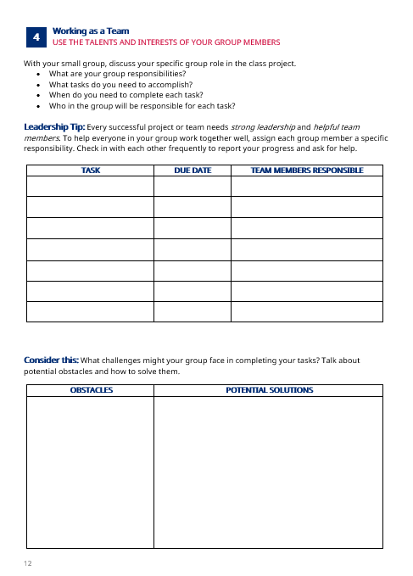  - Every successful project or team needs strong leadership and helpful team members. Ask each small group to use the Working as a Team handout as a guide to discuss their group responsibilities, define the tasks that they need to plan or accomplish, and divide the workload among the group members. Set a working timeline for when each task should be completed and ask group members to check in with each other frequently to help everyone stay on track. Group members should help each other as needed so that the work of the group can be accomplished successfully. The Working as a Team handout also includes prompts to help students think through obstacles they may face as they plan and implement their project and discuss ways to address those problems.  - Identify ways to involve the community in the project. For example, the guest speaker(s) that you invited to class may have suggestions for resources or groups in the community who could assist with the project or provide supplies. A group of students could develop ideas for raising awareness about the community issue. The students could publicize their project and invite community members to join in. After the project, the students could use social media to let the community know what they accomplished.  - Ask students to write an Inquiry Notebook entry using the Mid-Project prompts. | Project Materials – Item D. Planning a Project  As students begin planning their project, be sure to offer the support they need to be successful while still giving them opportunities to do the actual leading of other students whenever possible. Your role is to mentor the students as they lead, not to lead the project yourself.  Find time in this project stage to include meaningful English language development activities.  Teach students to listen carefully to ideas from their team members, follow up on assignments given, and thank everyone for their efforts at planning and implementing their projects.  Project Materials – Item E. Working as a Team  Teach or review the concepts and vocabulary in the “Teamwork” lesson. Remind students of the importance of clear communication and respecting others’ ideas.  Encourage small groups to establish good communication and support each other in completing their responsibilities successfully. This builds essential collaboration skills.
3 to 4 hours | 4. Put the plan into action  Once a project plan has been created by the students (and approved by you!), students can begin implementing their plan. Keep these ideas in mind:  - There are many opportunities before, during, and after the actual project that allow students to reinforce and practice English skills such as: learning vocabulary related to the issue students are researching, students reporting what they learned about the issue, creating a written plan of action to implement their project, and talking or writing about the impact of the project on the community and the students themselves. Adjust the amount of language instruction and practice according to the needs of your students.  - Be sure to talk with the students about documenting their work by taking photos and/or writing descriptions of the project. They can use this later as they reflect on the impact they made on the community and on themselves and as they celebrate and share the results of their project! | Allow the students to lead the action phase of the project, rather than YOU leading it! Mentor them by helping them think through each step of the project, but don’t do the work for them. Remember that this project is about developing students’ leadership skills while they are helping the community.
2 to 3 hours | 5. Reflect on impact  Ask students to reflect throughout the project on questions such as:  - The project: Did you successfully complete your project? What went well? What could be improved for next time? What are you most proud of? How well did your classmates work together during the project?  - The community: What short- and long-term impacts will your project have on your community? Who needs to know about the positive difference that you made?  - You: What skills are you learning or demonstrating through planning and doing this service project? How have you changed because of your participation in the project? How were your public speaking, leadership, or English skills strengthened by participating?  Ideas for reflecting on the project include:  - Start by using the Discovering Your Impact handout to help students discuss the impact their project has had on their community and on them personally. As they planned, organized, and carried out their project, they likely found that they learned more about their community, developed empathy for people around them, practiced critical thinking and problem-solving skills, improved their time management and organizational skills, and experienced firsthand what it means to be a good leader and a supportive team member. Give students a few minutes to discuss these ideas in pairs or small groups.  - Ask students to create a short video (20-30 seconds) with advice to a future class planning a community project, sharing their insights into the process and what they learned about leading and working as a team. Consider sharing student responses with other classes in your region as well as on the Community of Practice with teachers around the world.  - Divide the students into groups and have each group create a “Top Ten Tips” chart, summarizing the most important lessons they learned from this experience.  - Ask students to write an Inquiry Notebook entry using the End of Project prompts.  Ideas for demonstrating the impact of the community project include:  - Invite students or others in the community to visit the completed service project (a community garden, a cleared trail, a beautified park, etc.) to celebrate what you have accomplished.  - Post photos of the project on social media with a description of the impact on the community.  - Share the results of the project on the Community of Practice (CoP). Don’t forget the photos of the completed projects! | Reflecting on the project’s process and impact is an important part of this learning experience. Help students recognize the skills they have developed that will serve them well in the future.  Project Materials – Item C. Discovering Your Impact

Impact Statement Prompt
After completing the Youth Leadership lessons and Students in Action Impact Project, ask students to review all their Inquiry Notebook entries and reflect on their experience. Direct students to write an Impact Statement to respond to the following prompt:
- Think about the project you completed to make a positive change in your community. Review your inquiry notebook entries. How has this project impacted you? Your community?

Variations and Extensions
VARIATIONS

General differentiation and scaffolding
- For Lower Levels: For students at a lower proficiency level, provide sentence starters for the Determining Community Needs chart, which could help direct the students’ conversation. Also, be mindful of group selection, perhaps assigning some higher proficiency students to each group to assist the others in completing their tasks.
- For Higher Levels: During the investigation and planning steps of the project, higher proficiency students could be assigned to lead the discussion in their groups or present their group’s ideas to the class before a class decision is made about which project to develop. During the planning and implementing phases of the project, these students could take the role of documenting the project impact in descriptive ways to complement other types of documentation like videos or photos.
- In a multilevel class, consider organizing student groups in a way that ensures mixed abilities are represented within each group so students can support each other.

EXTENSIONS
- Additional Collaboration: Consider inviting the other class(es) to celebrate the successful conclusion of your project. Another option might be a virtual meeting with another class. Select some students to report on the project’s impact on the community and on the participating students by sharing their “Top Ten Takeaways” – five ways the project benefited the community and five things participating students learned about leadership and teamwork.

External links are provided for informational purposes only; there is no implied U.S. Department of State endorsement of the views, opinions, media content,
or privacy policies contained therein.

Unless otherwise noted, CC0 images in this resource are “no-attribution required” items sourced under the Pixabay simplified license or the Unsplash license. If sharing, adapting, or remixing portions of this Impact Project, please respect excepted permission and licensing statements noted in the credit statements for individual images, graphics, or other content. To learn about Creative Commons licenses, their uses, and their restrictions, visit the Creative Commons license explanation site.

Uncovering Your Resources
A
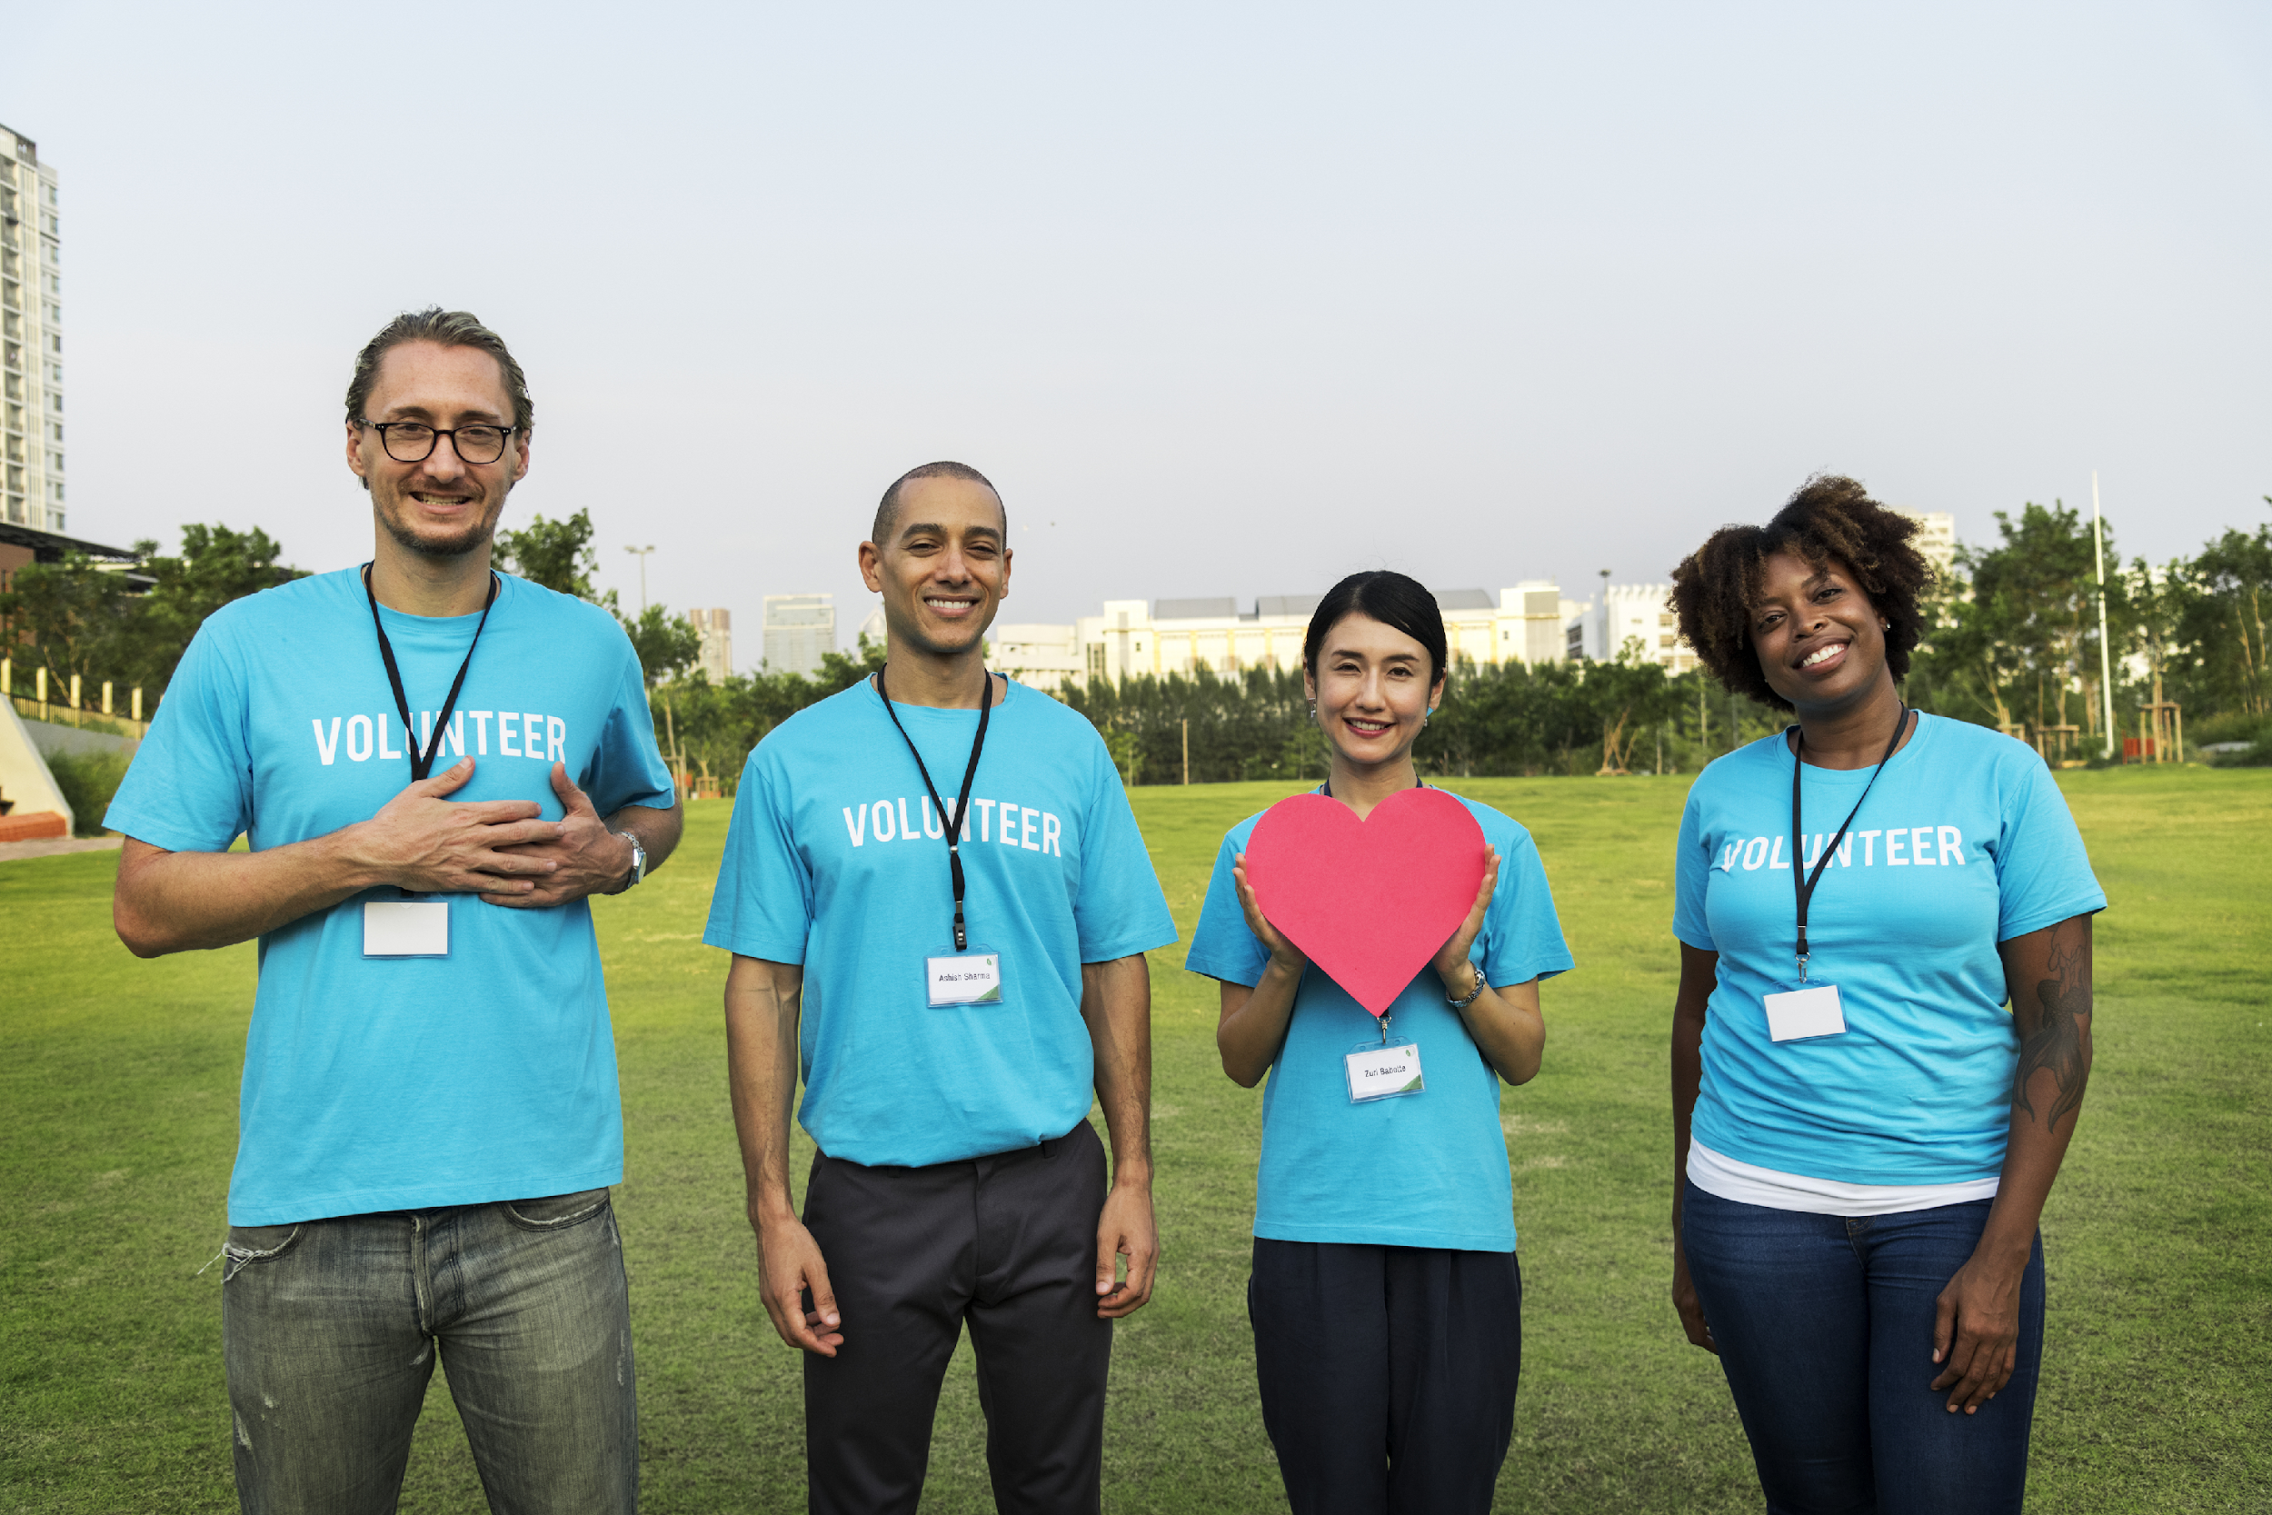
DETERMINE TALENTS AND INTERESTS

Your classmates are your greatest strength! They each have things they are good at. They each have things they are passionate about. Learn about their talents and interests. You can use these as you plan and do projects to help your community. When you can match talents + interests + a need in the community, you’ll be able to make a real difference!
(CC0)
Use the chart below to brainstorm your own skills (what am I good at) and interests (what am I passionate about).
In “Lead What You Love,” youth leader Renee Gastelum talks about making a difference in the world around you.

She encourages young people to ask themselves: “What am I good at? What am I passionate about?” and then match their talents and interests to a need in the community.

What am I good at?
What am I passionate about?

Leadership Tips:
When you lead others, you are part of a team! To be a good leader, you have to listen respectfully to the ideas of everyone in the group, recognize them for their efforts, and encourage your team members to work together. Always remind them of the purpose of your project and how it will help people around you. Remember these tips to improve your leadership skills:

Recognize that leading is hard work! But it is worth it when you realize that you and your friends are doing something really big!
1

Express your thanks to those you lead. The students you are leading are volunteering because they are passionate about making a difference in their community. Thank them for their efforts.
2

Believe you can make a difference. Together, you can make a difference in the world around you!
3

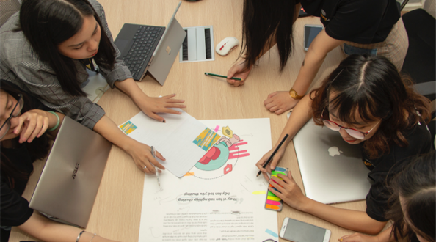
Determining Community Needs
B

EXPLORE LOCAL ISSUES

Work with a small group. Think about your school or community. What are some issues that people in your school or community face? Select three issues that are important to members of your group and discuss how these affect your community. What are people in the community doing to address the problem? Is there something else that still needs to be done?
(CC0)
TIP: Create specific statements of need such as:
“People in my neighborhood don’t have access to clean drinking water.” or “Some people are often in need of food or better clothing.” or “There is a lot of litter or garbage on the street in front of our school.”

What is the issue or challenge in your school  or community? | How does it affect your  school or community? | What are others doing to  help? | What still needs to  be done to address  the issue?
1
2
3

Do your research: After discussing the three issues with your group, choose one that interests the members of your group and research it further. There are many ways to find out more. You can read about the issue online. You can find out if any organizations in your area work on the issue. You will use this information when you begin planning a project for your class.

Discovering Your Impact
C
REFLECT ON THE BENEFITS OF THE PROJECT

Participating in a community project can have a big impact on the people in your community – and on YOU! As you plan, organize, and complete your project, you will learn more about your community, practice critical thinking and problem-solving skills, learn time management and organization skills, and experience what it means to be a good leader and a supportive team member.

BEFORE THE PROJECT

Impact on participating students

Impact on community members
Think about how this project might impact:
- the participating students
- people in your community

AFTER THE PROJECT
How did this project impact:
- the participating students
- people in your community

What evidence shows that the project has had a positive impact on:
- the participating students
- people in your community

Discuss ways that you can share the impact that this project has had on YOU and on your community.


Planning a Project
D
GET TO WORK!

Discuss the following questions as a class. They will help you to create a project plan to address a need in your community. Then choose a group of students to be responsible for each part of the plan.

- What needs in your local community did you select to research and take action on? How could students address those needs?
(CC0)
(CC0)

(CC0)

- What resources would you need to implement a project to address those needs (for example, time, equipment, money, and people in the community to support the project)?

- Decide when and where your project will take place. Will students participate in a project at school or offsite in the community out of school hours? Consider safety, transportation needs, and time commitments.

- Determine the steps you will need to take to plan and implement your project. List them below. Decide which group of students will be responsible for that part of the project plan.

STEPS IN THE PROJECT | GROUP RESPONSIBLE

Working as a Team
E
SHARE THE TALENTS AND INTERESTS OF YOUR GROUP MEMBERS

With your small group, discuss your specific group role in the class project.
- What are your group’s responsibilities?
- What tasks do you need to accomplish?
- When do you need to complete each task?
- Who in the group will be responsible for each task?

Leadership Tip: Every successful project or team needs strong leadership and helpful team members. To help everyone in your group work together well, assign each group member a specific responsibility. Check in with each other frequently to report your progress and ask for help.

TASK | DUE DATE | TEAM MEMBERS RESPONSIBLE

Consider this: What challenges might your group face in completing your tasks? Talk about potential obstacles and how to solve them.
OBSTACLES | POTENTIAL SOLUTIONS

Impact Statement
F


Name: ______________________________________________________

Prompt: Think about the project you completed to make a positive change in your community. Review your inquiry notebook entries. How has this project impacted you? Your community?

___________________________________________________________________________________________________________________________________________________________________________________________________________________________________________________________________________________________________________________________________________________________________________________________________________________________________________________________________________________________________________________________________________________________________________________________________________________________________________________________________________________________________________________________________________________________________________________________________________________________________________________________________________________________________________________________________________________________________________________________________________________________________________________________________________________________________________________________________________________________________________________________________________________________________________________________________________________________________________________________________________________________________________________________________________________________________________________________________________________________________________________________________________________________________________________________________________________________________________________________________________________________________________________________________________________________________________________________________________________________________________________________________________________________________________________________________________________________________________________________________________________________________

