We the Students: Crafting Our Class Constitution
Freedom 250
Overview
This lesson introduces Constitution Day and helps students explore how a class constitution can be used as a tool for creating a collaborative environment. Students are encouraged to take an active role in creating a classroom that represents what they want their learning environment to look like (actions), sound like (words), and feel like (values).

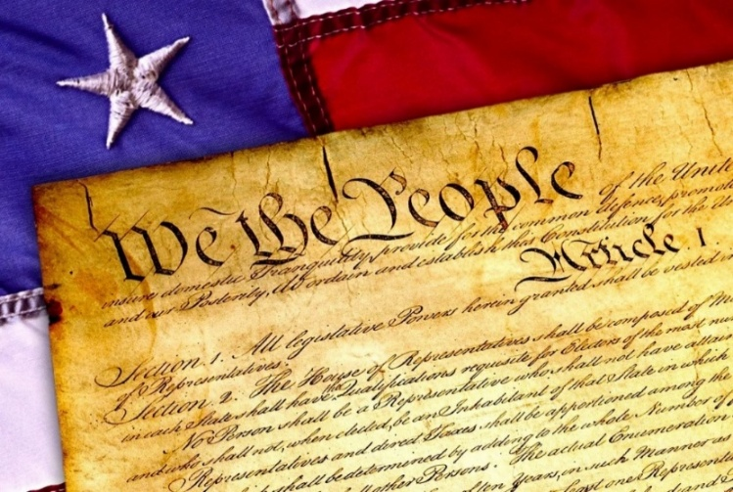
Goals
As a result of this lesson, students will be able to:
- learn more about why the U.S. Constitution was created
- identify student attitudes and behaviors they want in a classroom community
- collaborate with classmates
- think critically about what they want their classroom to look like
As a result of this lesson, teachers will be able to:
- use student-centered teaching practices
- collaborate with students to build classroom community
- prompt students to collaborate, communicate, and think critically
CC0


Lesson Materials
IN YOUR CLASSROOM
- Paper and pencils or pens
- Chalkboard and chalk or whiteboard and markers
- Large pieces of paper/poster paper
- Projector for displaying student reading or copies
- Clock or timing device
PROVIDED WITH THIS LESSON PLAN
- Vocabulary, Reading, and Comprehension Questions
- Teacher Reading (optional)
- Key Vocabulary Glossary
CC0
- Class Constitution Examples
- Additional Constitution Day Resources

Preparation
- This lesson utilizes the U.S. Constitution to help students understand reasons for creating a class constitution. Additional information on Constitution Day can be found in the teacher reading, Lesson Materials – Item B. Review the teacher reading before beginning the lesson. It may be helpful to find examples from your country to use as examples during the lesson. Then think about common rights and responsibilities in your classroom context. Some examples are given in Step 4; replace them with examples from your context as needed.
- Review the Procedures and Lesson Materials sections, then determine the formats you will use for the Lesson Materials.
  - Many items can be photocopied, enlarged, or projected onto the board or a wall. More suggestions for formatting these materials are in the Procedures steps and notes.
  - After selecting the formats for the activities, prepare the required number of materials to suit your class size, considering how many groups or individuals will participate in each lesson stage.
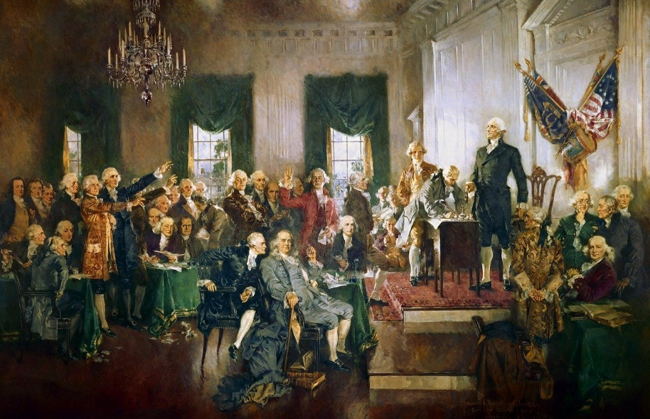
- Read the Skills and Language Topics and Key Vocabulary lists below. Review the glossary (Lesson Materials - Item C) to see how key vocabulary terms are used in this lesson. Will you need to activate prior knowledge, pre-teach, or otherwise provide scaffolding (support) for your students beyond the suggestions in the Procedures section? See the Variations and Extensions section for ideas.

Skills and Language Topics
- Expressing and supporting ideas using examples
- Reading for main ideas and details
- Teamwork: communicating and collaborating to complete a series of tasks

Key Vocabulary
- amend
- celebrate
- freedom
- majority
- responsibilities
- right
- rule
“Signing of the Constitution” by Howard Chandler Christy
Image: Architect of the Capitol (Public Domain)

- vote

Procedures
TIME | STEPS | NOTES
5 min | 1. Warm up: Vocabulary matching  - Provide each student with a copy of the vocabulary, reading, and comprehension questions handout or display it so everyone can see. Read the vocabulary list to the students.  - Direct students to match the words in the left column with the definitions in the right column.  - Set the timer for 5 minutes.  - When time is up, review the answers as a class. | Individual  See Lesson Materials – Item A for the vocabulary warm up, reading, and comprehension questions.
10 min | 2. Explore: Reading and comprehension questions  - Ask students to look at Parts 2 and 3 of the handout, Reading and Comprehension Questions.  - Tell students they will have 10 minutes to complete the reading and answer the questions.  - When time is up, discuss responses as a class. Clarify answers as needed.  - Direct students to look at Part 4, Class Discussion. Ask for volunteers to share their ideas with the class. | Individual  Lesson Materials – Item A  Whole-class discussion  For a large group discussion, solicit responses from student volunteers. Alternatively, conduct Part 4 as a think-pair-share discussion.
20 min | 3. Brainstorming an ideal classroom environment  - Draw the following chart on the board.  - Ask students to think about their ideal classroom environment. What helps them learn best? Tell students they will create an individual graphic organizer to answer the question, “What do you want our classroom to be?” Emphasize things students do (actions and behaviors), see/hear (words), and feel (values and attitudes) in the classroom. Ask students to draw the chart in their notebook.  - Together, put one example in each column on the board. Then direct students to spend 5-7 minutes completing the chart on their own paper.  - Ask students to share their completed chart with a partner. Invite them to look for similarities and differences in their responses.  - While the students are working with their partner, place 3 large pieces of paper around the room. Label one sheet of paper for each category: do, see/hear, and feel.  - When ready, ask students to move around the room and write their top 1-2 ideas for each category. As students add to the page, they should compare their ideas to their classmates’ ideas. Continue until students have added notes for each category, then ask them to return to their seats. Conduct a whole-class share out by reviewing each category’s paper.  - After reviewing all the ideas, ask students to identify the top 3-5 most important ideas overall. The teacher should identify the number of topics based on the number of groups they will use in Step 4. These topics will become the rights students explore in Step 4. | Think-Pair-Share  Students can create their own graphic organizer in their notebook or on a piece of paper. Model the example on the board. You will use your model for the class discussion.  Gallery Walk activity  With upper-level students, encourage each student to add new ideas to the page. With lower-level students, ask students to put a tally mark next to ideas that they share with their classmates.
  What do you want our classroom to be?
  Do | See/Hear | Feel
15 min | 4. Apply: Building a class constitution  - Group the brainstormed ideas into key categories or rights. For example, Help each other learn and Keep the classroom clean are rights. Write the rights on the board.  Examples  - Explain that all class members should contribute to creating an ideal classroom environment. To demonstrate the task, ask questions to help students understand their responsibilities as class members in upholding these rights. For example, “How will you help classmates learn? What will you do to create that environment for others?” Add an example of a responsibility to your model on the board. Explain that each group will create a list of responsibilities for one right. Encourage groups to think about what they want the class to do, see, hear, and feel.  Examples  - Place the class into small groups of 3 to 4 students. Designate roles such as recorder (writes answers), timekeeper (monitors time), reporter (shares with large group), and moderator (makes sure all group members contribute). Assign each group one of the rights on the board. Each group will create a list of responsibilities for their assigned right so all class members can experience it.  - Tell the students they will work in groups for 10 minutes to determine their role in creating an ideal classroom environment and what this looks, sounds, and feels like: these are their responsibilities to uphold the rights of all class members.  - When time is up, ask each group’s reporter to share ideas with the whole class. If each group is working with poster paper, display the rights and responsibilities as the class constitution in the classroom as a reminder all year. | The teacher may wish to prepare categories in advance based on what they anticipate students will identify as categories. However, teachers should also be prepared to identify new categories based on student-generated responses.  Teacher-led concept exploration  Small group work  It may be difficult for students to distinguish between rights and responsibilities. Review and clarify these terms during this part of the activity as needed.  See Extension Activity 1 for an additional step to extend the class discussion if desired.
  Right: Help each other learn
  Right: Keep the classroom clean
  Right: Help each other learn
  Responsibility: Listen when classmates speak
  Right: Keep the classroom clean
  Responsibility: Pick up my trash
5 min | 5. Wrap Up: Vote  - End the lesson by inviting students to vote to uphold the class rights and responsibilities. | Whole group reflection  The vote can take place by raising hands or using Extension Activity 2.

Variations and Extensions
VARIATIONS

1. General differentiation and scaffolding
- Based on students’ levels and prior knowledge, teachers can choose to cover the lesson content over one or more class sessions. This approach will allow teachers to provide additional instruction, review, and support as appropriate.
- To make the lesson more accessible for lower proficiency students, teachers may encourage the discussion of rights and responsibilities in the students’ primary language.
- To challenge upper-level students, teachers can use the Teacher Reading (Lesson Materials – Item B) to increase the complexity of the reading text. Teachers can also add additional vocabulary and comprehension questions.

EXTENSIONS

1. Incorporating a majority vote
- The creation of your class constitution can be extended by putting each of the responsibilities up for discussion. Give students an opportunity to ask questions and add or remove items from each list of responsibilities. Then, ask students to cast a vote for approval with a majority vote needed to pass. Voting could be done by ballot in a subsequent class period. Create opportunities to amend the constitution at mid-term or the start of a new term.

2. Create a class constitution display
- Ask students to design a creative poster that includes the class rights and responsibilities. Display your constitution in the classroom. See the example images in Lesson Materials – Item D for some ideas!
- Develop individual contracts for each student to sign.

3. Revisit for assessment
- After establishing the class constitution, ask students to self-assess their role in the class by answering some reflection questions:
  - What are you doing well in class? List 2-3 strengths and give an example.
  - What would you like to improve? Tell why you want to improve in this area.
- Compare the students’ self-assessments with your own observations. If there are common needs, use this as an opportunity to amend the constitution or further discuss class rights and responsibilities.

External links are provided for informational purposes only; there is no implied U.S. Department of State endorsement of the views, opinions, media content,
or privacy policies contained therein.

Images in this resource are in the public domain or “no-attribution required” unless otherwise noted. If sharing, adapting, or remixing portions of this lesson plan, please respect excepted permission and licensing statements noted in the credit statements for individual images, graphics, or other content. To learn about Creative Commons licenses, their uses, and their restrictions, visit the Creative Commons license explanation site.

We the Students: Crafting Our Class Constitution – Lesson Materials
Freedom 250

A. Vocabulary, Reading, and Comprehension Questions
Part 1: Vocabulary
Draw a line to connect each word with the correct definition.

- amend A. Duties or tasks that one is required or expected to do
- majority B. To make a change to a document, law, or agreement
- vote C. A guideline or principle that governs behavior
- rule D. The power or right to act, speak, or think without restriction
- celebrate E. More than half of a group
- responsibilities F. To make a choice in an election or decision
- freedom G. Something a person is allowed to have or do by law or by rules
- right H. To mark a special occasion with activities or festivities

Part 2: Constitution Day Reading
In 1787, the Founding Fathers of the United States gathered to create a nation ruled by laws. This set of rules is called the Constitution. These rules prevent one person from gaining too much power and protect individual freedoms. The Constitution describes our rights and responsibilities as citizens. The Founding Fathers also created a process to change, or amend, the Constitution. Changes, called amendments, can add rights, explain government rules, and solve problems. To become part of the Constitution, changes require a majority vote. On September 17, we celebrate Constitution Day. It honors the day the US government started under the Constitution.

Part 3: Comprehension Questions
- What is the Constitution?
- Why did the Founding Fathers create the Constitution?
- How can the Constitution be changed?

Part 4: Class Discussion
Countries use constitutions to describe the rights and responsibilities of citizens. How could we use a constitution to describe the rights and responsibilities in our class?

B. Teacher Reading

In 1787, the Founding Fathers of the United States gathered together to define who and what they wanted the new country of the United States to be. Their aim was to establish the safety, strength, and prosperity of the independent nation.

The Constitution represents the principles of the country and serves as a guide for running our country. It is a framework for government defining the executive, legislative, and judicial branches. The branches provide checks and balances that make sure power is divided equally across each group. The Constitution also protects individual freedoms and ensures the rule of law. The rights and responsibilities outlined in the Constitution reflect our core values.

To address new issues, the Founding Fathers developed a process for amending the Constitution. Amendments allow for the expansion of rights and freedoms, clarify government processes, correct injustices, and enhance democracy.

It is difficult to amend the Constitution, and the process begins with a two-thirds majority vote by Congress. Then the vote goes to the states. Three fourths of the states must vote in favor of the amendment before it can become part of the Constitution. Nearly 12,000 amendments have been proposed, but only 27 have been ratified.

Constitution Day is celebrated each year on September 17. It honors the day the US government began under the Constitution.

Photo: A. Christensen (CC0)

C. Key Vocabulary Glossary
Definitions below illustrate how key vocabulary terms are used in the context of this lesson.

to amend v. to make changes to a document, law, or agreement
to celebrate v. to mark a special occasion with activities or festivities
freedom n. the power or right to act, speak, or think without restriction
majority n. more than half of a group
responsibility n. a required or expected duty or task
right n. something a person is allowed to have or do by law or by rules
rule n. a guideline or principle that governs behavior
to vote v. to make a choice in an election or decision

D. Class Constitution Examples
Brainstorm list created by students in the Philippines
Photo: K. Wonder (CC0)

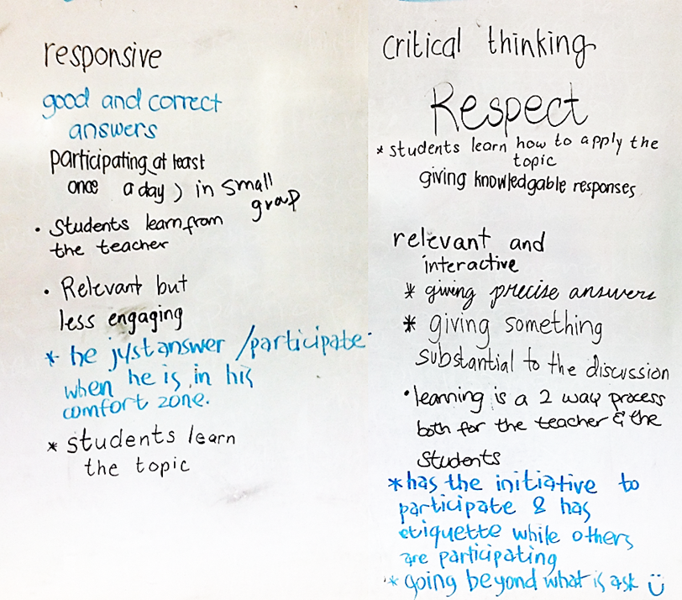

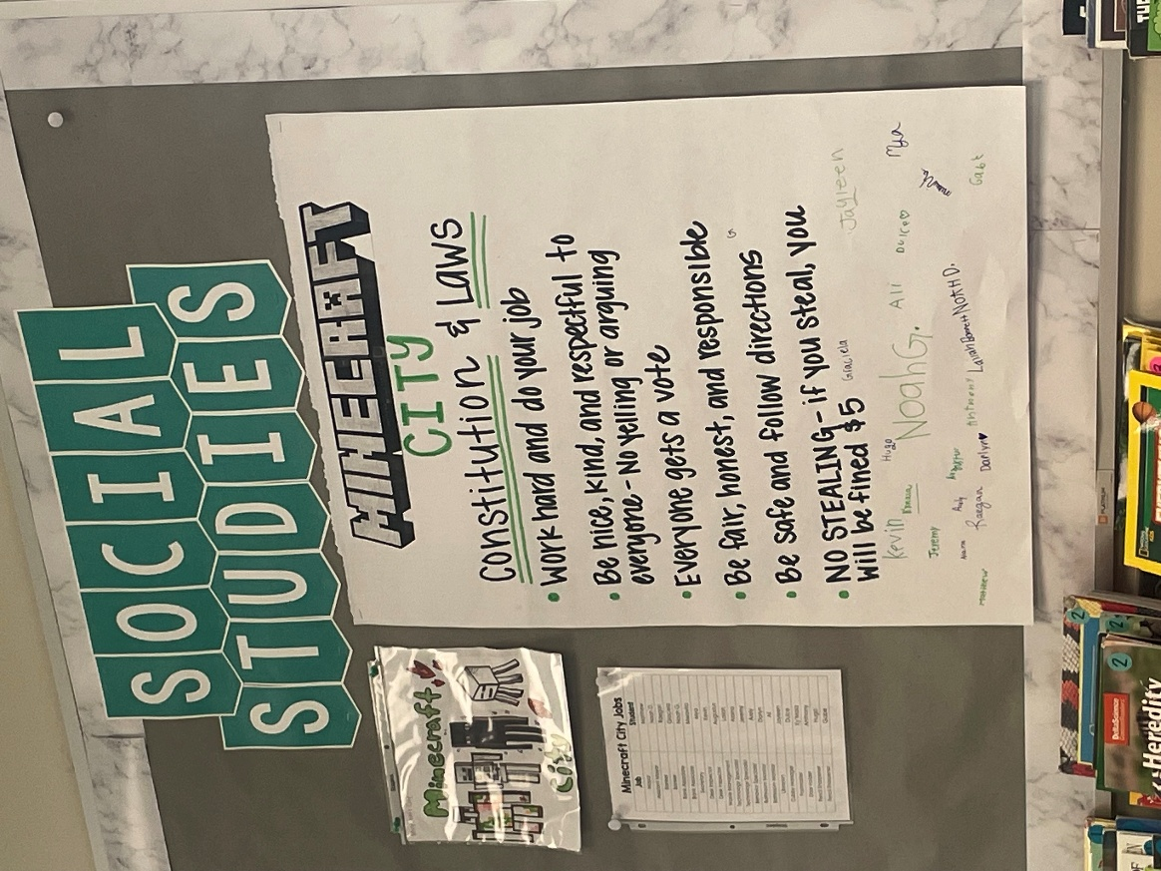
Classroom constitution and laws signed by all members of the class
Photo: N. Mahmassani (CC0)

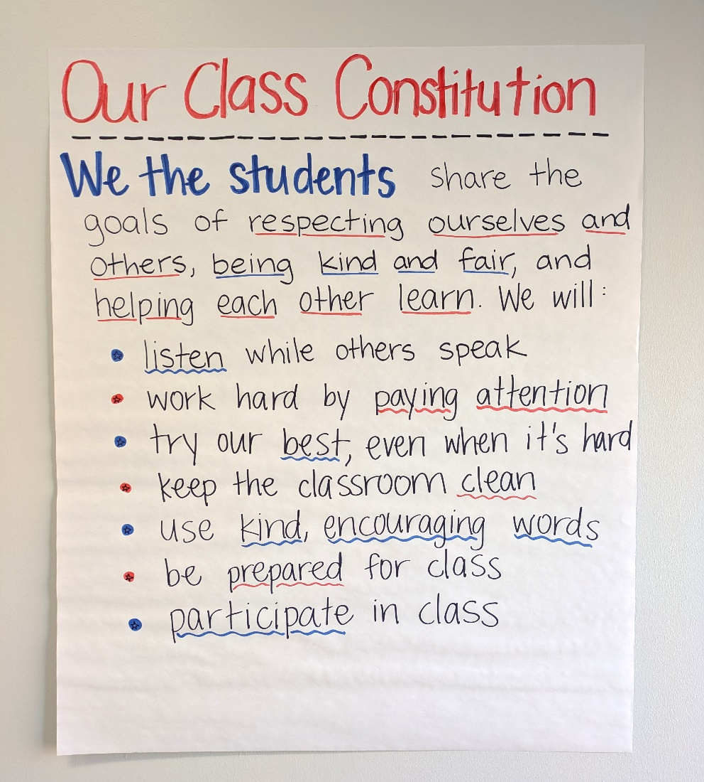
Classroom constitution including rights and responsibilities
Photo: M. Espino (CC0)

E. Additional Constitution Day Resources
Discover more about the topic featured in this lesson! The links below can help teachers build background knowledge before teaching the lesson and can inspire additional adaptation or extension ideas to use with students.
- The National Archives provides educators with a trove of information about America’s founding documents and additional resources for celebrating Constitution Day.
- The Library of Congress also offers classroom materials and teacher resources for learning about the U.S. Constitution.

