From History to Action: American Principles at Work
Freedom 250
(CC0)
Overview

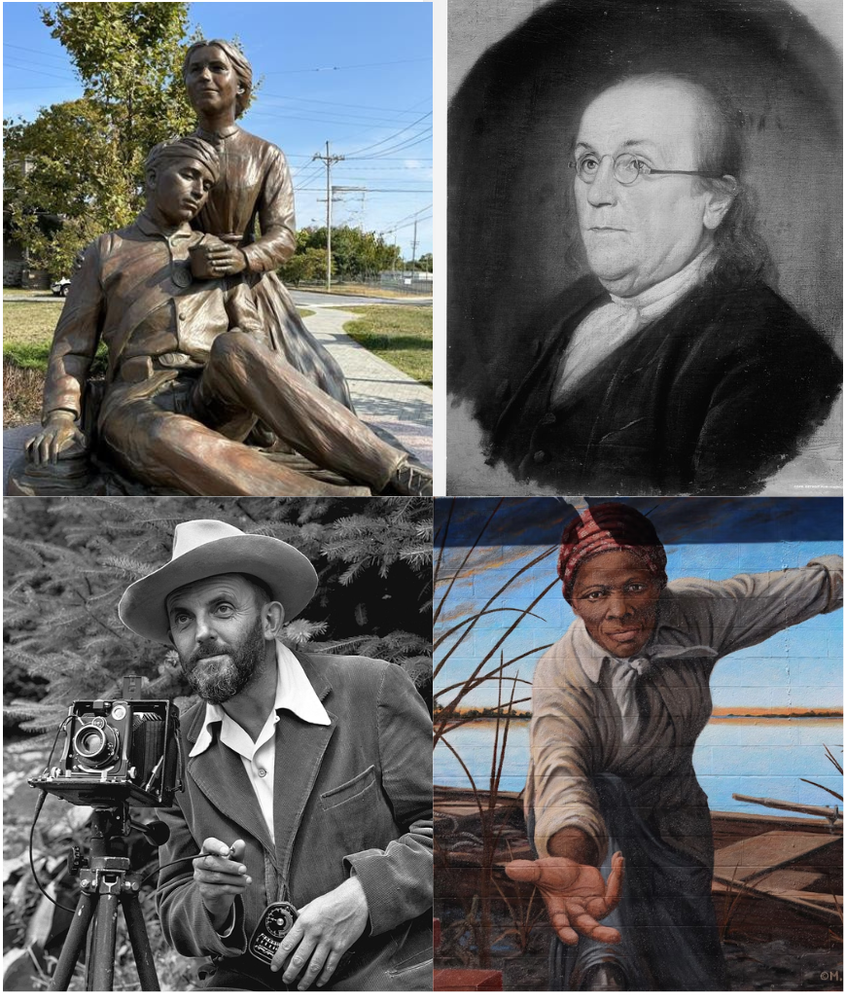
This lesson introduces some principles of admired Americans from history and helps students make connections to principles of people that they admire. Students are encouraged to brainstorm actions that demonstrate principles that are important to them and will use an acting game to showcase their ideas.

Goals
As a result of this lesson, students will be able to:
- identify principles held by admired Americans from history and make connections to their own principles
- use creativity to imagine ways of demonstrating important principles through actions
Library of Congress, Prints & Photographs Division, Detroit Publishing Company Collection
Photo: E. Mahmassani (CC0)
As a result of this lesson, teachers will be able to:

use student-centered teaching practices

help students think critically about how to demonstrate principles

prompt students to express their ideas creatively

Lesson Materials
IN YOUR CLASSROOM
- Paper and pencils or pens
- Chalkboard and chalk or whiteboard and markers
- Projector or TV for displaying images (optional)
(CC0)
- Speakers for playing audio (optional)
- Clock or timing device
Admired Americans from history (clockwise from top left): Clara Barton, Benjamin Franklin, Harriet Tubman, and Ansel Adams
PROVIDED WITH THIS LESSON PLAN
- Photos of Admired Americans and Objects
- Admired Americans Audio Text Transcripts
- Key Vocabulary Glossary

Preparation
- This lesson explores the stories of several admired Americans from history and the principles they demonstrated through their actions. The individuals and principles are Benjamin Franklin (innovative), Harriet Tubman (freedom-seeking), Ansel Adams (adventurous), and Clara Barton (dedicated to service). It may be helpful to prepare examples of individuals from your country’s history who demonstrated these principles. These examples are used to help students explore principles that are important to them and how they can act on those principles.
- Review the Procedures and Lesson Materials sections, then determine the formats you will use for the Lesson Materials.
  - Many items can be photocopied, enlarged, or projected onto the board or a wall. More suggestions for formatting and sharing these materials are in the Procedures steps and notes.
  - After selecting the formats for the activities, prepare the required number of materials to suit your class size, considering how many groups or individuals will participate in each lesson stage.
  - For Step 2, prepare to play an audio file in class. Download the audio files from the lesson plan resource page. If you are unable to play an audio file, read the transcripts (Lesson Materials – Item B).
- Read the Skills and Language Topics and Key Vocabulary lists below. Review the glossary (Lesson Materials - Item C) to see how Key Vocabulary terms are used in this lesson. Will you need to activate prior knowledge, pre-teach, or otherwise provide scaffolding (support) for your students beyond the suggestions in the Procedures section? See the Variations and Extensions section for ideas.

(CC0)

Skills and Language Topics
- Listening for main ideas and supporting details
- Expressing and supporting ideas using examples
- Creativity: focusing on innovation and imagination

Key Vocabulary
- admire
- adventurous
- dedicated to service
- demonstrate
- freedom-seeking
- innovative
- principle

Procedures
TIME | STEPS | NOTES
5 min | 1. Warm Up: Picture Matching  - Display the photos of objects in Lesson Materials - Item A. Ask students to identify the objects and their purposes. Direct students to think about the actions that a person can do with these objects.  - Next, display the photos of people and their names from Lesson Materials - Item A, explaining to students each person is an admired person from United States history. Ask students to work with a partner to match each object to the person who used it, explaining their reasoning. Review the correct answers with the class. | Whole group  See Lesson Materials - Item A for both photo sets.  Pair work
15 min | 2. Principles of Admired Americans  - Introduce the word principle as an idea that is important to a person or group of people. Introduce the principles of being innovative, freedom-seeking, adventurous, and dedicated to service as examples of principles that many people in the United States admire. Write them on the board. Review the definitions of these terms with students, referencing individuals who represent these principles from your country’s history, if desired. Ask students to work with a partner to predict which person from Step 1 represents which principle, reminding them of the objects they associated with each person and the actions they said a person can do with each object.  - Tell students that they are now going to listen to learn more about the four people from the photos and understand which principles they represent. Assign each of the four corners or four areas of the classroom to a principle, labeling the corners or areas if possible.  - Play the audio, pausing after each section. If you do not have an audio player, read the texts yourself or consider asking a confident student to read each text aloud. After each audio section, ask students to walk to the corner or area assigned to the principle they think the person represents. Ask students to discuss with their corner group what details in the audio text helped them come to their answer. Ask groups to share their reasons, eliciting specific actions from the audio text to support their answers. Write the person’s name and the actions students mention on the board with the correct principle. Repeat these steps with each audio text. | Emphasize to students that these four principles are just a few examples of many principles Americans admire. They are not necessarily the most important for all Americans.  Four Corners movement activity  For classes who are unable to move freely around the room, assign a simple action to each principle (like acting out scanning the horizon for adventurous). Students can act out their answer from their seats.  See Lesson Materials – Item B for transcripts of the audio text.
10 min | 3. Principles We Admire  - Explain that people demonstrate their principles in their daily actions. Give a recent class example, such as, “Our class demonstrated being innovative when we found a new way to share materials last week.”  - Ask students to think individually for several minutes about the questions: “Who are people in your life you admire? How would you describe them? What principles are important to them?” Students may want to think about family members, elders, friends, community members, or cultural figures.  - Ask students to share their responses with a partner. Tell them to look for similarities and differences in their responses.  - Collect responses from the class, writing all the principles on the board. If a principle is repeated, indicate this by drawing a star or check next to it. Choose 3 to 5 of the most popular principles to leave on the board and erase the others. | Think – Pair – Share
15 min | 4. Principles Into Action    - Draw the following example mind map on the board.  - Write a principle at the center of the mind map. Think aloud for the class as you think of actions that demonstrate the principle and write each one on the mind map.  - Give students 5 to 7 minutes to work in small groups to create their own mind map for a principle from Step 3. You can assign or let students choose a principle, but make sure each principle is covered.  - Elicit answers from each group and record them on the board. | Teacher-led demonstration  Using a think aloud (narrating your thoughts out loud as you complete a task) gives students a model for critical thinking.  Small group brainstorming  The lists of actions written on the board during this step will provide a word bank for language support during Step 5.
10 min | 5. Acting Out Our Principles  - Explain to students that they will play a game of charades, where they choose a principle from the board to demonstrate by acting it out silently for a partner to guess. Model an example, such as acting out helping an elderly person carry a heavy bag to represent dedicated to service.  - Put on music and tell students to walk around the room, making eye contact with each other. When the music stops, their partner is the last one they made eye contact with. Instruct students that partners should take turns acting out and guessing the principles they have chosen. Repeat this a few times, as time allows.  - If time allows, ask for volunteers to share their acting for the class to guess. | Rotating partners  If students are focused on guessing the action, remind them to also name the principle that action demonstrates.  Consider playing a song from Sing Out Loud! while students are walking around the room.
5 min | 6. Wrap-up  - Display or write the following questions on the board: “What is a principle that is important to you? What actions can you do to demonstrate this principle?” Ask students to discuss their answer with their last charades partner. If there is time, ask for volunteers to share their answer with the class. | Partner reflection  For lower-level students, provide sentence frames: “A principle that is important to me is…” and “I can demonstrate it by…”  See Variations and Extensions for an extended, written option.

Variations and Extensions
VARIATIONS

1. General differentiation and scaffolding
- Based on students’ levels and prior knowledge, teachers can choose to cover the lesson content over two or more class sessions. This approach will allow teachers to provide additional instruction, review, and support as appropriate.
- To make the listening activity in Step 2 more accessible for lower-level students, teachers can review the bold words in each text with students before listening. During listening, students can listen for each of these words, indicating that they’ve heard them with a motion like raising their hand. Focusing on these key words should help students understand the texts and which principle each individual represents.
- For larger groups, classrooms in which moving around the room is not possible, or lower-level students, the charades game can be played as reverse charades. Teachers can name one student a “guesser.” This person goes to the front of the classroom. The teacher then shows the other students an action to perform from their seats. The “guesser” guesses the action, with prompting and support from the teacher if needed.

EXTENSIONS

1. Principle play
- Ask students to work in small groups to plan a scene that demonstrates one of the principles the class identified in the lesson. The amount of speech in the scenes can vary based upon students’ levels, from silent scenes, to scenes with narration only, to scenes with complex dialogue. The scenes can be combined into a play, which students could perform for an audience.

2. Action plans
- Ask students to select several principles that are important to them and develop lists of actions they plan to take to demonstrate these principles. Their lists can focus on short-term actions or long-term plans. If desired, checking in on students’ progress on these action plans can become a class routine.

3. Research a principled person from your country
- Ask students to think about a person from your country’s history that they admire. Ask students to identify what principles this person demonstrated in their life. Students can research this person’s life to identify specific actions this person took to demonstrate this principle and prepare a timeline, written report, or presentation.

External links are provided for informational purposes only; there is no implied U.S. Department of State endorsement of the views, opinions, media content,
or privacy policies contained therein.

Images in this resource are in the public domain or “no-attribution required” unless otherwise noted. If sharing, adapting, or remixing portions of this lesson plan, please respect excepted permission and licensing statements noted in the credit statements for individual images, graphics, or other content. To learn about Creative Commons licenses, their uses, and their restrictions, visit the Creative Commons license explanation site.

From History to Action: American Principles at Work – Lesson Materials
Freedom 250

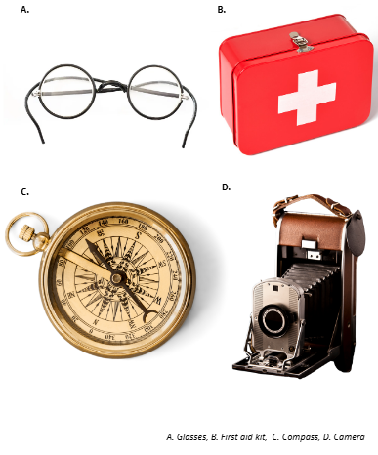
A. Photos of Admired Americans and Objects
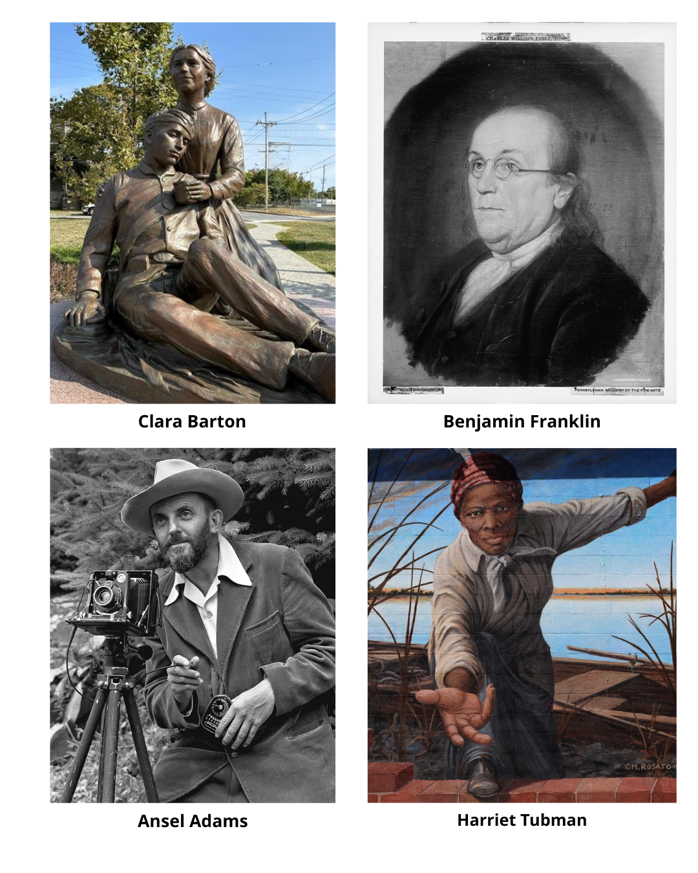
(CC0)
(CC0)
(CC0)
Photo: E. Mahmassani (CC0)
Library of Congress, Prints & Photographs Division, Detroit Publishing Company Collection

B. Admired Americans Audio Text Transcripts

A. Benjamin Franklin
Benjamin Franklin was an inventor and leader. He created useful things like special glasses to help people see better and the lightning rod to keep people and buildings safe during storms. He also helped write the American Declaration of Independence and taught people more about science.

B. Harriet Tubman
Harriet Tubman was a brave woman who escaped slavery. She used secret trails and houses to lead many other people to freedom. Her bravery and strength make her a strong example of someone who always fought for freedom.

C. Ansel Adams
Ansel Adams was a famous American photographer. He loved nature and adventure. He took beautiful photos of mountains and forests. He often explored wild areas to get the perfect picture. His work helped people learn more about nature.

D. Clara Barton
Clara Barton was a brave nurse who helped many people during a war in the United States. She delivered supplies and cared for injured soldiers. Later, she started the American Red Cross, which gives food, water, and medicine during disasters. Her life showed strong care and service.

C. Key Vocabulary Glossary
Definitions below illustrate how Key Vocabulary terms are used in the context of this lesson.

admire v. to like or think positively about something or someone
adventurous adj. enjoying trying new things or going to new places
dedicated to service adj. having a strong commitment to help other people
demonstrate v. to act to show a principle
freedom-seeking adj. wanting to make personal choices without control from others
innovative adj. doing things in a new, creative, and different way
principle n. an idea that is important to a person or group of people

