Public Art as a Tool for Expression
ART AS EXPRESSION
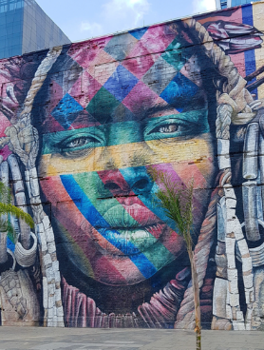
Overview
Brazil (CC0)
This lesson introduces several forms of public art and helps students explore how public art can be used as a tool for expressing ideas and feelings. Students are encouraged to share their thoughts and ideas and think about how lesson topics are relevant to their lives.

Goals
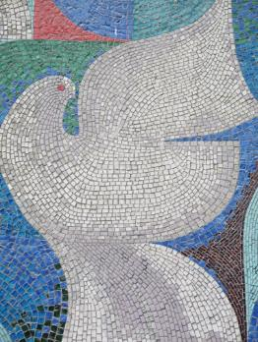
As a result of this lesson, students will be able to:
Germany (CC0)
- explore and define the concept of public art
- identify various art forms
- explain how public art can be used as a tool for expression
As a result of this lesson, teachers will be able to:
- assess students’ background knowledge on lesson topics

- guide students through student-centered learning group activities

give students choice about how they can show understanding of lesson topics
United States (CC0)

Lesson Materials
IN YOUR CLASSROOM
- Paper and pencils or pens
- Chalkboard and chalk or whiteboard and markers
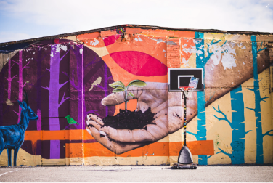
- Projector or TV for displaying images (optional)
Estonia (CC0)
- Clock or timing device
PROVIDED WITH THIS LESSON PLAN
- What is public art? “Home” mural (photo)
- Matching: art form images and definitions (4 pairs)
- Jigsaw reading texts (4)
- Jigsaw reading graphic organizer
- Exit ticket
- Key vocabulary glossary

TESOL Focus: Student-Centered Learning

Preparation
- This lesson utilizes student-centered learning techniques to explore public art as a tool for expression. Brainstorm or research a few examples of public art in your community, country, or region to use as examples during the lesson. It may be helpful to find images to share with the class. Consider how these works of art are used to express ideas or feelings.
- Review the Procedures and Lesson Materials sections, then determine the formats you will use for the Lesson Materials.
  - Many items can be photocopied, enlarged, or projected onto the board or a wall. More suggestions for formatting and sharing these materials are in the Procedures steps and notes.
  - After selecting the formats for the activities, prepare the required number of materials to suit your class size, considering how many groups or individuals will participate in each lesson stage.
  - If using printed versions of Items B and E, cut up the materials and group them as needed.
- Read the Skills and Language Topics and Key Vocabulary lists below. Review the glossary (Lesson Materials - Item F) to see how Key Vocabulary terms are used in this lesson. Will you need to activate prior knowledge, pre-teach, or otherwise provide scaffolding (support) for your students beyond the suggestions in the Procedures section? See the Variations and Extensions section for ideas.

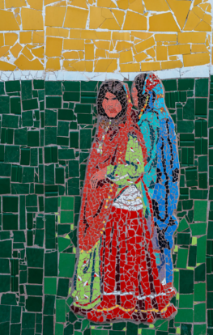
Skills and Language Topics
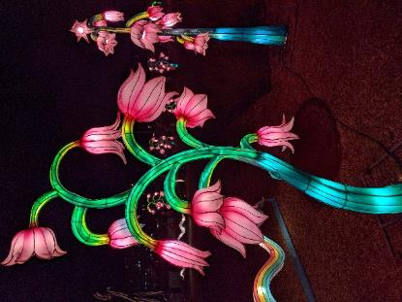
- Visual and textual analysis
Iran (CC0)
- Expressing and supporting opinions using examples
- Reading for main ideas and details
- Summarizing
- Teamwork: communicating and collaborating to complete a series of tasks

Key Vocabulary
USA. Photo: M. Espino (CC0)
Iran (CC0)
- expression  - mosaic  - mural  - light installation  - public art | - to represent  - sculptor  - statue  - three-dimensional (3-D)  - tile

Inquiry Notebook Prompts
PROMPTS | NOTES
- Think about public art in your community. What is the message of the artwork?  - Look at the mural called “Home.” How does the mural make you feel? Select an emoji or series of emojis to describe your feelings. | Adopt or modify these prompts for Inquiry Notebook engagement with concepts featured in this lesson. Before teaching this lesson, direct students to select one prompt to respond to in their Inquiry Notebook. For the first prompt, teachers might supply 1 to 3 examples of local art when possible.

Procedures
TIME | STEPS | NOTES
5 min | 1. Warm-up: What is public art?  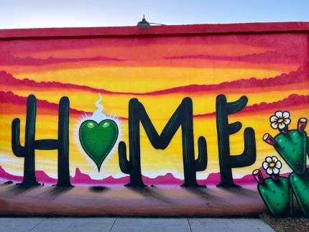  - Display the “Home” mural. Explain that it was painted on a wall in Phoenix, Arizona, USA.  - Ask, "What do you know or imagine about this place?” You can add to students’ discussion by sharing background information and asking guiding questions, such as:  - This mural includes the saguaro cactus, a unique desert plant that grows about 40 feet (12 meters) high.  - Arizona’s desert can grow dangerously hot.  - The saguaro cactus thrives in this harsh landscape.  - For thousands of years, saguaro fruits helped Indigenous people survive in this dry region.  Photo: A. Christensen (CC0)  - In the mural, saguaros are used to spell the word home.  - Why do you think the artist chose to spell the word using cactus?  - What feelings do you have when you see this painting?  - Ask students to imagine painting a mural, or wall painting, depicting their hometown. What plants, animals, buildings, or landscapes would be in their mural? Where might students want to paint such a mural?  - On the board, write the term public art; explain that the mural is an example of public art.  - To establish meaning for this term, ask volunteers to share their definitions or to give examples of local, regional, or international public artworks.  - Explain that public art is created for everyone, sometimes as part of a group process: people in a community may be able to share opinions about the art’s location, form, or content. Public art is free for all people to view.  - Explain that public art can have different purposes, including beautification, celebrating local or national cultures, and expressing an idea or feeling, which will be discussed later in the lesson.  - Ask students if they can think of any examples of public art in their own communities. | Teacher-led class discussion  A larger version of the mural photo is available in Lesson Materials – Item A. You can project the image or post several printed copies around the classroom for students to view.  Asking students questions helps teachers better understand students’ background knowledge on these topics. Teachers can also identify areas to clarify or strengthen understanding before moving on to the next activity.  Activating students’ background knowledge helps them make connections between past experiences, prior knowledge, and new information. This helps prepare students to be successful in future activities.
15 min | 2. Identifying public art forms  - Create groups of 3 or 4 students.  - Provide each group with one set of art images and definitions. Ask students to review the four images of public art from the United States and then match each public art form example to its definition. Groups should discuss their answers as they work to ensure the members agree.  - Tell groups who complete the matching activity quickly to create a list of other examples of each public art form; these examples can be from their own communities and beyond.  - Review answers to the matching activity as a whole class, clarifying the meaning and pronunciation of vocabulary words as needed. Ask a few volunteers to share additional examples of each art form as you review the answers. | Small group work  Lesson Materials - Item B  If it isn’t possible to print image and definition sets, project or post them on the wall or board along with the definitions listed in random order. Using their own paper, ask students to write the word that matches the number shown with each the image.  Examples: 1. mural 2. statue  This activity prioritizes student interaction. It also considers students’ needs by offering add-on activities for students who complete work more quickly. This allows them to remain engaged and on task.
30 min | 3. Define art as a tool for expression  - Write art as expression on the board. Explain that art can be used to express the feelings or ideas of individuals or communities. Share a few examples of feelings or ideas that your students might be familiar with, such as joy, hope, strength, etc.  - Ask students to give examples of other feelings or ideas. Write them on the board.  - Explain that public art can be a form of expression to help show pride in a local community. Ask students to share ideas about what makes their community special or unique and what they are proud of in their local communities. Some examples might include:  - Important or historic events  - Well-known community members or stories  - Beautiful buildings or neighborhoods  - Special festivals  - Positive qualities or values of local cultures  - Typical animals, plants, or foods  - Ask student groups to review the public art images used in the matching activity (Step 2) and to discuss what each example from the United States could be expressing. As they discuss, encourage students to share the reasons for their answers. Tell students that these public art examples can be interpreted in many ways … there is not only one right answer. Here are a few possible answers:  - “Children of the World Dream of Peace” à promotes peace; celebrates local people and cultures  - “Sacred Rain Arrow” à shows strength; tells an important story  - “16th Avenue Tiled Steps” à beautifies the neighborhood; increases neighborhood pride  - “Electronic Superhighway: Continental U.S., Alaska, Hawaii” à celebrates local people and cultures; promotes imagination and creativity  - Lead a whole-class share-out of the ideas the groups generated. Be sure to ask students to explain the reasons behind their answers.  - Ask a few volunteers to share local or national examples of public art as tool for expression that celebrate a community. | Teacher-led class discussion  Same groups as used in Step 2  This activity allows students to work together as a group on a task before sharing ideas with the rest of the class. Working together on group tasks creates more opportunities for students to express themselves and develop teamwork and leadership skills.
15 min | 4. Reading jigsaw - Expression through Public Art: Part 1, Preparing  - Divide the class as evenly as possible into four groups. Assign each group one of the four public art jigsaw reading texts and distribute copies of the reading texts accordingly. Give each student a graphic organizer or have students copy the graphic organizer onto their own paper from a model supplied on the board.  - Tell students to read their group’s text, working together to identify the most important and most interesting details about the art and artist. Explain that teams should write notes about their discussion in the column on the graphic organizer that relates to their assigned public artwork. | Groups created by dividing the class into quarters  Lesson Materials - Item C and Item D  Ideally, all students will have a copy of the reading text; however, students can work with one copy per 2-3 students. Monitor students, offering support as needed.
20 min | 5. Reading jigsaw - Expression through Public Art: Part 2, Sharing  - Create mixed groups of four that include an “expert” representing each artwork. If you have an odd number in one or more of the original groups, direct those groups to send one pair of experts to a mixed group.  - Tell the mixed groups to work together to complete the rest of the graphic organizer: each “expert” presents the information on their original group’s public art example; the other students in the mixed group should listen, ask questions, and take notes in their graphic organizers.  - If time permits, conduct a whole class debrief, answering any questions about the texts or asking a few students to share interesting insights from their group discussions. | New mixed groups of 4 (each reading text is represented in the mixed groups)  Jigsaw activities divide work and allow each student to share expertise and contribute to class knowledge. Teaching others is a great way to show mastery of a topic.
5 min | 6. Reflection: Exit ticket  - Ask a volunteer to pass out the exit tickets or have students copy the ticket information onto their own paper from a model supplied on the board.  - Ask students to choose one of the two exit ticket questions to answer before leaving the class. Encourage students to think quietly for a moment about what they learned during the lesson, reviewing their jigsaw graphic organizers as needed. Remind students to list at least one reason or piece of evidence to support their opinion when they write their answer.  - Collect the exit tickets before students depart. | Lesson Materials - Item E  Individual  Offering students choices helps to increase student motivation and satisfaction. Exit tickets like this also help teachers assess student understanding of and interest in lesson topics.

Variations and Extensions
VARIATIONS

1. General differentiation and scaffolding
- Based on students’ levels and prior knowledge, teachers can choose to cover the lesson content over two or more class sessions. This approach will allow teachers to provide additional instruction, review, and support as appropriate.
- To make the lesson more accessible for lower-level students, teachers can use labeled visuals to reinforce vocabulary terms, show realia (real items) related to the art forms (pieces of tile, a small mosaic, etc.), reduce the complexity of the reading texts, or reduce the quantity and complexity of information in the jigsaw graphic organizer. Teachers can create mixed-level groups for the reading jigsaw activity, so students can assist each other. Or teachers can assign less-proficient students to groups reading the first two texts, which contain simpler language.

2. Artwork prediction
- Ask student groups to predict the title and/or meaning of each public art example in the matching exercise (Step 2). Direct students to compare their predictions to the information collected and shared during the reading jigsaw activity (Steps 4 and 5).

3. Listening jigsaw
- Replace Step 4 written texts with recorded audio texts made by the teacher. Give groups an image of their assigned artwork. Set up “listening stations” in different parts of the room and let groups listen to their text at a low volume as many times as needed while making notes; (2) let groups listen in different nearby rooms/areas; or (3) make the audio available on student mobile devices for headphone listening. Update the graphic organizer instructions.
EXTENSIONS

1. Design your own public art to express a feeling or idea
- Ask individuals, pairs, or groups to draw, describe in writing, or otherwise represent a piece of public art they want to see in their community. For example, students may enjoy making meaningful mosaics with glue and colorful bits of paper or recyclable/scrap materials. Students should also briefly describe (orally or in writing) what their piece is expressing. It may be helpful to conduct a class brainstorming session about topics before students begin designing their art pieces—and don’t forget to give students a chance to see each other’s completed work!

2. Local art research
- Ask individuals or groups to research a local public artwork and its artist (if known). Students can read about the art and artist and share their findings. If possible, and with teacher support, the class can interview the artist via phone or using contact information on the artist’s website or social media.
  - What is the artist’s background? Why did the artist create the work?
  - What feelings or ideas does the artwork communicate? How have audiences responded to the work?
  - How was the work created? What were the challenges for creating and installing the public art?

External links are provided for informational purposes only; there is no implied U.S. Department of State endorsement of the views, opinions, media content,
or privacy policies contained therein.

Unless otherwise noted, CC0 images in this resource are “no-attribution required” items sourced under the Pixabay simplified license or the Unsplash license. If sharing, adapting, or remixing portions of this lesson plan, please respect excepted permission and licensing statements noted in the credit statements for individual images, graphics, or other content. To learn about Creative Commons licenses, their uses, and their restrictions, visit the Creative Commons license explanation site.

Public Art as a Tool for Expression – Lesson Materials
ART AS EXPRESSION

A. What is Public Art? "Home” Mural
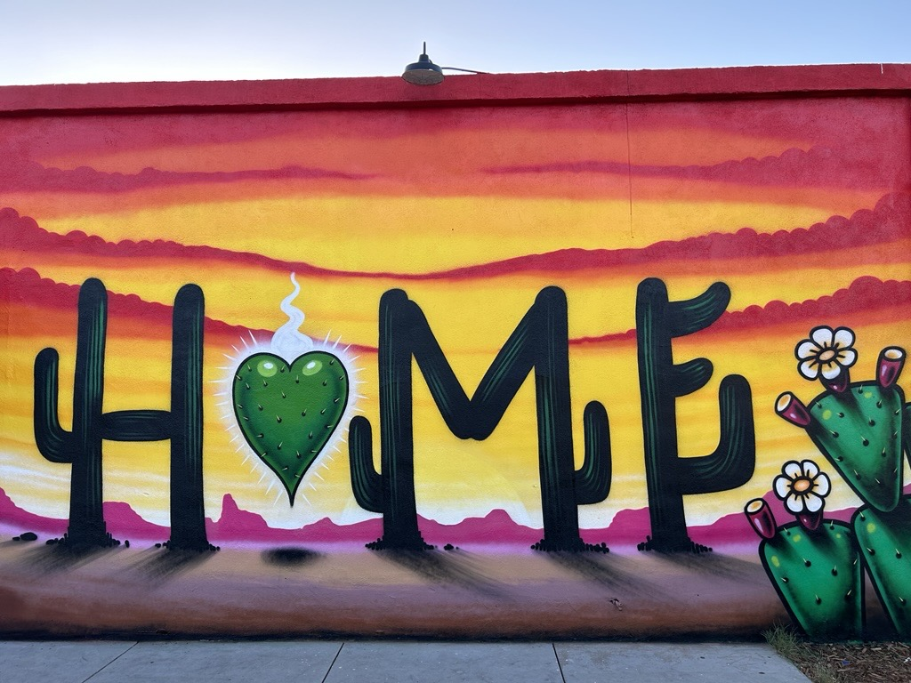
Photo: A. Christensen (CC0)

B. Matching: Public art form images and definitions
Copy and cut up the items below along the dotted lines. Provide a set of images and definitions to each group. Mix up the definitions before distributing. Ask students to match each art form example with its definition.
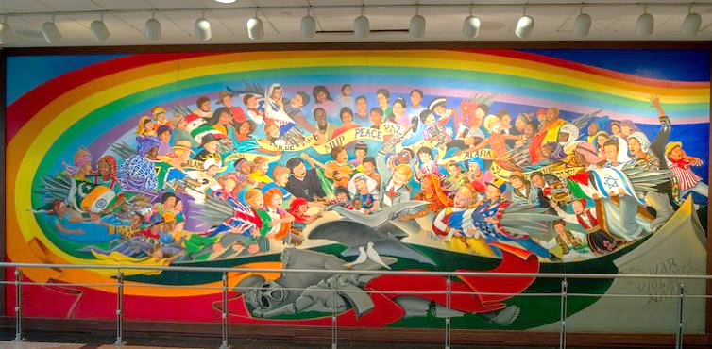  Photo: Jay Galvin (CC BY 2.0) | Mural  A painting (or artwork made of a different material) that is completed directly on a wall.
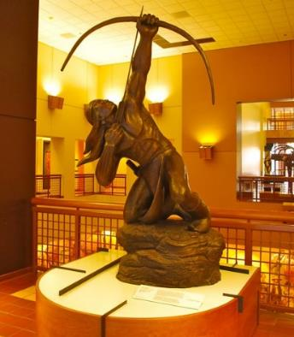  Photo: D. Merett (CC BY 2.0)  2. “Sacred Rain Arrow” by Allan Houser  1. “Children of the World Dream of Peace” by Leo Tanguma | Statue  Free-standing, three-dimensional artwork that looks like a person, animal, or other living thing. The artwork is realistic, and it is usually life-sized or larger.
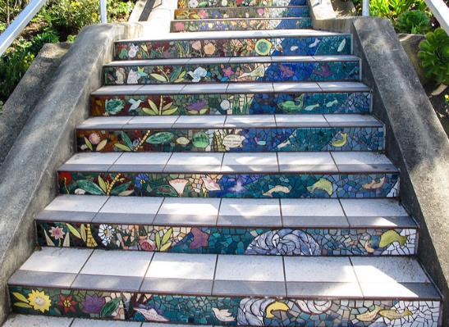  3. “16th Avenue Tiled Steps” designed by Aileen Barr & Colette Crutcher  Photo: edbierman (CC BY 2.0) | Mosaic  Artwork that uses small pieces of colored stone, tile, or other objects to create a picture.
  `  Photo: ideonexus (CC BY 2.0)  4. “Electronic Superhighway” by Nam June Paik | Light installation  Three-dimensional art that is usually designed for a specific place; it transforms the space with light and can also include music, video, or other media.

C. Jigsaw reading texts

“16th Avenue Tiled Steps”
designed by Aileen Barr and Colette Crutcher
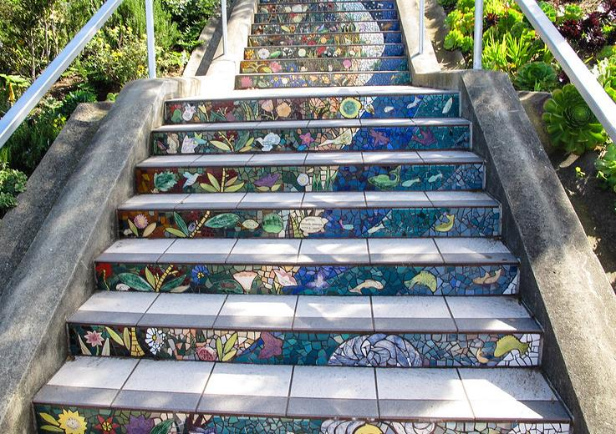

Photo: edbierman (CC BY 2.0)

The 16th Avenue Tiled Steps are a special example of public art. They were created by members of a community. Jessie Audette and Alice Yee Xavier had the idea for this project in their Golden Gate Heights neighborhood in San Francisco, California (USA). Neighborhoods in this area have steep hills and many stairs.

Artists Aileen Barr and Colette Crutcher created the mosaic design over 163 steps. Each step is covered with small pieces of tile that create pictures. At the bottom, the mosaic shows images of the sea. At the top, it shows the sky and the stars. Many neighbors learned how to make tiles and decorate them. Some people in the community gave money to pay for the project. Their names are painted on tiles that look like animals and shells. Can you see them?

It took two years to build the mosaic. The community celebrated when it was finished. People planted beautiful flower gardens next to the stairs. Volunteers take care of the gardens—both neighbors and visitors can help!

“Children of the World Dream of Peace” by Leo Tanguma

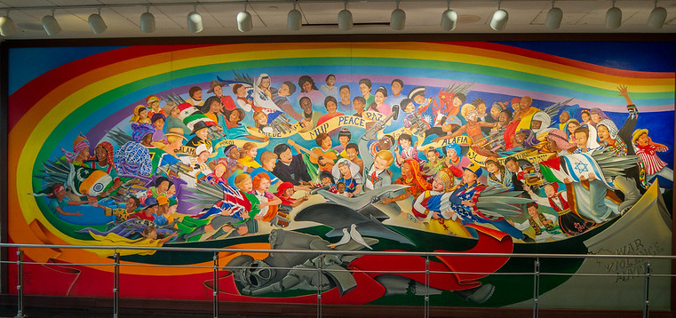

Photo: Jay Galvin (CC BY 2.0)

This is an example of public art in the Denver International Airport in Colorado (USA). Leopold “Leo” Tanguma, a Mexican American artist, painted the mural.

Leo is from Beeville, a small town in southern Texas (USA). At age 8, Tanguma began to create art with pencils on pieces of cardboard. A lot of Tanguma’s art celebrates Mexican American culture.

The airport mural shows children in traditional clothing from different countries. They are celebrating peace.

How many countries do you see represented in the mural? Is your country included? If not, how would you represent your country in the mural?

“Sacred Rain Arrow” by Allan Houser
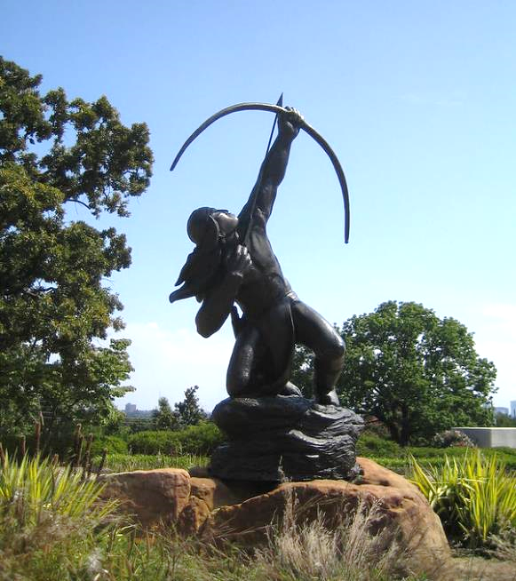

Photo: Granger Meador (CC BY-NC 2.0)

Allan Houser was born in 1914 in Oklahoma (USA). His parents were from the Chiricahua Apache Native American tribe. When Houser was young, he loved boxing, outside activities, and drawing. When he was 20 years old, he joined the painting school at the Santa Fe Indian School. His father didn’t want him to study art, but Houser wanted to paint what he learned from his parents about his tribe and their customs. Houser began working as a painter and made murals, and later he became a sculptor. Houser was the first Native American to receive the National Medal of Arts, the highest award an artist can receive from the United States government.

The “Sacred Rain Arrow” statue comes from a story a Chiricahua Apache elder told Houser when he was a boy. In the story, after a long time without rain, a young warrior traveled to see a medicine man and asked for his help. The medicine man blessed the bow and arrow. The warrior shot the special arrow up into the Spirit World, hoping it would bring rain for his people.

“Electronic Superhighway: Continental U.S., Alaska, Hawaii”
by Nam June Paik
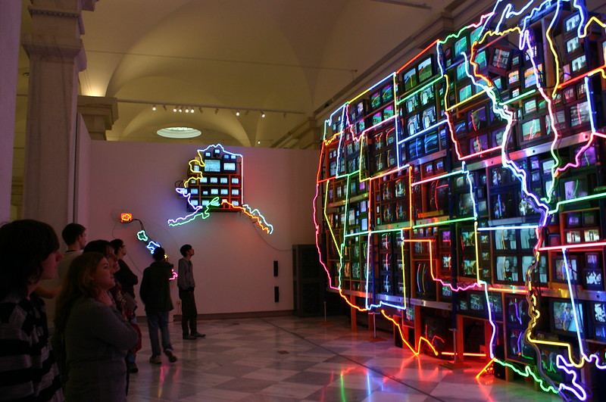
Photo: ideonexus (CC BY 2.0)

Korean American artist Nam June Paik created this light installation in Washington, D.C. (USA). Paik wanted to show what he thought communication might look like in the future. He made this installation in 1995, before the internet was popular. Paik called his work the “electronic superhighway” because he thought future communication would be very fast across long distances. He was right! Today, some people use Paik’s words, calling the internet the “electronic superhighway.”

Paik’s artwork also shows a variety of climates and events that differ across the United States. He used lights to make the state borders. Televisions inside each state show information about the location, its people, and important events there. For example, in Kentucky, there is a video about the Kentucky Derby, a famous horse race. Televisions for Alaska show snow and ice. The videos for Hawaii show beaches and the ocean.

Guess how many televisions Paik used for his artwork … 336!

D. Jigsaw reading graphic organizer
Instructions:
- Read about your group’s example of public art. If you need help with a word, ask your group members before you ask the teacher. As you read, write short notes about the artwork in the chart below.
- Discuss and compare your notes with your group members. Do they have different opinions about the artist and artwork? (It’s okay to have different opinions.)
- When the teacher tells you to, join your new group. You will be the “expert” on your first group’s artwork. Tell your new group what you learned about the artwork and artist you read about. Your group will listen, ask questions, and take notes.
- Listen to the members of your group. Ask questions and take notes to finish your chart. Write the information in your own words.

Title of public artwork | Artist name and something interesting about them | What was most interesting about the artwork? | What does this public art express?  How do you know?
“Children of the World Dream of Peace”
“Electronic Superhighway”
“Sacred Rain Arrow”
“16th Avenue Tiled Steps”

E. Exit tickets

Copy and cut up; distribute one ticket to each student.

Exit Ticket
Answer one of these questions before you leave today. Circle the question you answered.
- What was the most interesting public art you learned about today? Why?
- What is an example of local or national public art that you want to learn more about? Why?
________________________________________________________________________________________________________________________________________________________________________________________________________________________________________________________

Exit Ticket
Answer one of these questions before you leave today. Circle the question you answered.
- What was the most interesting public art you learned about today? Why?
- What is an example of local or national public art that you want to learn more about? Why?
________________________________________________________________________________________________________________________________________________________________________________________________________________________________________________________

Exit Ticket
Answer one of these questions before you leave today. Circle the question you answered.
- What was the most interesting public art you learned about today? Why?
- What is an example of local or national public art that you want to learn more about? Why?
________________________________________________________________________________________________________________________________________________________________________________________________________________________________________________________

Exit Ticket
Answer one of these questions before you leave today. Circle the question you answered.
- What was the most interesting public art you learned about today? Why?
- What is an example of local or national public art that you want to learn more about? Why?
________________________________________________________________________________________________________________________________________________________________________________________________________________________________________________________

F. Key Vocabulary glossary
Definitions below illustrate how Key Vocabulary terms are used in the context of this lesson.

expression n. showing how you feel or what you think
light installation n. a kind of art that uses light and technology to create shapes, patterns and images
mosaic n. an image created by putting together small pieces of hard materials such as stone or tile
mural n. a large design or image that is painted on a wall
public art n. art that is created for everyone and free for all people to view
to represent v. to show or describe something or someone; to be a sign or symbol of something
sculptor n. a person who creates sculptures
statue n. a kind of three-dimensional art made from a hard material (like stone or metal) that looks like a person or animal
three-dimensional adj. art with three dimensions (height, width, and length)
tile n. a thin piece of baked clay used to cover floors or walls

