What is a Community Artist?
ART AS EXPRESSION
Overview
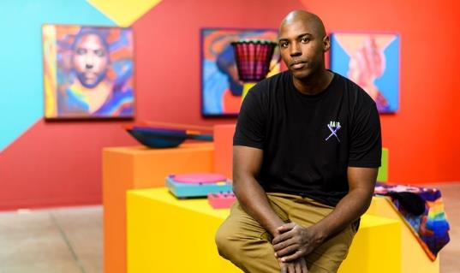
This lesson helps students explore the question, “What is a community artist?” and introduces them to two American community artists, Thomas “Detour” Evans and Crystal Worl.
Thomas “Detour” Evans

Goals
As a result of this lesson, students will be able to:
- explore how artists use their work as a tool to share their perspectives
- consider important people and topics in their communities and how art might be used to learn and share more about them
- plan and discuss a short, creative biographical profile
Photo: courtesy of T. Evans.
Used with permission.
As a result of this lesson, teachers will be able to:
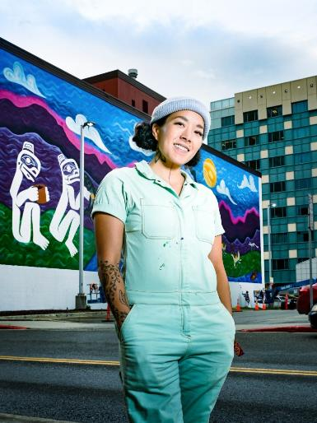
- assess student interest and understanding of lesson topics to help plan future activities
Crystal Worl
- build students’ confidence by guiding them through making predictions and small group discussions

facilitate class discussions on lesson topics and model active listening skills

Lesson Materials
IN YOUR CLASSROOM
- Paper and pencils or pens
- Chalkboard and chalk or whiteboard and markers
- Projector or TV for displaying images (optional)
- Clock or timing device
PROVIDED WITH THIS LESSON PLAN
- Murals by Thomas “Detour” Evans and Crystal Worl (photos of public art)
- “Meet the Community Artist” reading texts (2)
Photo: C. Tice; courtesy of C. Worl.
Used with permission.
- “Introducing a Community Artist” biographical profile graphic organizer
- Key vocabulary glossary

TESOL Focus: Student-Centered Learning

Preparation
- This lesson utilizes student-centered learning techniques to guide students’ exploration of two American artists. If possible, brainstorm or research one or two examples of art—especially murals—in your community, country, or region to use during the lesson. It may be helpful to have images and information about the artist(s) to share with the class. Consider how or if these works of art are used for sharing perspectives and interacting with the community.
- Review the Procedures and Lesson Materials sections, then determine the formats you will use for the Lesson Materials.
  - Many items can be photocopied, enlarged, or projected onto the board or a wall. More suggestions for formatting and sharing these materials are in the Procedures steps and notes.
  - After selecting the formats for the activities, prepare the required number of materials to suit your class size, considering how many groups or individuals will participate in each lesson stage.
- Read the Skills and Language Topics and Key Vocabulary lists below. Review the glossary (Lesson Materials - Item D) to see how Key Vocabulary terms are used in this lesson. Will you need to activate prior knowledge, pre-teach, or otherwise provide scaffolding (support) for your students beyond the suggestions in the Procedures section? See the Variations and Extensions section for ideas.
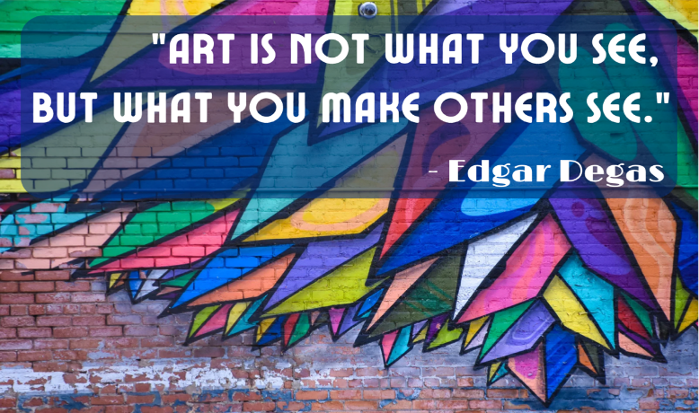

Skills and Language Topics
- Visual and textual analysis
Iran (CC0)
- Reading for main ideas and details
- Creative writing: drafting a fictional biographical profile

Key Vocabulary
Image: H. Benucci (CC0)
(CC0)
- biographical profile
- community
- Indigenous, Native
- justice
- muralist - mural
- public art
- to represent
Image: H. Benucci (CC0)

Procedures
TIME | STEPS | NOTES
20 min | 1. Warm-up: Mural response and interpretation  - Show students the photo of Thomas “Detour” Evans’ mural (large wall painting) created in tribute to teachers. Don’t tell them about the mural’s meaning or who the artist is yet.  Photo: Courtesy of T. Evans  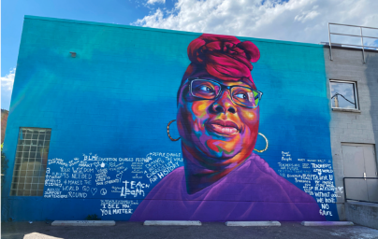  - Ask students to turn to a partner or create small groups; direct the class to discuss these questions displayed on the board:  - Describe the mural. What special features do you notice? (patterns, colors, symbols, text, etc.)  - How does the mural make you feel? What do you like about it?  - Why do you think the artist created this mural? What could it represent?  - Ask a few pairs or groups to share their responses.  - Explain that the mural’s painter is American artist Thomas “Detour” Evans. This mural in Colorado (USA) honors teachers everywhere. Detour created a space along the bottom of the mural where community members could write messages to teachers. Point out this text in the mural.  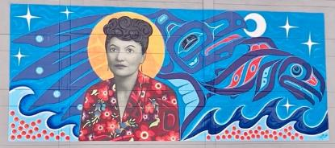  - Repeat the “display-discuss-share” process with Crystal Worl’s Elizabeth Peratrovich mural.  Photo: H. Benucci (CC0)  - Explain that American artist Crystal Worl painted this mural in Alaska (USA) to honor Elizabeth Peratrovich, a Tlingit (Native Alaskan) woman. In addition to Peratrovich’s portrait, the mural features water, salmon (fish), and raven (bird) symbols that are important in Native Alaskan cultures.  - Explain that Detour and Worl are both community artists. Write the word on the board.  - Ask students to guess what it means to be a community artist. Explain that community artists are people who create art that involves collaboration between artists and community members.  - Ask students to predict or describe what makes a community artist’s work special. (Possible answers: community artists’ work shares their beliefs about important social or cultural issues; community artists’ work can inspire curiosity, respect, celebration, or action in relation to a topic.)  - Ask students if they can think of examples of community artists or collaborative art in their neighborhood, city, or country. If desired, show or describe a local example you found before class. | Teacher-led class discussion; pair or small-group discussion  Larger versions of the mural photos are available in Lesson Materials – Item A. You can project the images or post several printed copies around the classroom for students to view.  Using the “display-discuss-share” process creates a low-pressure environment where everyone has a chance to clarify and share their ideas.  Asking students to guess meaning from context or make predictions helps them engage more actively with information, make connections with prior knowledge, and improve comprehension by encouraging them to anticipate events and information. These activities also help teachers gauge students’ understanding of topics and speed up or slow down pacing as needed.
30 min | 2. Getting to know community artists Thomas “Detour” Evans and Crystal Worl  - Tell students they are going to read more about the two community artists discussed at the start of class. They will learn about the artists’ backgrounds and topics in their work by reading a biographical profile.  - Distribute copies of the reading texts. Divide the class in half, giving each half one of the two texts to read.  - Preview the “while reading” questions and then direct students to read the text silently. Students who finish more quickly than others can make notes about the answers to the questions.  - When ready, ask students to join with others who read the same text. Students should discuss the answers to the questions in the pairs or small groups.  - Conduct a whole class share out, discussing student responses to the two texts and their thoughts about the additional mural images in the readings. Write student ideas on the board as desired.  - Ask students to write an Inquiry Notebook entry using the prompts provided. | Individual  Lesson Materials - Item B  Previewing questions before reading helps students know what information to focus on as they read.  Pairs or small groups; Teacher-led class discussion  This “read-discuss-share” process is similar to the activity in Step 1. It helps students learn more about a topic and supports learners at different language proficiencies.
30 min | 3. Future community artists: Planning a short biographical profile  - Tell students that they are going to imagine themselves as future community artists. They will think about what ideas they might want to communicate through art, and they will plan a short biographical profile about themselves as community artists. Explain that they can use the reading texts as models as they plan.  - If desired, lead students through guided imagining: ask them to close their eyes and picture themselves as an artist. What form of art do they make? Sculptures? Paintings? Drawings? What colors do they use? What topics and ideas do their work show?  - Distribute Introducing a Community Artist graphic organizers or display the content on the board so students can copy the information onto their own paper.  - Review the graphic organizer instructions. Direct students to begin working individually, offering support and assistance as needed.  - Put students into pairs or small groups. Ask them to share their biographical profiles with each other and to note similarities and differences in their ideas.  - Ask a few volunteers to share their profiles with the whole class if time permits. | This activity can be adapted to support students of differing language proficiencies by adjusting the requirement for the writing output. See the Variations section for more ideas.  Lesson Materials - Item C  Individual  Pairs or small groups  Teacher-led class discussion
10 min | 4. Reflection: Finish this line…at the finish line  - Write Art can ____________________. on the board  - Before leaving, ask students to think about what they learned in class and to complete the sentence on a sticky note or small piece of paper. Students don’t need to write the introductory phrase on their paper.  - As they exit the classroom, direct students to post their response on a piece of poster board or defined area of the board with the phrase: Art can ______________________. written in the center. Creative responses can be shared in the next class, and the responses can remain on display if the class continues to explore this topic in future sessions.  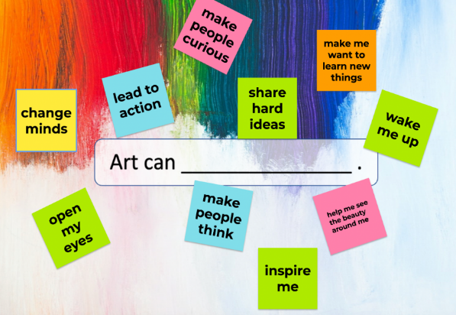  Image: H. Benucci (CC0) | Individual reflection response  This exit ticket activity helps teachers assess student understanding and interest in lesson topics. This information can help teachers plan for future lessons.  By sharing an open-ended prompt, this activity allows students to express ideas that were most meaningful and relevant for them.

Inquiry Notebook Prompts
PROMPTS | NOTES
- How can art help you learn more about a topic or person?  - Look at the photo of Thomas “Detour” Evans’ mural created to honor teachers. What questions would you ask the artist about this work?  - If you had a chance to interview Thomas “Detour” Evans or Crystal Worl about their art, what would you ask them? | Adopt or modify these prompts for Inquiry Notebook engagement with concepts featured in this lesson. Direct students to select one prompt to respond to in their Inquiry Notebook after completing Step 2.

Variations and Extensions
VARIATIONS

1. General differentiation and scaffolding
- Based on students’ levels and prior knowledge, teachers can choose to cover the lesson content over two or more class sessions. This approach will allow teachers to provide additional instruction, review, and support as appropriate. To reduce instructional timings or complexity, teachers may choose to conduct the activities using materials associated with one of the featured artists instead of both.
- To make the lesson more accessible for lower-level students, reduce the complexity or length of the reading texts or define/translate challenging vocabulary items. Modify the graphic organizer for lower-level learners by providing sentence stems in the notes section for each question or by reducing the quantity and complexity of information it contains. Challenge more advanced students to write notes and share their profiles using third-person narrative statements like those seen in the reading texts: Rashida Jackson is a muralist. She was born in Athens, Georgia and currently lives in New York City.

2. Online variations
- Biographic profiles: Using any locally popular social media platform as a model, ask students to create a social media bio (profile) statement for themselves as a future community artist. In addition, direct students to create a post that describes their current work. (Note: this concept can be completed in hardcopy format; ask students to draw their content using the platform’s layout on paper.)
- Reflection board: To provide students with additional time for reflection or to offer creative digital output options, collect responses to the reflection prompt after class using an online multimedia curation tool. Ask students to consider how to use classroom-appropriate multimedia content (photos, gifs, audio) and design choices (font selection, color, etc.) to enhance their responses.
EXTENSIONS

1. Full biographical profile
- Ask students to use their planning notes from Step 3 to write an (auto)biographical profile. Students may write the profiles as homework or as an in-class extended writing assignment. The students’ output could also be created in audio or video format.

2. Getting to know local community artists…and spreading the word!
- Ask students to work individually or in small groups to research local, national, or regional community artists and their work.
- Support students in using the research information to write biographical profiles that introduce English-speaking visitors to these community artists and the significance of their work. Students can use a modified version of the graphic organizer included with this lesson to plan their writing. Output could be created and shared in hardcopy, as a collection of online documents, a blog, or with a multimedia curation tool.

External links are provided for informational purposes only; there is no implied U.S. Department of State endorsement of the views, opinions, media content,
or privacy policies contained therein.

Unless otherwise noted, CC0 images in this resource are “no-attribution required” items sourced under the Pixabay simplified license or the Unsplash license. If sharing, adapting, or remixing portions of this lesson plan, please respect excepted permission and licensing statements noted in the credit statements for individual images, graphics, or other content. To learn about Creative Commons licenses, their uses, and their restrictions, visit the Creative Commons license explanation site.

What is a Community Artist? – Lesson Materials
ART AS EXPRESSION

A. Mural photos – Thomas “Detour” Evans and Crystal Worl
Photo: Courtesy of T. Evans; used with permission
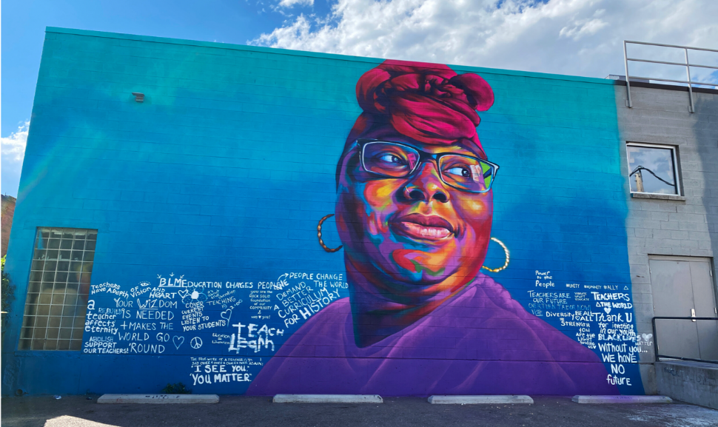

Interactive mural honoring teachers by Thomas “Detour” Evans in Denver, Colorado (USA).

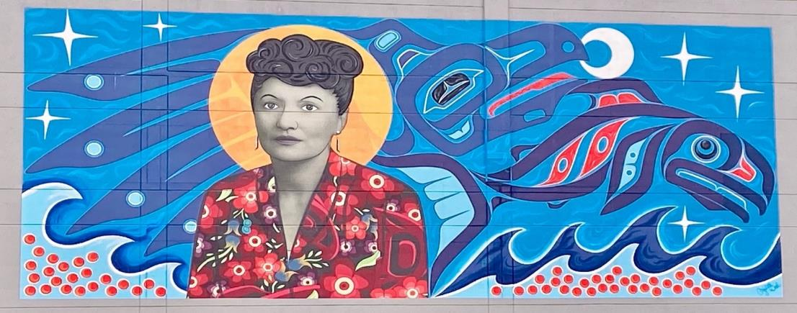
Photo: H. Benucci (CC0) – mural by C. Worl

Crystal Worl’s mural honoring Elizabeth Peratrovich in Juneau, Alaska. (USA)

B. Meet the Community Artist – Reading texts
Photo: A. Christensen (CC0)

Instructions:
Read the profile of community artist Thomas “Detour” Evans. While you read, think about these questions:
- What kind of artist is Detour? What type of art does he create?
- What topics or subjects are shown in Detour’s artwork? Where is his public art located?
- What do you notice about how he uses color, light, shapes, symbols, or body language in his work?
- How might Detour’s work help others learn more about his beliefs and the communities where his art was created?

Meet the Community Artist: Thomas “Detour” Evans
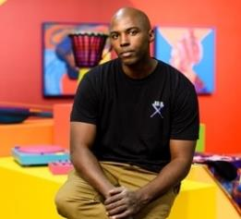
Thomas “Detour” Evans is an artist living in Denver, Colorado (USA). When he was young, his father’s job required many relocations, and his family lived in several cities. Detour used his artwork to meet people and make friends when he moved to a new place.
Photo: Courtesy of T. Evans;
used with permission

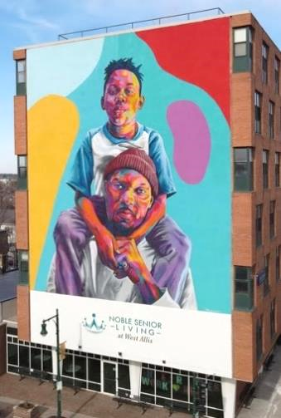
These days, Detour is a well-known painter and designer. He creates portraits (pictures of people) and public works of art called murals. Murals are large paintings on a wall or another large surface. Detour’s largest mural of a father and son is 62 feet (almost 19 meters) tall! His public art can also be interactive. Interactive art allows viewers and community members to add to the artwork.
In the United States, many of Detour’s murals celebrate famous Black Americans. For example, he painted a mural in memory of John Lewis (1940-2020), a Black American who worked with Martin Luther King Jr. to fight for justice. Later, Lewis became a politician. Detour has painted musicians—like jazz piano player Thelonious Monk, singer Nina Simone, and rapper Jay Z—and athletes like basketball star Michael Jordan and baseball legend Jackie Robinson. Detour also celebrates everyday people from his community. For example, he paints friends, other artists, teachers, and nurses. Many of Detour’s murals are in Denver, but he has also created murals in the states of Oklahoma and Wisconsin, and in Buenos Aires, Argentina.
Photo: Courtesy of T. Evans;
used with permission

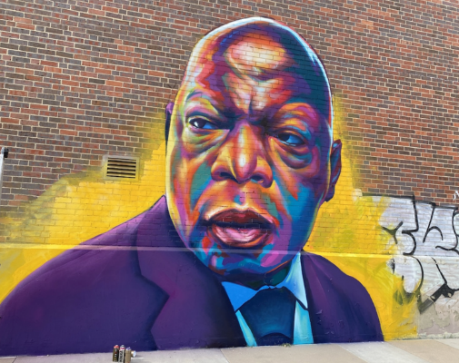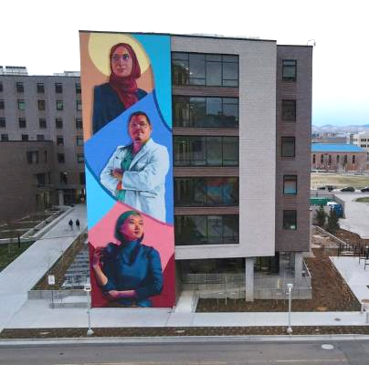
Photo: Courtesy of T. Evans; used with permission
Photo: Courtesy of T. Evans; used with permission

Mural honoring John Lewis by Detour Evans

Mural honoring health care workers by Detour Evans

Detour believes supporting young artists is important. Every week on social media, he gives advice about creating art and about the “business” of being an artist. He also wrote a book to help creative people become professional artists. Detour wants to help young people “find their voice”—their unique way of expressing their ideas—to create meaningful art in their communities.
If you were a muralist, what would you paint for your community? What topics are important to you and the people where you live?

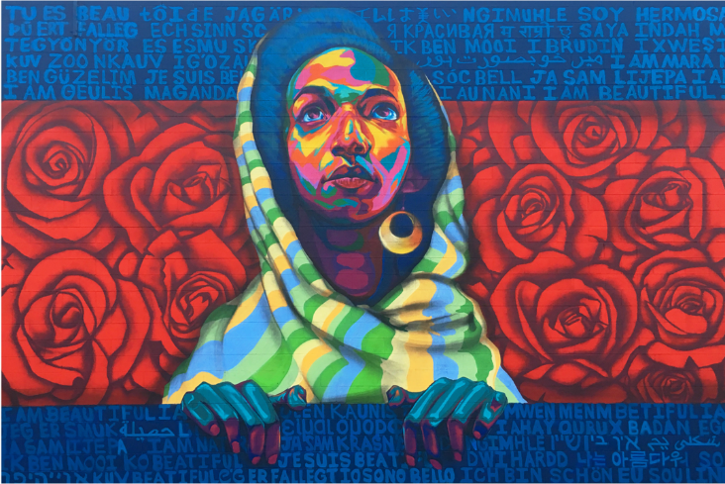
Photo: Courtesy of T. Evans; used with permission

Detour included the phrase “I am beautiful” in many languages in this mural featuring a friend. Instagram community members helped him with many of the translations.

Information adapted from “Street artist represents his community with giant vibrant murals [Interview]” by Jessica Stewart. My Modern Met, 31 July 2020.
Instructions:
Read the profile of community artist Crystal Worl. While you read, think about these questions:
- What kind of artist is Crystal? What type of art does she create?
- What topics or subjects are shown in Crystal’s artwork? Where is her public art located?
- What do you notice about how she uses color, light, shapes, symbols, or body language in her work?
- How might Crystal’s work help others learn more about her beliefs and the communities where her art was created?

Meet the Community Artist: Crystal Worl
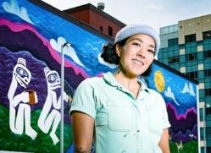
Crystal Worl is a Native Alaskan artist living in Juneau, Alaska (USA). Her family background is Tlingit, Athabascan, Yupik, and Filipino. Crystal grew up in the cities of Fairbanks and Juneau. From a young age, she learned about Indigenous art and storytelling.
Photo: C. Tice; courtesy of C. Worl.
Used with permission.
Today Crystal is a co-owner of Trickster Company with her brother, artist Rico Worl. Trickster Company combines modern designs with ideas from Native Alaskan cultures. As an artist, Crystal works with glass, silver, printing, and painting. She also uses interesting materials like fish skin and fur. Her art explores the relationships between people, the land, and animals. Athabascan images of ravens, eagles, salmon, whales, and other animals often appear in her work. She uses art to retell and to modernize her cultures’ stories.
Crystal has created many types of public art, including murals (large wall paintings). Each year, thousands of visitors to Juneau see her beautiful mural featuring Tlingit woman Elizabeth Peratrovich. Elizabeth supported Native Alaskan people in the 1940s and beyond and helped pass the first anti-discrimination law in Alaska.
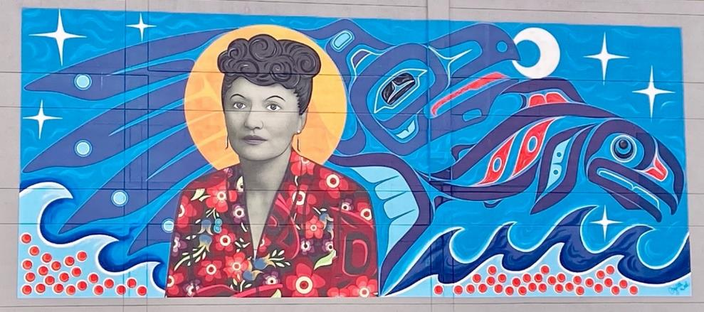
Photo: H. Benucci (CC0) – mural by C. Worl

In 2022, Crystal created a public mural in Anchorage, Alaska’s largest city. This mural uses bright, modern colors to show connections—past and present—between Alaskans, water, land, the sun, and animals. The animals’ spirits are represented with yellow circles. Can you see them?
Photo: H. Benucci (CC0) – mural by C. Worl
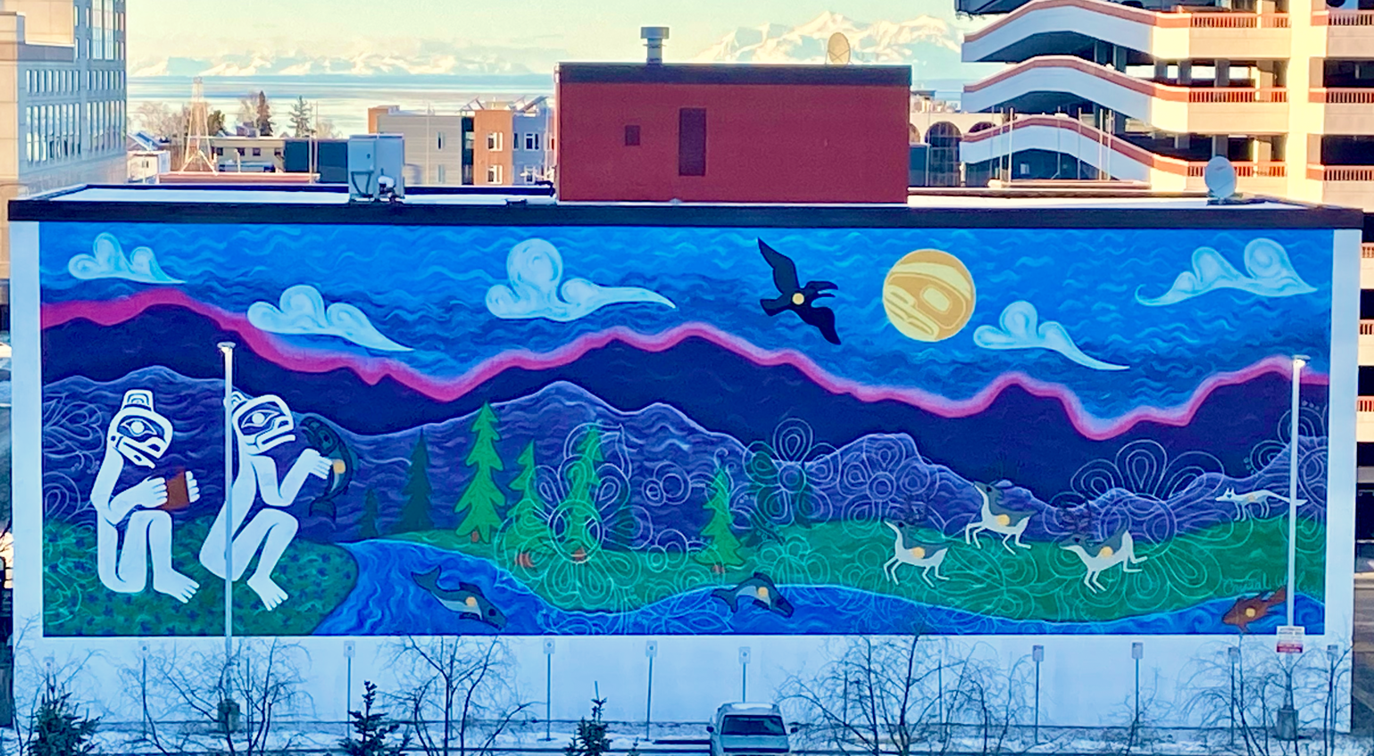
Photo: H. Benucci (CC0) – mural by C. Worl

Photo: H. Benucci (CC0) – mural by C. Worl
Crystal hopes her murals will help visitors and residents learn more about the rich Native Alaskan cultures in Alaska.
If you were a muralist, what would you paint for your community? What topics are important to you and the people where you live?
Information adapted from “I Am — Crystal Worl.” Crystal Worl, [n.d.].

C. Introducing a Community Artist – Graphic Organizer

Instructions:
- Imagine you are a future community artist working on a new piece of art. Think about these questions:
  - What kind of art will you create?
  - What is the purpose of your work? Will you want to make people curious about the subject, celebrate the subject, or something else?
- Use the chart below to plan your (fictional) biographical profile. Be creative! You can imagine any future possibility.
- Be ready to discuss your profile with others. Be proud of your work, future community artist!
Introducing a Community Artist
Your name
Background information
- Where are you from?
- Describe yourself. What important facts or qualities do you want others to know about you?
Your community art
- What kind of art do you create?

- Where can people see your work?

- Describe a current community art project you are working on:

  - What is the subject? (Think about important or special people, places, things, or ideas in your community.)
  - Why is this subject important?
  - What type of art is it (mural, sculpture, statue, painting, mosaic, etc.)?
  - What does it look like? Describe the size, shape, colors, or other features.
  - Where is it?
  - What do you hope people will think about when they see your artwork?

Optional: Draw a picture of your imagined artwork.

D. Key Vocabulary glossary
Definitions below illustrate how Key Vocabulary terms are used in the context of this lesson.

biographical profile n. a piece of writing that tells about a person’s life
community n. a group of people who live in a particular place or who are part of a specific group
Indigenous, Native adj. people who were the first to live in a particular place or country
justice n. behavior that is fair and follows morals or laws
muralist n. a person who designs and paints a large image on a wall
public art n. art that is created for everyone and free for all people to view
to represent v. to be an example or symbol of something

