Graffiti: Art or Crime?
ART AS EXPRESSION
Overview

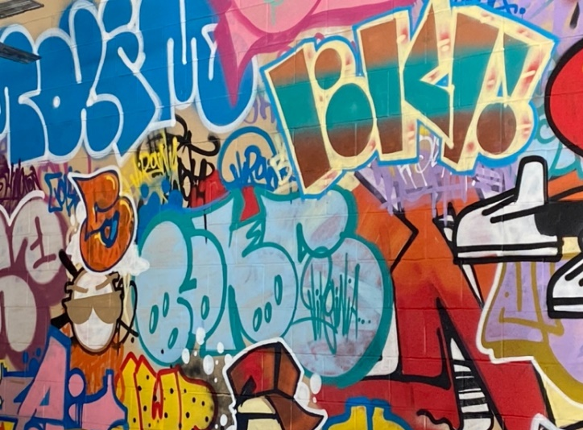
This lesson asks students to think about issues of permission and a graffiti creator’s intent in relation to public spaces: Is graffiti always vandalism? Can it ever be considered art?

Goals
As a result of this lesson, students will be able to:
- analyze visual examples and written information as they consider and discuss the question, “Is graffiti art or a crime?”
- identify main ideas and key details in a text about graffiti’s history in the United States
- connect meanings of words or phrases with design elements seen in graffiti-style art
- create positive graffiti-style art that relates to an uplifting principle or message
As a result of this lesson, teachers will be able to:
- build on students’ prior interests and background knowledge with lesson topics to support development of new interests and skills
Photo: H Benucci (CC0)
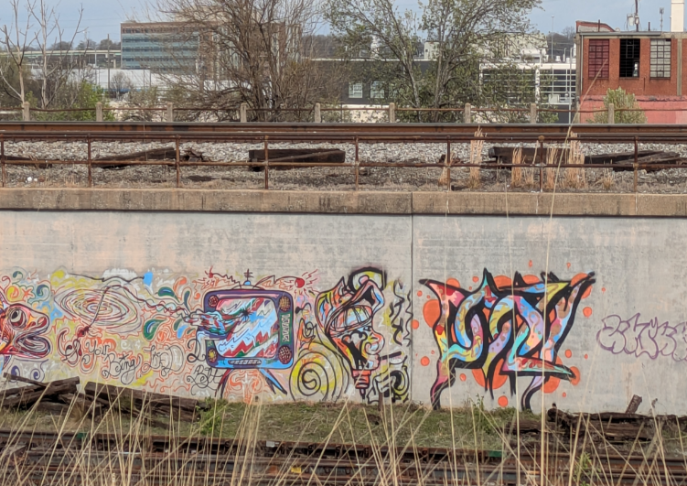
- create trust in the classroom by modeling active listening techniques during discussions
- support development of students’ critical thinking skills

Lesson Materials
IN YOUR CLASSROOM
- Paper and pencils or pens
- Art supplies, such as markers, crayons, colored pencils, or paints in a variety of colors
- Chalkboard and chalk or whiteboard and markers
- Optional: Projector for displaying images; tape or putty to hang pictures; sticky notes
- Clock or timing device
PROVIDED WITH THIS LESSON PLAN
- Graffiti examples (photos)
(CC0)
- “A Brief History of Graffiti in the United States” reading text
- The Four Hip-hop Principles templates
- Exit tickets
- Key vocabulary glossary
TESOL Focus: Student-Centered Learning

Preparation
- This lesson utilizes student-centered learning techniques to facilitate students’ development of critical thinking and analysis skills. If possible, brainstorm about, observe, or research examples of graffiti where you live. Do people have both positive and negative opinions about graffiti? Why? It may be helpful to collect relevant images or information about local graffiti artists to share with the class. Do any local graffiti artists create pieces to raise awareness about important issues, to inspire people, or for other positive or interesting reasons?
- Review the Procedures and Lesson Materials sections, then determine the formats you will use for the Lesson Materials.
  - Many items can be photocopied, enlarged, or projected onto the board or a wall. More suggestions for formatting and sharing these materials are in the Procedures steps and notes.
  - After selecting the formats for the activities, prepare the required number of materials to suit your class size, considering how many groups or individuals will participate in each lesson stage.
- Read the Skills and Language Topics and Key Vocabulary lists below. Review the glossary (Lesson Materials - Item E) to see how Key Vocabulary terms are used in this lesson. Will you need to activate prior knowledge, pre-teach, or otherwise provide scaffolding (support) for your students beyond the suggestions in the Procedures section? See the Variations and Extensions section for ideas.
Skills and Language Topics
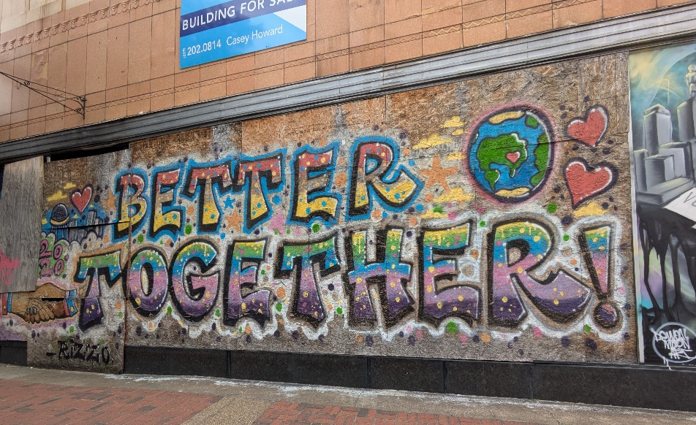
- Reading for main ideas and details
- Creativity in action: planning and creating images
- Critical thinking: using a flexible mindset along with visual and textual analysis to consider and discuss a complex question

Key Vocabulary
(CC0)
- destructive  - “fill” [graffiti term; noun]  - graffiti  - hip-hop  - permission  - principle | - public space  - to raise awareness  - sparkle  - spray paint  - to tag – tagger  - vandalism  - unity

Procedures
TIME | STEPS | NOTES
10 min | 1. Warm-up: Is graffiti art?  - Write the word graffiti on the board. Ask students if they have heard or seen the term before. Ask students to share the meaning of the word. If necessary, explain that this word is from the Italian language: graffio = scratch + iti = little little scratched writing. Explain that English speakers use this uncountable noun to refer to painting or writing in public spaces, usually without permission. Graffiti is often made with spray paint (paint in a handheld can that sprays out of the top), although it can be written with markers or other tools.  - Display examples of graffiti on the board or the classroom walls.  - Tell students to view the graffiti images and then discuss with a partner (or a small group) the questions below. Write the questions on the board. When discussion time is over, ask a few volunteers to share their thoughts.  - Is graffiti “art”? Why or why not?  - Have you seen graffiti your community? Is it artistic, destructive, or does it have other meanings? | Teacher-led class discussion; pair or small-group discussion  This activity of asking questions and discussing answers helps activate and build on students’ prior interest and background knowledge, which helps develop new interests and skills.  Lesson Materials – Item A. You can project the images or post several printed copies around the classroom for students to view.
25 min | 2. Reading: A Brief History of Graffiti in the United States  - Pass out copies of the reading text. Pre-teach or review any potentially difficult vocabulary items in the text.  - Ask students to read the text silently; when they finish, students should write down three things they learned from the text. If desired, ask students to record new vocabulary words from the reading in their notes and look up their meanings.  - After students are finished, tell them to share the three things they learned with a partner. Direct them to compare their responses and look for similarities and differences.  - As time allows, conduct a whole class debrief. Ask a few volunteers to share their responses and highlight key points from the text. Answer any remaining questions about the reading text. | Individual  Lesson Materials – Item B. See the Variations section for options for managing the reading activity.  Teacher-led class discussion  This “read-discuss-share” activity (also used in the previous lesson in this unit) asks students to share what they learned, rather than just answering comprehension questions. This develops critical thinking skills and gives students an opportunity to practice their language skills as they discuss their ideas with a partner.
20 min | 3. Practice: Positive hip-hop principles and graffiti fills  - Write this quote on the board: “Words create the reality that you live in.” – Marlon Richardson  - Explain that this quote is by Marlon Richardson, also known as “UnLearn the World” or “UnLearn.” Originally from New York, UnLearn is now a hip-hop singer and educator in San Francisco, California. He teaches the history of hip-hop, a music culture that often uses graffiti imagery for artistic expression. Ask students to provide examples of hip-hop songs or artists if they are familiar with this musical style.  - Ask volunteers to share what they think UnLearn’s phrase means.  - Explain that UnLearn teaches that the four principles of hip-hop are Peace, Love, Unity, and Having Fun. Write the word principle and the four hip-hop principles on the board. Explain that a principle is a rule or belief that guides a person’s or group’s behavior and the way they live their lives. Ask students to share the meaning of the four hip-hop principles and record a few student-generated examples on the board.  - Show students the templates for the four principles and ask them to choose one to illustrate. These templates were created by San Francisco, California graffiti artist Nathan Tan, also known as “Nate1.”  - Tell students they are going to “practice their fills.” Write the term fill (noun) on the board. Explain that fills are the colors and patterns that artists use inside graffiti letters. If desired, point out fills in the example images shown in Step 1. Tell students to use art supplies to create fills for the hip-hop principle they chose. The fill’s colors and design should reflect how the word makes the student feel.  - After students are done working, ask them to share their work with at least two classmates. Tell students to explain how their fill choices connect to the hip-hop principle.  - Direct students to return to their seats. If time permits, ask volunteers to share what they learned about their partners through their fill designs, or ask students how their work relates to UnLearn’s quote on the board. | Teacher-led class discussion  When leading this discussion, use open-ended questions and model active listening techniques like noticing (and using) non-verbal cues, paraphrasing, and reflecting back what has been said. This helps build trust in the classroom and ensure that everyone understands what others are saying.  Lesson Materials – Item C  The handouts include two principles per page; you can enlarge them. Consider creating four printout sets sorted by principle, so students can easily choose their desired template.  Class mingle; pair discussions  Giving students time to share their ideas with a partner first helps them clarify and practice their ideas in English before sharing them with others.
25 min | 4. Making it personal: What’s your positive principle?  - Explain that now that they are familiar with principles and graffiti fills, students are going to create their own graffiti-style art based on a positive principle that is important to them. The principle they choose can be something that guides their personal behavior, shapes how they interact with others, or that could uplift and improve their community.  - Using the graffiti examples (Step 1) and their hip-hop principle fills (Step 3) as models, ask students to create a practice sketch (quick drawing) of their principle on a piece of paper in graffiti-style font (lettering style). Tell them they can make a few sketches as they plan their final design.  - When students are ready, ask them to create a larger version, similar in size to their fill work.  - Students should outline the letters in their principle in a dark color and complete the fill as they did in Step 3.  - If time permits—or if some students work more quickly than others—encourage students to add a background design to their art. The background can include clouds, flowers, stars, sparkle effects, or any shapes, patterns, and colors that connect with their chosen word or phrase.  - If possible, ask students to hang their completed work on a wall or on the board for others to view. | Teacher-led preparation with individual work  It is helpful for students to make their sketches in pencil if possible.
5 min | 5. Reflection: Exit ticket  - Ask a volunteer to pass out the exit tickets or have students copy the ticket information onto their own paper from a model supplied on the board.  - Direct students to choose one of the two exit ticket questions to answer prior to departing class. Prompt students to think quietly for a moment about what they learned and did during the lesson before responding.  - Collect the exit tickets before students depart.  - Ask students to write an Inquiry Notebook entry using the prompts provided. | Lesson Materials – Item D  Individual  By keeping student responses anonymous, students are free to be more honest in their responses.  Reviewing and analyzing student responses to the exit tickets helps teachers gauge reactions to the lesson and understanding of content. This helps teachers identify problematic areas to address during future instruction. If you have a large class, review an exit ticket sampling for time and practicality purposes.

Inquiry Notebook Prompts
PROMPTS | NOTES
- Write a list of words that show your positive principles.  - Look back at the question from the beginning of the lesson: Is graffiti art? What do you think now? Why or why not?  - Following the class discussion and activity about “Words create the reality that you live in,” how does your work relate to UnLearn’s quote? | Adopt or modify these prompts for Inquiry Notebook engagement with concepts featured in this lesson. Direct students to select one prompt to respond to in their Inquiry Notebook after completing the lesson.

Variations and Extensions
VARIATIONS

General differentiation and scaffolding
- Based on students’ levels and prior knowledge, teachers can choose to cover the lesson content over two or more class sessions. This approach will enable teachers to provide additional instruction, review, and support as appropriate.
- To make the lesson more accessible for lower-level students, reduce the length or complexity of the reading text, gloss challenging vocabulary items, or ask students to only identify one thing they learned from the reading.
- Challenge more advanced students to write their own comprehension and discussion questions to share with their classmates after the reading.
EXTENSIONS

1. Gallery walk
- Ask students to post their principle-related artwork (Step 4) on walls around the room. Supply students with two sticky notes (or two pieces of tape and small pieces of paper). Ask students to walk around, viewing their classmates’ work and posting reactions or comments below two other students’ art. Remind students to write kind, constructive comments—the type they would like to receive—and to make sure that everyone in the class receives at least one comment. Be sure to decide in advance whether students will display their names on their art and comments.
  - Online option: Complete an online gallery walk by asking students to upload a photo of their art to a tool like Padlet or a private social media group. Students can view each other’s work and use virtual sticky notes or the comments feature to leave feedback.

2. Reflection essay
- For homework or an in-class writing extension, ask students to write a short essay describing or explaining their graffiti-style work (Step 4), or ask them to reflect on and write about how (or if) their opinions have changed in response to the question “Is graffiti an art or a crime?”

3. Graffiti in our community
- If appropriate where you live, ask students to take and bring in photos of graffiti in their community. Working in small groups, ask students to view and analyze the images. Direct groups to consider whether the images show examples of art or vandalism; ask students to explain their reasoning.
- As a class, consider if the community or a local institution would benefit from a graffiti cleanup. Are there walls, buildings, desks, objects, or other areas that could be cleaned or repainted with permission and prior coordination? Note: Depending on how this project is structured in terms of student planning, scope, and opportunities for reflection, it might make a great service-learning opportunity!

External links are provided for informational purposes only; there is no implied U.S. Department of State endorsement of the views, opinions, media content,
or privacy policies contained therein.

Unless otherwise noted, CC0 images in this resource are “no-attribution required” items sourced under the Pixabay simplified license or the Unsplash license. If sharing, adapting, or remixing portions of this lesson plan, please respect excepted permission and licensing statements noted in the credit statements for individual images, graphics, or other content. To learn about Creative Commons licenses, their uses, and their restrictions, visit the Creative Commons license explanation site.

Graffiti: Art or Crime? – Lesson Materials
ART AS EXPRESSION

A. Graffiti example photos
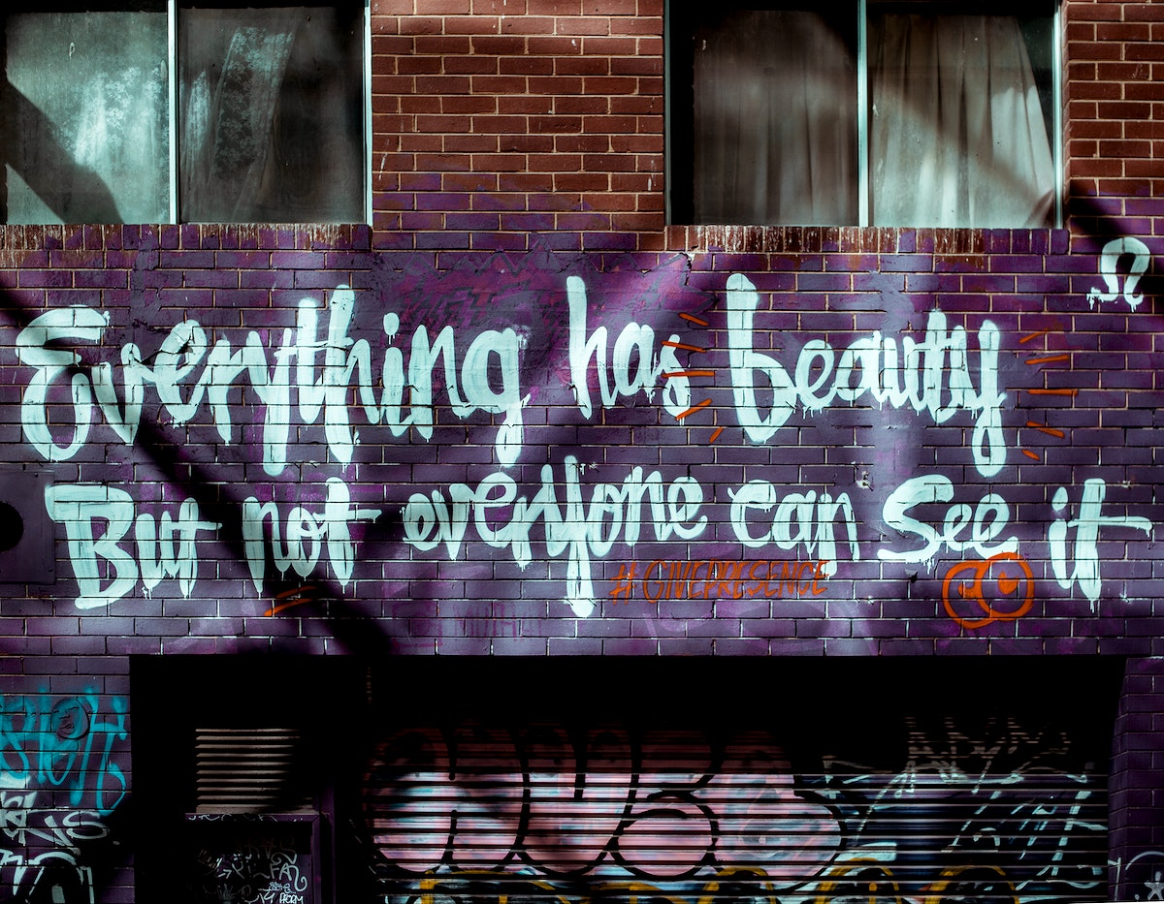
Photo: Melbourne, Australia (CC0)

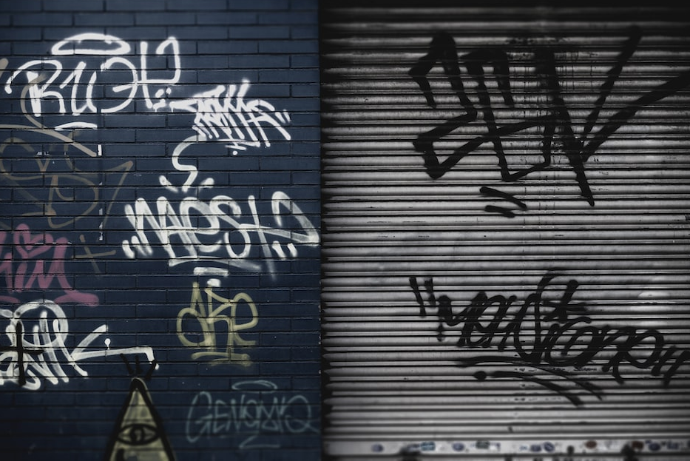

Photo: Terrassa, Spain (CC0)

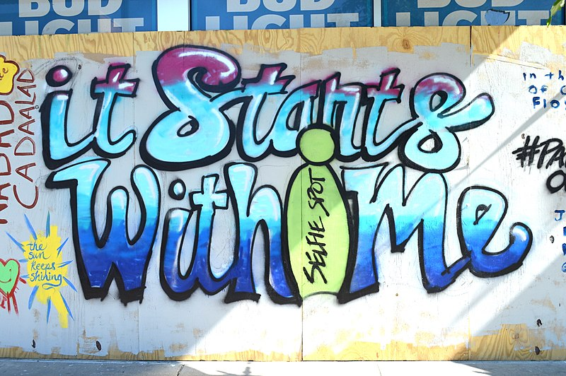
Photo: Minneapolis, Minnesota (USA) (CC0)

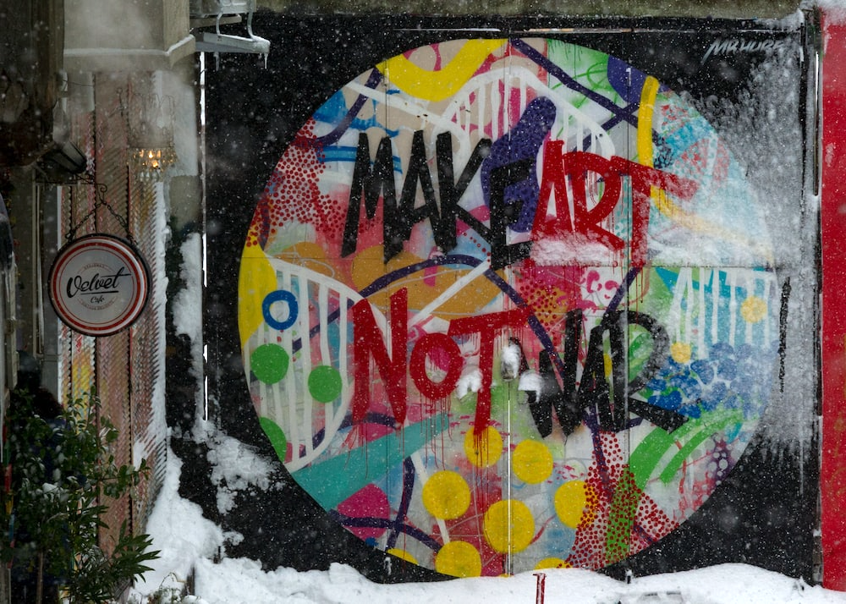

Photo: Istanbul, Türkiye (CC0)

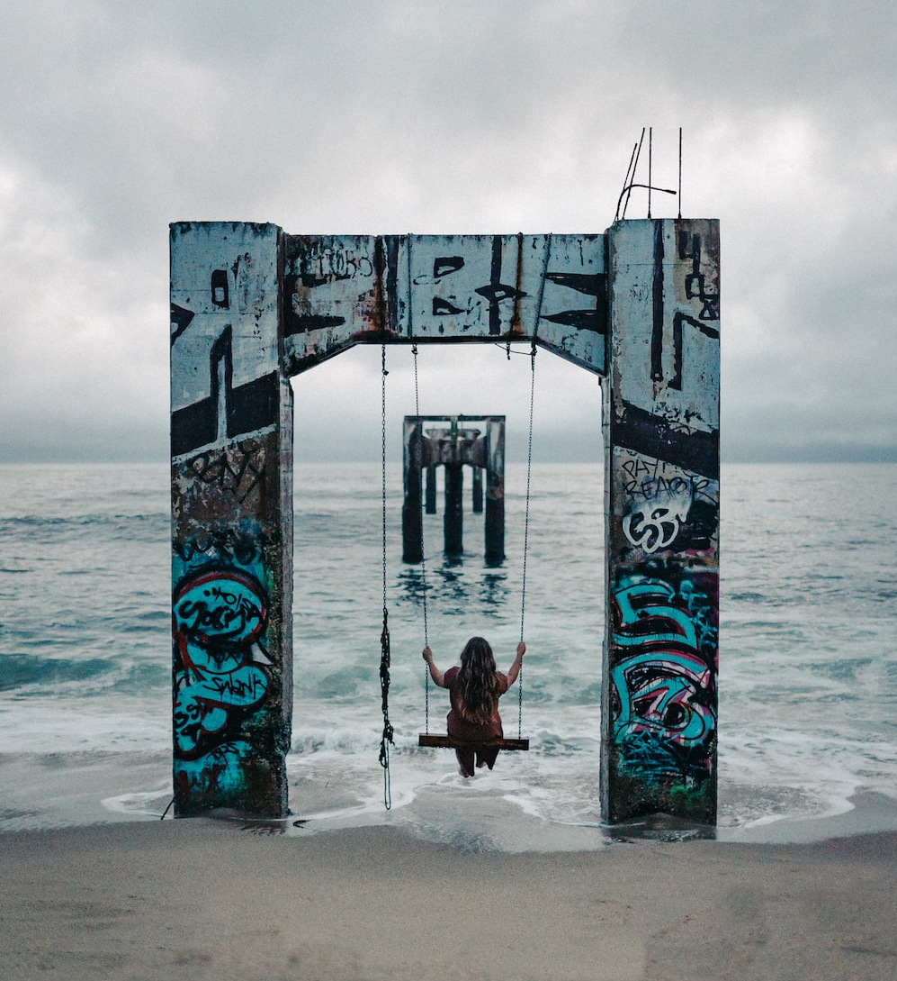

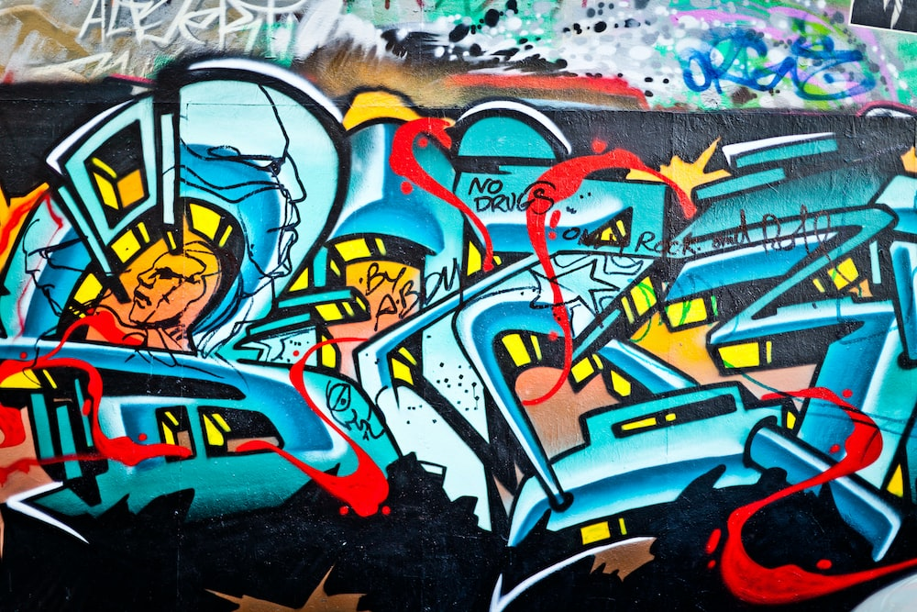
Photo: Location unknown (CC0)
Photo: Monterrey, California (USA) (CC0)

B. A Brief History of Graffiti in the United States – Reading text

A Brief History of Graffiti in the United States
Graffiti is words or images written or painted on a wall or other public place. Usually, it is created without permission. Graffiti can be destructive. It can ruin public places or objects, like sculptures or fountains, share hurtful messages, or mark areas that criminals use. However, graffiti can also express powerful ideas. Graffiti has existed for thousands of years. Ancient graffiti has been found on Greek and Roman walls, Egyptian monuments, Mayan ruins, and more! Over the years, people have asked, “Is graffiti art or a crime?”
Modern graffiti culture in the United States began during the 1960s and 1970s in East Coast cities like Philadelphia and New York City. New York City taggers (graffiti artists, also called “writers”) used spray paint to make graffiti on subway trains. These trains—and the graffiti—traveled around the city. Graffiti in New York used big, simple, round letters to be seen on the fast-moving trains.
In the 1980s, graffiti culture became popular in California cities like Oakland, San Francisco, and Los Angeles. Taggers in these cities worked on walls and objects that didn’t move. West Coast graffiti included colors and designs to create feelings of motion, add depth, and make light or sparkle effects.
During the 1980s, graffiti also became connected with hip-hop music. Like graffiti, hip-hop came from big cities in the U.S. along the east and west coasts. Some hip-hop artists included graffiti designs in their album artwork, music videos, and clothing.
Many people in the United States do not like graffiti. In most places, graffiti is a crime called vandalism, and taggers can be punished. Some people disagree. They think graffiti can be an important—and beautiful—art form. These people buy graffiti artists’ work and use graffiti art to decorate their homes and businesses. Today, graffiti pieces are in American and international museums. They can sell for millions of dollars! So, the question remains: Is graffiti art or is it a crime? What do you think? Why?

It’s your turn!
In your own words, write three things you learned while reading:
- ____________________________________________________________________________________________________________________________________________________________________________________________________________________________________
- ____________________________________________________________________________________________________________________________________________________________________________________________________________________________________
- ____________________________________________________________________________________________________________________________________________________________________________________________________________________________________

C. Hip-hop principles: Peace, love, unity, and having fun – Templates
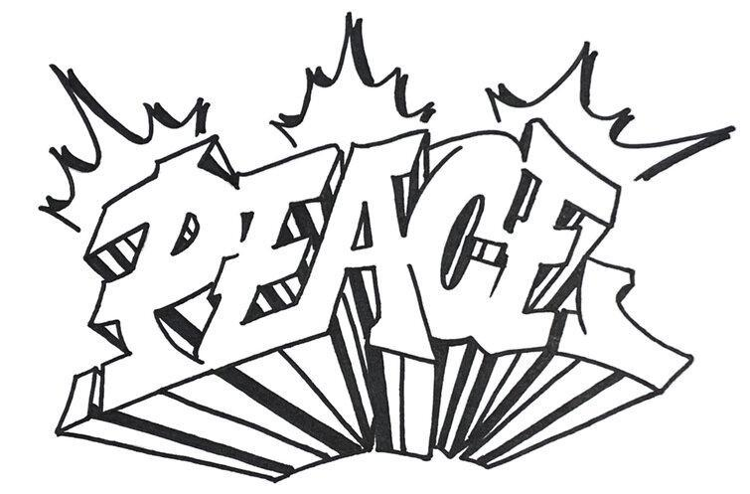

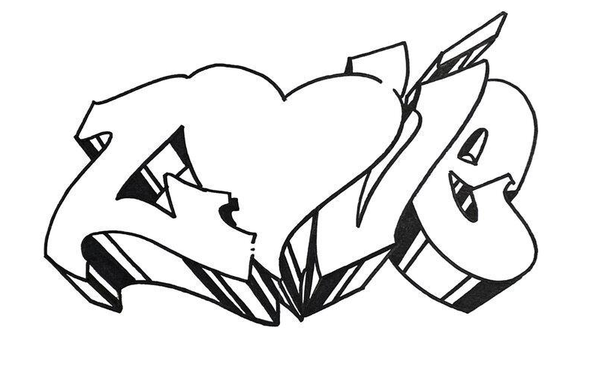

These templates were created by Nate1 for Where Art Lives. (CC BY-NC 4.0)
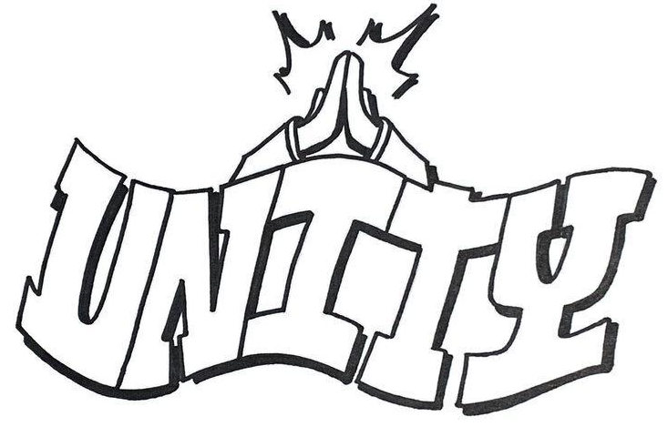

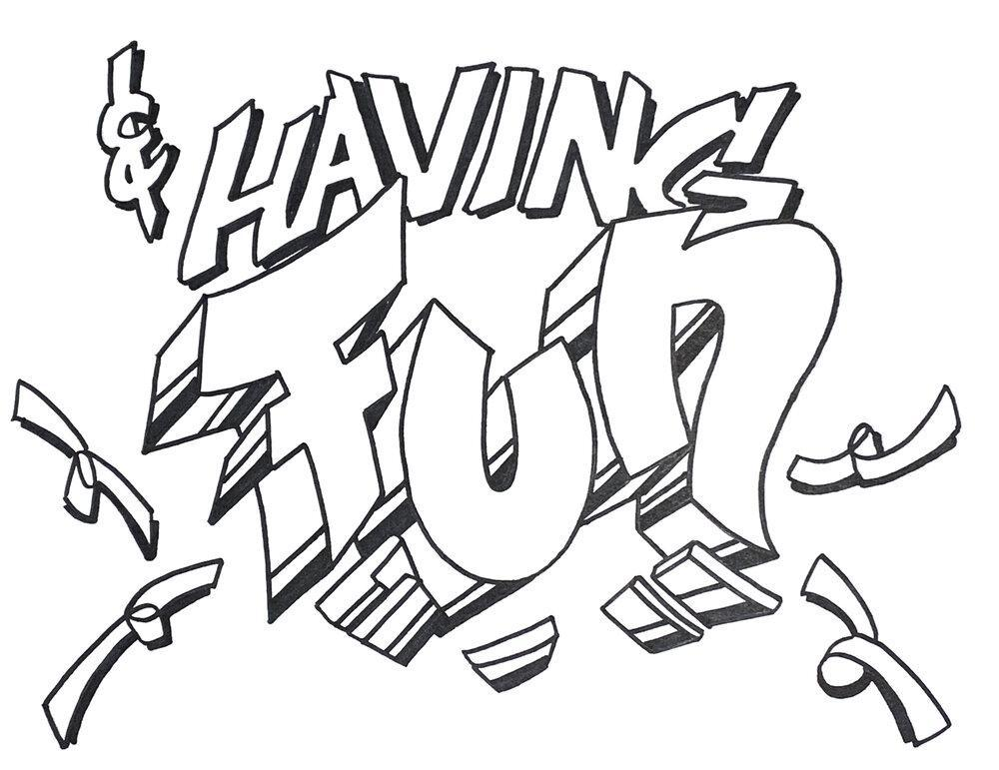

These templates were created by Nate1 for Where Art Lives. (CC BY-NC 4.0)

D. Exit tickets
Copy and cut up; distribute one ticket to each student.

Exit Ticket: Answer one of these questions before you leave today. Circle the question you answered.
- What was the most surprising thing you learned about graffiti today?
- After today’s class, do you think graffiti is art, a crime, or both? Why?
________________________________________________________________________________________________________________________________________________________________________________________________________________________________________________________________________________________________________________________________________________________________ 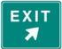

Exit Ticket: Answer one of these questions before you leave today. Circle the question you answered.
- What was the most surprising thing you learned about graffiti today?
- After today’s class, do you think graffiti is art, a crime, or both? Why?
________________________________________________________________________________________________________________________________________________________________________________________________________________________________________________________________________________________________________________________________________________________________

Exit Ticket: Answer one of these questions before you leave today. Circle the question you answered.
- What was the most surprising thing you learned about graffiti today?
- After today’s class, do you think graffiti is art, a crime, or both? Why?
________________________________________________________________________________________________________________________________________________________________________________________________________________________________________________________________________________________________________________________________________________________________

E. Key Vocabulary glossary
Definitions below illustrate how Key Vocabulary terms are used in the context of this lesson.

destructive adj. causing a lot of damage
fill n. a graffiti term for the color and design inside outlined letters or shapes
graffiti n. writing or pictures painted on walls or public places, often illegally
hip-hop n. a fun, energetic culture encompassing music (rap and DJing), dance (breakdancing), and art (graffiti)
permission n. approval to do something
public space n. a place that is open and available to most people
to raise awareness v. to help people learn more about an issue or topic
sparkle adj. shining brightly because of reflected light
spray paint n. paint that comes in a pressurized can
tagger n. someone who paints their name or special mark on public spaces
vandalism n. intentionally damaging or destroying other people’s property
unity n. working together or in agreement

