What is Bullying?
CREATING AN ANTI-BULLYING CULTURE

Overview
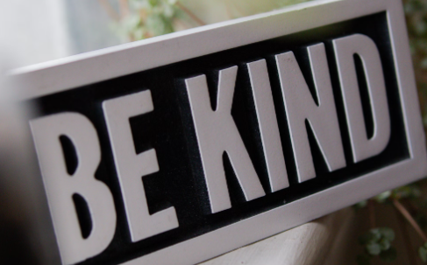
This lesson asks students to define bullying and think about effective responses to observing bullying or being bullied.

Goals
As a result of this lesson, students will be able to:
- explain the concept of bullying and recognize its forms
- identify, evaluate, and plan to apply anti-bullying responses
(CC0)
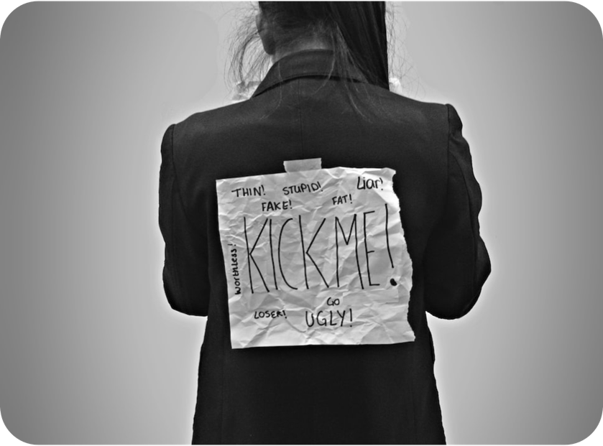
(CC0)

Lesson Materials

IN YOUR CLASSROOM

- Paper and pencils or pens
- Chalkboard and chalk or whiteboard and markers
- Projector for displaying images or lesson content (optional)
- English language dictionary or dictionaries, online or physical (optional)

PROVIDED WITH THIS LESSON PLAN
- Bullying situation visuals
- “Identifying and Responding to Bullying” reading text
- “How to Respond to a Bully” worksheet
- Exit ticket: My anti-bullying plan

(CC0)

Preparation
- Review the Procedures and Lesson Materials sections, then determine the formats you will use for the Lesson Materials.
  - Many items can be photocopied, enlarged, or projected onto the board or a wall. More suggestions for formatting and sharing these materials are in the Procedures steps and notes.
  - After selecting the formats for the activities, prepare the required number of materials to suit your class size, considering how many groups or individuals will participate in each lesson stage.
- Brainstorm about or research local bullying behaviors occurring in your students’ age group: What forms of bullying occur? How do students respond? How do people in positions of authority respond to reports of bullying? Does your institution or classroom have an anti-bullying plan or policies? Are there cultural differences between suggestions shared in these lesson materials and what is acceptable where you live? How might you highlight these differences in class?
- Read the Skills and Language Topics and Key Vocabulary lists below. Will you need to activate prior knowledge, pre-teach, or otherwise provide scaffolding (support) for your students beyond the suggestions in the Procedures section? See the Variations and Extensions section for ideas.

Skills and Language Topics
- Reading for main ideas and details
- Inferring meaning from written context clues and prior knowledge
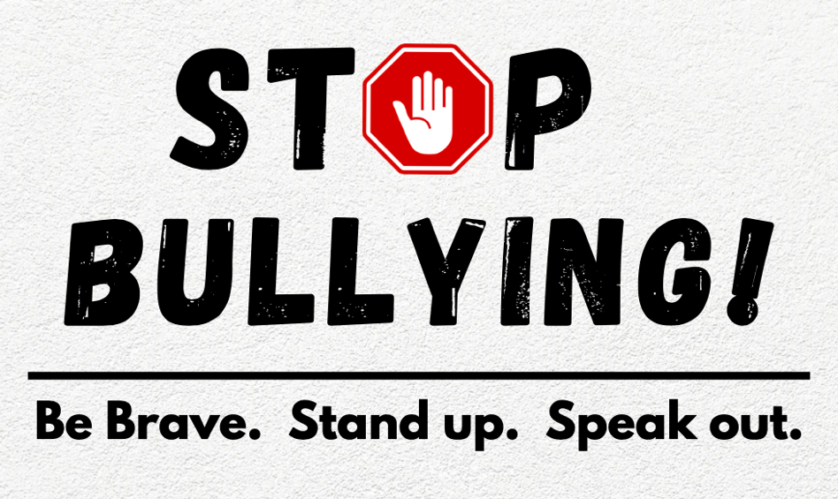
- Verbally expressing opinions, reasoning, and responses to hypothetical situations
- Critical thinking: making plans to respond to difficult situations

Key Vocabulary
Image: H Benucci (CC0)
- anti-bullying  - bystander  - bullying – bully – to bully – to be bullied  - cyberbullying  - empathy  - emotional (bullying)  - to harm | - mobbing  - outsider  - physical (bullying)  - rumor  - to retaliate  - target – to target  - verbal (bullying)

Procedures
TIME | STEPS | NOTES
15 min | 1. Warm-up: Defining bullying  - Show one or both of the bullying situation images. Ask students to write down (individually) as many English words or phrases as possible to describe the image(s): What do they see? What do they think is happening?  - Ask students to count how many items they wrote down. Determine which student(s) wrote the most items. Ask him/her/them to share the words or phrases aloud. Write them on the board. Ask the rest of the class to put a checkmark next to the items in their lists that are the same as those on the board. Ask other students to supply additional items, directing the class to continue marking off shared items.  - If not supplied by the class, add the word for the behavior seen in the picture—bullying—on the board. Explain the associated English forms if helpful: bullying (n.); a bully (n.); to bully [someone] (v.); to be bullied [by someone] (v.) Also, explain the term bystander, people who “stand by” to watch an event while not directly participating or stopping it. Ask students to identify the bystanders in the image. What do they notice about them and their reactions to the bullying?  - Explain or elicit meanings for any unknown words on the board; invite students to share explanations, too.  - Based on your students’ level(s), display a selection of the questions below on the board. Ask student volunteers to share responses.  - What do bullies do? or What does bullying look or sound like?  - What types of people are often bullied? or Can anyone be bullied?  - Where are people bullied?  - What happens when people see others being bullied? | Teacher-facilitated class activity and discussion.  Lesson Materials – Item A. You can project the image or post printed copies around the classroom for students to view.  If students require assistance before responding, allow them to first prepare answers in pairs or small groups. If you need ideas for answers to the questions, review the Lesson Materials – Item B reading.
40 min | 2. Reading and discussion: Identifying and responding to bullying  - Tell the class they are going to read a short article about bullying and how to respond to it. Pass out copies of the “Identifying and Responding to Bullying” text.  - Review the instructions at the top of the text:  - Before you read: Define the word bullying in one sentence. Use your own words.  - As you read: Underline examples of bullying and circle examples of how to support people who are bullied.  - After you read: On your own paper, copy the words in bold letters and write what you think each means based on the reading text.  - Answer questions about the instructions; model underlining and circling examples if needed. Direct students to begin working. Monitor students and offer assistance as needed.  - After students finish, put students in pairs or small groups. Ask students to compare and discuss their answers. If students do not agree on a Part 3 word’s meaning, they can consult a dictionary (if available), another pair/group, or the teacher. As you monitor the discussions, make note of any universally tricky words; discuss them with the class.  - When ready, ask volunteers to share something they learned from the reading about bullying and/or how to respond to it. Ask students to share examples of bullying behaviors or possible responses that weren’t mentioned in the reading. Write their ideas on the board.  - Finally, ask students why they think a person might bully someone else. Elicit or reinforce explanations in the reading: Bullies want to feel powerful and control how the person they are targeting (bullying) feels. For example, a bully might want the target to cry, get upset, run away, or retaliate (respond in a similar way, like trying to fight back). Bullies don’t expect others—friends or bystanders—to challenge their negative behaviors. By responding differently to bullying, we can take away the power the bully wants; through action, we can be allies (supporters or advocates) of bullying targets. | Lesson Materials - Item B  As desired: Direct students to complete Part 1 before explaining other instructions. Model how to mark up the text in Part 2. Tell students they’ll improve their Part 3 definitions with classmate or dictionary help later.  Individual  Pair or small-group discussions  Teacher-led class discussion
30 min | 3. Deeper thinking: How would I respond to bullying?  - Give each student a “How to Respond to a Bully” handout.  - (Think) Ask students to read the examples of how bullying targets and their allies can respond to a bully. Ask students to do the following as they read:  - Put a checkmark () next to responses you have used or seen other people use.  - Put a plus (+) next to responses you think you want to try (if necessary).  - Put a question mark (?) next to responses that you have a question about.  - Write down any additional suggestions you can add to the lists.  - (Pair) Put students in pairs or small groups of three. Tell students to compare and discuss their checkmark, plus, and question mark responses: How are their responses similar? How are they different? Why? Which responses are most or least effective for targets? Why? Display these discussion prompts on the board if needed.  - (Share) Ask volunteer pairs to share their findings with the class; elicit examples of additional “responses to bullying” suggestions. Remind students to explain the reasoning for their answers about the most/least effective strategies. Depending on the class proficiency level, you might also discuss why some suggestions in the handout are / are not culturally appropriate (or practical) where you live. | Lesson Materials - Item C  Think – Pair (group) – Share
5 min | 4. Reflection: Exit ticket  - Ask a volunteer to pass out the exit tickets or have students copy the ticket information onto their own paper from a model supplied on the board.  - Direct students to think about what they learned about anti-bullying strategies and being an anti-bullying ally. Tell them to write down a plan for one action to take if they are ever bullied and one action they can take to support someone else who is being bullied.  - Collect the tickets before students depart. Review and analyze their responses for information such as reactions to the lesson, content understanding, and problematic areas to address during future instruction. | Lesson Materials - Item D  Individual  If you have a large class, you can review a planned or random exit ticket sampling (a small group to represent the whole) for time and practicality purposes.

Variations and Extensions
VARIATIONS

General differentiation and scaffolding
- Based on students’ levels and prior knowledge, teachers can choose to cover the lesson content over two class sessions. This approach will enable teachers to provide additional instruction, review, and support as appropriate.
- To make the reading activity more accessible for lower-level students, reduce the length or complexity of the reading text items and suggest that students create their Part 3 definitions using a combination of English, their home language (L1), drawings, examples, etc.
- To simplify the “How to Respond to a Bully” handout, reduce the number of examples in the two charts, retaining the simplest items.

EXTENSION

Scenarios and roleplays: Responding to a bully
- Scenario (hypothetical situation) exercises help students prepare and practice effective responses to bullies in a safe, controlled space. They are also a good opportunity to practice using English modals in an authentic way: What would you do? I would …. You could …. I might …. If needed, review, model, or offer sentence starters for using this target language before beginning the activity.
- Put students in groups of three. Divide the class in half to create Team A groups and Team B groups. Explain that all groups will write a short scenario about bullying: Team A groups will write a scenario about being bullied. Team B groups will write scenarios about seeing someone else being bullied.
- Model example scenarios such as the ones shown below; elicit a few student responses if desired:
  - Team A: You are walking home from class on a quiet street. You notice two older, bigger students following you. They begin to shout at you and move closer to you. You feel scared. What would you do?
  - Team B: You see a lot of students in the lunchroom standing in a circle. Two female students are in the middle. One of them is calling the other “ugly” and making fun of her clothes. The target of the mean comments is beginning to cry. What would you do?
- After the groups create their scenarios, direct them to share scenarios with another group in the same team (A:A, B:B). Then direct students to repeat the scenario exchange with a group from the other team (A:B). Debrief the scenario exchanges with a whole-class discussion.
- If desired, student groups can then write longer roleplay scripts based on the scenarios they heard. Groups can perform their roleplays, and the audience can explore what went well along with alternative options for responding to the roleplay’s bullying situation.

External links are provided for informational purposes only; there is no implied U.S. Department of State endorsement of the views, opinions, media content,
or privacy policies contained therein.

Unless otherwise noted, CC0 images in this resource are “no-attribution required” items sourced under the Pixabay simplified license or the Unsplash license. If sharing, adapting, or remixing portions of this lesson plan, please respect excepted permission and licensing statements noted in the credit statements for individual images, graphics, or other content. To learn about Creative Commons licenses, their uses, and their restrictions, visit the Creative Commons license explanation site.

What is Bullying? – Lesson Materials
CREATING AN ANTI-BULLYING CULTURE

A. Bullying situation visuals
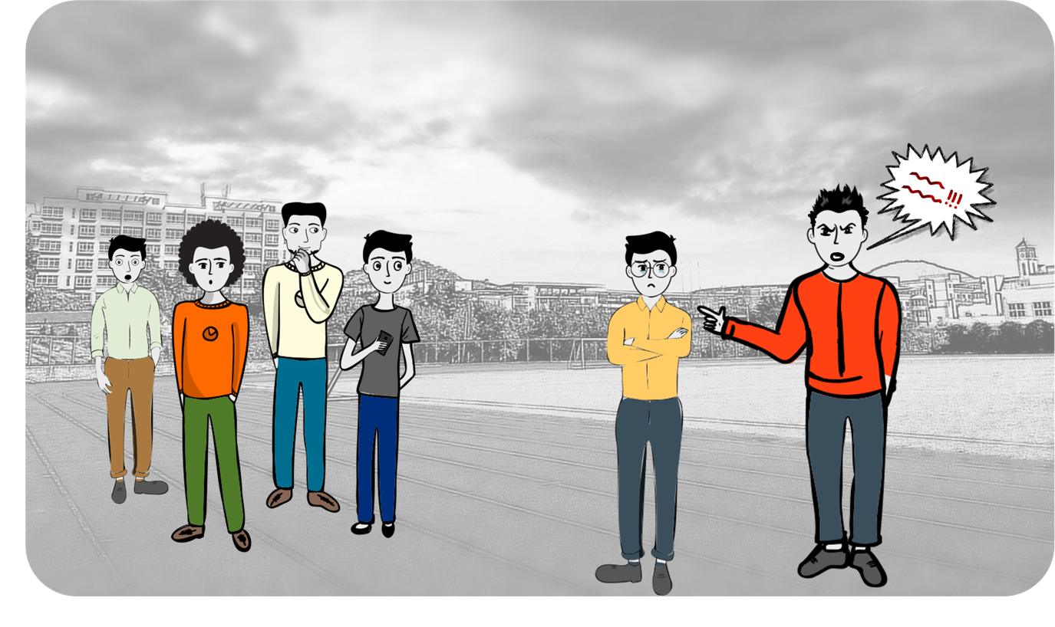

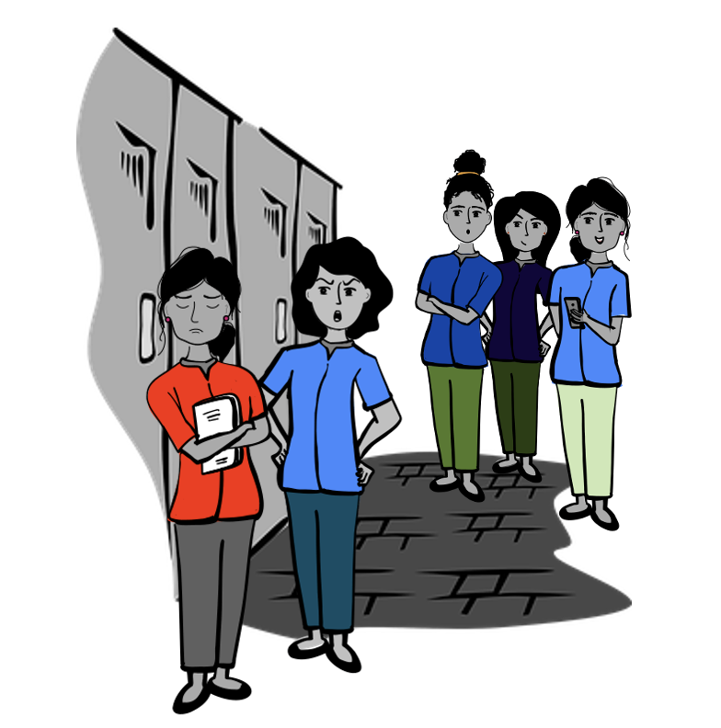

Images: H. Benucci (CC0); created in part with ComicGen CC0 content
Istanbul, Turkey CC0
Location unknown CC0

B. “Identifying and Responding to Bullying”– Reading text
- Before you read: Define the word bullying. Use your own words.

________________________________________________________________________________________________________________________

- As you read: Underline examples of bullying and circle examples of how to support people who are bullied.

- After you read: On your own paper, copy the words in bold letters and write what you think each means.

Identifying and Responding to Bullying
Bullies hurt or scare less powerful people. Bullying can be verbal, like calling someone a bad name or spreading untrue rumors; it can be physical, like pushing or hitting someone; and it can be emotional, like not sitting by someone to make them feel like an outsider. Bullying is usually a repeated behavior, something that happens again and again. Being bullied makes people feel alone, sad, angry, and helpless.
Bullying can be done by one person or by many. For example, “mobbing” is a group of bullies bothering someone, like when several bullies follow a target home from school while yelling mean things. Bullying can happen in person or online. When the behavior happens online, it is called cyberbullying. Cyberbullies use false, scary, or hurtful emails, texts, or social media posts to upset their targets.
Bullies want power over their targets. Bullies often choose targets they think are “different.” For example, targets may be physically weaker, less wealthy, differently abled (someone who uses a wheelchair or has a speech difference, for example), from a minority group, or newly arrived in a community. Bullies believe bystanders who observe their actions will not try to help these targets.
However, one of the most important ways to stop bullying is to become an ally. Anti-bullying allies act to support targets of bullying. For instance, an ally might walk home from school with a bullied classmate so the person doesn’t have to travel by themselves. An ally might sit with someone at lunch who has been bullied so they don’t feel sad. An ally might invite someone to participate in a group activity when bullies have been making them feel alone. And an ally might say something to the bully or ask other people—like friends, teachers, or trusted adults—to help stop the bullying.
Think about it! How can you be an anti-bullying ally?

C. How to Respond to a Bully – Worksheet
How to Respond to a Bully

You can respond in several ways if you are being bullied or if you observe someone else being bullied. Read the suggestions in the charts below and complete steps 1– 4.
- Put a checkmark () next to responses you have used or seen other people use.
- Put a plus (+) next to responses you think you want to try (if necessary).
- Put a question mark (?) next to response that you have a question about.
- Write down any other suggestions you can add to the lists.

How to respond if you are being bullied: | Why?
Say “Stop!” or “Leave me alone.” | This response lets the bully know the behavior is unwanted.
Walk away. | This choice can end the bullying situation.
Remain calm. Take deep breaths. Stand tall. Use a steady voice. | These actions let the bully know that you do not feel less powerful, and they may stop trying to bother you.
Encourage empathy from the bully. | Try to help bully think about the harm their words and actions cause by asking:  - “How would you feel if someone said that to you?”  - “How would you feel if someone did that to your [brother, sister, friend]?”  (This may work better when alone with a bully rather than in front of a group of bystanders.)
Use humor. | The bully wants to control how someone feels. Humor is the opposite of what the bully expects. However, don’t make the bully the target of a joke. This could make things worse.
Respond neutrally or agree. | Using statements like “Maybe,” “That’s your opinion,” “If you say so,” or “Whatever” is not what bullies expect. They may stop bothering you if they can’t control your feelings or get a strong response.
Be kind. | This approach relates to the English language saying “When they go low, we go high.” It can take time to see results of responding with kindness like asking, “Are you upset?” or “Is something wrong I can help you with?” This strategy can be effective, but it is also one of the most difficult to use. (It is hard to be kind to someone who is upsetting you.)
Find an ally. | Find someone who can help, such as a trusted adult or older student, to help end the situation.
Your ideas:

How to respond if you see bullying: | How?
Interrupt. | You might say one of these things to the bully:  - “Leave him/her/them alone!”  - “Don’t say that. It’s really mean.”  - “That’s not cool.”  - “Would you like it if someone treated you that way?”
Help the person being bullied get away from the bully. | - Tell the person being bullied they are needed by someone: “The teacher wants to see you.”  - Invite the person being bullied to go somewhere with you: “Hey, why don’t you come inside with me?”
Be a friend to the person being bullied. | - Talk privately to them later to ask if they are okay.  - Invite them to play sports or include them in group activities.  - Eat lunch with them.  - Listen to them when they talk about being bullied.
Ask for help. | People you might ask for help can include:  - Other students  - Family members  - Teachers  - Coaches  - Counselors  - Religious leaders  - School or class leaders
Set a good example. | - Treat others the way you want to be treated.  - “Keep cool,” and use confident, kind words and actions whenever possible. Do not respond to bullying with bullying behaviors.
Your ideas:

D. Exit tickets – My anti-bullying plan
Copy and cut up; distribute one ticket to each student.

Make an anti-bullying plan!
Answer both questions below. Think about strategies we learned about in class before you answer.
- What action will you take if someone bullies you?

- What will you do next time you see someone else being bullied? How can you be an ally?

Make an anti-bullying plan!
Answer both questions below. Think about strategies we learned about in class before you answer.
- What action will you take if someone bullies you?
- What will you do next time you see someone else being bullied? How can you be an ally?

Make an anti-bullying plan!
Answer both questions below. Think about strategies we learned about in class before you answer.
- What action will you take if someone bullies you?
- What will you do next time you see someone else being bullied? How can you be an ally?

Make an anti-bullying plan!
Answer both questions below. Think about strategies we learned about in class before you answer.
- What action will you take if someone bullies you?
- What will you do next time you see someone else being bullied? How can you be an ally?

