Cyberbullying: Curbing Hurtful Behavior Online
CREATING AN ANTI-BULLYING CULTURE


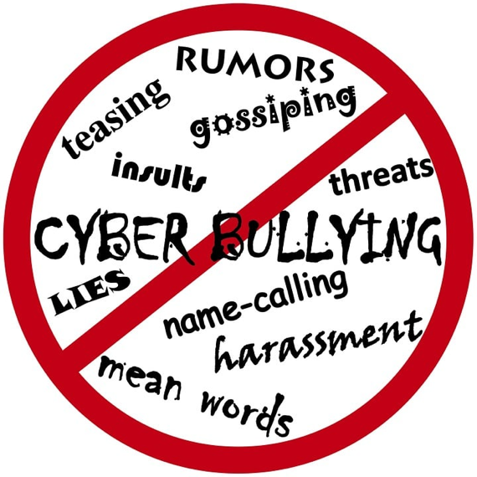
Overview
This lesson asks students to define cyberbullying and think about effective responses to observing cyberbullying or being cyberbullied.

Goals
As a result of this lesson, students will be able to:
- explain and apply knowledge about the concept of cyberbullying and its effects
- identify, evaluate, and plan to apply anti-cyberbullying responses
(CC0)


Lesson Materials

IN YOUR CLASSROOM
- Paper and pencils or pens
- Chalkboard and chalk or whiteboard and markers
- Projector for displaying images or lesson content (optional)

PROVIDED WITH THIS LESSON PLAN
- Cyberbullying questionnaire (student and teacher versions)
- “The Cyber Story” comic (digital presentation and printable versions)
- “Cyberbullying: Result or Action?“ handout (student and teacher versions)
- Comic creation frames (see the Variations and Extension section)
(CC0)

Preparation
- Review the Procedures and Lesson Materials sections, then determine the formats you will use for the Lesson Materials.
  - Many lesson materials can be photocopied, enlarged, projected onto the board or a wall, or copied by students on to their own paper. After selecting the formats, prepare the required number of materials to suit your class size, considering how many groups or individuals will participate in each lesson stage.
    - Procedures Step 3 uses a comic about cyberbullying (Lesson Materials: Item B). Some comic content is blank for student groups to fill in; pages 1-3 and 23 don’t have blanks. The Step 3 instructions are designed for teachers using the Digital Presentation comic (.ppt). If you are unable to digitally display the comic, print enough copies (two-sided, greyscale or color) of the Student Version (.pdf) for the number of student groups in the activity. Groups can share a printed copy to develop their answers. The teacher can use the Teacher Version (.pdf). to read aloud the missing information for each blank. Alternatively, post 1-2 copies of the Teacher Version on a wall away from student desks, and direct groups to get up and check their predictions against the Teacher Version once they have filled in all the blanks.
  - Learn about local cyberbullying behaviors in your students’ age group: What forms of cyberbullying occur? How do students respond? How do people in positions of authority respond to cyberbullying reports? Does your institution have an anti-cyberbullying policy? Are there cultural differences between suggestions in these lesson materials and what is acceptable where you live? How can you highlight these differences?
- Read the Skills and Language Topics and Key Vocabulary lists below. Will you need to activate prior knowledge, pre-teach, or otherwise provide scaffolding (support) for your students beyond the suggestions in the Procedures section? See the Variations and Extensions section for ideas.

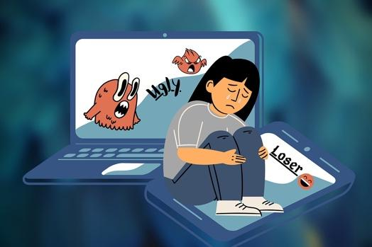
Skills and Language Topics
- Building awareness about writing genres: comics and graphic novels
- Critical thinking: making predictions and inferences
- Expressing opinions, reasoning, and responses to hypothetical situations

(CC0)
Key Vocabulary
- anti-bullying  - anonymous – anonymously  - consequence  - bullying – bully | - to bully – to be bullied  - cyberbullying  - hacked – to hack  - to harm | - to humiliate  - to intimidate  - panel  - to pose as (another person) | - to post  - rumor  - speech bubble, thought bubble  - target – to target

Procedures
TIME | STEPS | NOTES
5 min | 1. Warm-up: What is cyberbullying?  - Write the word cyberbullying on the board. Ask students to identify the two main parts in this word (cyber and bullying). Elicit or explain the meanings for the two parts: cyber = related to computers, online, or virtual spaces; bullying = repeated, unwanted, aggressive/mean behavior designed to make people feel upset, ashamed, or less powerful.  - Direct students to think about these two pieces together. Ask them to share possible cyberbullying definitions or examples. Write students’ ideas on the board.  - As students contribute, ask concept-checking questions about the format, mode, and targets (victims) of cyberbullying to ensure they understand that cyberbullying can be any form of bullying that occurs online; it is meant to intimidate (make people feel less powerful) and humiliate (make people feel bad about themselves).  Concept-checking questions might include:  - How does cyberbullying happen?  - What devices or online tools and platforms do cyberbullies use?  - How do targets of cyberbullying react or feel?  - Who can be cyberbullied?  - Why might someone be a cyberbully?  - Do we always know who cyberbullies are? Can cyberbullying happen anonymously? | Teacher-facilitated class discussion
10 min | 2. Questionnaire  - Put students in pairs; distribute one copy of the cyberbullying questionnaire (student version) to each pair.  - Explain the instructions and direct the students to begin working. Monitor their progress and offer assistance as needed.  - When they’re ready, ask students to work with a neighboring pair to compare and discuss their answers. Then tell students to set their questionnaires aside until later in the class session. Let them know they will revisit their responses. | Lesson Materials - Item A, part 1  Pair and small group work
35 min | 3. Reading a comic: “The Cyber Story”  - Put students into small groups of 3-5 learners.  - Introduce students to the “The Cyber Story” comic by Wendy Vélez-Torres. Digitally display the Presentation Version (.ppt) of the comic and read the first 15 panels aloud (slides 1-3) with the class to introduce the setting, plot, and main characters. As needed, teach or point out examples of comic-related terms and concepts like, panel, thought bubble, and speech bubble.  - Explain that as the story continues, some thought or speech bubbles will be empty (blanks marked with dotted outlines and ???). Tell students that each time the story has a blank, they will discuss with their groupmates how to complete the missing information. Explain that they should use visual clues, information about what happened earlier in the story, and their prior awareness of cyberbullying to make predictions.  - Lead the class through the rest of the comic: (1) read the comic panels aloud using your best “acting” voice to convey the emotions and character traits shown in the story or (2) ask student volunteers to read specific characters’ speech and thought bubbles. List the characters on the board—including a narrator who will read contextual information like “Later that day ….”—along with the related student “voice actors.”  - Each time there is a blank, direct students to discuss briefly with their groups how to complete it. Tell the class that the goal isn’t to guess the exact missing words, but to make logical guesses based on the situation and their prior knowledge. When most groups appear ready, ask volunteers to share their group’s answer.  - Move the presentation forward to reveal the missing information. Compare the student answers to the original comic—this process may lead to laughter when predictions differ from the original and can cause celebration when predictions were accurate. Repeat this process for the remaining blanks.  - During whole-class sharing, direct students’ attention to theme-specific vocabulary items such as hacking (to hack), posing (to pose) as needed.  - Explore the final four comic panels (slide 23) together. Recap the main cyberbullying concepts shared in the comic and answer any questions from the class. | Whole-class introduction  Lesson Materials - Item B, Comic Presentation Version  Some characters in the comic aren’t named. Feel free to name them or ask students to give them names. Note: These instructions refer to the digital presentation version of the comic; see the Preparation section for other options for sharing the comic with students if you can’t digitally project the comic.  Whole-class reading (teacher-led or with student participation); group work, and whole-class share outs
10 min | 4. Reading reflection: Revisiting the questionnaire  - Ask students to return to the questionnaire completed in Step 2. Allow students to review and make desired answer changes.  - Review the correct answers with students, provide or elicit additional explanatory information, and answer any questions from the class. Refer to the teacher’s version of the questionnaire as needed. | Individual  Whole-class review  Lesson Materials - Item A, part 2
20 min | 5. Classification: Negative consequence or helpful action?  - Give each student a copy of the “Cyberbullying: Result or Action?” worksheet or display it on the board and ask students to copy it on their own paper.  - Direct students to read each item in the lefthand column and to put a checkmark in the correct center or righthand column, classifying it as a cyberbullying consequence (result) or an action taken to limit or prevent cyberbullying.  - Ask students to turn to a nearby partner to discuss their answers.  - Review and discuss students’ responses as a class, answer any questions about the content. Refer to the teacher’s version of the worksheet if needed. | Lesson Materials - Item C, part 1  Individual  Pair discussion  Whole-class review  Lesson Materials - Item C, part 2
10 min | 6. Reflection and application: What would you do?  - Display the scenario below on the board.  - Read the scenario aloud. Direct students to write individual responses to the three questions that follow the scenario on their own paper.  Scenario: You are on a popular social media channel. You see a few students in your class are posting publicly about an overweight student they don’t like. Someone posted a photo of the student that he probably doesn’t know was taken. His clothes and hair are messy, and his eyes are half-closed. The photo post tells viewers to reply with what they think. Several unkind comments, memes, and .gifs have already been posted in response. Almost everyone at school views this site.  Is this an example of cyberbullying? What would you do? Why?  - If time allows, ask a few volunteers to share their response strategies. Collect the written responses. After class, review the responses for information such as reactions to the lesson, content understanding, and topics to address during future instruction. | Individual  Tailor this scenario to make it more relevant for your context; insert the name of a popular social media tool where you live, give the bullying target a name, change the target’s gender or reason for being bullied, etc.

Variations and Extensions

VARIATIONS

1. General differentiation and scaffolding
- Based on students’ levels and prior knowledge, teachers can choose to cover the lesson content over two class sessions. This approach will enable teachers to provide additional instruction, review, and support as appropriate.
- To make the questionnaire and classification chart activities more accessible for lower-level students, reduce the number or complexity of items in each handout. (Lesson Materials - Items A1 and C1).
- For ideas about how to introduce some of the anti-bullying terms and concepts in this lesson, see the What Is Bullying? lesson plan.

2. Options for working with the anti-bullying comic
- The panel prediction and completion activity is a fun way to teach and apply new vocabulary, practice reading comprehension skills, and strengthen critical thinking skills. However, this comic can be used in other ways. For example, print a few copies of the Teacher Version. Leave pages 1-3 and 23 whole and cut up the individual panels on pages 4-22, keeping them in order and together as complete sets of the comic.
  - Complete comic reconstruction: Mix up the cut panels in the comic sets. Introduce the comic using the complete pages 1-3; preview the ending by reading page 23. Distribute a mixed-up panel set to each student group. Ask them to try to put the remaining panels in order.
  - Partial reconstruction, summarize, and order: Divide each cut panel set into four parts, perhaps grouping panels from pages 4-8, 9-13, 14-18, 19-22. Mix up the panels in these partial sets. Introduce the comic using the complete pages 1-3; preview the ending by reading page 23. Distribute a partial mixed-up panel set to each student group. Direct groups to try to put their panels in order. Ask each group to summarize what happened in their story segment for the whole class. Support the class in putting the whole story in order based on the summaries.
EXTENSION

Create an anti-cyberbullying comic
- Support students in using blank comic frames (Lesson Materials - Item D) to create their own original comics that address cyberbullying or other anti-bullying themes. These comics should include a clear example of bullying and depict actions the characters take to address it. Students can work individually or in pairs. If students are motivated by this activity, help them refine their work through a draft and revision process; allow students to enhance their comics with markers or colored pencils if desired. Create a class collection of anti-bullying comics that can be published or shared with others.

External links are provided for informational purposes only; there is no implied U.S. Department of State endorsement of the views, opinions, media content,
or privacy policies contained therein.

Unless otherwise noted, CC0 images in this resource are “no-attribution required” items sourced under the Pixabay simplified license or the Unsplash license. If sharing, adapting, or remixing portions of this lesson plan, please respect excepted permission and licensing statements noted in the credit statements for individual images, graphics, or other content. To learn about Creative Commons licenses, their uses, and their restrictions, visit the Creative Commons license explanation site.

Cyberbullying: Curbing Hurtful Behavior Online - Lesson Materials
CREATING AN ANTI-BULLYING CULTURE

A. Cyberbullying Questionnaire

Part A1 - student version
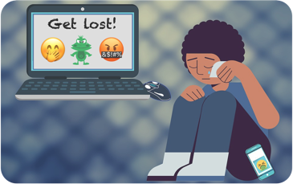
Instructions:
What do you know about cyberbullying?
- Put an ‘X’ in the True column if you think the statement is correct.
- Mark the False column if you think the statement is incorrect.
(CC0)

Cyberbullying | True | False
1 … can happen to anyone.
2 … happens only on social media.
3 … is against the law (or against the rules) in some countries.
4 … can be public—seen by many people—including those you don’t know.
5 … can happen at any time, day or night.
6 … should be stopped by immediately deleting all bullying messages.
7 … is less harmful than traditional face-to-face bullying.
8 … often happens outside the view of adults.
9 … can be anonymous (you don’t know who is doing it).
10 … can happen while the target is in a safe location.

- - - - - - - - - - - - - - - - - - - - - - - - - - - - - - - - - - - - - - - - - - - - - - - - - - - - - - - - - - - - - - - - - - - -
Instructions:
What do you know about cyberbullying?
- Put an ‘X’ in the True column if you think the statement is correct.
- Mark the False column if you think the statement is incorrect.
(CC0)

Cyberbullying | True | False
1 … can happen to anyone.
2 … happens only on social media.
3 … is against the law (or against the rules) in some countries.
4 … can be public—seen by many people—including those you don’t know.
5 … can happen at any time, day or night.
6 … should be stopped by immediately deleting all bullying messages.
7 … is less harmful than traditional face-to-face bullying.
8 … often happens outside the view of adults.
9 … can be anonymous (you don’t know who is doing it).
10 … can happen while the target is in a safe location.

Part A2 - teacher version

Instructions:
What do you know about cyberbullying?
- Put an ‘X’ in the True column if you think the statement is correct.
- Mark the False column if you think the statement is incorrect.

Cyberbullying | True | False
1 … can happen to anyone.  The internet’s reach and anonymity make it easier for cyberbullies to target anyone, even the rich, powerful, and famous. | X
2 … happens only on social media.  It can also take place through email, text messages, message boards, online gaming, chatrooms, etc. |  | X
3 … is against the law (or against the rules) in some countries.  Some laws also protect against bullying related to race, ethnicity, gender, disability, etc. These types of bullying are sometimes called harassment or hate crimes. | X
4 … can be public—seen by many people—including those you don’t know. The ability to instantly spread hurtful content to a large group is what makes cyberbullying so damaging. | X
5 … can happen at any time, day or night.  The global online community is always active, day or night. | X
6 … should be stopped by immediately deleting all bullying messages. Messages should be saved as evidence and used to address the bully and the problem. |  | X
7 … is less harmful than traditional face-to-face bullying.  All kinds of bullying are harmful. However, cyberbullying often has a larger online audience and can be more difficult to address or remove. |  | X
8 … often happens outside the view of adults.  Adults may not be aware of or able to monitor young people’s e-communication. | X
9 … can be anonymous (you don’t know who is doing it).  Hacking and fake usernames can make it hard to know the cyberbully’s identity. | X
10 … can happen while the target is in a safe location.  A target can be in a safe physical location, but still face the negative impact of cyberbullying. | X

B. “The Cyber Story” comic – Presentation, Student and Teacher Versions
Please locate and download the lesson materials listed below on the
resource page for this lesson plan.

Presentation Version (digital display .pptx file)
- This version of the comic can be digitally displayed for the class.
- All panels on slides 1-3 and 23 are complete.
  - There are blank thought and speech bubbles in the remaining slides. After students make their predictions about how to fill in each blank, move the presentation forward to reveal the original version of the comic associated with that blank.
Student Version (printable .pdf)
- This version of comic includes some blank thought and speech bubbles on pages 4-22. The panels on pages 1-3 and 23 are complete.

Teacher Version (printable .pdf)

- This is the complete version of the comic.

“The Cyber Story” comic was created by Wendy Vélez-Torres; the author has granted use of the comic with this lesson plan under a CC BY-NC 4.0 license. When using this comic, credit to author should be given, and it should not be used for commercial (money-making) purposes.

C. “Cyberbullying: Result or Action?” worksheet

Part C1 – Student version

Cyberbullying: Result or Action?

Instructions:
- Read the items in the column on the left.
- Place a checkmark () in the middle column if you think the item is a possible consequence or result of cyberbullying.
- Place a checkmark () in the column on the right if you think the item is a possible action to prevent or reduce cyberbullying.

 | Cyberbullying consequence | Action to  prevent or reduce cyberbullying harm
- Begin to miss school
- Feel bad about who you are or feel depressed
- Add people you know well to your social media networks
- Don’t post photos you don’t want shared
- Have a negative change in mood or attitude
- Have nightmares (bad dreams)
- Choose a strong password
- Change your eating habits (eat more or less than usual)
- Tell someone you trust if you know someone is being cyberbullied
- Feel alone and scared
- Be careful about information you share online
- Block people who bully you (don’t allow them access to your information)
- Ask a trusted adult to help to stop the bullying
- Have trouble sleeping
- Report the bullying behavior to parent, teacher, or another adult
- Lose friends or interest in activities you enjoy
- Get lower grades/marks than usual
- Save bullying messages or images as evidence
- Take a break from social media
- Talk to a friend or someone you trust
- Don’t share your passwords with anyone

Part C2 – Teacher version
Cyberbullying: Result or Action?

Instructions:
- Read the items in the column on the left.
- Place a checkmark () in the middle column if you think the item is a possible consequence or result of cyberbullying.
- Place a checkmark () in the column on the right if you think the item is a possible action to prevent or reduce cyberbullying.

 | Cyberbullying consequences | Actions to  prevent or reduce cyberbullying harm
- Begin to miss school
- Feel bad about who you are or feel depressed
- Add people you know well to your social media networks
- Don’t post photos you don’t want shared
- Have a negative change in mood or attitude
- Have nightmares (bad dreams)
- Choose a strong password
- Experience a change in eating habits (eat more or less than usual)
- Tell someone you trust if you know someone is being cyberbullied
- Feel alone and scared
- Be careful about information you share online
- Block people who bully you (don’t allow them access to your information)
- Ask a trusted adult to help to stop the bullying
- Have trouble sleeping
- Report the bullying behavior to parent, teacher, or another adult
- Lose friends or interest in activities you enjoy
- Get lower grades/marks than usual
- Save bullying messages or images as evidence
- Take a break from social media
- Talk to a friend or someone you trust
- Don’t share your passwords with anyone

D. Comic templates – Extension option



