The Power of Positive Personal Mottos
CREATING AN ANTI-BULLYING CULTURE
\


Overview
In this lesson, students will explore how personal mottos can help people overcome challenges—like being the target of bullying—and approach others with empathy.

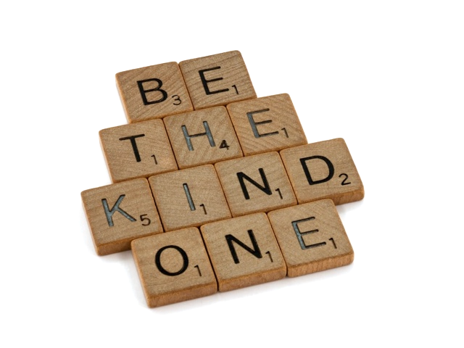
Goals
As a result of this lesson, students will be able to:
- consider the effects of bullying on others
- explore the concepts of empathy and compassion
(CC0)

- explain the purpose of a personal motto
- select personal mottos for creating an inclusive, supportive community

Lesson Materials
(CC0)

IN YOUR CLASSROOM

- Paper and pencils or pens
- Chalkboard and chalk or whiteboard and markers
- Art supplies – scissors; markers, crayons, or colored pencils
- Projector for displaying images or lesson content (optional)
(CC0)
PROVIDED WITH THIS LESSON PLAN
- Starting from empathy: Effects of bullying (head and shoulders visual)
- “Lizzie Velásquez: Anti-bullying Motivational Speaker” reading text
- Examples: Personal mottos for promoting empathy, compassion, and inclusion
(CC0)
- “My Personal Motto for Empathy and Compassion” worksheet and exit ticket

Preparation
- Review the Procedures and Lesson Materials sections, then determine the formats you will use for the Lesson Materials.
  - Many items can be photocopied, enlarged, or projected onto the board or a wall. More suggestions for formatting and sharing these materials are in the Procedures steps and notes.
  - After selecting the formats for the activities, prepare the required number of materials to suit your class size, considering how many groups or individuals will participate in each lesson stage.
  - For the warm-up activity (Procedures Step 1), plan to give your “head and shoulders” outline a locally relevant name. Think of a short bullying-related scenario that person might have experienced. For example, “This is Paulo. Nobody sits next to him at lunch or in the library. He is always picked last for sports teams. Sometimes two bigger boys in class whisper mean things at him, like calling him a baby.”
- Think about your personal motto(s): do you have a motto, saying, proverb, or mantra that guides your approach to treating others with compassion? What is the motto in your language? How would you communicate that idea in English? When and how do you use your motto? Apply these insights as you prepare the lesson: how might you model or establish concepts, create interest, or build rapport with students by sharing some of this information?

- Read the Skills and Language Topics and Key Vocabulary lists below. Will you need to activate prior knowledge, pre-teach, or otherwise provide scaffolding (support) for your students beyond the suggestions in the Procedures section? See the Variations and Extensions section for ideas.

Skills and Language Topics

- Reading for main ideas and details
- Creativity and self-awareness: identifying personal mottos
- Flexible thinking and empathy development

Key Vocabulary
(CC0)
- anti-bullying  - (physical) appearance  - bullying – bully – to bully – to be bullied  - cyberbullying  - compassion  - to define (someone’s worth/importance)  - to be grateful | - hurtful – to hurt  - inspiring – to inspire  - motto – personal motto  - motivation – to motivate  - motivational speaker  - to overcome

Procedures
TIME | STEPS | NOTES
10 min | 1. Warm-up: Practicing empathy and compassion    - Hold up the head and shoulders drawing. Introduce this “person” and share the bullying scenario this person has experienced. For example, “This is Paulo. Nobody sits next to him at lunch or in the library. He is always picked last for sports teams. Sometimes two bigger boys in class whisper mean things at him, like calling him a baby.”  - Ask students to sit quietly for a moment and think about how the “person” might feel. Then ask them to reflect on how they would feel if they were in the same situation.  (CC0)  - Direct students’ attention to you as you tightly crumple up the piece of paper. Explain this act represents the effects the hurtful words and actions have on the “person.”  - Try to smooth out the paper while the class observes. Hold up the paper, showing the wrinkles and creases that remain. Explain that negative, bullying behaviors often have lasting effects, like the wrinkles in the piece of paper. They are difficult to smooth out or remove.  - Crumple the paper and try to smooth it again quickly a couple of times, mentioning that the “person” likely experiences bullying behaviors more than one time; like the wrinkles, the negative effects build up over time.  - Ask students to think for a moment again quietly about how the “person” probably feels, and then reflect on how they would feel if they faced repeated bullying.  - Explain that the ability to imagine ourselves experiencing someone else’s situation and to think about their feelings is called empathy. Write the word on the board. If desired, you might briefly introduce related English idioms such as to put yourself in [someone else’s] position or to walk a mile in [someone else’s] shoes.  - Explain that empathy (understanding) often leads to compassion, a desire to help others (action). Tell students that empathy and compassion are important parts of creating an anti-bullying environment, and of building an inclusive, connected community.  - Share an example of how you practice empathy and compassion. (You might say something like, “When I get frustrated that a student isn’t paying attention, I try to remember that he or she might be having a difficult day … I talk to the person privately after class if possible. I ask how they are doing. Trying to understand someone else’s situation (empathy), leads to action (compassion)… asking how they are doing and if I can help.”) Ask student volunteers to share additional examples. | Teacher-facilitated class activity and discussion  Lesson Materials – Item A. You can draw this image on a large piece of paper if you’d prefer not to print a copy. You can also darken the lines of the printed image with a marker if needed for visibility purposes.
25 min | 2. Reading and discussion: Identifying and responding to bullying  - Tell the class they are going to read a short text about Lizzie Velásquez, an American woman who was bullied throughout her time at school and cyberbullied as a teenager. Review or present terms related to bullying and cyberbullying as needed.  - Pass out copies of the “Lizzie Velásquez: Anti-bullying Motivational Speaker” text.  - Review the instructions at the top of the text:  - Before you read: Define the word anti-bullying or give an example of an anti-bullying action.  - As you read: Think about what it means to be a motivational speaker. Underline details in the text about why Lizzie became a motivational speaker.  - After you read: Prepare to discuss: (1) your understanding of what a motivational speaker is and why Lizzie became one; and (2) your answer to the question at the end of the text.  - Answer questions about the instructions. Direct students to begin working. Monitor students and offer assistance as needed.  - After students finish, put students in pairs or small groups. Ask students to compare and discuss their answers.  - When ready, ask volunteers to share their answers for Parts 1–3. Write their responses and ideas on the board as needed for concept reinforcement. | Lesson Materials - Item B  As desired: Direct students to complete Part 1 before explaining the other instructions.  Individual  Pair or small-group discussions  Teacher-led class discussion  Keep students in pairs or small groups; they will continue working together in the next step.
15 min | 3. Concept exploration: Personal mottos  - Write the word motto on the board. Ask the class if they have heard or seen this word before; ask student volunteers to share definitions or examples. Elicit or explain that a personal motto is a belief or “guiding idea” that someone uses to make decisions, including decisions about how to react to a challenging situation such as being bullied like Lizzie Velásquez.  - Working in their Step 2 pairs or groups, ask students to discuss the three questions below; display them on the board for reference while students work.  - What is Lizzie Velásquez’s personal motto? (Review the reading if needed.) “I define who I am.”  - What does her motto mean? How does it help her? She doesn’t let negative words or actions make her feel weak, ugly, etc. Lizzie uses negative words to motivate her to set goals and to reach them. She demonstrates her persistence and strength this way.  - Do you know anyone who has a personal motto? What is it? How does it help them?  - Ask volunteers to share their group’s responses with the class.  - Explain that in addition to helping us respond to challenges, personal mottos can also remind us to view other people with empathy and compassion.  - Display and explore several example mottos on the board. Demonstrate that these personal mottos for empathy and compassion can be expressed as a single word (Lead, Love), a social media hashtag (#respect; #YouBeYou; #compassion), a short phrase (Honor differences; Be kind), a sentence (Be the change you want to see; Peace begins with me; We all have a gift to share with the world.), or a proverb (Treat others as you want to be treated.). Ask concept-checking questions about the mottos’ meanings; ask students to assist with translating the mottos into a shared local language if helpful.  - If possible, share one of your personal mottos about treating others with empathy and compassion. Describe why it is meaningful to you and how it helps you approach situations with an empathetic mindset.  - Explain that these personal mottos encourage people connect with each other: practicing empathy helps us see beyond our differences, both physical (race, gender, physical appearance/ability) and non-physical (politics, wealth, religion, culture, etc.); focusing on what people have in common can reduce situations like bullying, which highlights differences in harmful ways; empathy can lead to compassionate action in support of people who are excluded (left out) or harmed because of a difference.  - Answer any remaining questions about the concept of personal mottos for encouraging empathy and compassion. | Teacher-guided concept establishment  Pair or small-group discussions  Teacher-guided concept establishment  Example mottos (images and text) are available in Lesson Materials - Item C; you can also write your own examples on the board or build an inspirational slide show that contains these and other visual examples you find or make. Motto language can be figurative or idiomatic, so exploring the meaning of several examples—including one of your mottos—can improve student’s comprehension of individual mottos and enhance their confidence for the next step of the lesson. Leave these example mottos on the board so they will be available for students during Step 4.
30 min | 4. Choosing a personal motto for empathy and compassion  - Tell students they are going to select or create and illustrate a personal motto that promotes practicing empathy and compassion.  - Explain that students can choose a personal motto that has been shared on the board or discussed earlier in class, or they can create their own personal motto in English.  - Put students into small groups.  - Distribute a “My Personal Motto for Empathy and Compassion” worksheet to each student. Review the instructions and answer any questions about them. Instruct students to begin working individually. Monitor student progress; offer support as they choose or create their mottos. Pass out scissors and art supplies to the groups while students work.  - When ready, ask students to work in groups, sharing their illustrated personal mottos and discussing their answers to the two questions on the bottom of the worksheet.  - Lead a whole-class discussion in which a few groups share their mottos and reactions to each other’s work. | Lesson Materials – Item D. You can display this content on the board and students can copy the material onto their own paper if needed.  Individual. Students can create mottos based on local knowledge or proverbs about empathy and overcoming differences, or they might have a creative original motto in mind!  Small-group and class discussions
5 min | 5. Reflection: The power of personal mottos  - Direct students’ attention to the two exit ticket questions at the bottom of the personal motto worksheet. Ask them to answer the questions, adding their names to the exit tickets if you require it.  - Tell students to cut out their illustrated motto and take it with them. Encourage them to follow their exit ticket plan to use the illustrated motto as visual reminder to practice empathy and compassion.  - Ask students to cut off the completed exit ticket at the bottom of the sheet and return it to you as they depart class. Review student responses. | Individual  Students can write the answers to the exit ticket questions on their own paper if needed.

Variations and Extensions
VARIATIONS

General differentiation and scaffolding
- Based on students’ levels and prior knowledge, teachers can choose to cover the lesson content over two class sessions. This approach will enable teachers to provide additional instruction, review, and support as appropriate.
- To make the reading activity more accessible for lower-level students, reduce the length or complexity of the reading text and gloss challenging vocabulary terms. For more advanced classes, consider showing a portion of one of Lizzie Velásquez’s TED talk videos to reinforce ideas from the reading.
- To make working with a personal motto (Step 4) more accessible for less-proficient students, print out a selection of mottos students can choose from; students can illustrate a page featuring a motto that is meaningful to them.
- For ideas about how to introduce the anti-bullying terms and concepts in this lesson, see the What Is Bullying? lesson plan.

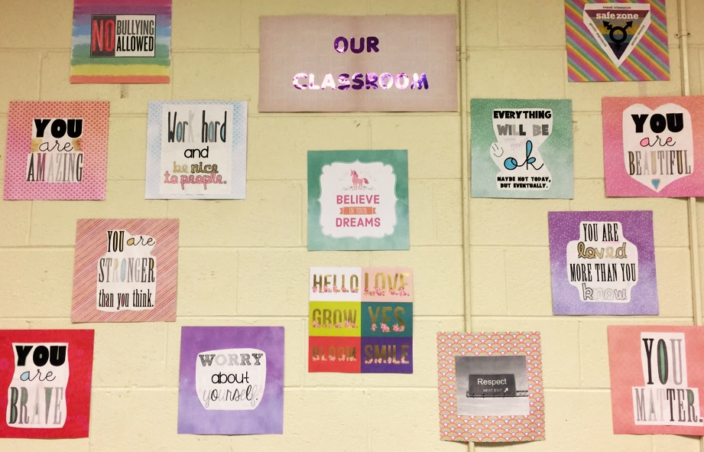
Create an inspirational empathy and compassion wall display
- After students create their illustrated mottos in Step 4, make a temporary wall display featuring them. Ask students to do a “gallery walk” of the display, making notes about these questions as they view their classmates’ work:
  - Which motto is your favorite?
  - Which motto is the most creative? [You can substitute another superlative, such as the funniest, the most effective, most inspirational, etc.]
(Photo: Luis Javier Pentón Herrera (CC BY 4.0)
  - Overall, how does the class personal motto display make you feel?
- Guide a whole-class debrief or facilitate small-group discussions about the students’ responses and how they feel about the power of personal mottos. When you take the display down, return the illustrated mottos to the students.

EXTENSION
- Share the power of your students’ mottos with other classes or groups of people. If the audience doesn’t read English, students can translate and present (orally or in writing) their mottos in a local language, too. Ask audience members to share personal mottos that can be added to motto display. Sharing can occur online, too: Ask students to upload a photo of their hardcopy motto or design an e-version; create a motto e-display with a free content curation tool like Padlet. Students can add explanatory captions, voice comments, and more!

External links are provided for informational purposes only; there is no implied U.S. Department of State endorsement of the views, opinions, media content,
or privacy policies contained therein.

Unless otherwise noted, CC0 images in this resource are “no-attribution required” items sourced under the Pixabay simplified license or the Unsplash license. If sharing, adapting, or remixing portions of this lesson plan, please respect excepted permission and licensing statements noted in the credit statements for individual images, graphics, or other content. To learn about Creative Commons licenses, their uses, and their restrictions, visit the Creative Commons license explanation site.

The Power of Personal Mottos
CREATING AN ANTI-BULLYING CULTURE


A. Starting from empathy: Effects of bullying (visual)

(CC0)
Istanbul, Turkey CC0
Location unknown CC0

B. “Lizzie Velásquez: Anti-bullying Motivational Speaker”

- Before you read: Define the word anti-bullying or give an example of an anti-bullying action:
__________________________________________________________________________________________________________________________
- As you read: Think about what it means to be a motivational speaker. Underline details in the text about why Lizzie became a motivational speaker.
- After you read: Prepare to discuss: (1) your understanding of what a motivational speaker is and why Lizzie became one; (2) your answer to the question at the end of the text

Lizzie Velásquez: Anti-bullying Motivational Speaker
Lizzie Velásquez is an American motivational speaker and author. She has a rare illness. Only one other person in the world is known to have the same condition. Lizzie cannot gain weight. Her body is very thin. As an adult, Lizzie has never weighed more than 64 pounds (29 kilos). Also, she is blind in her right eye. That eye is a light color, and her other eye is brown.
People bullied Lizzie at school because of her appearance. When Lizzie was a 17-year-old student, she found a video online. The video’s title was “The Ugliest Woman in the World.” The video did not have any sound. It showed images of Lizzie for eight seconds. The video had four million views. Many people responded to the video with hurtful comments about Lizzie.
Lizzie decided this cyberbullying experience and other bullying would not control her life. She became a motivational speaker, talking to people in person and online about being bullied. Her talks turn her terrible experiences into something positive: she explains how bullying hurt her and shares how she overcame it. Lizzie says she doesn’t let bullies define her (say what is most important about her). Her personal motto is: “I define who I am.” In her talks, Lizzie discusses her abilities and many things she is grateful for, even though her illness is difficult and people react negatively to her appearance. Her motto helps her use negative words as motivation to be strong. Lizzie tells her audiences to use other people’s negative actions to inspire success in life. She says, “I'm going to turn [negative things] around, and I’m going to use them as a ladder to climb up to my goals.” People have watched Lizzie’s inspirational “How Do You Define Yourself?” TEDx video over 13 million times!
Stop and think: How would you feel in Lizzie’s situation as a teenager? What would you do?

C. Examples: Personal mottos for empathy and compassion





(CC0)
(CC0)



(CC0)
More personal mottos:
(CC0)
- I can learn from everyone I meet.
- Help others when they can’t help themselves.
- Stop—think about how the other person feels.

- Lead with your words and actions.
- Do the right thing…even when nobody is watching.
- Spread kindness.
- Find out what we have in common.
- A world without differences would be boring!
- You can’t judge a book by its cover.
- Always ask: “How can I help?”
(CC0)
- Look for the good in everyone.

D. “My Personal Motto for Empathy and Compassion” worksheet and exit ticket
Instructions:
- Choose a personal motto from the board or create your own personal motto (in English) about practicing empathy and compassion.
- Write your personal motto in the box below. Fill a lot of space in the box. Use big letters if needed.
- Decorate or illustrate your motto.
- Answer questions 1 and 2 below the box. Be ready to share your motto and these answers with your classmates.
- Do not answer the exit ticket questions until your teacher asks you to.

- Why did you choose this personal motto? What do you like about it?


- How can your motto help you or others practice empathy and compassion?

Exit ticket:
Where can you keep your illustrated motto to remind you to practice empathy and compassion?

In your opinion, what was the most powerful motto in your group? Why?

